An Thang Primary School  Name: ...................................................  Class: ................................................... | THE 1st TERM TEST 2025- 2026  English – Grade 4  Time: 35 minutes
Marks | Teacher’s comments
I.LISTENING (3pts)
Question 1. Listen and match. There is one example. (1pt)
0 | 1 | 2 | 3 | 4
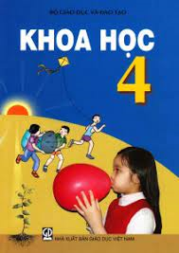 |  | 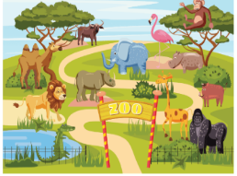 |  | 
Question 2. Listen and circle the correct answer. There is one example. (1pt)
0.A. | B. | C.
1.A. | B.  | C. 
2.A | B.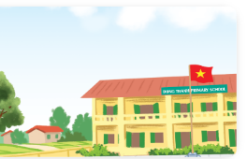 | C.
3.A.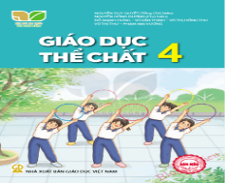 | B.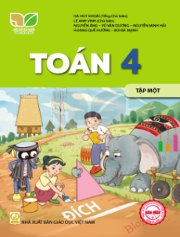 | C.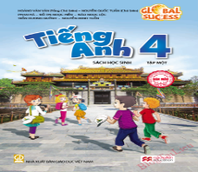
4.A. | B. | C.
Question 3. Listen and write. There is one example. (1pt)
0. When’s your sports day? - It’s in November.
1. Where are you from? - I’m from …………………………………………
2. What subjects do you have today? - I have …………………...…….
3. Why do you like art? - Because I want to be a ………………………
4. What do you want to eat? I want some …………………………......
II. READING AND WRITING (5pts)
Question 4. Read and choose the odd one out. (1pt)
1.A.Monday | B.Sunday | C.March | D.Friday
2.A.Malaysia | B.America | C.Australia | D.English
3.A.can | B.roller skate | C.play | D.swim
4.A.city | B.town | C.school | D.village
Question 5. Read and choose the correct answer. (1pt)
1. ………………….. do you get up?- At 6 o’clock.
A. How B. Why C. Who D. What time
2. When is your birthday? It’s ……………………..May.
A. to B. in C. on D. at
3. How many……………………are there at your school?- There is one playground.
A. playgrounds B. playground C. grounds D. garden
4. Why do you like maths?-………………I want to be a maths teacher.
A. So B. And C. But D. Because
Question 6: Look at the picture and write. (1pt)
1.V_ _ _ _ _ _ _ _ _  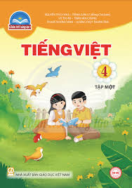 |   2. p_ _ _ _ |   3. s_ _ _ _ _ |   4.l_ _ _ _ _ _ _
Question 7: Read and complete. (1 pt)
teacher /Maths/ study/city/gardens
Hello, I'm Mary. This is my school with three buildings. It's in the city. There are two (1)…………… and a playground in my school. Here is our computer room. We (2)……………. IT here on Fridays. My favourite subject is (3) ………... Because I want to be a maths (4)……………It's really great.
Question 8. Rearrange the words to make complete sentences. (1pt)
1. is / Australia / Laura / from/.
…………………………………………………………………………..
2. housework / I / do / Sundays. / on/ and/ Saturdays/
…………………………………………………………………………..
3. rooms / school / computer / your / at / are / How / many / there/?
…………………………………………………………………………..
4. I / singer / to / be / music / want / because / a / like / I/.
…………………………………………………………………………..
II.SPEAKING (2 pts)

