AN THANG PRIMARY SCHOOL  Full name: .................................................  Class: 3…… | THE FIRST TERM TEST  SCHOOL YEAR 2025-2026  SUBJECT: ENGLISH - GRADE 3
PART 1 : LISTENING
Question 1: Listen and tick. There is one example (1pt)
0. A. 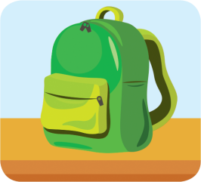 | B. 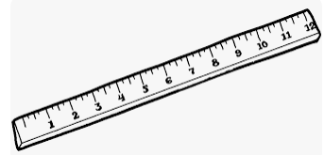
1. A. 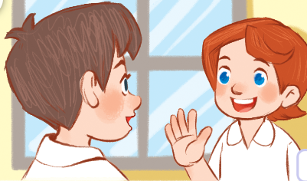 | B. 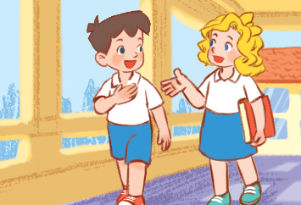
2. A. 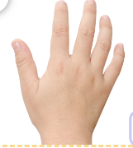 | B. 
3. A. 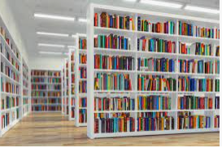 | B. 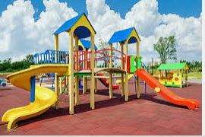
4. A.  | B. 
Question 2: Listen and match. There is one example. (1 pt)
A. 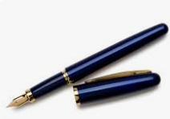 | B. 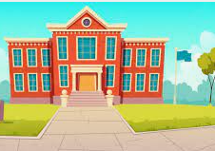 | C.  | D. 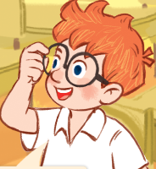 | E. 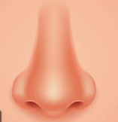

0
1
3
4
2

Question 3: Listen and number. There is one example. (1 pt)
0 | 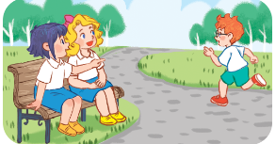  A. |   B. | 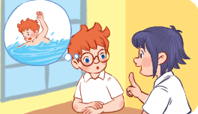  C. | 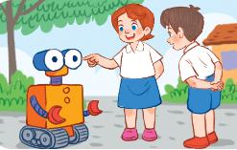  D.
PART II: READING
Question 4: Odd one out (1 pt)
1. a. swimming | b. eyes | c. hair | d. ears
2. a. six | b. to | c. ten | d. nine
3. a. a pen | b. a ruler | c. a school bag | d. pens
4. a. blue | b. colour | c. red | d. black
Question 5: Choose the best answer (1 pt )
1. A: May I open the book ?
B: No, you_______.
A. can B. is C. can’t D. isn’t
2. A: Do you have a ruler ?
B: __________.
A. Yes, it is B. Yes, you can C. No, I don’t D. No, it isn’t
3. A: What colour is it ?
B: ______ red .
A. They’re B. It’s C. He’s D. She’s
4. A. What’s your hobby?
B. __________.
A. I like cooking B.I am cooking C. It’s cook D. I like cook
Question 6: Read and choose True (T) or False (F) (1 pt)
My name is Tony. I am nine years old. My hobby is swimming. I love my school, there are many rooms in my school: an art room, a gym, a library, a music room. In my school bag, I have a pen, it’s red. I have three notebooks, they’re white. I have a ruler and two erasers, they are brown.
 | True | False
1. He’s nine years old.  2. He likes playing basketball.  3. There are 2 art rooms.  4. His ruler and erasers are brown. | ....................  ....................  .....................  ..................... | ....................  ....................  ....................  ....................

PART III: WRITING
Question 7. Look at the picture and complete the words (1 pt)
1. E__ __ __ __r  | 2. P__ __ __ __ l 
3 S __ __ g  | 4. C__ __ __ __ __ m 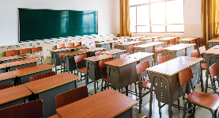
Question 8: Order the words to make sentences (1 pt)
1. are/ you/ Hello,/ how/ ? …………………………..……….....…………………………
2. go/ Let’s/ the/ library./ to ……………………………………………….………………………
3. have/ pencil / Do/ green/ you/ a/ ? ………………………………………………...……………
4. play / I / at/ football / breaktime/ and / badminton/./ …………………………………

PART IV: SPEAKING (2 pts)

