UBND HUYỆN AN LÃO  TRƯỜNG THCS TRƯỜNG SƠN | ĐỀ KIỂM TRA CUỐI HỌC KỲ II  MÔN: TIẾNG ANH 6  Năm học: 2022-2023
 | Thời gian làm bài: 60 phút
A. LISTENING (2 points)
I. Listen to the conversation again. What is important to Linda? What is important to Nick? Tick the columns.
 | Linda | Nick
1. Park view
2. City view
3. Sea view
4. Swimming pool
5. Garden
II. Listen to two students talking about what they will do if they become the presidents of the 3Rs club. Fill each blank with a word or a number.

Name | 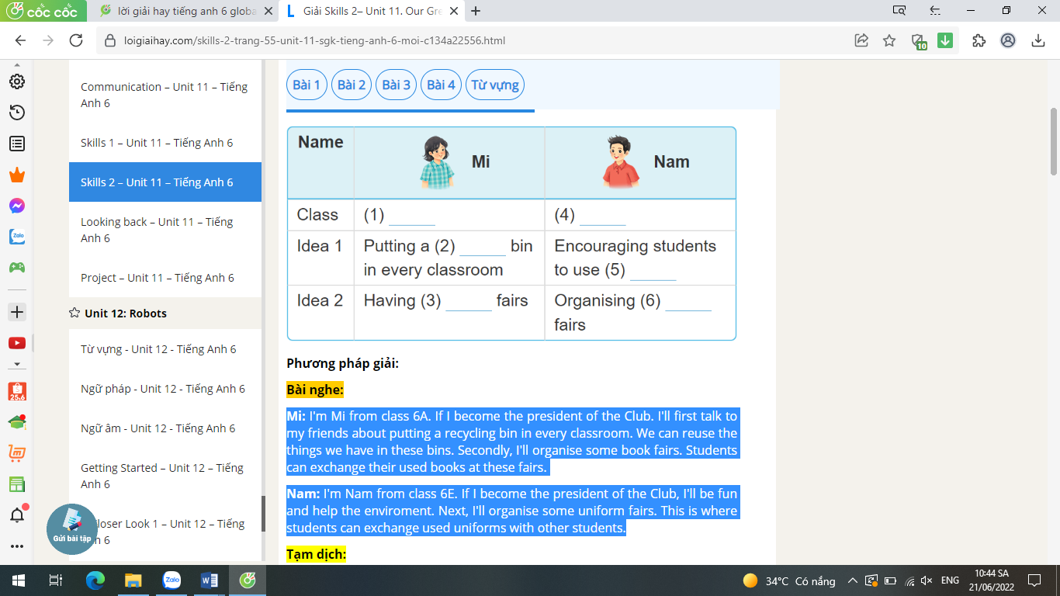
Class | - 6A | - (3) ……………….
Idea 1 | - Putting a (1)…………….. bin in every classroom | - Encouraging students to go to school by (4) …………………..
Idea 2 | - Having (2) …………… fairs | - students can exchange the (5) …………….. with other students
B. LANGUAGE (2 pts)
I. Choose the word that has the underlined part pronounced differently from that of the others(0,4pt).
1.A. hole B. flower C. cold D. nose
2. A. brother B. weather C. think D. than
II. Choose the word that does not belong to the group of the other three (0,4pt)
1. A.thought B. talked C.looked D. played
2. A. river B. mountain C.lake D.sea
III. Choose the best answer A, B or C to complete the following sentences. (1,2pt)
1. The Nile River is the __________ river in the world.
A. longest B. long C. most long D. longer
2. She is interested ………… learning English
A. on B. at C. of D.in
3. We can ……………….things like plastic bottles and cans
A. cook B. do C. reuse D. reduce
4. I like chicken, beef ……………..fish.
A. so B. and C. but D. or
5. Choose the best word that is OPPOSITE in meaning to the underline word.
Ho Chi Minh City is an exciting city
A. dangerous B. boring C. interesting D. expensive
6. James: “The car of the future will probably run on water.” – Steve: “………………..”
A. How fantastic! B. Good job! C. Well done! D. Good idea!
PART 3: READING. (2 points)
I. Choose the correct word A, B or C to fill each blank in the following passage.
VTV1 is a national television channel in Viet Nam. It attracts millions of (1)…………because it offers many different interesting programmes. The 7 o’clock news tells people what is happening in Viet Nam and the rest of the world. (2)…………................…..bring a lot of laughter and help people relax after a hard working day. The (3)………….exciting programmes (4)………… game shows. They can be both entertaining (5)………… educational.
1. A. viewers B. players C. workers D. readers
2. A cartoons B. documentaries C. comedies D sports
3. A. more B. best C. most D. many
4. A. was B. were C. is D. are
5. A. and B. or C. so D. but
II. Choose the correct answers.
A robot cannot think or do things alone. People use a computer to control it. Today, robots are becoming useful in our lives. They can help us to save a lot of time and work. A robot can do the same work for 24 hours, and yet, it does not complain or get tired. In the US, people use robots as security guards in some important places. These robots can listen for certain noises and send signals for help if there’s trouble or danger. In Japan, people use robots in factories to build cars. In the future, scientists will design many types of intelligent robots. Their robots will help us to do many more complicated things. However, some people do not like robots. They fear that one day robots will be too powerful.
1. Why do people use a computer to control a robot?
A. Because it can save time and work.
B. Because it is very useful.
C. Because it cannot think or do things alone.
D. Because it is too expensive.
2. Which of the following statements is NOT TRUE according to the text?
A. Robots cannot do the same work for 24 hours.
B. Robots do not get tired of working.
C. People use computers to control robots.
D. People use robots as security guards in some important places in the US.
3. The word “it” in the text refers to………..
A. work B. the US C. a computer D. a robot
4. In Japan, people use robots in factories to……………..
A. guard important places B. build cars
C. listen to certain noises D. do many more complicated things
5. Some people fear that one day robots ………………………
A. will have too much power B. will make too much noise
C. will be busier than humans D. will do complicated things
PART 4: WRITING (2 points)

I. Choose the part that needs correcting by circling A, B, C or D then correct it

1. One day, we might to travel to the moon for holiday. ..................................

A B C D
2. Do not eat too much salt. It’s not good for you. ………………………
A B C D
II. Put the words in the correct order.
1. housework/ help/ robots/ do/ the/ will/ me.
……………………………………………………………………………..
2. in / Ho Chi Minh / the / city / biggest /is / Viet Nam.
……………………………………………………………………………..
3.future/ My/ will/ on/ island/ house/ be/ an.
…………………………………………………………………………………
III. Complete the second sentence so that it has a similar meaning to the first.
1. My computer didn’t work last night, so I couldn’t email you.
→ I ……………………………………………………………………….
2. Don’t play with matches. You will hurt yourself.
→ If ………………………………………………………………………
IV. Write the sentences with the words provided.
1. Jenny /think/ robots /might/ help us / do / housework
………………………………………………………………………………….
2. We / not win / game, but /we had / lot /fun
……………………………………………………………………………
3. If/ there / no water, /plants / die
……………………………………………………………………………

PART 5: SPEAKING

I. Introduction: Talk about yourselves
* Giáo viên có thể hỏi một số câu hỏi cơ bản dưới đây:
1. What’s your full name?
2. Which class are you in?
3. Where do you live?
* Học sinh tự nói ít nhất 5 câu về bản thân mình
- Name / middle name / family name.
- Age.
- Job.
- Class / grade.
- School
- Home address.
II. Topic speaking
- Talking about different houses in the future
III. Questions &Answers
1. Where will you live in the future?
2. What will it be surrounded by?
3. What will it be like?
4. How many rooms?
5. What appliances might it have?

ĐÁP ÁN ĐỀ KIỂM TRA CUỐI HỌC KỲ II
MÔN: TIẾNG ANH 6
PART 1: LISTENING
I. Tick the columns.
 | Linda | Nick
1. Park view |  | v
2. City view |  | v
3. Sea view | v
4. Swimming pool | v
5. Garden | v
II. Listen to two students talking about what they will do if they become the presidents of the 3Rs club. Fill each blank with a word or a number.
1. recycling 2. Book 3.6E
4. Bus 5. uniform
PART 2 . LANGUAGE (2 points)
I. Choose the word that has the underlined part pronounced differently from that of the others.
1. B. flower 2. C. think
II. Choose the word that does not belong to the group of the other three (0,4pt)
1. A.thought 2. B. mountain
III. Choose the best answer A, B or C to complete the following sentences. (1,2pt)
1. A. longest 2. D.in 3. C. reuse 4. B. and 5. B. boring 6. A. How fantastic!
PART 3: READING. (2 points)
I. Choose the correct word A, B or C to fill each blank in the following passage.
1. A. viewers 2. C. comedies 3. C. most 4. D. are 5. A. and
II. Choose the correct answers.
1. C. Because it cannot think or do things alone.
2. A. Robots cannot do the same work for 24 hours.
3. D. a robot 4. B. build cars 5. A. will have too much power
PART 4: WRITING (2pts)

I. Choose the part that needs correcting by circling A, B, C or D then correct it

1. C => travel 2. A => don’t
I. Put the words in the correct order.
1. Robots will help me do the housework. 2. Ho Chi Minh is the biggest city in Viet Nam.
III. Complete the second sentence so that it has a similar meaning to the first.
1. I couldn’t email you because my computer didn’t work last night.
2. If you play with matches, you will hurt yourself.
IV. Write the sentences with the words provided.
1. Jenny thinks robots might help us (to) do the housework
2. We did not win the game, but we had a lot of fun
3. If there is no water, Plants will die.

