PEOPLE’S COMMITTEE OF AN LAO DISTRICT  AN THANG PRIMARY SCHOOL | THE MIDLE FIRST SEMESTER TEST  Subject: English 3 - Time: 35'

Name: ........................................................................................ Class: 3…
Question1. Listen and number. (1 pt)

  A. | 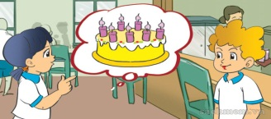  B. | 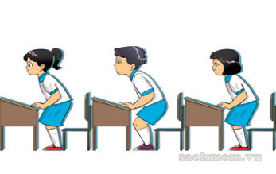  C. | 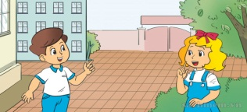  D.

Question 2. Listen and tick. (1 pt)

1. 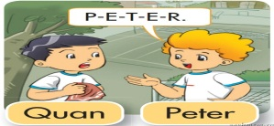 A | 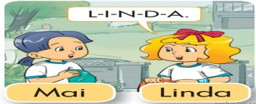 B
2. 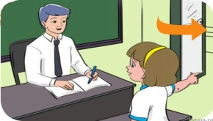 A | 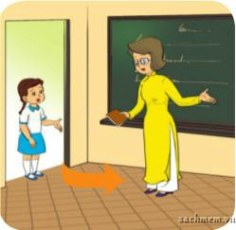 B
3. 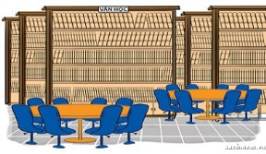 A | 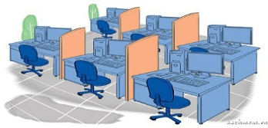 B
4.  A |  B
Question 3. Read and match.(1pt)
1. Hello, Tom. | a. My name’s Linda. | 1 - .............
2. What’s your name? | b. Yes, it is. | 2 - .............
3. How do you spell you name? | c. Hi, Tony. | 3 - .............
4. Is this your pen? | d. M - A - I | 4 - .............
Question 4 : Look and complete these words, using the given letters .(1pt)
ss - oo - en - ci - in
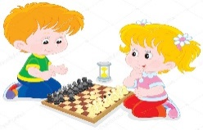
Ví dụ: 0. I play che_ss_
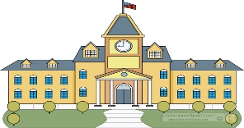

1. Op__ __ your book, please ! 3. My sch__ __l is big.



2. They are my pen__ __ ls. 4. I like badm__ __ton.

Question 5: Look and circle the best answer.(1pt)
1. I play_________
A. basketball B. badminton C. chess

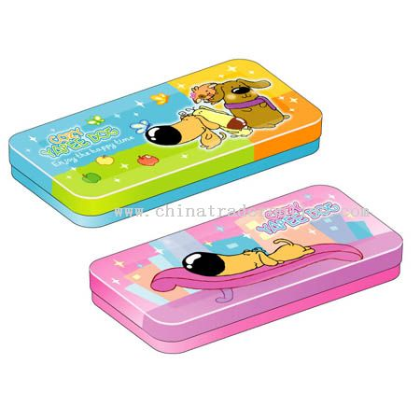  1.They are my_________________  A. notebooks  B. pencil cases  C. rulers | 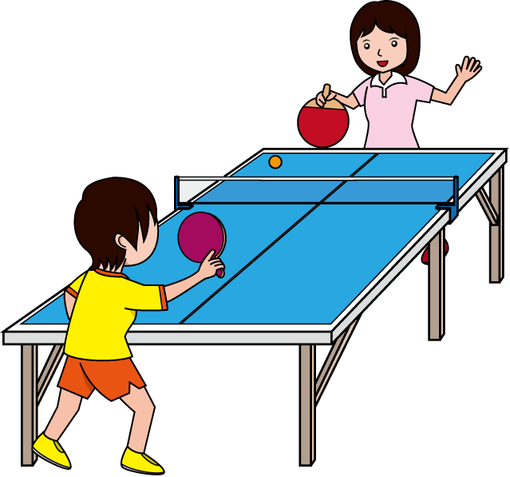  2.I play ____________________  - table tennis  - B. football  - C. chess
  3.Do you like____________?  A. hide-and-seek  B. skating  C. skipping |   4.I'm_________________ years old.  A. ten  B. eight  C. six
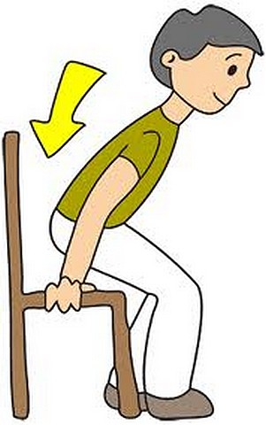
5. We play…………………………… 6. A. stand up
A. football B. sit down
B. chess C.come in
C.badminton
Question 6: Re-order the words to make the sentences.(2pts)
- your / Open / , please. / book ..............................................................................
- your / What / name ? / is .............................................................................
- you / much. / Thank / very............................................................................................
4. do / How / spell/you/ your/ name? ..............................................................................
Question 7: Read and complete the paragraph with the suitable word. (1pt)
nine - name - school - is
Hello. My (1)_____________ is Nga. I'm (2)______________years old. I'm in class 3A. This is my (3)___________________. It's big. It has ten classrooms, a gym, a library and a computer room. It (4) _____________ very beautiful.
Speaking: ( 2pts)
The end.

KEY FOR TEST – GRADE 3

Question | Answer | Point | Total
1 | 1.c 2.a 3.d 4.b | 0.25/ each | 1
2 | 1. A 2.B 3.B 4.A | 0.25/ each | 1
3 | 1.F 2.T 3.F 4.T | 0.5/ each | 2
4 | 1.c 2. a 3. d 4. b | 0.25/ each | 1
5 | . No 2. Yes 3. Yes 4.No | 0.25/ each | 1
6 | 1. Hello 2. school  3.book 4. sit | 0.25/ each | 1
7 | 1. school bag 2.pen  3. pencils 4.notebooks. | 0.5/ each | 2

SPEAKING TEST
- Getting to know each other
Ask 3 questions below
1.What is your name?
2.How are you?
3.How do you spell your name?

- Talking about a familiar object
Give some school things and ask some question
- What is this?
- What colour is it?
- What are they?
- What colour are they?
- Describing the picture

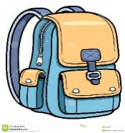
      - What’s this?
      - Is it big?
      - What colour is it?

