PEOPLE’S COMMITTEE OF AN LAO DISTRICT  AN THANG PRIMARY SCHOOL  ------------------------- | THE MIDDLE FIRST SEMESTER TEST  Subject: English 5 - Time: 35'

Name: ........................................................................................ Class:5…..
Question 1. Listen and number ( 1 pt ) .

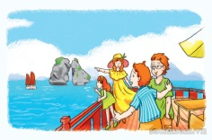 | A. | 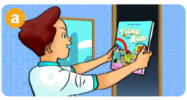 | B. | 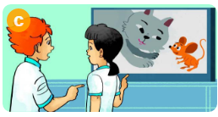 | C. | 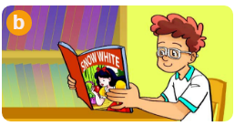 | D.

Question 2 . Listen and tick ( 1 pt ) .

1. 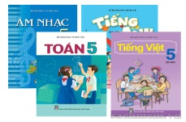A. | 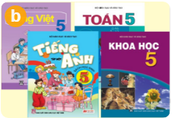 B. | 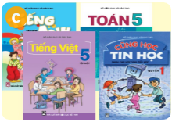 C.
2.A. | 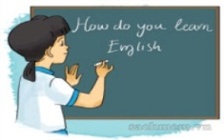 B. |  C.
3.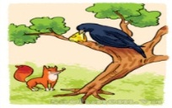 A. | 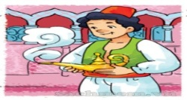 B. | 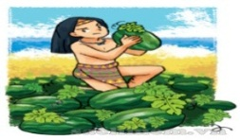C.
4.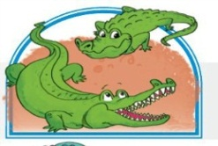A. | 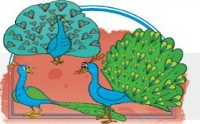 B. | 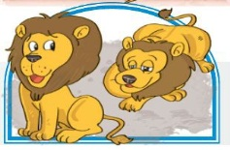 C.
Question 3. Listen and complete ( 1pt) .
1. Where did you go last Sunday, Linda? - I went to .....................................
2. How many lessons do you have today?
- I have three : ...................., IT and Science.
3. What’s Tam like? - She’s ...............................
4. What did the ……………………….. do when you were there?
Question 4. Fill in each gap with a suitable word from the box ( 1 pt ) .

Art | four | lessons | Wednesday | Tuesday

My name is Trung. I’m a new pupil in Class 5B. Today is (0) ..........Tuesday....... I have five (1) ........................ : Maths, Vietnamese, Science, IT and PE. Tomorrow is (2) ...................... I’ll have (3) ..........................lessons: Maths, Vietnamese, Music and (4) ........................
Question 5. Read the text carefully. Tick () True or False.(1 pt)
Tom likes reading. On Sunday, he often stays at home and reads comic books. He likes Case Closes very much. It is a Japanese story. The main character is a schoolboy called Jimmy Kudo. He often helps the police. He is good at his job. Jimmy Kudo is Tom’s favourite character because he is clever and brave.
 | True | False
0. Tom likes reading books in his free time
1. Case Closed is a Malaysian story.
2. The main character is Jimmy Kudo
3. Jimmy Kudo is a policeman
4. Jimmy Kudo is clever and brave

Question 6. Put the letters in the correct order to make a correct word.(1pt)
1. 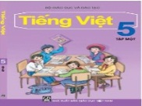 | Venimatees => | ________________
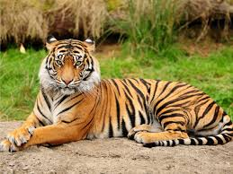  2. | itegr => | ________________
3. 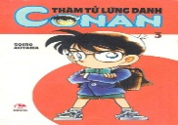 | iCocm => | ________________
4.  | dRea => | ________________

Question 7. Reorder the words to make sentences .(2 pts)

- monkeys / saw / two / at / the / He / zoo/. =>……………………………………………………….………..
- I / times / have / a / English / four / week / =>………………………………………………………..……….
- kind / Aladdin / and / is / generous / . =>………………………………………………………..……….
4. about / reading / I / a / am / story / Christmas /.
=>………………………………………………………..……….
SPEAKING. (2pts)

The end

MA TRẬN HKI MÔN TIẾNG ANH 5

Kỹ năng | Nhiệm vụ đánh giá/kiến thức cần đánh giá | Mức/Điểm |  |  |  | Tổng số câu, số điểm, tỷ lệ %
Nghe | Nhiệm vụ đánh giá/kiến thức cần đánh giá | M1 | M2 | M3 | M4 | 12 câu  4 điểm  40%
Nghe | Listen and number | 2  0,5đ | 1  0,25đ | 1  0,25đ |  | 12 câu  4 điểm  40%
Nghe | Listen and tick | 1  0,25đ | 1  0,25đ | 1  0,25đ | 1  0,25đ | 12 câu  4 điểm  40%
Nghe | Listen and complete | 2  1đ | 1  0,5đ | 1  0,5đ |  | 12 câu  4 điểm  40%
Đọc | Read the text and tick True or False | 2  0,5đ | 1  0, 5đ | 1  0,25đ |  | 8 câu  2 điểm  20%
Đọc | Fill in the blank with a suitable word | 1  0, 25đ | 2  0,5đ |  | 1  0,25đ | 8 câu  2 điểm  20%
Viết | Put the letters in the correct order to make a correct word.(1pt) | 1  0,25đ | 1  0,25đ | 1  0,25đ | 1  0,25đ | 8 câu  3 điểm  30%
Viết | Order the word to make sentences | 2  1đ | 1  0,5đ |  | 1  0,5đ | 8 câu  3 điểm  30%
Nói | Getting to know each other | 1  0,25đ | 2  0,5đ |  |  | 10 câu  1 điểm  10%
Nói | Talking about familiar object |  | 1  0,25đ | 3  0,75đ |  | 10 câu  1 điểm  10%
Nói | Describing the picture |  | 1  0,25đ | 1  0,25đ | 1  0,25đ | 10 câu  1 điểm  10%
Tổng |  | 12  32% | 12– 32% | –9 24% | 5 – 12%

KEY FOR TEST – GRADE 5

Question | Answer | Point | Total
1 | 1. B 2. D 3. C 4. A | 0.25/ each | 1
2 | 1. C 2. C 3. A 4. B | 0.25/ each | 1
3 | 1.Hanoi 2.Maths  3. kind 4. lions | 0.5/ each | 2
4 | 1.F 2.T 3.F 4.T | 0.25/ each | 1
5 | 1. lessons 2. Wednesday  3. four 4. Art | 0.25/ each | 1
6 | 1.Vietnamese 2.Pandas  3. Comic 4. Read | 0.25/ each | 1
7 | 1. He saw two monkeys at the zoo.  2. I have English four times a week.  3. Aladdin is kind and generous.  4. I am reading a story about Chistmas. | 0.5/ each | 2

SPEAKING TEST
I. Getting to know each other
Ask 3 questions below
1.What is your name?
2.How are you?
3.How do you spell your name?

II. Talking about a familiar object
Give some story book and ask some question
- What are you reading?
- What is he/ she like?
- Who is the main character?
III. Describing the picture
- What subjects do you have today?
- Do you like English? Why/ why not?
- What’s your favourite subjects?

