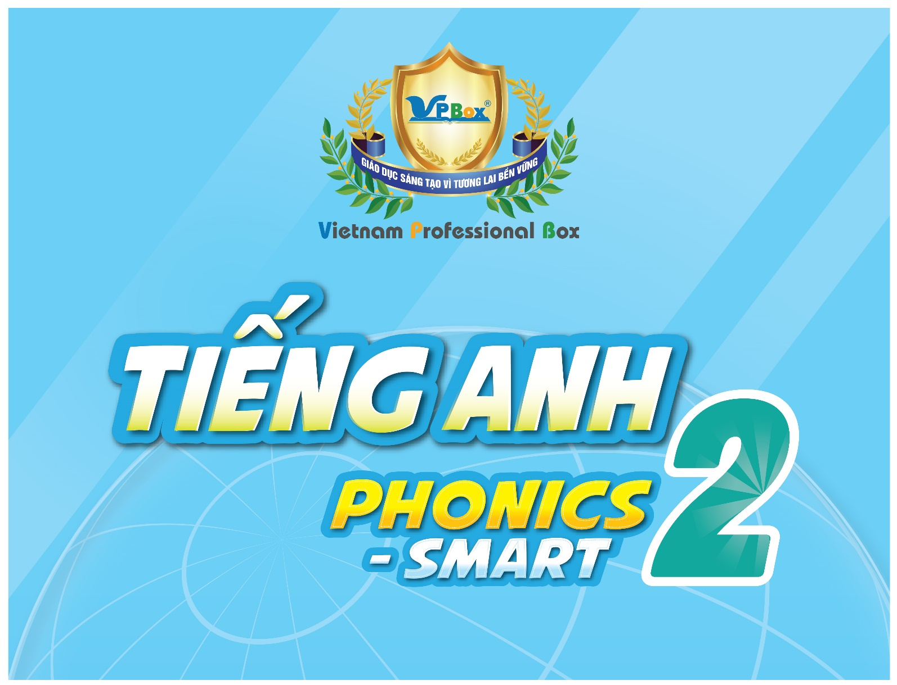

TIẾNG ANH 2 PHONICS-SMART
TERM 2 (2023 – 2024) – TEST
For pupil  Full name: ………………………………………………  School: ………………………………………………  Class: ………………………………………………  Date:  ……………………………………………… | For examiner: Code: T2_PS2  Section 1: Listening: ………/ 2.5 pts  Section 2: Reading: ………/ 2.5 pts  Section 3: Writing: ………/ 2.5 pts  Section 4: Speaking: ………/ 2.5 pts  Total: ………/ 10 pts  For teacher (signature)

SECTION 1 – LISTENING (2.5 pts)
Part I. Listen and number the pictures. There is one example. (1.25 pts)
 |  |  | 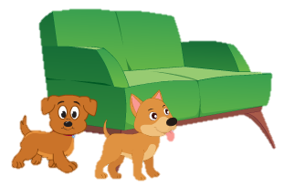   |  |   Hồng
0

Part II. Listen and tick () the box. There is one example. (1.25 pts)
 |   Example | A |  | B | 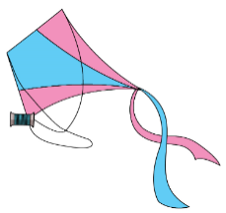 | C
1. |  | A |  | B |  | C
2. | 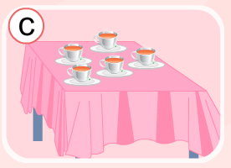 | A | 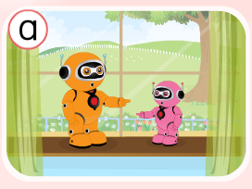 | B | 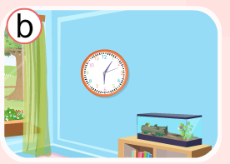 | C
3. |  | A |  | B |        | C
4. |  | A |  | B |  | C
5. |  | A |  | B |  | C

SECTION 2 – READING (2.5 pts)

Part I. Read and match. There is one example (1.25 pts)
Example

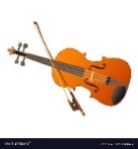
I see a bag. A.

- This is my grandma. B.

- This is a violin. C.

- I’d like new shoes. D.
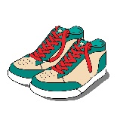
- The cat is next to the box. E.

- The ant has got six legs. F.

Part II. Look and read. Put a tick () or a cross (x) in the box.
There are two examples. (1.25 pts)
Examples |  | This is my brother.
Examples |  | There is a blue dress.
1. |  | There is a window.
2. | 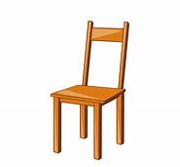 | This is a sofa.
3. |  | The dog has got a ball.
4. |    | There are eleven robots.
5. |  | This is a green yo-yo.
SECTION 3 – WRITING (2.5 pts)
Part I. Look at the pictures. Look at the letters. Write the words.

There is one example. (1.25 pts)
x
o

Example
_ _
o
xan

l
w
l

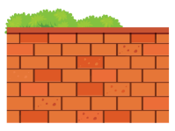
a

- __ __ __ __

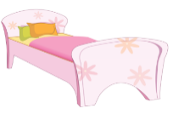
b

e
d

a
w
d
r

- __ __ __
3. 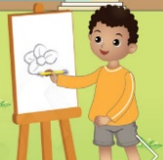 __ __ __ __
t
e
s

v

t
br
o
ar


4. __ __ __ __
c
h
a
y
5. __ __ __ __ __
t

Part II. Fill in the blanks with the correct words.
There is one example. (1.25 pts)
chair guitar robots twelve fox uncle


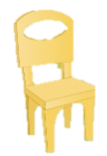
Example This is my uncle.
- I see a __________.

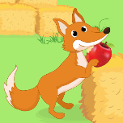
- The __________ has got an apple.
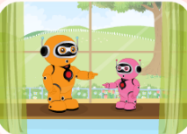

- The __________are at the window.


- I’d like a new __________.
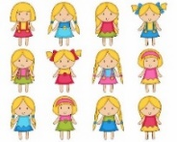
- There are __________ dolls.

