SCHOOL: …………………………………………  CLASS: ……………………………………………  NAME: ……………………………………………  DATE: …………………………………………… | TIẾNG ANH 3 PHONICS-SMART  PHONICS-SMART TEST  PROGRESS TEST 2  TOTAL POINTS: ………………

SECTION 1 – LISTENING
Part I. Listen and number the pictures. There is one example. (1 point)
Example:
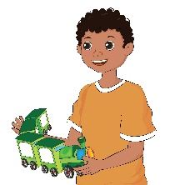 | 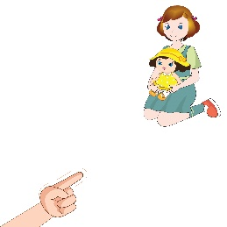 | 
 | 
 | 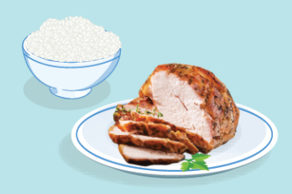 | 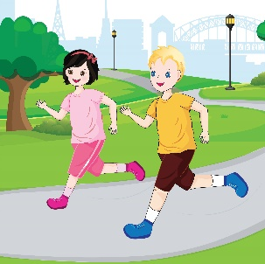

Part II. Listen and tick the correct picture. There is one example. (1 point)
 | Example:
 | 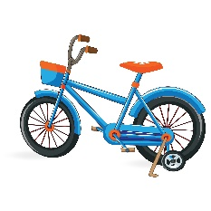 |  | 
 | A | B | C
1 | 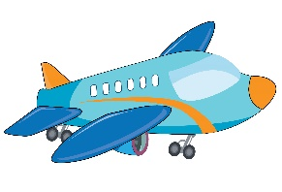 | 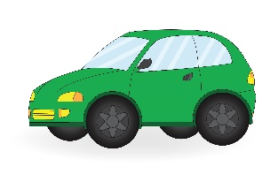 | 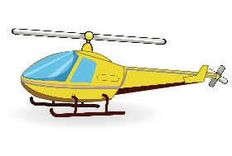
 | A | B | C
2 | 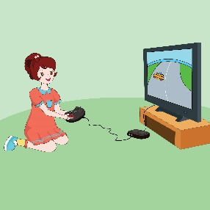 | 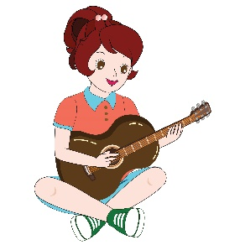 | 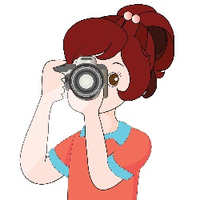
 | A | B | C
3 | 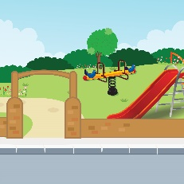 |  | 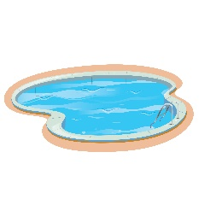
 | A | B | C
4 | 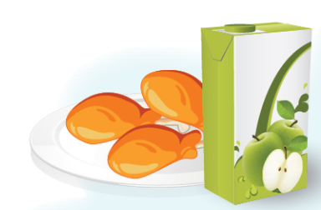 | 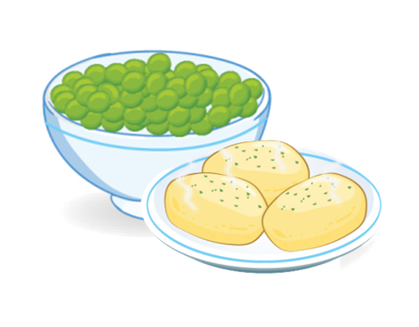 | 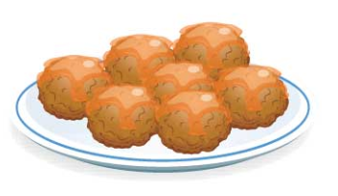
 | A | B | C
5 | 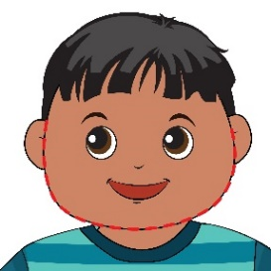 | 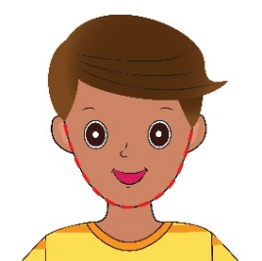 | 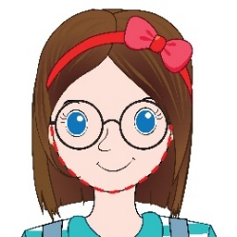
 | A | B | C

Part III. Listen and tick () Yes or No. There is one example. (2 points)
 | Yes | No
Example: There is a computer in the room.
1. There are a lot of meatballs.
2. They like drawing.
3. His favourite sport is tennis.
4. She is kicking the ball.
5. Their bats are under the tree.

SECTION 2 – READING
Part I. Look at the pictures. Read and put a tick () or a cross (). There are two examples. (1 point)
Examples: | 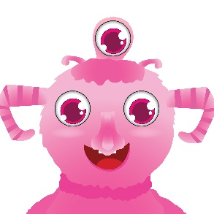 | She’s got three eyes.
 | 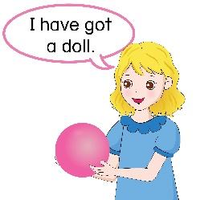 | I have got a doll.
1 | 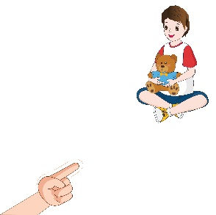 | That is his teddy bear.
2 | 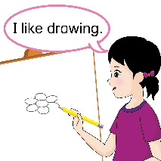 | I like drawing.
3 |  | This is a bat.
4 | 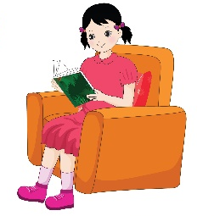 | She is listening to music.
5 | 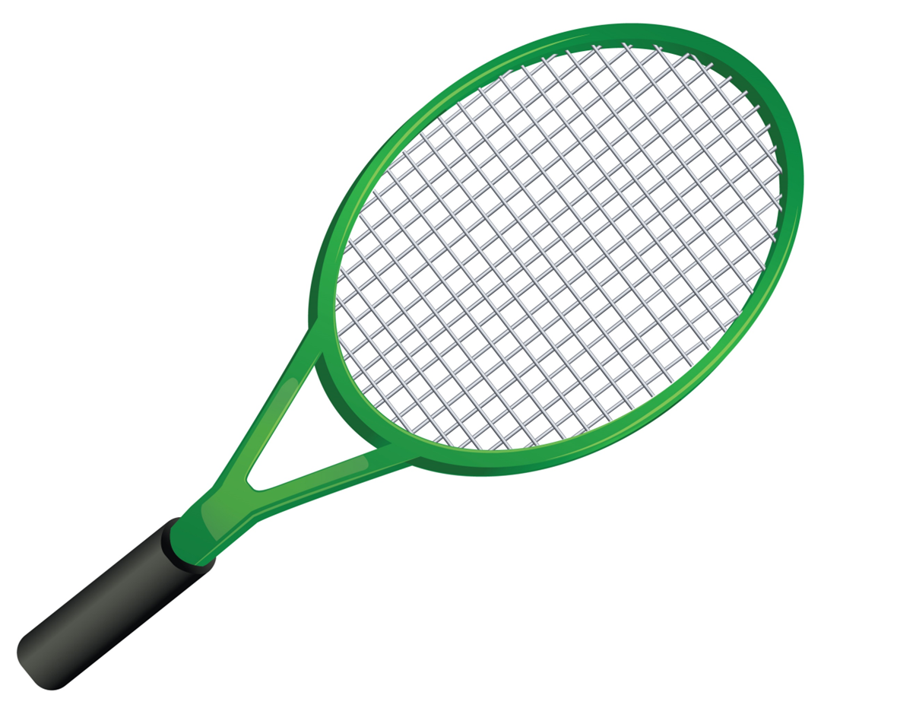 | This is a tennis racket.

Part II. Look at the picture. Read and write Yes or No. There are two examples.
(1 point)

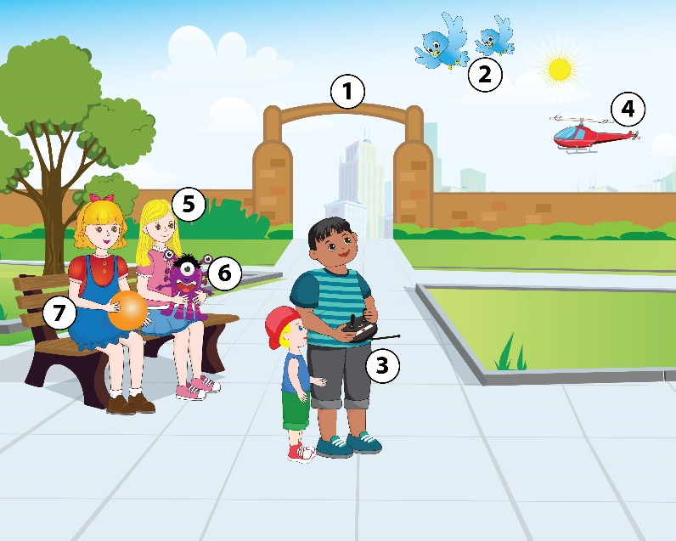 | Examples:  1. It’s a park.  2. There are bees.  3. He has got a big body.  4. It’s a skateboard.  5. She has got black hair.  6. He has got one head.  7. She is bouncing the ball. | Yes  No  ______  ______  ______  ______  ______

SECTION 3 – WRITING
Part I. Look at the pictures. Write the words. There is one example. (1 point)
Example | 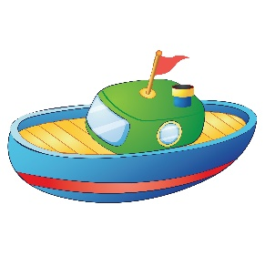 | b o a t
1 |  | __ __ __ __ __
2 | 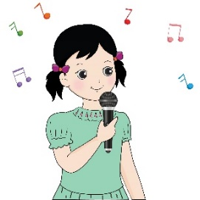 | __ __ __ __
3 | 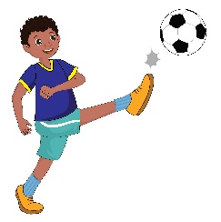 | __ __ __ __
4 | 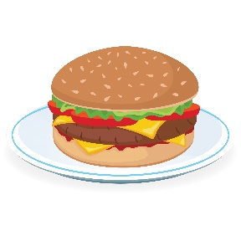 | __ __ __ __ __ __
5 |  | __ __ __ __ __ __ __ __
Part II. Fill in the blanks with suitable words from the box. There is one example. (1 point)
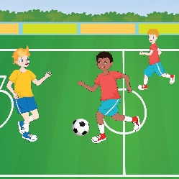 | 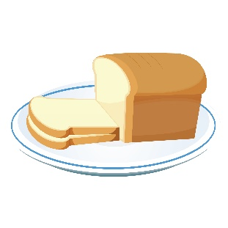 | 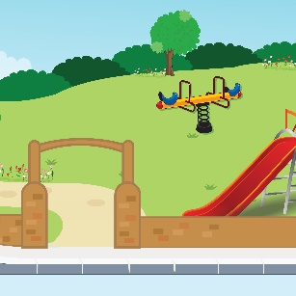
football | bread | park
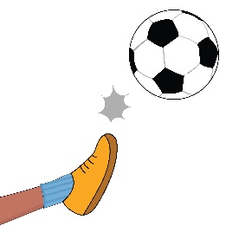 | 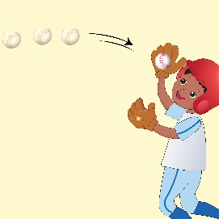 | 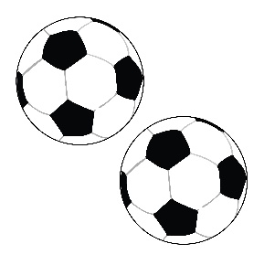
kicking | catch | balls

My favourite sport is (0) football. I have got two (1) ______________. I like (2)______________ a ball into the goal. In my free time, I like going to the (3) ______________. I can bounce, throw, or (4) ______________ a ball with my friends. We often have some (5) _________ and juice after playing. That’s great.

_The end_

