UNIT 1 : LEISURE TIME
Lesson 1: GETTING STARTED
I’m keen on doing DIY (do-it-yourself)
Period: 2
Class | Date of teaching | Attendance
8D
8E
I. OBJECTIVES
By the end of the lesson, students are expected to achieve the following objectives:
1. Knowledge:
*Vocabulary:
- Vocabulary to talk about about LEISURE ACTIVITIES: a kniting kit; keen on; DIY; spend; hang out; join; puzzles; message…
* Pronunciation:
- Pronounce the new words correctly: a kniting kit; keen on; DIY; spend; hang out; join; puzzles; message…
- pronounce the sounds /ʊ/ and /u:/ correctly in words and sentences;
* Grammar:
- Use verbs of liking / disliking followed by gerunds or to-infinitives to talk about likes and dislikes;
2. Competencies:
a. General competencies:
- Group work and independent working, pair work, linguistic competence, cooperative learning and communicative competence.
- Develop communication skills and enhance awareness of preserving the culture
- Be co-operative and supportive in pair work and teamwork.
- Actively join in class activities.
b. Specific competencies:
- use words related to the topic leisure activities;
- Asking and answering questions about leisure time
- pronounce the sounds /ʊ/ and /u:/ correctly;
- read for general and specific information about leisure activities
- talk about leisure activities;
3. Qualities:
- Develop awareness of relaxing time
- Be concerned to the interests and hobbies
- Develop self-study skills.
- Ss have the good attitude to working in groups, individual work, and pairwork, cooperative learning and working.
II. PREPARATIONS
Teacher: Text book, laptop, loudspeaker, projector…
Students: Text books, studying equipment’s….
III. PROCEDURE
ACTIVITY 1: WARM-UP (5’- GW/PW/IW)
1. Aim:
- To create an active atmosphere in the class before the lesson;
- To lead into the new unit.
2. Content:
- Have some warm-up activities to create a friendly and relaxed atmosphere to inspire Ss to warm up to the new class.
3. Products:
- Interest and concentration of Sts on the class activities.
4. Implementation:
- Teacher instructs
- Sts do as required
TEACHER AND STUDENTS' ACTIVITIES | CONTENTS
Step 1: Task delivering  - Chatting  Step 2: Task performance  + Greeting  + Teacher (T) asks Ss some questions about the previous lessons,  - T may introduce some warm-up activities to create a friendly and relaxed atmosphere to inspire Ss to warm up to the subject and new class…  - T encourages Ss to talk in English as much as possible  + Students (Ss) listen and learn how to do the tasks.  -students Open the book and write the tittle of the lesson.  + Before ss open their books, T asks ss what they like doing for pleasure in their free time. Summarise ss' answers and ask them what these activities are called.  - Elicit the phrase leisure activities. Tell ss that free time can be called leisure time. Write the unit title on the board Leisure time. Let ss open their books and start the lesson. Otherwise, T can:  - Show a picture with a lot of leisure activities for 15 seconds (see below).  - Hide the picture and ask ss to name the activities they see in the picture.  - Lead into the new lesson by saying: We do these activities in our free time or leisure time. Write the unit title on the board Leisure time.  - Share with ss the objectives of the lesson and let them open their books and start the lesson. It is a good idea to write the objectives in a corner of the board and leave them  Step 3: Report and discussion  - Sts work in group to discuss  - Sts join in the discussion  Step 4: Judgement  - T summarizes the discussion and leads to Activity 2. | + Greeting  Chatting
ACTIVITY 2: KNOWLEDGE FORMATION (15'- PW/GW/IW)
1. Aim:
- To set the context for the introductory dialogue;
- To introduce the topic of the unit, the vocabulary, the sounds, and the grammar points to be learnt.
- To help ss understand the conversation.
- To introduce some vocabulary items related to leisure activities.
2. Content:
Learn some new words. Read the conversation and find out new words. Focus on topic of the lesson, grammar points…
Listen and read the conversation. Answer the question.
3. Products:
Knowing more new words. Understanding the conversation; topic of the lesson, grammar points…
Understanding more the content of the conversation.
4. Implementation:
TEACHER AND STUDENTS' ACTIVITIES | CONTENTS
Step 1: Task delivering  - T sets the scene/ context for the listening and reading.  Step 2: Task performance  Task 1. Listen and read: (Ex 1, p. 70-71)  * Teach vocabulary:  + Teacher uses different techniques to teach vocab (situation, realia, translation.)  + Teacher introduces the vocabulary by:  - providing the pictures  - eliciting the definition of the words  + Teacher do the “Rub out and remember” checking technique.  - Ask ss to look at the pictures on page 8 - 9 and answer the questions below:  - What are they talking about?  - What activities can you see in the small pictures?  - Elicit answers from ss.  - Introduce the two characters:Tom and Trang. Explain that they are friends, and they meet each other by chance in a shopping mall.  - Play the recording twice for ss to listen and read along. Have ss underline the words that are related to the unit topic while they are listening and reading.  - Invite some pairs of ss to read the conversation aloud.  - Have ss say the words in the text that they think are related to the topic Leisure time. Quickly write the words on one part of the board. Comment on ss' answers.  Task 2. Read the conversation again and complete the sentences.  + First, ask ss to read the sentences and fill in the blanks without reading the conversation again.  - Elicit the answers from ss. Quickly write these answers on the board.  Now have them read the conversation again to check their answers.  + Allow them to share answers with a partner before discussing as a class,  - Ask Ss for their answers again, referring to the answers that have been written on the board before.  - Confirm the correct answers.  -Students Work individually.  - Students Give the answers  Step 3: Report and discussion  - Sts write down the new vocabulary  - T asks, Sts answer some more questions about the conversation  Step 4: Judgement  - T gives feedback on the reaction of Sts | Task 1. Listen and read:  *Vocabulary:  1. knitting kit (n) bộ dụng cụ đan len  2. DIY (n) tự tay làm lấy  3. Dollhouse (n) nhà búp bê  4. make paper flowers (v.phr)  làm hoa giấy  5. hang out (v) đi chơi  Task 2. Read the conversation again and complete the sentences - * Key:  1. knitting kit 2. leisure time  3. other people 4. hang out  5. Sunday
ACTIVITY 3: PRACTICE (20' - GW/PW/IW)
1. Aim:
To introduce some vocabulary items related to leisure activities.
To help ss revise the leisure activities they have learnt in 3.
2. Content:
Write words under the pictures.
Further practice. Ask and answer the questions.
3. Products:
Ss understand more the use of words. Know more the words
Ss understand the content of the conversation and know the vocabulary related to the topic.
4. Implementation:
TEACHER AND STUDENTS' ACTIVITIES | CONTENTS
Step 1: Task delivering  - T let Sts learn Task 3 – Getting Started - Unit 1  Step 2: Task performing  Task 3. Work in pairs. Write the activities from the box under the correct pictures.  - Have Ss work individually to write the word and phrases in the box under the pictures. Have them compare their answers with a partner.  - Invite some ss to go to the board and write their answers.  - Confirm the correct answers.  - Have ss practise saying the word and phrases again.  Task 4. Work in pairs. Read the phrases, and guess which activities in 3 are described  - Have Ss work in pairs and read the key words and phrases given, then guess the leisure activities.  - Ask for Ss' answers and confirm the correct ones.  For a more able class, have ss work in groups. Each group writes down some key words and phrases about one or two leisure activities they do or know. Then they read aloud these words / phrases for the class to guess the activities.  Task 5. Work in groups. Ask one another the question below. Then report your friends’ answers to the class.  - Set time (3 — 5 minutes) for ss to do this activity.  - Have ss work in groups to ask one another the question in the book. Invite some ss to share the answers of their groups with the class.  - For a more able class, ask ss to work in their groups again and brainstorm all the leisure activities they know. After three minutes, the group with the most answers wins, and they are invited to share their answers with the whole class.  Step 3: Report and discussion  - Ss work independently  - Share the answers  Step 4: Judgement  - T gives feedback on the answers. | Task 3. Work in pairs. Write the activities from the box under the correct pictures.  - T_ Ss  * Key:  1. messaging friends 2. cooking  3. playing sport 4. doing puzzles  5. doing DIY 6. surfing the net  Task 4. Work in pairs. Read the phrases, and guess which activities in 3 are described  * Key:  1. doing puzzles  2. doing DIY  3. playing sport  4. messaging friends  5. surfing the net  Task 5. Work in groups. Ask one another the question below. Then report your friends’ answers to the class.  * Report it.  * Example:  If you have some free time this weekend. What will you do?  * Suggested outcome:  If I have free time this weekend, I will go to the cinema to see the latest film.
ACTIVITY 4: APPLICATION (5' - WC)
1. Aim:
To consolidate what Ss have learnt in the lesson.
To review the lesson and prepare for the next lesson.
To give Home assigment
2. Content:
Home assigment
3. Products:
Know more some words about hobbies
Take note Home assigment
4. Implementation:
TEACHER AND STUDENTS' ACTIVITIES | CONTENTS
Step 1: Task delivering (Home assignment)  - Ask one or two Ss to tell the class what they have learnt.  - Ask Ss to say some words / phrases and grammar points they remember from the lesson. Tell Ss that they will learn these language points in the following lessons.  - Home assigment  Step 2: Task performance  -T asks Ss to talk about what they have learnt in the lesson.  - T let Sts take note the home assigments.  Step 3: Report and discussion  - T says something about the class time.  -Step 4: Judgement  T gives feedback and requires Sts do homework. | * Home assigments:  - Do more exercises in workbook.  - Prepare new lesson: Lesson 2: A CLOSER LOOK _1
IV. FEED-BACK:
………………………………………………………………………………………………
………………………………………………………………………………………………
……………………………………………………………………………………………….
……………………………………………………………………………………………….
………………………………………………………………………………………………..

UNIT 1: LEISURE TIME
Lesson 2: A CLOSER LOOK 1

Period: 3
Class | Date of teaching | Attendance
8D
8E
I. OBJECTIVES
By the end of the lesson, students are expected to achieve the following objectives:
1. Knowledge:
*Vocabulary:
- Vocabulary to talk about about LEISURE ACTIVITIES: be fond of ; be keen on ; be crazy about…
* Pronunciation:
- Pronounce the new words correctly: be fond of ; be keen on ; be crazy about…
- pronounce the sounds /ʊ/ and /u:/ correctly in words and sentences;
* Grammar:
- Use verbs of liking / disliking followed by gerunds and / or to-infinitives to talk about likes and dislikes;
2. Competencies:
a. General competencies:
- Group work and independent working, pair work, linguistic competence, cooperative learning and communicative competence.
- Develop communication skills and enhance awareness of preserving the culture
- Be co-operative and supportive in pair work and teamwork.
- Actively join in class activities.
b. Specific competencies:
- use words related to the topic leisure activities;
- Asking and answering questions about leisure time
- pronounce the sounds /ʊ/ and /u:/ correctly;
- read for general and specific information about leisure activities
- talk about leisure activities;
3. Qualities:
- Develop awareness of relaxing time
- Be concerned to the interests and hobbies
- Develop self-study skills.
- Ss have the good attitude to working in groups, individual work, and pairwork, cooperative learning and working.
II. PREPARATIONS
Teacher: Text book, laptop, loudspeaker, projector…
Students: Text books, studying equipment’s….
III. PROCEDURE
ACTIVITY 1: WARM-UP (5’- GW/PW/IW)
1. Aim:
- Revise the old lesson.
- Do some activities to creat a friendly and relaxed atmostphere to warm up to the new lesson…
2. Content:
- Have some warm-up activities to create a friendly and relaxed atmosphere to inspire Ss to warm up to the new class.
- Guessing game
3. Products:
- Interest and concentration of Sts on the class activities.
- A friendly and relaxed atmostphere to the new lesson
- Having a chance to speak English and focus on the topic of the lesson..
4. Implementation:
- Teacher instructs
- Sts do as required
TEACHER AND STUDENTS' ACTIVITIES | CONTENTS
Step 1: Task delivering  - Chatting  Step 2: Task performance  + Greeting  + Teacher (T) asks Ss some questions about the previous lessons,  - T may introduce some warm-up activities to create a friendly and relaxed atmosphere to inspire Ss to warm up to the subject and new class…  - T encourages Ss to talk in English as much as possible  + Show some pictures of the leisure activities ss learnt in the previous lesson. Have some say the activities aloud. Lead into this lesson which focuses on expressions about likes and dislikes and /ʊ/ and /u:/ .  - Share with ss the lesson objectives and have them open their books and start the lesson. It is a good idea to write the objectives in a corner of the board and leave them there or put them on a slide to show Ss.  + Students (Ss) listen and learn how to do the tasks.  - Students Open the book and write the tittle of the lesson.  Step 3: Report and discussion  - Sts join in the discussion  Step 4: Judgement  - T summarizes the discussion and leads to Activity 2. | + Greeting
ACTIVITY 2: KNOWLEDGE FORMATION (15'- PW/GW/IW)
1. Aim:
To present some expressions about likes and dislikes.
To help ss practise the expressions about likes and dislikes
To give ss further practice with expressions about likes and dislikes
2. Content:
Learn some new words
Do the filling with a correct word from the box. Complete the sentences.
3. Products:
Knowing more new words. Students know how to use the target vocabulary.
Students understand how to use the vocabulary related to the topic
4. Implementation:
TEACHER AND STUDENTS' ACTIVITIES | CONTENTS
Step 1: Task delivering  - T sets the scene/ context for the reading and vocabulary learning  - T ask the whole class to do the Tasks in A Closer Look 1  Step 2: Task performance  Task 1. Match a word/ phrase in column A with a word in column B to make expression about likes  * Teach vocabulary:  + Teacher uses different techniques to teach vocab (situation, realia, translation.)  + Teacher introduces the vocabulary by:  - providing the pictures  - eliciting the definition of the words  + Teacher do the “Rub out and remember” checking technique.  ** Have Ss read the words / phrases in column A and B and match them to make expressions about likes. Remind them that a word / phrase in column A can only go with one preposition in column B.  Have ss work in pairs to compare their answers before giving T the answers.  Check and confirm the correct answers. Ask them to change the expressions they have got so that the expressions can be about dislikes.  Elicit answers from ss. Confirm that when we want to change the expressions into those about dislikes, we can put not after the forms of the verb be. Give them the example: is fond of, which is changed into is not fond of. Invite some ss to do the same with other expressions.  - Ask Ss about the form of the verbs placed after these expressions. Tell them that the verbs need to be in -ing form.  + Give them one example: I'm fond of making paper flowers.  - Demonstrate the negative form: He is not fond of making paper flowers  Task 2. Fill in each blank with a correct word from the box  - Have Ss do this activity individually. Have ss read all the sentences carefully to make sure they understand the sentences and fill in the blanks with the words in the box.  - Let them share their answers in pairs. Invite some ss to give the answers and confirm the correct ones  - Ask Ss to make sentences with some of the expressions they have learnt. Invite ss to share their sentences. This activity can be carried out as a competitive game. Ask ss to work in groups and make as many sentences as possible with the expressions about likes and dislikes. The group with the most sentences wins and will be asked to say their sentences  Step 3: Report and discussion  - Sts write down the new vocabulary  - T asks, Sts answer some more questions about the lesson  Step 4: Judgement  - T gives feedback on the reaction of Sts | Task 1. Match a word/ phrase in column A with a word in column B to make expression about likes  *Vocabulary  1. be interested in (n) quan tâm , thich  2. be fond of (n) thích (rất nhiều )  3. be keen on (n) mê , thich  4. be crazy about (adj) thích (Phát cuồng)  5. be into (adj) thích  * LANGUAGE NOTE:  - To be keen on means to be very interest in or willing to do something.  (- To keen on có nghĩa là rất quan tâm hoặc sẵn sàng làm điều gì đó.)  - I'm quite keen on football. ( Tôi khá mê bóng đá.)  - To be fond of means to like someone/something or doing something very much.  ( - To be fond of có nghĩa là thích ai đó / cái gì đó hoặc làm điều gì đó rất nhiều.)  I'm very keen on strawberries.  ( Tôi rất thích/ quan tâm đến dâu tây.)  I'm keen on going to the party.  ( Tôi rất thích đi dự tiệc.)  - To be crazy about is stronger than keen /fond.  - To be crazy about (Phát cuồng) Dùng nó mạnh hơn quan tâm / thích.  * Negative:  Example: I'm fond of making paper flowers.  - The negative form: He is not fond of making paper flowers.  Task 2. Fill in each blank with a correct word from the box  * Key:  1. fond 2. interested  3. keen 4. into  5. about
ACTIVITY 3: PRACTICE (20' - GW/PW/IW)
1. Aim:
To give ss further practice with expressions about likes and dislikes.
- To help ss identify how to pronounce the sounds /ʊ/ and /u:/
- To help ss practise pronouncing these sounds in words.
- Listen and repeat the words. Pay attention to the sounds /ʊ/ and /u:/
2. Content:
Do the filling with a correct word from the box. Complete the sentences.
Listen and reapeat the words. Practice the sentences. Underline the bold words..
3. Products:
Students understand how to use the vocabulary related to the topic.
Students repeats the words correctly
4. Implementation:
TEACHER AND STUDENTS' ACTIVITIES | CONTENTS
Step 1: Task delivering  - T let Sts learn Task 4-5 – A Closer look 1  Step 2: Task performing  Task 3. Complete the sentences about what you like or dislike doing. Use the word or phrases from the box or your own ideas.  - Ask ss to look at the example to make sure they understand what to do.  - Have them complete the sentences about themselves, using the given word and phrases.  - Invite ss to share their sentences orally or in the written form.  - The activity can be done another way: After ss complete the sentences, ask them to work with a classmate to share their answers. Then invite ss to share information with their classmates.  Task 4. Listen and repeat the words. Pay attention to the sounds /ʊ/ and /u:/  - Have some Ss read out the words first. Then play the recording for them to listen and repeat the words they hear. \  - Play the recording as many times as necessary.  - Explain to Ss that these words have the sounds and /u:/. Tell them the difference between the two sounds if needed. Tell ss that /ʊ/ is a short vowel sound while /u:/ is a long vowel sound.  - Ask Ss to work in pairs to practise saying the words and put the words into the correct columns.  - Check the answers with the class and confirm the correct ones.  - Invite some Ss to say some other words they know that include the two sounds.  * Teacher gives corrections and feedbacks to students’ pronunciation  Task 5. Listen and practise the sentences. Underline the bold words with /ʊ/, and circle the bold words with /u:/.  - Have Ss quickly read the sentences. Now play the recording for ss to listen to the sentences. Ask them to pay attention to the bold words and underline the bold words with /ʊ/ and circle the bold words with /u:/.  - Invite some Ss to share their answers. Confirm the correct ones.  - Play the record ing again for ss to repeat the sentences,  - Have Ss practise the sentences in pairs. Invite some pairs to read the sentences aloud. Comment on their pronunciation of the sounds.  Step 3: Report and discussion  - Ss work independently  - Share the answers  Step 4: Judgement  - T gives feedback on the answers and studying attitucde of Sts in class. | Task 3. Complete the sentences about what you like or dislike doing. Use the word or phrases from the box or your own ideas.  * Key:  1. messaging friends 2. cooking  3. playing sport 4. doing puzzles  5. doing DIY 6. surfing the net  Task 4. Listen and repeat the words. Pay attention to the sounds /ʊ/ and /u:/  * Audio script - Track 3:  cook group push June school  would woman move  * Key:  Task 5. Listen and practise the sentences. Underline the bold words with /ʊ/, and circle the bold words with /u:/.  * Example:  1. She likes reading books and swimming in the pool.  2. When it is cool, we like to play f'ootball.  3. She drew and made puddings in her free time.  4. My mum loves pumpkin soup and  coffêe with a little sugar.  5. My brother is fond ofwatching the cartoon about a clever wolf'.
  /ʊ/ | /u:/
  cook, push, would, woman | group, June, school. Move
ACTIVITY 4: APPLICATION (5'- WC )
1. Aim:
To consolidate what students have learnt in the lesson.
To reactivate the knowledge that students have gained
2. Content:
Make sentences using the new words and structures
Home assigment
3. Products:
Know more some words about community service
Take note Home assigment
4. Implementation:
TEACHER AND STUDENTS' ACTIVITIES | CONTENTS
Step 1: Task delivering (Home assignment)  - Ask one or two Ss to tell the class what they have learnt.  - Ask Ss to say aloud some words they remember from the lesson and make sentences with them  - Home assigment  Step 2: Task performance  - Teacher summarizes the lesson  - T let Sts take note the home assignment  Step 3: Report and discussion  - T asks, Sts answer about volunteer work  -Step 4: Judgement  T gives feedback and requires Sts do homework. | * Home assigment:  - Remember some new words.  - Do more exercises in workbook.  - Prepare new lesson. A CLOSER LOOK_ 2
IV. FEED-BACK:
………………………………………………………………………………………………
………………………………………………………………………………………………
……………………………………………………………………………………………….
……………………………………………………………………………………………….
………………………………………………………………………………………………..

UNIT 1: LEISURE TIME
Lesson 3: A CLOSER LOOK 2
Period: 4
Class | Date of teaching | Attendance
8D
8E
I. OBJECTIVES
By the end of the lesson, students are expected to achieve the following objectives:
1. Knowledge:
*Vocabulary:
- Vocabulary to talk about about LEISURE ACTIVITIES.
* Pronunciation:
- Pronounce the new words correctly.
* Grammar:
- Use verbs of liking / disliking followed by gerunds and / or to-infinitives to talk about likes and dislikes;
2. Competencies:
a. General competencies:
- Group work and independent working, pair work, linguistic competence, cooperative learning and communicative competence.
- Develop communication skills and enhance awareness of preserving the culture
- Be co-operative and supportive in pair work and teamwork.
- Actively join in class activities.
b. Specific competencies:
- use words related to the topic leisure activities;
- Asking and answering questions about leisure time
- pronounce the sounds /ʊ/ and /u:/ correctly;
- read for general and specific information about leisure activities
- talk about leisure activities;
3. Qualities:
- Develop awareness of relaxing time
- Be concerned to the interests and hobbies
- Develop self-study skills.
- Ss have the good attitude to working in groups, individual work, and pairwork, cooperative learning and working.
II. PREPARATIONS
Teacher: Text book, laptop, loudspeaker, projector…
Students: Text books, studying equipment’s….
III. PROCEDURE
ACTIVITY 1: WARM-UP (5’- GW/PW/IW)
1. Aim:
- To create an active atmosphere in the class before the lesson;
- To lead into the new lesson.
2. Content:
Review the previous lesson or have some warm-up activities to create a friendly and relaxed atmosphere to inspire Ss to warm up to the new lesson.
3. Products:
- Interest and concentration of Sts on the class activities.
- A friendly and relaxed atmostphere to the new lesson
- Having a chance to speak English and focus on the topic of the lesson..
4. Implementation:
- Teacher instructs
- Sts do as required
TEACHER AND STUDENTS' ACTIVITIES | CONTENTS
Step 1: Task delivering  - game  Step 2: Task performance  + Greeting  + Chatting.  + Teacher (T) asks Ss some questions about the previous lessons,  - T may introduce some warm-up activities to create a friendly and relaxed atmosphere to inspire Ss to warm up to the subject and new class…  - T encourages Ss to talk in English as much as possible  * Ask Ss some questions: What do you like doing in your free time? What does your mum like doing in her free time?..  - Invite some ss to answer the questions. Quickly write some of their answers on the board.  - Underline the -ing form of verbs in ss' answers.  + Students (Ss) listen and learn how to do the tasks.  - Ask them if they remember the -ing form of verbs after some verbs such as like or hate they learnt in English 8. Tell them that today they are going to learn some more verbs to describe likes and dislikes.  - Lead to the lesson.  - Introduce the objectives of the lesson. Write the objectives in the left corner of the board.  - students Open the book and write the tittle of the lesson.  Step 3: Report and discussion  - Sts join in the discussion and do as required  Step 4: Judgement  - T summarizes the discussion and leads to Activity 2. | + Greeting  + Chatting.
ACTIVITY 2: KNOWLEDGE FORMATION (15'- IW/PW/GW)
1. Aim:
To help ss identify the verbs that go with only gerunds and those that go with both gerunds and to-infinitives.
To help Ss practise the correct form of verbs after verbs of liking / disliking.
2. Content:
Verbs of liking/ disliking
further practice with verbs of liking / disliking
3. Products:
Students know how to use the target grammar.
Ss produce sentences with verbs of liking / disliking.
4. Implementation:
TEACHER AND STUDENTS' ACTIVITIES | CONTENTS
Step 1: Task delivering  - T sets the scene/ context for the listening and reading.  - T ask the whole class to do the Tasks in A Closer Look 2  Step 2: Task performance  Task 1. Work in pair. Put the verbs in the appropriate column  * INTRODUCTION OF GERUNDS AND  TO-INFINITIVES  - Remind Ss of the concept of the gerund that they learnt in grade 7. Ask them how gerunds are formed and how they function grammatically.  - Write on the board: I didn't know you like knitting. and I love to watch TV on Saturdays.  - Explain that in English if we want tofollow a verb with another action, we must use age run do ran infinitive. There are certain verbs that can only befollowed by one or the other,and these verbs must be memorised. Go through the Remember! box with ss. Tell ss that verbs of liking / disliking are often followed by gerunds and to-infinitives, and verbs such as love, like, hate and prefer may go with gerunds or toinfinitives with almost no change in meaning.  - Have Ss read the examples in the Remember! box, and then encourage them to give their own examples.  Task 2. Choose the correct answer A, B, or  - Have ss do this exercise individually and then compare their answers with a partner.  Ask some ss to share their answers. Confirm the correct answers.  Step 3: Report and discussion  - Sts write down the new vocabulary  - T asks, Sts answer some more questions about the lesson  Step 4: Judgement  - T gives feedback on the reaction of Sts | Task 1. Work in pair. Put the verbs in the appropriate column  * Verbs of liking:  love  like  fancy  prefer  enjoy  * Verbs of disliking:  detest  hate  dislike  * Suggested answers:  - Verbs followed by gerunds only: detest, fancy, dislike, enjoy  - Verbs followed by both gerunds and to-infinitives: love, like, hate, prefer  Task 2. Choose the correct answer A, B, or  * Keys:  1. A 2. A 3. C 4. B 5. A
ACTIVITY 3: PRACTICE (20' - GW/PW/IW)
1. Aim:
To help Ss produce sentences with verbs of liking / disliking
To help ss ask and answer about leisure activities, using verbs of liking / disliking.
2. Content:
Ss practise using verbs of liking and disliking with gerunds and to-infinitives.
3. Products:
Students understand how to use the target grammar.
4. Implementation:
TEACHER AND STUDENTS' ACTIVITIES | CONTENTS
Step 1: Task delivering  - T let Sts study the examples, consume the rules and do the exercises  Step 2: Task performing  Task 3. Look at the pictures and complete the sentences, using the verbs in brackets in their suitable form.  + Ask Ss what they see in each picture. For a less able class, T may want to write some key language on the board (e.g. play computer games / surfthe net).  - Have Ss do this exercise individually and then compare their answers With another classmate.  - Invite some ss to write their answers on the board.  - Check the answers with the whole class. Confirm the correct answers. Accept different sentences provided that they are correct.  Task 4. Complete the sentences about yourself.  - Have Ss work individually to write the sentences about themselves.  - Invite some Ss to write their answers on the board.  - Comment on their answers. Accept different answers provided that they are logical and correct.  * Teacher corrects for students as a whole class.  GAME: Likes and dislikes mimes  + Divide ss into groups. Assign a group leader to manage the game.  + Explain the rules of the game:  One student mimes a leisure activity he / she likes or dislikes. Other ss guess what the activity is by asking Yes / NO questions using the verbs they have learnt.  + For each correct guess, each student gets one point. The group leader records the points of his / her group members.  + Have Ss read the example in the book and model the way to play the game with one student if needed.  + Let groups play the game for about 3 — 5 minutes.  + Invite some groups to perform the game in front of the whole class. Comment on their performance.  * Teacher gives corrections and feedbacks.  Step 3: Report and discussion  - Ss work independently  - Share the answers  Step 4: Judgement  - T gives feedback on the answers and studying attitude of Sts in class. | Task 3. Look at the pictures and complete the sentences, using the verbs in brackets in their suitable form.  * Key:  1. Mark likes surfing / to surf the net.  2. The girls enjoy knitting.  3. My cousin dislikes cooking.  4. My father hates going / to go shopping.  5. Tom and his sister prefer doing / to do puzzles  Task 4. Complete the sentences about yourself.  * Suggested answer:  - I like playing basketball.  - I hate cooking.  GAME: Likes and dislikes mimes  * Example:  * Suggested outcome:  A: Do you like surfing the net?  B: No, I don’t.  C: Do you love messaging your friends?  B: Yes, I do.
ACTIVITY 4: APPLICATION (5'- WC )
1. Aim:
To help Ss revise all they have learnt.
To give Home assigment
2. Content:
Make sentences using the the past simple.
Home assigment
3. Products:
Review the old lesson
Take note Home assigment
4. Implementation:
TEACHER AND STUDENTS' ACTIVITIES | CONTENTS
Step 1: Task delivering (Home assignment)  - Ask one or two Ss to tell the class what they have learnt.  - T asks some Ss to give a sentence about themselves, using the past simple .  - Home assigment  Step 2: Task performance  - Teacher summarizes the lesson  - T lets Sts take note the home assignment  Step 3: Report and discussion  - T asks, Sts answer about leisure activities  -Step 4: Judgement  T gives feedback and requires Sts do homework. | * Home assigment:  - Remember the use the prepositions of time and place.  - Do more exercises in workbook.  - Prepare new lesson: COMMUNICATION.
IV. FEED-BACK:
………………………………………………………………………………………………
………………………………………………………………………………………………
……………………………………………………………………………………………….
……………………………………………………………………………………………….
………………………………………………………………………………………………..

UNIT 1: LEISURE TIME
Lesson 4: COMMUNICATION
Period: 5
Class | Date of teaching | Attendance
8D
8E
I. OBJECTIVES
By the end of the lesson, students are expected to achieve the following objectives:
1. Knowledge:
*Vocabulary:
- Vocabulary to talk about about LEISURE ACTIVITIES: cooking club, paper flower, homemade pizza, snowboarding, ski resort.
* Pronunciation:
- Pronounce the new words correctly: cooking club, paper flower, homemade pizza, snowboarding, ski resort.
* Grammar:
- Use verbs of liking / disliking followed by gerunds and / or to-infinitives to talk about likes and dislikes;
2. Competencies:
a. General competencies:
- Group work and independent working, pair work, linguistic competence, cooperative learning and communicative competence.
- Develop communication skills and enhance awareness of preserving the culture
- Be co-operative and supportive in pair work and teamwork.
- Actively join in class activities.
b. Specific competencies:
- use words related to the topic leisure activities;
- Asking and answering questions about leisure time
- read for general and specific information about leisure activities
- talk about leisure activities;
3. Qualities:
- Develop awareness of relaxing time
- Be concerned to the interests and hobbies
- Develop self-study skills.
- Ss have the good attitude to working in groups, individual work, and pairwork, cooperative learning and working.
II. PREPARATIONS
Teacher: Text book, laptop, loudspeaker, projector…
Students: Text books, studying equipment’s….
III. PROCEDURE
ACTIVITY 1: WARM-UP (5’- GW/PW/IW)
1. Aim:
- To revise the old lesson.
- To lead in the targeted vocabulary and pronunciation.
2. Content:
Review the previous leson or have some warm-up activities to creat a friendly and relaxed atmostphere to inspire Ss to warm up to the new lesson
3. Products:
- Interest and concentration of Sts on the class activities.
- A friendly and relaxed atmostphere to the new lesson
- Developing the language skills by asking and answering questions about themselves.
4. Implementation:
- Teacher instructs
- Sts do as required
TEACHER AND STUDENTS' ACTIVITIES | CONTENTS
Step 1: Task delivering  - Chatting  Step 2: Task performance  + Greeting  + Teacher (T) asks Ss some questions about the previous lessons,  - T may introduce some warm-up activities to create a friendly and relaxed atmosphere to inspire Ss to warm up to the subject and new class…  - T encourages Ss to talk in English as much as possible  ** Show some pictures of the hobbies that Ss learnt in the previous lessons. Ask some ss to make sentences about themselves, using the verbs of liking / disliking.  - Introduce the objectives of the lesson: learning how to invite and accept invitations and learn about teen leisure activities around the world.  + Students (Ss) listen and learn how to do the tasks.  - Open the book and write the tittle of the lesson.  - Open their book and write  Step 3: Report and discussion  - Sts join in the discussion and do as required  Step 4: Judgement  - T summarizes the discussion and leads to Activity 2. | + Greeting
ACTIVITY 2: KNOWLEDGE FORMATION (15'- PW/IW/GW)
1. Aim:
EVERYDAY ENGLISH
Inviting and accepting invitation
To introduce ways of inviting and accepting invitations
To help Ss practise inviting and accepting invitations.
To practise inviting and accepting invitations in the situations.
To introduce some more leisure activities appearing in the texts that follow.
To provide Ss with information about different leisure activities that teens in different countries enjoy doing.
2. Content:
Listen and read the dialogue. Learn how to invite and accept invitation.
Practice inviting and accepting invitations. Answer the questions. Read and complete the table.
3. Products:
Students know how to invite and accept invitation.
Students know how to use the structures to invite and accept invitation
4. Implementation:
TEACHER AND STUDENTS' ACTIVITIES | CONTENTS
Step 1: Task delivering  - T sets the scene/ context to reading and listening  - T ask the whole class to do the Tasks in Communication  Step 2: Task performance  Task 1. Listen and read the dialogues below. Pay attention to the highlighted part.  * T elicits the dialogues.  - Play the recording for ss to listen and read the dialogues at the same time. Ask Ss to pay attention to the highlighted parts. Tell them that these are two ways to invite someone and two ways to accept invitations.  - Have Ss practise the dialogues in pairs. Call on some pairs to practise the dialogues in front Of the class.  * Teacher checks students’ understanding by asking some checking questions.  Task 2. Work in pairs. Practise inviting and accepting invitations in the following situations. Remember to use the highlighted language in 1.  - Ask Ss to work in pairs to make similar dialogues, using the language they have learnt.  - Move around to observe and provide help.  - Call on some pairs to practise in frontofthe Class. - Comment on their performance.  - Have ss react the role-plays, but this time Trang starts with "Do you and Tom starts with "Would you like .  - Confirm the correct answers.  Step 3: Report and discussion  - T asks, Sts answer some more questions about the lesson  Step 4: Judgement  - T gives feedback on the reaction of Sts | Task 1. Listen and read the dialogues below. Pay attention to the highlighted part.  *Trang: Would you like to go to the cooking club with me this Sunday?  Ann: I'd love to. Thanks.  Tom: Do you fancy going for a walk?  Mark: That's great. Thanks.  Task 2. Work in pairs. Practise inviting and accepting invitations in the following situations. Remember to use the highlighted language in 1.  * you invite your friend to play badminton.  - you invite your friend to make paper flowers with you.  - you invite your friend to try home-made pizza.  A. Would you like to …… ?  B. I’d love to. Thanks.
ACTIVITY 3: PRACTICE (20' - GW/PW/IW)
1. Aim:
- To introduce some more leisure activities appearing in the texts that follow.
- To provide Ss with information about different leisure activities that teens in different countries enjoy doing.
- To provide ss with a chance to share their opinions about the leisure activities in 4.
2. Content:
- To practice inviting and accepting invitations. Answer the questions. Read and complete the table.
- Ask and answer about the places Ss would like to visit.
3. Products:
- Students know how to use the structures to invite and accept invitation
- Students’ conversations. Report the group’s answers
4. Implementation:
TEACHER AND STUDENTS' ACTIVITIES | CONTENTS
Step 1: Task delivering  - T let Sts study the examples, consume the rules and do the exercises  Step 2: Task performing  Task 3. Ask and answer the question - - Ask Ss to look at each picture and say what leisure activity it shows. If time allows, ask them what things are needed for each activity.What is the activity in each picture?  - Elicit answers from Ss.  - Confirm the correct answers.  Task 4. Read what three teenagers say about their leisure activities. Complete the table with the information from the text.  - Tell Ss that they are going to read about different leisure activities that teens in different countries enjoy doing.  - Have them look at the table of information and ask them to read the three short texts and complete the table.  - Ask Ss to work in pairs to do this activity. They can draw this table on a sheet of paper. After pairs finish their work, ask them to share their table with the whole class.  - Comment on their answers. Confirm the correct answers.  - If time allows, have some pairs give a short talk about each teen and his / her leisure activity.  Task 5. Work in pairs. Which village in 3 would you like to visit for a holiday? Explain your choice to your partner.  - Have Ss work in groups to ask and answer the two questions in the book. Have ss in each group note down their friends' answers.  - Ask some Ss to report their group's answers to the class.  Step 3: Report and discussion  - Ss work independently and in groups  - Share the answers  Step 4: Judgement  - T gives feedback on the answers and studying attitude of Sts in class. | Task 3. Ask and answer the question  - T_ Ss  - Ss to work individually.  * Suggested answers:  Picture a: doing origami  Picture b: playing badminton  Picture c: snowboarding  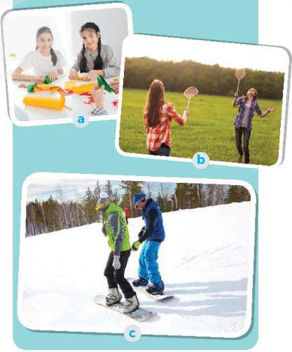  Task 4. Read what three teenagers say about their leisure activities. Complete the table with the information from the text.  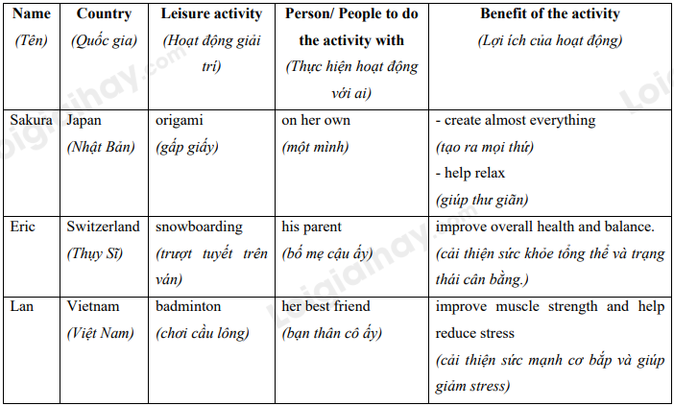  Task 5. Work in pairs. Which village in 3 would you like to visit for a holiday? Explain your choice to your partner.  * Questions:  - Which of the activities in 4 do you want to try?  - Why do you want to try it?
ACTIVITY 4: APPLICATION (5'- WC )
1. Aim:
To consolidate what Ss have learnt in the lesson.
To give Home assigment
2. Content:
Revision of the lesson
Home assigment
3. Products:
Review the old lesson
Take note Home assigment
4. Implementation:
TEACHER AND STUDENTS' ACTIVITIES | CONTENTS
Step 1: Task delivering (Home assignment)  - T summarizes the lesson and let Sts tell what the have learnt  T asks Ss to talk about what they have learnt and ticked the objectives they can do in the lesson.  - Home assigment  Step 2: Task performance  - Teacher summarizes the lesson  - T has Ss tell what they have learnt  - T lets Sts take note the home assignment  Step 3: Report and discussion  - T asks, Sts answer about community service  -Step 4: Judgement  T gives feedback and requires Sts do homework. | * Home assigment:  - Do more exercises in workbook.  - Prepare new lesson. SKILLS_1
IV. FEED-BACK:
………………………………………………………………………………………………
………………………………………………………………………………………………
……………………………………………………………………………………………….
……………………………………………………………………………………………….
………………………………………………………………………………………………..

UNIT 1: LEISURE TIME
Lesson 5: SKILLS 1
Period: 6
Class | Date of teaching | Attendance
8D
8E
I. OBJECTIVES
By the end of the lesson, students are expected to achieve the following objectives:
1. Knowledge:
*Vocabulary:
- Vocabulary to talk about about LEISURE ACTIVITIES: connect, to be into, recipe, costume contest, reduce stress.
* Pronunciation:
- Pronounce the new words correctly: connect, to be into, recipe, costume contest, reduce stress.
* Grammar:
- Use verbs of liking / disliking followed by gerunds and / or to-infinitives to talk about likes and dislikes;
2. Competencies:
a. General competencies:
- Group work and independent working, pair work, linguistic competence, cooperative learning and communicative competence.
- Develop communication skills and enhance awareness of preserving the culture
- Be co-operative and supportive in pair work and teamwork.
- Actively join in class activities.
b. Specific competencies:
- use words related to the topic leisure activities;
- Asking and answering questions about leisure time
- read for general and specific information about leisure activities
- talk about leisure activities;
3. Qualities:
- Develop awareness of relaxing time
- Be concerned to the interests and hobbies
- Develop self-study skills.
- Ss have the good attitude to working in groups, individual work, and pairwork, cooperative learning and working.
II. PREPARATIONS
Teacher: Text book, laptop, loudspeaker, projector…
Students: Text books, studying equipment’s….
III. PROCEDURE
ACTIVITY 1: WARM-UP (5’- GW/PW/IW)
1. Aim:
- To create an active atmosphere in the class before the lesson;
- To lead into the new lesson.
2. Content:
- Having some warm-up activities to create a friendly and relaxed atmosphere to inspire Ss to warm up to the new lesson.
3. Products:
- Interest and concentration of Sts on the class activities.
- A friendly and relaxed atmostphere to the new lesson
- A chance to speak English and focus on the topic of the lesson..
4. Implementation:
- Teacher instructs
- Sts do as required
TEACHER AND STUDENTS' ACTIVITIES | CONTENTS
Step 1: Task delivering  - Chatting  Step 2: Task performance  + Greeting  + Teacher (T) asks Ss some questions about the previous lessons,  - T may introduce some warm-up activities to create a friendly and relaxed atmosphere to inspire Ss to warm up to the subject and new class…  - T encourages Ss to talk in English as much as possible  - Ask some Ss what leisure activities they usually do and who in the family they do the activities with.  - Ask them about the good things of doing these activities with family members. Elicit answers from ss.  - Lead into the new lesson: Reading and Speaking about leisure activities that can be done with family members.  + Students (Ss) listen and learn how to do the tasks.  - Introduce the objectives of the lesson. Write the objectives in the left corner of the board.  - Open the book and write the tittle of the lesson  Step 3: Report and discussion  - Sts join in the discussion and do as required  Step 4: Judgement  - T summarizes the discussion and leads to Activity 2. | + Greeting
ACTIVITY 2: KNOWLEDGE FORMATION (15'- PW/GW/IW)
1. Aim:
To activate Ss' knowledge of the topic of the reading text
To help Ss develop the skill of finding the main idea and guessing the meaning of new words in context
2. Content:
Learn some new words . Look at the pictures. Answer questions.
Read and choose the correct answer;
3. Products:
Knowing more new words. Answer the questions
To Improve the skill of reading for specific information.
4. Implementation:
TEACHER AND STUDENTS' ACTIVITIES | CONTENTS
Step 1: Task delivering  - T sets the scene/ context for the speaking and reading.  - T ask the whole class to do the Tasks in Skills 1  Step 2: Task performance  Pre- reading  Task 1. Look at the pictures. What activities can you see?  * Teach vocabulary:  + Teacher uses different techniques to teach vocab (situation, realia, translation.)  + Teacher introduces the vocabulary by:  - providing the pictures  - eliciting the definition of the words  + Teacher do the “Rub out and remember” checking technique.  * Have Ss look at the pictures in the book or show the pictures on a slide. Ask ss what activity is shown in each picture. If time allows, ask ss to describe the pictures (who they can see and what the people are doing).  - Tell Ss that they are going to read a text about leisure activities that Ann does with her family members.  Task 2. Read about Trang’s leisure activities. Choose the correct answer  - Tell Ss what they are going to do.  - Ask Ss to do the exercise individually and then check their answer in pairs.  - Invite some ss to share their answers. Confirm the correct answers.  Step 3: Report and discussion  - Sts write down the new vocabulary  - T asks, Sts answer some more questions about the lesson  Step 4: Judgement  - T gives feedback on the reaction of Sts | Task 1. Look at the pictures. What activities can you see?  *Vocabulary  1. connect (v) kết nối  2. recipe (n) công thức  3. ingredient (n) nguyên liệu  4. costume (n) trang phục  * Key :  Picture a: riding bikes / cycling  Picture b: making a dress  Picture c: cooking  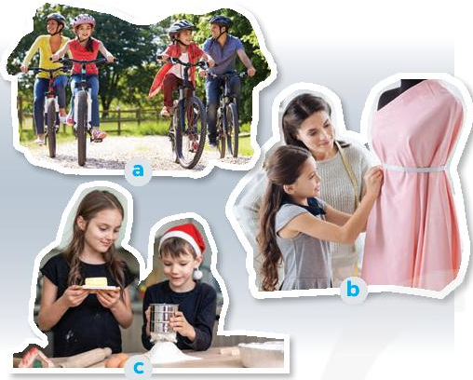  Task 2. Read about Trang’s leisure activities. Choose the correct answer  * Key: 1. C 2. B
ACTIVITY 3: PRACTICE (20'- PW/IW/GW )
1. Aim:
To help Ss develop their reading skill for details (scanning).
To help Ss prepare ideas to talk about the leisure activities they do with their family members.
To give Ss a chance to report their group's answers about leisure activities they do with their family members.
2. Content:
Read the text again and answer the questions
Asking and answering the questions; Report the answers to the class.
3. Products:
Ss can answer the questions correctly.
Students can ask and answer the questions correctly; Report what activities are the most common.
4. Implementation:
TEACHER AND STUDENTS' ACTIVITIES | CONTENTS
Step 1: Task delivering  - T let Sts study the examples, consume the rules and do the exercises  Step 2: Task performing  Task 3. Read the text again and answer the questions.  - Ask Ss what they are going to do.  - Have Ss share how to do this exercise.  - Briefly tell them the steps: Read the questions, underline the key words in each question, locate the keywords in the text and find the information to answer the question.  - Ask Ss to repeat the steps if necessary.  - Ask Ss to do the exercise individually and then check their answers in pairs.  - Invite some Ss to share their answers. Have them explain their answers. Confirm the correct answers.  - Ask some Ss to tell the class about Trang's leisure activities.  Task 4. Work in groups. Take turns to ask and answer the questions. Record the friends’ answers in the table.  - Tell Ss that they are going to work in groups to answer the questions in the book. Model the answers to the questions yourself.  - Have Ss work in groups of four to ask and answer the three questions in the book. Ask them to draw a similar table on a sheet of paper to record their group members' answers.  - Ask Ss to practise reporting the group's answers within the group.  - Move around to observe and offer help if needed.  Task 5. Report your group members’ answers to the class. What activities are the most common?  - Invite some Ss to share their group's answers to the class.  - Ask other groups to listen and give comments.  - Comment on Ss' answers.  * Teacher gives corrections and feedback  Step 3: Report and discussion  - Ss write down the new vocabulary  - T asks, Ss answer some more questions about the lesson  Step 4: Judgement  - T gives feedback on the reaction of Ss | Task 3. Read the text again and answer the questions.  * Key:  1. She goes for a bike ride, cooks and does DIY.  2. Her brother does.  3. No, it isn't.  4. She loves doing DIV projects with her mum the most.  5. Her mum teaches her to make her own dresses and doll clothes.  6. She won first prize in a costu  Task 4. Work in groups. Take turns to ask and answer the questions. Record the friends’ answers in the table.  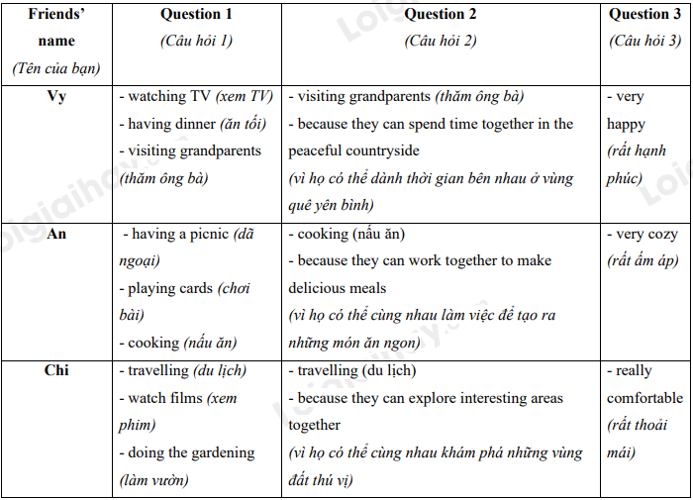  Task 5. Report your group members’ answers to the class. What activities are the most common?  * Example:  - Some teenagers enjoy spending free time with their friends.  - Some of them prefer spending time with theeir family .  - I love going for a bike ride. ….
ACTIVITY 4: APPLICATION (5' - WC)
1. Aim:
- Check Ss’ understanding about the reading passage.
- To help some Ss enhance presentation skill.
- To consolidate what Ss have learnt in the lesson.
- To give Home assigment
2. Content:
A mind map summarising the main points of the lesson.
Home assigment
3. Products:
Review the old lesson
Take note Home assigment
4. Implementation:
TEACHER AND STUDENTS' ACTIVITIES | CONTENTS
Step 1: Task delivering (Home assignment)  - T has Ss summarise what they have learnt with the two skills.  - T can instruct them to draw a mind map to summarise the main points of the lesson.  - Home assigment  Step 2: Task performance  *T allows Ss to give comments for their friends and vote for the most interesting and informative presentation.  ** Ss do as required.  *** T calls Ss to share answer.  ****T gives feedback and comments.  - T lets Sts take note the home assignment  Step 3: Report and discussion  - T asks, Sts answer about community service and tips for treating health problems.  -Step 4: Judgement  T gives feedback and requires Sts do homework. | * Home assigment:  - Do more exercises in workbook.  - Prepare new lesson. Skills 2.
IV. FEED-BACK:
………………………………………………………………………………………………
………………………………………………………………………………………………
……………………………………………………………………………………………….
……………………………………………………………………………………………….
………………………………………………………………………………………………..

UNIT 1: LEISURE TIME
Lesson 6: SKILLS 2
Week 3
Period: 7
Class | Date of teaching | Attendance
8D
8E
I. OBJECTIVES
By the end of the lesson, students are expected to achieve the following objectives:
1. Knowledge:
*Vocabulary:
- Vocabulary to talk about about LEISURE ACTIVITIES: boost your happiness, reduce your stress, improve your self-confidence and self-worth, overcome sad time.
* Pronunciation:
- Pronounce the new words correctly: boost your happiness, reduce your stress, improve your self-confidence and self-worth, overcome sad time.
* Grammar:
- Use verbs of liking / disliking followed by gerunds and / or to-infinitives to talk about likes and dislikes;
2. Competencies:
a. General competencies:
- Group work and independent working, pair work, linguistic competence, cooperative learning and communicative competence.
- Develop communication skills and enhance awareness of preserving the culture
- Be co-operative and supportive in pair work and teamwork.
- Actively join in class activities.
b. Specific competencies:
- use words related to the topic leisure activities;
- Asking and answering questions about leisure time
- pronounce the sounds /ʊ/ and /u:/ correctly;
- Listening to someone talking about their leisure activities with friends
- Writing a paragraph about leisure activities with friends
3. Qualities:
- Develop awareness of relaxing time
- Be concerned to the interests and hobbies
- Develop self-study skills.
- Ss have the good attitude to working in groups, individual work, and pairwork, cooperative learning and working.
II. PREPARATIONS
Teacher: Text book, laptop, loudspeaker, projector…
Students: Text books, studying equipment’s….
III. PROCEDURE
ACTIVITY 1: WARM-UP (5’- GW/PW/IW)
1. Aim:
- To develop student’s listening skills for specific information. It also provides input for the writing skills.
- To lead in the new lesson
2. Content:
- Review the previous lesson or have some warm-up activities to create a friendly and relaxed atmosphere to inspire Ss to warm up to the new lesson.
3. Products:
- Interest and concentration of Ss on the class activities.
- A friendly and relaxed atmostphere to the new lesson
- A chance to speak English and focus on the topic of the lesson..
4. Implementation:
- Teacher instructs
- Ss do as required
TEACHER AND STUDENTS' ACTIVITIES | CONTENTS
Step 1: Task delivering  - Chatting  Step 2: Task performance  + Greeting  + Greeting  + Teacher (T) asks Ss some questions about the previous lessons,  - T may introduce some warm-up activities to create a friendly and relaxed atmosphere to inspire Ss to warm up to the subject and new class…  - T encourages Ss to talk in English as much as possible  - Invite some Ss to go to the board. Give him/ her one leisure activity that they learnt in the previous lesson. Ask them to describe the words without saying anything. The rest of the class guess the words.  + Students (Ss) listen and learn how to do the tasks.  - Lead to the new lesson: Listening and Writing about activities with friends.  - Introduce the objectives of the lesson.  - Introduce the objectives of the lesson. Write the objectives in the left corner of the board.  - Open the book and write the tittle of the lesson.  Step 3: Report and discussion  - Ss join in the discussion and do as required  Step 4: Judgement  - T summarizes the discussion and leads to the lesson. | + Greeting  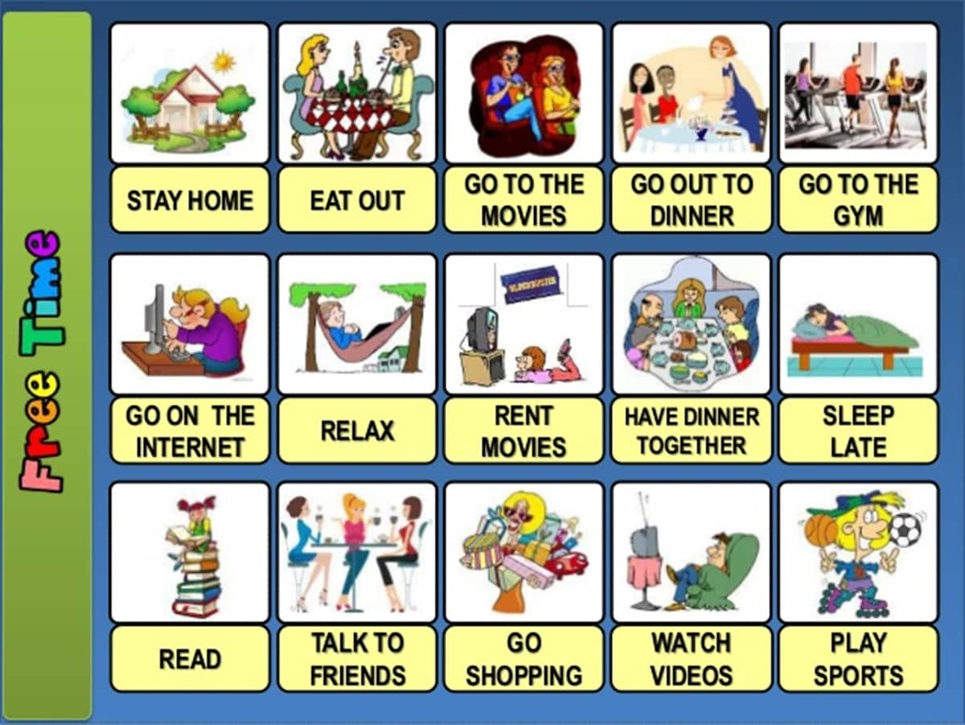
ACTIVITY 2: KNOWLEDGE FORMATION (15'- PW/IW/GW)
1. Aim:
To prepare ss for the listening text
To help ss develop the skill of listening for specific information.
2. Content:
Answer the questions to focus on the topic on the lesson.
Listen to an interview with Mark about his leisure activities do the tasks that follow.
3. Products:
Ss answer the two questions freely.
Improve listening skill
4. Implementation:
TEACHER AND STUDENTS' ACTIVITIES | CONTENTS
Step 1: Task delivering  - T sets the scene/ context for the listening and reading.  - T ask the whole class to do the Tasks in Skills 2  Step 2: Task performance  Pre-Listening:  Task 1. To help ss develop the skill of listening for specific information.  * Teach vocabulary:  + Teacher uses different techniques to teach vocab (situation, realia, translation.) if have  - Have Ss answer the questions in the book.  - Elicit answers from ss. This is an open activity, so accept all answers provided they make sense.  While-listening  Task 2. Listen to an interview with Mark about his leisure activities. Choose the correct answer.  - Tell Ss that they are going to listen to an interview about the leisure activities Mark does.  - Have Ss read the questions first and underline the key words.  - Play the recording and ask ss to listen and choose the correct answers. ss wo rk in pairs to compare their answers.  - Ask for Ss' answers and write them on the board without confirming whether they are right or wrong.  Step 3: Report and discussion  - Ss write down the new vocabulary  - T asks, Ss answer some more questions about the lesson  Step 4: Judgement  - T gives feedback on the reaction of Ss | Task 1. To help ss develop the skill of listening for specific information.  - We can hang out, play sport….  - To improve social skills; reduce stress…  Task 2. Listen to an interview with Mark about his leisure activities. Choose the correct answer.  * Key:  1.A  2. C
ACTIVITY 3: PRACTICE (20'- PW/IW/GW )
1. Aim:
To help ss develop the skill of listening for specific information.
To help ss brainstorm ideas and make an outline for their writing.
To help ss practise writing an email to a pen pal to tell him/ her about the leisure activities they do with their friends
2. Content:
Choose the best answer; do the filling in the table.
An email about the leisure activities they do with their friends
3. Products:
To Improve the skill . To do the tasks correctly
Ss can write an e-mail.
4. Implementation:
TEACHER AND STUDENTS' ACTIVITIES | CONTENTS
Step 1: Task delivering  - T let Ss study the examples, consume the rules and do the exercises  Step 2: Task performing  Task 3. Listen to the interview again. Fill in each blank in the table with no more than two words.  - Tell Ss that they are going to listen to the interview again and complete the table Of information.  - Have Ss read the table. Have ss guess the word or phrase to fill in each blank and write their guesses on the board.  - Play the recording and ask ss to listen again and complete the table. ss work in pairs to compare their answers with each other and with the words / phrases on the board.  - Play the recording once more for pairs to check their answers to both activities 2 and 3.  - Ask for Ss' answers to 2. Confirm and tick the correct answers. Ask for ss' answers to 3.  - Write them on the board next to their guesses.  - Confirm the correct answers.  Task 4. Work in pairs. Ask and answer the questions.  - Have ss work in pairs to answer the questions in the book.  - Have some Ss present their answers or write their answers on the board.  - Move around to observe and offer help if needed  - Comment on their answers  Task 5. Write an email (80 - 100 words) to a pen-friend to tell him / her about what you usually do with your friends in your free time. use your answers in 4.  - Have Ss write their emails individually based on their answers in 4.  - Ask one student to write his or her email on the board. Other ss and T comment on the email on the board.  - T collects some of the texts to correct at home. Otherwise, ask ss to revise and rewrite at home based on the T's comments of their friends' texts.  - Have them bring their new texts to class in the next lesson.  - Collect some for marking.  Step 3: Report and discussion  - Ss write down the new vocabulary  - T asks, Ss answer some more questions about the lesson  Step 4: Judgement  - T gives feedback on the reaction of Ss | Task 3. Listen to the interview again. Fill in each blank in the table with no more than two words.  * Key:  1. video 2. cinema 3. park  4. shape 5. bike ride 6. places  Task 4. Work in pairs. Ask and answer the questions.  - Have ss work in pairs to answer the questions in the book.  - Have some Ss present their answers or write their answers on the board.  - Move around to observe and offer help if needed  - Comment on their answers  Task 5. Write an email (80 - 100 words) to a pen-friend to tell him / her about what you usually do with your friends in your free time. use your answers in 4.  * Start and end the email as follows:  * Example:  Hi Ann,  It’s nice to hear from you again.Let me tell you about the things I usually do with my friends in my free time.  I usually free time at weekend, and I often spend Sunday mornings with my friends. I have three close friends, and they live near my house. We usually play badminton together for about one hour in the playground. After that, we cycle around the neibourhood. It’s a lot of fun.  What about you? What do you usullay do with your friends in your free time?  Tell me in your next email.  Bye for now,  Mi
ACTIVITY 4: APPLICATION (5'- WC )
1. Aim:
To help Ss revise all they have learnt.
To give Home assigments
2. Content:
A mind map summarising the main points of the lesson.
Home assigments
3. Products:
Review the old lesson
Take note Home assigments
4. Implementation:
TEACHER AND STUDENTS' ACTIVITIES |  | CONTENTS
Step 1: Task delivering (Home assignment)  - T has Ss summarise what they have learnt with the two skills.  - T can instruct them to draw a mind map to summarise the main points of the lesson.  - Home assigments  Step 2: Task performance  - Ask Ss to summarise what they have learnt in the lesson. Have Ss look at the objectives written on the board at the beginning of the lesson and tick the objectives they can do.  - Encourage Ss not to refer back to the unit. Ask them to keep a record of their answers to each exercise so that they can use that information to complete the self-assessment table at the end of the unit.  - T lets Ss take note the home assignments  Step 3: Report and discussion  - T asks, Ss answer about hobbies  -Step 4: Judgement  T gives feedback and requires Ss do homework. |  | * Home assigments:  - Do more exercises in workbook.  - Prepare for the next lesson: Lesson 7: LOOKING BACK & PROJECT
IV. FEED-BACK:
………………………………………………………………………………………………
………………………………………………………………………………………………
……………………………………………………………………………………………….
……………………………………………………………………………………………….
………………………………………………………………………………………………..

UNIT 1: LEISURE TIME
Lesson 7: LOOKING BACK
Week 3
Period: 8
Class | Date of teaching | Attendance
8D
8E
I. OBJECTIVES
By the end of the lesson, students are expected to achieve the following objectives:
1. Knowledge:
*Vocabulary:
- Vocabulary to talk about about LEISURE ACTIVITIES
* Pronunciation:
- Pronounce the new words correctly
- pronounce the sounds /ʊ/ and /u:/ correctly in words and sentences;
* Grammar:
- Use verbs of liking / disliking followed by gerunds and / or to-infinitives to talk about likes and dislikes;
2. Competencies:
a. General competencies:
- Group work and independent working, pair work, linguistic competence, cooperative learning and communicative competence.
- Develop communication skills and enhance awareness of preserving the culture
- Be co-operative and supportive in pair work and teamwork.
- Actively join in class activities.
b. Specific competencies:
- use words related to the topic leisure activities;
- Asking and answering questions about leisure time
- pronounce the sounds /ʊ/ and /u:/ correctly;
3. Qualities:
- Develop awareness of relaxing time
- Be concerned to the interests and hobbies
- Develop self-study skills.
- Ss have the good attitude to working in groups, individual work, and pairwork, cooperative learning and working.
II. PREPARATIONS
Teacher: Text book, laptop, loudspeaker, projector…
Students: Text books, studying equipment’s….
III. PROCEDURE
ACTIVITY 1: WARM-UP (5’- GW/PW/IW)
- Aims:
- This is the review and drill section of the unit. Encourage Ss not to refer back to the unit pages.
Instead they can use what they have learnt during the unit to help them answer the questions.
- That will help you and your Ss see how far they have progressed, and which areas need further practice.
- Encourage Ss to review and drill section of the unit 1
2. Content:
Review the previous lesson or have some warm-up activities to create a friendly and relaxed atmosphere to inspire Ss to warm up to the new lesson.
3. Products:
- Interest and concentration of Ss on the class activities.
- A friendly and relaxed atmostphere to the new lesson
- A chance to speak English and focus on the topic of the lesson..
4. Implementation:
- Teacher instructs
- Ss do as required
TEACHER AND STUDENTS' ACTIVITIES | CONTENTS
Step 1: Task delivering  - Chatting  Step 2: Task performance  + Greeting  + Teacher (T) asks Ss some questions about the previous lessons,  - T may introduce some warm-up activities to create a friendly and relaxed atmosphere to inspire Ss to warm up to the subject and new class…  - T encourages Ss to talk in English as much as possible  + Students (Ss) listen and learn how to do the tasks.  - Open the book and write the tittle of the lesson.  Step 3: Report and discussion  - Ss join in the discussion and do as required  Step 4: Judgement  - T summarizes the discussion and leads to the lesson. | + Greeting: T_ Ss
ACTIVITY 2: KNOWLEDGE FORMATION (15'- PW/IW/GW)
1. Aim:
To help Ss revise the vocabulary items they have learnt in the unit.
To help Ss revise the vocabulary items they have learnt in the unit and write complete sentences.
2. Content:
Revision. Complete the sentences.
Write complete sentences from the given cues.
3. Products:
Knowing more new words.
4. Implementation:
TEACHER AND STUDENTS' ACTIVITIES | CONTENTS
Step 1: Task delivering  - T sets the scene/ context for doing exercises  - T ask the whole class to do the Tasks in Looking Back  Step 2: Task performance  Task 1. Complete the senteneces with appropriate leisure activities.  - Have Ss do this activity individually then compare their answers with their partners.  - Ask for Ss' answers or ask one student to write his / her answer on the board.  - Confirm the correct  Task 2. Write complete sentences from the given.  - Have ss write complete sentences using the cues given. Remind them to add necessary words and make changes to the cues if needed  - Ask them to share their answers with a classmate.  - Invite some ss to write their sentences on the board. T and other ss comment.  - Confirm the correct answers.  Step 3: Report and discussion  - Ss write down the new vocabulary  - T asks, Ss answer some more questions about the lesson  Step 4: Judgement  - T gives feedback on the reaction of Ss | Task 1. Complete the senteneces with appropriate leisure activities.  Key:  1- doing puzzles  2. doing DIY  3. Messaging friends  4. playing sports.  5. surfing net  Task 2. Write complete sentences from the given.  * Key:  1. My cousin is crazy about surfing the net and playing computer games.  2. They are interested in playing badminton after school.  3. I'm not fond of making models because I'm not patient.  4. Why are you not into cooking? -Because I often burn myself.  5. My friends are keen on doing judo, and they go to the judo club every Sunday.
ACTIVITY 3: PRACTICE (20'- PW/IW/GW )
1. Aim:
To help ss revise the form of the verbs after verbs of liking / disliking
To help Ss practise doing a survey on leisure time.
2. Content:
Learn some new words .
Do the fillings with the correct forms of verbs in brackets.
Complete the passage.
3. Products:
Knowing more new words.
Fill in each blank with correct forms of the verb correctly.
Use the correct forms of the verbs to complete the passage correctly.
4. Implementation:
TEACHER AND STUDENTS' ACTIVITIES | CONTENTS
Step 1: Task delivering  - T let Ss study the examples, consume the rules and do the exercises  Step 2: Task performing  Grammar  Task 3. Fill in each blank with correct forms of the verb in brackets.  - Ask ss to explain the form of the verbs after verbs of liking / disliking that they have learnt in the unit.  - Have Ss do this exercise individually then compare their answers with a partner.  - Call on some ss to give the answers.  - Confirm the correct answers and write them on the board.  Task 4. Complete the passage. Use the correct forms of the verbs in brackets and pictures. Add more words if necessary.  - Tell Ss that they are going to complete a passage about Ann's likes and dislikes, using the pictures and the language given. Remind them to add some words if necessary. Ask them to read the example carefully.  - Have ss do this exercise individually then compare their sentences with a partner.  - Invite some ss to read their answers aloud. Give feedback.  PROJECT  + Ask ss to read the instructions. Make sure they understand what to do. Ask ss to work in groups to do the project.  - Instruct ss how to carry out this project. Model the way to ask questions and record the answers in the table with one student.  - If time is limited, assign the project in earlier lessons such as in GETTING STARTED lesson.  - Make sure you guide them carefully and check their progress after each lesson. In the last lesson (LOOKING BACK), ask Ss to present their report to the class.  - Ss to present their report to the class.  - Ss display all the posters on the wall or bulletin board ; Each group presents the poster they prepare to the whole class.  Step 3: Report and discussion  - Ss write down the new vocabulary  - T asks, Ss answer some more questions about the lesson  Step 4: Judgement  - T gives feedback on the reaction of Ss | Task 3. Fill in each blank with correct forms of the verb in brackets.  * Key:  1. cycling  2. reading / to read  3. playing  4. chatting / to chat  5. to do / doing  Task 4. Complete the passage. Use the correct forms of the verbs in brackets and pictures. Add more words if necessary.  * Key:  1. reading / to read books  2. messaging / to message her friends  3. making / to make paper flowers  4. knitting / to knit  5. playing badminton  PROJECT  Leisure time survey  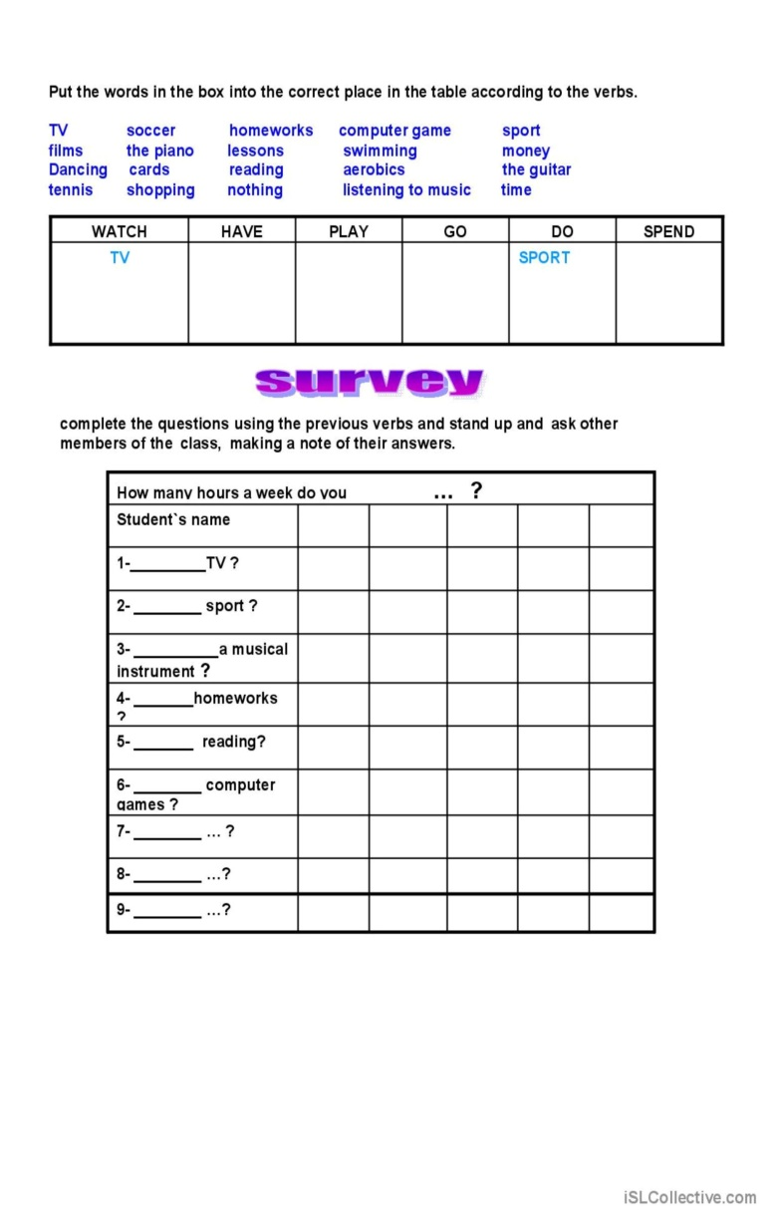
ACTIVITY 4: APPLICATION (5' - WC)
1. Aim:
To help Ss revise all they have learnt.
To give Home assigments
2. Content:
A mind map summarising the main points of the lesson.
Home assigments
3. Products:
Review the old lesson
Take note Home assigments
4. Implementation:
TEACHER AND STUDENTS' ACTIVITIES |  | CONTENTS
Step 1: Task delivering (Home assignment)  - T has Ss summarise what they have learnt with the two skills.  - T can instruct them to draw a mind map to summarise the main points of the lesson.  - Home assigments  Step 2: Task performance  - T summarises the main points.  - T asks Ss what they have learnt so far. Have them recall the important elements:  - T lets Ss take note the home assignments  Step 3: Report and discussion  - T asks, Ss answer.  -Step 4: Judgement  T gives feedback and requires Ss do homework. |  | * Home assigments:  - Do more exercises in workbook.  - Prepare Unit 2: LIFE IN THE COUNTRYSIDE.
IV. FEED-BACK:
………………………………………………………………………………………………
………………………………………………………………………………………………
……………………………………………………………………………………………….
……………………………………………………………………………………………….
………………………………………………………………………………………………..

