Period: 9


UNIT 2: LIFE IN THE COUNTRYSIDE
Lesson 1: Getting started - Last Summer holiday
Class | Date of planning | Date of teaching | Attendence
8A | 01/09/2023 | 25/09/2023
I. OBJECTIVES: * By the end of this unit, students will be able to:
- gain an overview about the topic Life in the countryside
- gain vocabulary to talk about Life in the countryside.
1. Knowledge:
+ Vocabulary: harvest (v); combine harvester (n); herd (v); paddy field (n)
+ Language: Comparative forms of adverbs.

+ Pronunciation: Sounds: /ə/ and /ɪ/
2. Competence:
a) General competencies:
- By the end of the lesson students will be able to know the form and use Comparative forms of adverbs.
- Develop communication skills and creativity.
- Be collaborative and supportive in pair work and teamwork.
- Actively join in class activities.
b) Specific competencies:
- Group work and independent working, pair work, linguistic competence, cooperative learning and communicative competence.
- Ability of using Present Simple Tense, some popular verbs of liking.
- Sts can introduce themselves or one another fluently
3. Qualities: - Love talking about activities in the countryside. Having benefits of their hobbies in daily life. Ss have the good attitude to working in groups, individual work, pair work, cooperative learning.
II. PREPARATIONS
Teacher: Grade 8 textbook, laptop, TV, pictures and realia, Computer connected to the Internet. Phần mềm tương tác hoclieu.vn
Students: Text books, pencils, pics, blank papers, realia,….
III. PROCEDURE

I. WARM-UP ACTIVITY (5’ - IW, PW)
a) Aim:
- To set the context for the introductory dialogue.
- To introduce the topic of the unit.
b) Content:
- Questions & answers about summer activities
- Watching video of summer in the countryside
c) Product:
- Students know the topic of the unit and are ready for the conversation.
d) Implementation:
TEACHER’S AND STUDENTS’ ACTIVITIES | CONTENTS AND BOARD DISPLAY
Asking questions:  Step 1: Task delivering  - T asks Ss “What did you do last summer?”.  Step 2: Task performance  - Ss answer the question individually.  - Teacher shows students a video of summer in the countryside.  Step 3: Report and discussion  - Students guess what the video is about.  - Teacher calls 3-5 students to answer.  Step 4: Judgement  - T sets the context for the listening and reading text: Write the title on the board Life in the countryside – Last summer holiday. | Observation  Questions & answers  Suggested answers:  Life in the countryside
II. KNOWLEDGE FORMATION (10’-IW, PW)
a) Aim:
- To prepare vocabulary for students to understand the conversation.
b) Content: - Vocabulary pre-teaching.
c) Product: - Students know how to use the target vocabulary.
d) Implementation:
Vocabulary pre-teaching  Step 1: Task delivering  - Teacher introduces the vocabulary.  - Teacher explains the meaning of the new vocabulary by pictures.  - Teacher reveals that the words corresponding to the pictures will appear in the reading text.  Step 2: Task performance  - Students to open their textbook to find these words.  Step 4: Judgement  - Teacher checks students’ understanding with the “Rub out and remember” technique. | Observation  Questions & answers  Vocabulary:  1. harvest (v)  2. combine harvester (n)  3. herd (v)  4. paddy fields (n)
3. PRACTICE ACTIVITIES (20’-IW, PW, GW)
a) Aim:
- To help Ss use words and phrases related to farm work in the countryside.
- To help Ss further understand the text.
- To introduce some vocabulary items related to activities that rural people often do.
b) Content:
- Task 1: Listen and read)
- Task 2: Read the conversation and choose the correct answer to each question.
- Task 3: Complete the sentences with the words and phrases from the box.
- Task 4: Match the activities (1 - 6) that people living in the countryside often do with the pictures (a - f).
c) Product:
- Students understand the conversation and know the vocabulary related to the topic)
d) Implementation:
Task 1: Listen and read  Step 1: Task delivering  - Teacher plays the recording.  Step 2: Task performance  Student’s listening  Observation  Step 3: Report and discussion  - Ss circle the words learnt in the Presentation stage.  Step 4: Judgement  - Teacher can play the recording more than once.  - Students listen and read.  Task 2: Read the conversation again and choose the correct answer to each question.  Step 1: Task delivering  - Teacher asks Ss to read the dialogue in detail to answer the questions.  - Ask them how to do this kind of exercise.  - Explain the strategies, if necessary (e.g. reading the questions and the options (A, B, C), underlining the key words in the questions and options, locating the key words in the text, and then reading that part and answering the questions).  Step 2: Task performance  - Ss underline parts of the dialogue that help them to answer.  - Set a strict time limit to ensure Ss read the text quickly for information.  Step 3: Report and discussion  - Ss compare their answers in pairs before sharing them with the class.  - Ss give evidence to support their answers.  Step 4: Judgement  - Teacher checks the correct answers as class.  Task 3: Complete the sentences with the words and phrases from the box.  Step 1: Task delivering  - Teacher tells Ss to read the conversation again.  Step 2: Task performance  - Ss work independently to do the task  - Ss share their answers with one or more partners.  Step 3: Report and discussion  - T can ask for translation of some of the words and phrases in the box to check their understanding.  - T asks 2 students to write their answers on the board.  Step 4: Judgement  - Check the answers as a class.  Task 4: Match the activities (1 - 6) that people living in the countryside often do with the pictures (a - f).  Step 1: Task delivering  - T has Ss work individually to match the words and phrases in the box with the pictures.  Step 2: Task performance  - Ss compare their answers with their partners. Then ask for Ss’ answers.  - Ss quickly write their answers on the board without confirming the correct answers.  Step 3: Report and discussion  - T has Ss listen to the recording, check their answers, and repeat the words / phrases.  - Ss look at the answers on the board and say if they are right or wrong.  Step 4: Judgement  - Confirm the correct answers.  - Teacher checks the answers as a class and gives feedback. | 1: Listen and read  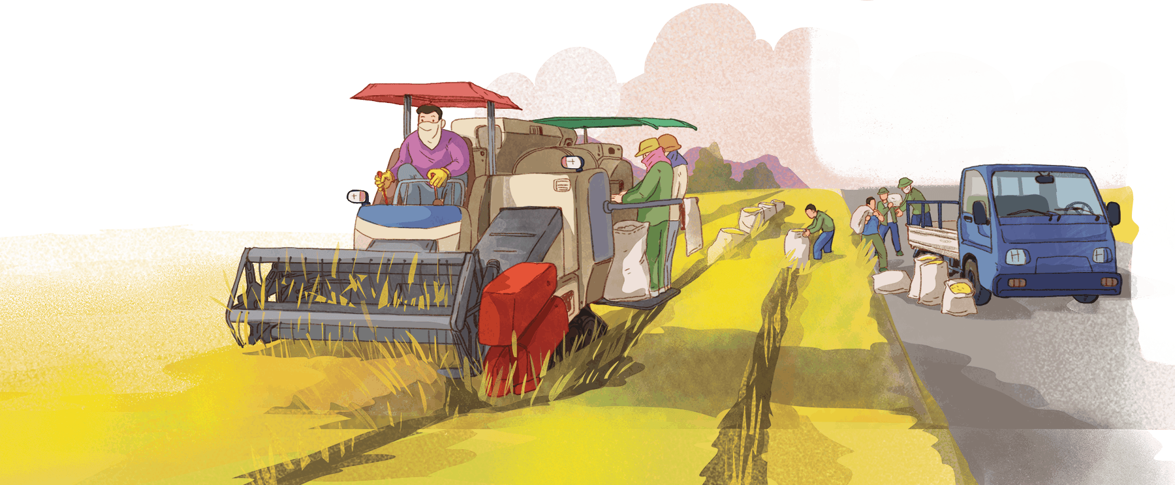  2: Read the conversation again and choose the correct answer to each question.  Student’s answers  Observation  Answer key:  1. A  2. B  3. C  4. A  3: Complete the sentences with the words and phrases from the box.  Answer key:  1. load  2. combine harvester  3. herd  4. paddy field  5. harvest time  4: Match the activities (1 - 6) that people living in the countryside often do with the pictures (a - f).  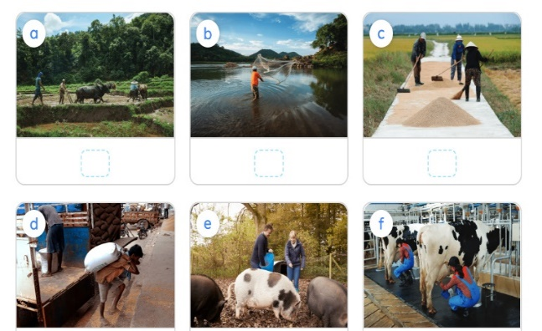  Answer key:  1. d  2. a  3. f  4. e  5. b  6. c
4. APPLICATION (5’-IW, PW)
a) Aim:
- To get students to ask and answer about activities that rural people often do.
b) Content: - Task 5: Work in pairs. Ask and answer about the pictures in 4.
c) Product: - Students’ conversations
d) Implementation:
Task 5: Work in pairs. Ask and answer about the pictures in 4.  Step 1: Task delivering  - Model this activity with a student.  - Remind Ss that they should only use the phrases and the pictures in 4 to ask and answer about activities that rural people often do.  Step 2: Task performance  - Ss work in pairs.  - T goes round to help weaker Ss.  Step 3: Report and discussion  - Some pairs to practise in front of the class.  - one or two Ss to tell the class what they have learnt.  Step 4: Judgement  - Comment on their performance.  - Ss say aloud some words and phrases they remember from the lesson. | Students’ answers  Observation  Example:  - What are they doing in picture a?  - They’re ploughing a field)
* Home assignment  - T assigns the homework.  - Ss copy their homework.  - T explains it carefully | * Home assignment  - Learn by heart vocabulary  - Prepare the next lesson: A closer look 1  - Prepare Project:  Teacher randomly puts Ss in groups of 4 or 5 and asks them to choose a village in Viet Nam or in a foreign country that they would like to visit. They have to find suitable photos to create a poster about it. Students will show their posters and present their ideas in Lesson 7 – Looking back and Project. (Teacher should check the progress of students’ preparation after each lesson.)  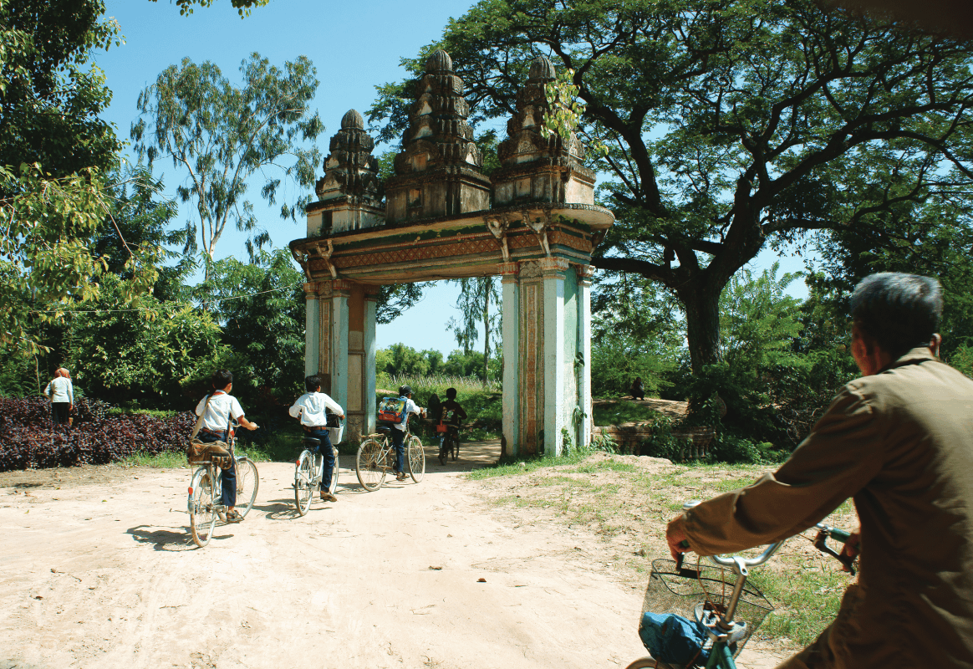  
V. FEEDBACK:
With 8A …………………………..………………………………………………………………..…

Period: 10
UNIT 2: LIFE IN THE COUNTRYSIDE
Lesson 2: A closer look 1
Class | Date of planning | Date of teaching | Attendence
8A | 01/09/2023 | 29/09/2023
I. OBJECTIVES: * By the end of this unit, students will be able to:
- use lexical items related to Life in the countryside
1. Knowledge:
+ Vocabulary: cattle (n); poultry (n); crop (n); vast (adj); hospitable (adj); picturesque (adj).
+ Language: Comparative forms of adverbs.

+ Pronunciation: Sounds: /ə/ and /ɪ/
2. Competence:
a) General competencies:
- By the end of the lesson students will be able to know the form and use Comparative forms of adverbs.
- Develop communication skills and creativity.
- Be collaborative and supportive in pair work and teamwork.
- Actively join in class activities.
b) Specific competencies:
- Group work and independent working, pair work, linguistic competence, cooperative learning and communicative competence.
- Sts can introduce themselves or one another fluently
3. Qualities: - Love talking about activities in the countryside. Having benefits of their hobbies in daily life. Ss have the good attitude to working in groups, individual work, pair work, cooperative learning.
II. PREPARATIONS
Teacher: Grade 8 textbook, TV, pictures and realia, Computer connected to the Internet. Phần mềm tương tác hoclieu.vn
Students: Text books, pencils, pics, blank papers, realia,….
III. PROCEDURE
I. WARM-UP (5’ - IW)
a. Aim:
- To create an active atmosphere in the class before the lesson.
- To lead into the new lesson.
b. Content:
- Game: Matching words with pictures
c. Product:
- Students get some vocabulary from the lesson and be ready for the lesson.
d. Implementation:
TEACHER’S AND STUDENTS’ ACTIVITIES | CONTENTS AND BOARD DISPLAY
Game: Matching words with pictures  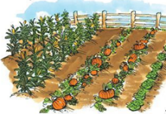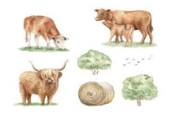    1: Task delivering  - T gives out the handouts.  - T divides the class into 10 groups and explains the rules.  Step 2: Task performance  - Ss match the given words to the pictures and they have to send one to stick the handout onto the board as quickly as possible.  Step 3: Report and discussion  - Teacher shows students the answer on the screen and announces the winning group.  Step 4: Judgement  - T sets the context for the lesson. | Suggested answers:  1. cattle (n)  2. vast (adj)  3. crop (n)  4. hospitable (adj)  5. poultry (n)  6. picturesque (adj)
II. KNOWLEDGE FORMATION (7’-IW, PW,GW)
a. Aim:
- To present some nouns that go with action verbs to describe activities which rural people often do.
b. Content:
- Vocabulary pre-teaching.
c. Product:
- Students understand how to use the vocabulary related to the topic.
d. Implementation:
ACTIVITY 1:  Vocabulary pre-teaching  - Teacher asks students to guess the meaning of the words that they have matched in the Warm-up activity.  - Teacher introduces the vocabulary.  - Teacher checks students’ understanding by the follow-up tasks in the student's book. | * Vocabulary  1. cattle (n)  2. poultry (n)  3. crop (n)  4. vast (adj)  5. hospitable (adj)  6. picturesque (adj)
III. PRACTICE (30’-IW,PW,GW)
a. Aim:
- To present some nouns that go with action verbs to describe activities which rural people often do.
- To teach Ss new adjectives for describing people and scenes in the countryside.
b. Content:
- Task 1: Circle the correct words to complete the sentences.
- Task 2: Match the following adjectives with their definitions.
- Task 3: Complete the sentences with the words from 2.
c. Product:
- Students understand how to use the vocabulary related to the topic.
d. Implementation:
Task 1: Circle the correct words to complete the sentences.  Step 1: Task delivering  - Teacher asks Ss to read each sentence.  Step 2: Task performance  - Ss choose the suitable noun that goes with the action verb before it.  - Let Ss work in pairs.  Step 3: Report and discussion  compare their answers before sharing their answers.  Step 4: Judgement  - Check and confirm the correct answers.  Task 2: Match the following adjectives with their definitions.  Step 1: Task delivering  - Teacher tells Ss quickly match the adjectives in the left column with their meanings in the right column  individually.  Step 2: Task performance  - Match the adjectives in the left column with their meanings in the right column individually.  Step 3: Report and discussion  - Ss check their answers with their partners.  - Ask for translation of some of the adjectives on the list to check their understanding.  Step 4: Judgement  - Confirm the correct answers.  Task 3: Complete the sentences with the words from 2.  - Teacher ask Ss to do the exercise individually and then check with the whole class.  - When checking, ask Ss to refer to 2 to make the meanings of the adjectives clearer to them.  - Teacher checks the answers as a class and gives feedback.  Task 4: Listen and repeat the words. Pay attention to the sounds /ə/ and /ɪ/.  Step 1: Task delivering  - Teacher asks some Ss to read out the words first.  - T plays the recording for them to listen and repeat the words they hear.  Step 2: Task performance  - Ss pay close attention to the two sounds.  - Play the recording as many times as necessary.  - Explain to Ss the difference between the two sounds if needed:  + /ɪ/ is a “front vowel”, meaning the front part of the tongue is raised while articulating this vowel. It’s  also a “close vowel”. A close vowel is one where the jaws come close to each other.  + /ə/ on the other hand is a “mid vowel”; it means that the jaws aren't closer to each other. It's also a “central vowel”. A central vowel means the central part of the tongue is raised while articulating this vowel. It's often unrounded)  Step 3: Report and discussion  - Invite some Ss to say some words they know that include the two sounds.  Step 4: Judgement  - Comment on their pronunciation of the sounds. | * VOCABULARY  1: Circle the correct words to complete the sentences.  Answer key:  1. cattle  2. fruit  3. crops  4. unloaded  5. catching  2: Match the following adjectives with their definitions.  Answer key:  1. c  2. d  3. e  4. b  5. a  3: Complete the sentences with the words from 2.  Answer key:  1. hospitable  2. well-trained  3. picturesque  4. vast  5. surrounded  * PRONUNCIATION  4: Listen and repeat the words. Pay attention to the sounds /ə/ and /ɪ/.  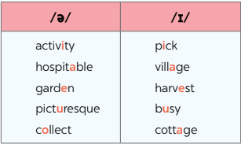  Suggested outcome:  Students repeats the words correctly
4. APPLICATION (5’-IW,PW,GW)
a. Aim:
- To help Ss identify how to pronounce the sounds /ə/ and /ɪ/.
- To help Ss practise pronouncing these sounds in words and sentences.
b. Content:
- Task 5: Listen and practise the sentences. Underline the bold words with /ə/, and circle the bold words with /ɪ/.
c. Product:
- Students repeat the words correctly in words and sentences.
d. Implementation:
Task 5: Listen and practice the sentences. Underline the bold words with /ə/ and circle the bold words with /ɪ/.  Step 1: Task delivering  - Teacher aks Ss to quickly read the sentences.  - T plays the recording for Ss to listen to the sentences.  Step 2: Task performance  - Ss pay attention to the underlined parts  - Underline and circle the appropriate sounds.  Step 3: Report and discussion  - Ss share their answers. Confirm the correct ones.  - Play the recording again for Ss to repeat the sentences.  - Ss practice the sentences in pairs. Invite some pairs to read the sentences aloud)  Step 4: Judgement  - Comment on their pronunciation of the sounds. | Student’s answers  Observation  Suggested outcome:  1. There is a lot of water in the bottle.  2. The farmers here are hard-working.  3. They are picking fruits in the orchard)  4. People in my village usually gather at weekends.  5. Please buy some milk and pasta at the supermarket.
* Home assignment  - T assigns the homework.  - Ss copy their homework.  - T explains it carefully | * Home assignment  - Learn by heart vocabulary  - Practice pronounces the sounds /ə/ and /ɪ/  - Prepare: A closer look 2

V. FEEDBACK:
With 8A …………………………..………………………………………………………………..…

Period:11
UNIT 2: LIFE IN THE COUNTRYSIDE
Lesson 3: A closer look 2 P₃₂₋₃₃
Class |  | Date of teaching | Attendence
8A | 01/09/2023 | 30/09/2023
I. OBJECTIVES: * By the end of this unit, students will be able to:
- use lexical items related to Life in the countryside
1. Knowledge:
+ Vocabulary: cattle (n); poultry (n); crop (n); vast (adj); hospitable (adj); picturesque (adj).
+ Language: Comparative forms of adverbs.

+ Pronunciation: Sounds: /ə/ and /ɪ/
2. Competence:
a) General competencies:
- By the end of the lesson students will be able to know the form and use Comparative forms of adverbs.
- Develop communication skills and creativity.
- Be collaborative and supportive in pair work and teamwork.
- Actively join in class activities.
b) Specific competencies:
- Group work and independent working, pair work, linguistic competence, cooperative learning and communicative competence.
- Sts can introduce themselves or one another fluently
3. Qualities: - Love talking about activities in the countryside. Having benefits of their hobbies in daily life. Ss have the good attitude to working in groups, individual work, pair work, cooperative learning.
II. PREPARATIONS
Teacher: Grade 8 textbook, TV, pictures and realia, Computer connected to the Internet. Phần mềm tương tác hoclieu.vn
Students: Text books, pencils, pics, blank papers, realia,….
III. PROCEDURE
I. WARM-UP
a. Aim:
- To review comparative forms of adjectives before the lesson.
- To introduce the term of comparative form of adverbs.
b. Content:
- Making comparison between two pictures.
c. Product: - Students’ answers.
d. Implementation:
TEACHER’S AND STUDENTS’ ACTIVITIES | CONTENTS AND BOARD DISPLAY
Step 1: Task delivering  - Teacher shows the pictures on the screen.  Step 2: Task performance  - Teacher asks students to make comparative sentences to describe the difference between the 2 pictures.  - Teacher gives some follow-up questions to lead in the introduction of the target grammar point.  Questions:  1. Who lives faster than the other: people in the countryside or people in the city?  2. Who lives more peacefully than the other: people in the countryside or people in the city?  Step 4: Judgement  - Teacher sets the context for the lesson.  - Teacher corrects students (if needed). | Making comparison  Suggested answers:  1. People in the countryside live more slowly than people in the city.  2. People in the countryside live more peacefully than people in the city.
II. KNOWLEDGE FORMATION (10’)
a. Aim:
- To teach Ss the comparative forms of some adverbs that Ss normally use in everyday conversations.
b. Content:
- The comparative adverbs
c. Product:
- Students know how to use the target grammar.
d. Organization
ACTIVITY 1: PRESENTATION  Step 1: Task delivering  - T tells Ss about Grammar teaching: Comparative adverbs.  1. For most adverbs (often with two or more syllables), we make comparative forms by adding more.  2. For adverbs that have the same forms as adjectives like fast, hard, soon, etc), we make comparative forms by adding -er.  3. Some irregular adverbs  Step 2: Task performance  - Observation  - Questions & answers  Step 3: Report and discussion  Ss make example.  Step 4: Judgement  - Teacher checks students’ understanding by asking some questions. | 1. adding more:  slowly → more slowly  carefully → more carefully  2. adding -er:  fast → faster  hard → harder  3. irregular adverbs:  well → better  badly → worse
III. PRACTICE (16’)
a. Aim:
- To help Ss practise the correct comparative forms of adverbs in sentences.
b. Content:
- Task 1: Write the comparative forms of the adverbs in the table below.
- Task 2: Complete the sentences with the comparative forms of the adverbs in brackets.
- Task 3: Complete the sentences with suitable comparative forms of the adverbs from the box.
- Task 4: Read the situations and complete the sentences using the comparative forms of the adverbs in brackets.
c. Product:
- Students understand how to use the target grammar.
d. Implementation:
Task 1: Write the comparative forms of the adverbs in the table below.  Step 1: Task delivering  - Teacher asks Ss to do the exercise individually.  Step 2: Task performance  - Ss’ Observation.  - Do the exercise individually.  Step 3: Report and discussion  - Teacher invites some Ss to share their answers.  - Check their answers in pairs.  Step 4: Judgement  - Confirm the correct answers.  Task 2: Complete the sentences with the comparative forms of the adverbs in brackets.  Step 1: Task delivering  - Have Ss do the exercise individually and then compare their answers with their partners.  Step 2: Task performance  - Student’s Observation  - Do the exercise individually.  Step 3: Report and discussion  - Ss write their answers on the board.  - Check the answers with the whole class.  - Ss explain how to make the comparative form of the adverb given in each sentence.  Step 4: Judgement  - Confirm the correct answers.  Task 3: Complete the sentences with suitable comparative forms of the adverbs from the box.  Step 1: Task delivering  - Have Ss do the exercise individually and then compare their answers with their partners.  Step 2: Task performance  - Student’s Observation  - Do the exercise individually.  Step 3: Report and discussion  - Ss write their answers on the board.  - Check the answers with the whole class.  - Ss explain how to make the comparative form of the adverb given in each sentence.  Step 4: Judgement  - Confirm the correct answers.  Task 4: Read the situations and complete the sentences using the comparative forms of the adverbs in brackets.  Step 1: Task delivering  - Have Ss do the exercise individually and then compare their answers with their partners.  Step 2: Task performance  - Student’s Observation  - Do the exercise individually.  Step 3: Report and discussion  - Ss write their answers on the board.  - Check the answers with the whole class.  Step 4: Judgement  - Confirm the correct answers. | 1: Write the comparative forms of the adverbs in the table below.  Answer key:  2: Complete the sentences with the comparative forms of the adverbs in brackets.  Answer key:  1. more beautifully  2. more clearly  3. faster  4. harder  5. more heavily  3: Complete the sentences with suitable comparative forms of the adverbs from the box.  Student’s answers  Observation  Answer key:  1. more carefully  2. faster  3. more quietly  4. more soundly  5. earlier  4: Read the situations and complete the sentences using the comparative forms of the adverbs in brackets.  Suggested answer:  1. The red car can run faster than the black car.  2. Nick can jump higher than Tom.  3. Mai did better on the exam than Hoa)  4. The workers arrived earlier than my dad expected)  5. The buses run more frequently than the trains.
  Adverbs | Comparative forms
  long | longer
  high | higher
  late | later
  quickly | more quickly
  frequently | more frequently
  early | earlier
  much | more
  little | less
4. APPLICATION (10’)
a. Aim:
- To help Ss practise using comparative adverbs to make comparisons
b. Content:
- Task 5. Work in pairs. Ask and answer to find out who...
c. Product:
- Students’ conversations
d. Implementation:
Task 5. Work in pairs. Ask and answer to find out who...  Step 1: Task delivering  - Model this activity with a student.  - Remind Ss that they should only use the phrases and the pictures in 4 to ask and answer about activities that rural people often do.  Step 2: Task performance  - Student’s Observation  - Ask Ss to work in pairs.  - T goes round to help weaker Ss.  Step 3: Report and discussion  - Some pairs to practise in front of the class.  Step 4: Judgement  - Comment on their performance.  - Summarise the main points of the lesson.  * Home assignment  - T assigns the homework.  - Ss copy their homework.  - T explains it carefully. | 5. Work in pairs. Ask and answer to find out who...  Who:  - can run faster  - can jump higher  - stay up late at night  - gets up earlier in the morning  Suggested outcome:  A: How fast can you run?  B: I can run 15 kilometres an hour.  A: Ok, so you can run faster than me.  I can run fast but B can run faster than I do.  * Home assignment  - Ask Ss to make sentences about themselves, using comparative adverbs.  - Practice the comparative form of adverbs  - Prepare: Communication
V. FEEDBACK:
With 8A …………………………..………………………………………………………………..…

Period:12
UNIT 2: LIFE IN THE COUNTRYSIDE
Lesson 4: Communication P₃₃₋₃₄
Class | Date of planning | Date of teaching | Attendence
8A | 01/09/2023 | 02/10/2023

I. OBJECTIVES: * By the end of this unit, students will be able to:
- use lexical items related to Life in the countryside
1. Knowledge:
+ Vocabulary:
+ Language: - Give and respond to compliments: How to respond to compliments: Thank you. / I’m glad you like it.
+ Pronunciation: Sounds: /ə/ and /ɪ/
2. Competence:
a) General competencies:
- By the end of the lesson students will be able to know the form and Give and respond to compliments.
- Develop communication skills and creativity.
- Be collaborative and supportive in pair work and teamwork.
- Actively join in class activities.
b) Specific competencies:
- Group work and independent working, pair work, linguistic competence, cooperative learning and communicative competence.
- Sts can introduce themselves or one another fluently
3. Qualities: - Love talking about activities in the countryside. Having benefits of their hobbies in daily life. Ss have the good attitude to working in groups, individual work, pair work, cooperative learning.
II. PREPARATIONS
Teacher: Grade 8 textbook, TV, pictures and realia, Computer connected to the Internet. Phần mềm tương tác hoclieu.vn
Students: Text books, pencils, pics, blank papers, realia,….
III. PROCEDURE
I. WARM-UP (7’-IW)
a. Aim:
- To create an active atmosphere in the class before the lesson.
- To lead into the new lesson.
b. Content:
- Rearrange to make a conversation.
c. Product:
- Students’ answers.
d. Implementation:
TEACHER’S AND STUDENTS’ ACTIVITIES | CONTENTS AND BOARD DISPLAY
Jumbled conversation:  Step 1: Task delivering  - Teacher gives out a jumbled conversation.  1. Thank you. Yours is, too.  2. Happy birthday. Wow, you’re wearing such a beautiful dress.  3. Here is your present. I hope you like it.  4. I’m glad you like it.  5. This is the best gift I have ever had) I love it.  Step 2: Task performance  - Ss’ Observation  - Questions & answers  Step 3: Report and discussion  - Students rearrange it to make a meaningful conversation.  - Teacher gives some follow-up questions to lead in the introduction of the target grammar point. | Observation  Questions & answers  Suggested answers:  2. Happy birthday. Wow, you’re wearing such a beautiful dress.  1. Thank you. Yours is, too.  3. Here is your present. I hope you like it.  5. This is the best gift I have ever had) I love it.  4. I’m glad you like it.
II. KNOWLEDGE FORMATION (13’-IW,PW)
a. Aim:
- To introduce ways of giving and responding to compliments.
- To help Ss practise giving and responding to compliments.
b. Content:
- Task 1: Listen and read the conversations. Pay attention to the highlighted sentences.
- Task 2: Work in pairs. Make similar conversations to practise giving and responding to compliments, using the cues below.
c. Product:
- Students know how to use the structures to give and respond to compliments.
d. Implementation:
Task 1: Listen and read the conversations. Pay attention to the highlighted sentences.  Step 1: Task delivering  - Play the recording for Ss to listen and read the two dialogues between Tom and Mai, Nick and Hoa at the same time.  Step 2: Task performance  - Ss pay attention to the questions and answers.  - Have Ss practise the dialogues in pairs.  Step 3: Report and discussion  - Some pairs to practise the dialogues in front of the class.  Step 4: Judgement  - Comment on their performance.  - Confirm the correct answers.  Task 2: Work in pairs. Make similar conversations to practise giving and responding to compliments, using the cues below.  Step 1: Task delivering  - Ask Ss to work in pairs to make similar dialogues with the given cues.  - Move around to observe and provide help.  Step 2: Task performance  - Ss’Observation  - Questions & answers  Step 3: Report and discussion  - Some pairs to practise in front of the class.  Step 4: Judgement  - Comment on their performance. | * EVERYDAY ENGLISH  1:Listen and read the conversations. Pay attention to the highlighted sentences.  Observation  Questions & answers  2: Work in pairs. Make similar conversations to practise giving and responding to compliments, using the cues below.    Cues:  - a shirt  - a bicycle  - a school bag
III. PRACTICE (17’-IW,PW,GW)
a. Aim:
- To help Ss learn about two traditional villages in Viet Nam and the Netherlands.
- To help Ss develop their reading skills for specific information (scanning).
- To provide Ss with practice in giving a presentation about the similarities and differences
between two places.
b. Content:
- Task 3: Read the adverts for the two beautiful villages. Tick the boxes to show which village the statements describe. Sometimes both boxes need to be ticked.
- Task 4: Work in groups. Take turns to talk about the similarities and differences between Duong Lam and Hollum.
c. Product:
- Students know about two traditional villages in Viet Nam and the Netherlands.
d. Implementation:
Task 3: Read the adverts for the two beautiful villages. Tick the boxes to show which village the statements describe. Sometimes both boxes need to be ticked)  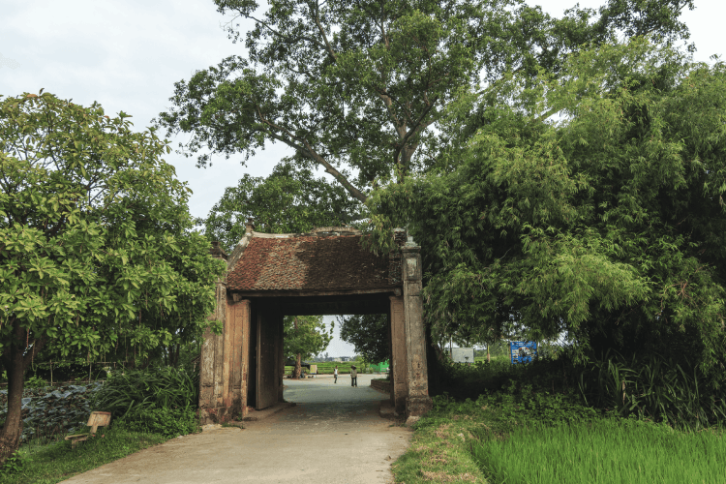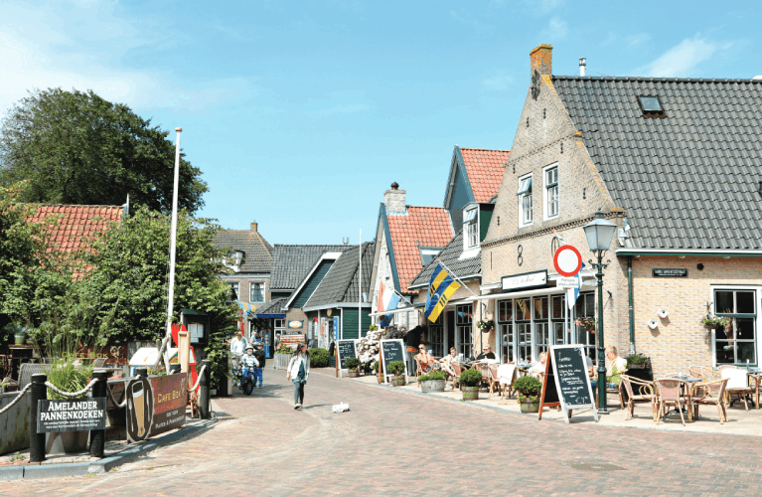  Step 1: Task delivering  - Have Ss read the instructions to understand what they are going to do.  - Remind them that they have to read each statement in the table and then read the two adverts to scan for the necessary information to help them tick the correct boxes.  Step 2: Task performance  - Ss read the two adverts and tick the boxes in the table.  - Go around and offer help, if necessary.  Step 3: Report and discussion  - Swap answers in pairs.  - Check the answers as a class.  Step 4: Judgement  - Comment on their performance.  - Confirm the correct answers.  Task 4: Work in groups. Take turns to talk about the similarities and differences between Duong Lam and Hollum.  Step 1: Task delivering  - Teacher introduces some words or phrases that are often used to talk about the similarities and differences, such as: both, also, too, like, as, unlike, but, however, etc)  - T gives examples to illustrate.  Step 2: Task performance  - Student’s Observation  - Ss work in groups, taking turns to talk about the similarities and differences between the two villages.  - T may go round to observe.  Step 3: Report and discussion  - Ss to say as many sentences as possible.  - T asks Ss not to interrupt their group members while they are speaking in order to correct their errors.  - Tell them to correct only common errors after their group members have finished speaking.  - Some Ss to give the presentation to the whole class. After each student finishes his or her presentation,  Step 4: Judgement  Ss comment on his or her clarity, language, and fluency from other Ss.  - Confirm the correct answers. | ADVERTS FOR BEAUTIFUL VILLAGES  3: Read the adverts for the two beautiful villages. Tick the boxes to show which village the statements describe. Sometimes both boxes need to be ticked)  Student’s answers  Observation  Suggested answers:  4: Work in groups. Take turns to talk about the similarities and differences between Duong Lam and Hollum.  Example:  Duong Lam and Hollum are both ancient villages, …
  Statements | Duong Lam | Hollum
  1. It’s an ancient village. | ✔ | ✔
  2. We can visit an ancient pagoda, traditional houses, and temples in this village. | ✔
  3. We can get there by plane or ferry. |  | ✔
  4. We can go there by car, bus, or bike. | ✔
  5. It has a lighthouse. |  | ✔
4. APPLICATION (5’-IW)
a. Aim:
- To help Ss learn about two traditional villages in Viet Nam and the Netherlands.
- To help Ss develop their reading skills for specific information (scanning).
- To provide Ss with practice in giving a presentation about the similarities and differences
between two places.
b. Content:
- Task 5: Work in pairs. Which village in 3 would you like to visit for a holiday? Explain your choice to your partner.
- Home assigment
c. Product:
- Students know about two traditional villages in Viet Nam and the Netherlands.
- Take note Home assigment
d. Implementation: Teacher’s instructions…
Task 5: Work in pairs. Which village in 3 would you like to visit for a holiday? Explain your choice to your partner  - Have students work in pairs, asking and answering questions about the villages they would like to visit. T goes around and corrects mistakes or gives help when necessary. Encourage Ss to ask more questions.  - Call on some pairs to perform the task in front of the class. T and other Ss listen and make comments.  - Have Ss say what they have learnt in the lesson.  * Home assignment  - T assigns the homework.  - T explains it carefully. | 5: Work in pairs. Which village in 3 would you like to visit for a holiday? Explain your choice to your partner  Student’s answers  Observation  Suggested outcome:  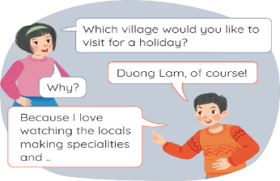  * Home assignment  - Practice responding to compliments  - Prepare: Skills 1
Period: 13
UNIT 2: LIFE IN THE COUNTRYSIDE
Lesson 5: Skills 1 P₃₃₋₃₄
Class | Date of planning | Date of teaching | Attendence
8A | 01/09/2023 | 06/10/2023

I. OBJECTIVES: * By the end of this unit, students will be able to:
- Read about different aspects of a Vietnamese village.
- Talk about a village or town where one lives or which one knows.
1. Knowledge:
+ Vocabulary: stretch (v), canal (n), canal (n), orchard (n).
+ Language: - Give and respond to compliments: How to respond to compliments: Thank you. / I’m glad you like it.
+ Pronunciation: Sounds: /ə/ and /ɪ/
2. Competence:
a) General competencies:
- By the end of the lesson students will be able to know the form and Give and respond to compliments.
- Develop communication skills and creativity.
- Be collaborative and supportive in pair work and teamwork.
- Actively join in class activities.
b) Specific competencies:
- Group work and independent working, pair work, linguistic competence, cooperative learning and communicative competence.
- Sts can introduce themselves or one another fluently
3. Qualities: - Love talking about activities in the countryside. Having benefits of their hobbies in daily life. Ss have the good attitude to working in groups, individual work, pair work, cooperative learning.
II. PREPARATIONS
Teacher: Grade 8 textbook, TV, pictures and realia, Computer connected to the Internet. Phần mềm tương tác hoclieu.vn
Students: Text books, pencils, pics, blank papers, realia,….
III. PROCEDURE
WARM-UP (5’ -IW,PW,GW)
a. Aim:
- To help Ss understand and activate their knowledge of the topic.
- To help Ss remember some adjectives that are often used to describe scenes and sceneries in the countryside.
b. Content:
- Task 1: Work in pairs. Look at the picture and discuss the following questions.
c. Product:
- Students’ answers.
d. Implementation:
TEACHER’S AND STUDENTS’ ACTIVITIES | CONTENTS AND BOARD DISPLAY
Task 1: Work in pairs. Look at the picture and discuss the following questions.  Questions:  - What can you see in the picture?  - Which adjectives in the box can be used to describe the picture?  Step 1: Task delivering  - Ask Ss to work in pairs discussing what they can see in the picture.  Step 2: Task performance  - Ss work in pairs discussing what they can see in the picture.  - Ss’ Observation  - Questions & answers  Step 3: Report and discussion  - Some Ss say their answers in front of the class.  - T may ask other questions to elicit other things in the picture.  - Ss work in pairs again, discussing which adjectives in the box can be used to describe the picture.  - Ask some Ss to say their answers in front of the class.  Step 4: Judgement  - Comment on their performance.  - Confirm the correct answers. | 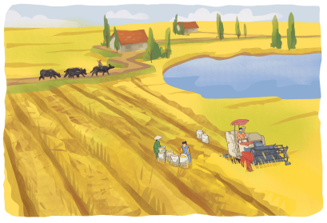  Suggested answers:  - paddy fields, cattle (buffaloes), farmers, a combine harvester, a lake / pond, trees, houses, a dirt road, horizon, etc)  - peaceful, vast, picturesque
II. KNOWLEDGE FORMATION (5’-IW,PW,GW)
a. Aim:
- To improve Ss’ knowledge of vocabulary related to community activities.
- To improve Ss’ skill of reading for specific information.
b. Content: Vocabulary
c. Product:
- Students understand how to use the target grammar.
d. Implementation:
* PRE-READING  Vocabulary  Step 1: Task delivering  - Teacher introduces the vocabulary.  - Teacher explains the meaning of the new vocabulary by pictures.  Step 2: Task performance  - Ss’ Observation  - Listen and repeat.  - Teacher reveals that the words according to the pictures will appear in the reading text.  Step 3: Report and discussion  - Ss open their textbook to find these words.  - Teacher checks students’ understanding with with follow-up questions.  - Read aloud.  Step 4: Judgement  - Comment on their performance. | Observation  Questions & answers  1. Vocabulary  1. stretch (v)  2. canal (n)  3. cultivate (v)  4. orchard (n)
3. PRACTICE (22’-IW,PW,GW)
a. Aim:
- To improve Ss’ knowledge of vocabulary related to community activities.
- To improve Ss’ skill of reading for specific information.
b. Content:
- Task 2: Read the text about life in a village in Viet Nam. Match the highlighted words in the text with their meanings.
- Task 3: Read the text again and tick T (True) or F (False) for each sentence.
c. Product: Students understand how to use the target grammar.
d. Implementation:
Task 2: Read the text about life in a village in Viet Nam. Match the highlighted words in the text with their meanings.  Step 1: Task delivering  - Ask Ss to work individually to read the passage.  - Ss find the highlighted words.  Step 2: Task performance  - Ss’ observation  - Ss read aloud the highlighted words.  - T corrects their pronunciation if needed.  Step 3: Report and discussion  - Ss match the highlighted words with their meanings in the table.  - T reminds them to use the context to help them.  Step 4: Judgement  - Check the answers as a class.  Task 3: Read the text again and tick T (True) or F (False) for each sentence.  Step 1: Task delivering  - Ask some Ss to read out loud the sentences in the table.  Step 2: Task performance  - Ss’ observation  - Questions & answers  Step 3: Report and discussion  - Ss work individually for five minutes and tick T (True) or F (False).  - Ss take turns to give the answers.  - Ss show the part in the passage where they found the answers.  - Ss read aloud the sentences.  Step 4: Judgement  - Check the answers as a class.  - Comment on their performance. | 2. Read the text about life in a village in Viet Nam. Match the highlighted words in the text with their meanings.  Answer key:  1. c  2. a  3. d  4. b  3: Read the text again and tick T (True) or F (False) for each sentence.  Observation  Questions & answers  Answer key:  1. T  2. T  3. F  4. F  5. T
4. APPLICATION (15’-IW,PW,GW)
a. Aim:
- To help Ss prepare ideas for the next activity.
- To provide an opportunity for Ss to practise talking about a village or town where they live or which they know.
b. Content:
- Task 4: Make notes about the village or town where you live or which you know.
- Task 5: Work in groups. Take turns to talk about the village or town where you live or which you know. Use the information in 4.
- Home assignment.
c. Product:
- Students’ speaking.
- Take note - Home assignment.
d. Implementation: Teacher’s instruction.
* POST READING (SPEAKING)  Task 4: Make notes about the village or town where you live or which you know.  - Tell each student to make notes. Set a time limit for Ss to do it.  - Ask Ss to think about a village or town where they live or which they know (its name, location, scenery, special features) and the people living there (how they live, what they often do, how they get along with each other).  - Have them note down these ideas quickly.  Task 5: Work in groups. Take turns to talk about the village or town where you live or which you know. Use the information in 4.  Step 1: Task delivering  - T asks a strong student to model this activity in front of the class.  - Ss work in groups, taking turns to talk about the village or town where they live or which they know about. Remind Ss to use the ideas they have prepared in 4. T may go round to observe.  Step 2: Task performance  - Ss say as many sentences as possible.  - Ss not to interrupt their group members while they are speaking in order to correct their errors.  Step 3: Report and discussion  T tell them to correct only common errors after their group members have finished speaking.  - If there is enough time, call on some Ss to talk before the whole class.  - Some positive comments from other Ss.  Step 4: Judgement  - Check the answers as a class.  - Comment on their performance.  * Home assignment  - T assigns the homework.  - Ss copy their homework.  - T explains it carefully | 4: Make notes about the village or town where you live or which you know.  Students’ conversations/ interactions  Student’s answers  Observation  Suggested outcome:  Name: Ha Noi  Location: Northern Vietnam  Scenery: ancient buildings and beautiful sights  How people live: fast, lively  Activities adults or children often do: chatting, having a coffee with friends, going shopping  The relationships among the people: friendly, helpful  Special feature: Old quarter, museums,…  5: Work in groups. Take turns to talk about the village or town where you live or which you know. Use the information in 4.  Suggested outcome:  I live in Duong Lam. It’s an old village  outside Ha Noi. It has ...  * Home assignment  - Learn by heart vocabulary  - Prepare for skills 2
V. FEEDBACK:
With 8A …………………………..………………………………………………………………..…

Period:14
UNIT 2: LIFE IN THE COUNTRYSIDE
Lesson 6: Skills 2 P₂₅
Class |  | Date of teaching | Attendence
8A | 01/09/2023 | 7/10/2023

I. OBJECTIVES: * By the end of this unit, students will be able to:
1. Knowledge:
+ Vocabulary:
+ Language: - Listen to someone’s opinion about life in the countryside
- Write a paragraph about what someone likes or dislikes about life in the countryside.
+ Pronunciation: Sounds: /ə/ and /ɪ/
2. Competence:
a) General competencies:
- Develop communication skills and creativity.
- Be collaborative and supportive in pair work and teamwork.
- Actively join in class activities.
b) Specific competencies:
- Group work and independent working, pair work, linguistic competence, cooperative learning and communicative competence.
- Sts can introduce themselves or one another fluently
3. Qualities: - Love talking about activities in the countryside. Having benefits of their hobbies in daily life. Ss have the good attitude to working in groups, individual work, pair work, cooperative learning.
II. PREPARATIONS
Teacher: Grade 8 textbook, TV, pictures and realia, Computer connected to the Internet. Phần mềm tương tác hoclieu.vn
Students: Text books, pencils, pics, blank papers, realia,….
III. PROCEDURE
1. WARM-UP (5’-IW,PW,GW)
a. Aim:
- To create an active atmosphere in the class before the lesson.
- To lead into the new lesson.
b. Content:
- Miming game: Activities that rural people do.
c. Product:
- Students’ answers
d. Implementation:
TEACHER’S AND STUDENTS’ ACTIVITIES | CONTENTS AND BOARD DISPLAY
Game: Miming Activities that rural people do.  Step 1: Task delivering  - Invite some Ss to go to the boar.  Step 2: Task performance  - Ss mime some activities that rural people often do.  Step 3: Report and discussion  - Ss guess what the activities are.  Step 4: Judgement  - Lead to the new lesson: Listening and Writing opinions on life in the countryside.  - Introduce the objectives of the lesson. | Observation  Questions & answers  Questions:  - What am I doing?  Suggested answers:  - cultivating  - harvesting  …
2. KNOWLEDGE FORMATION (5’-IW,PW,GW)
a. Aim:
- To help Ss understand and activate their knowledge of the topic.
b. Content:
- Task 1: Work in pairs. Discuss the following question.
c. Product:
- Students get vocabulary and knowledge for the listening tasks.
d. Implementation:
* PRE-LISTENING  Task 1: Work in pairs. Discuss the following question.  Step 1: Task delivering  - Ask Ss to work in pairs discussing questions about what they like or dislike about life in the countryside.  Step 2: Task performance  - Student’s answers  - Observation  Step 3: Report and discussion  - Some Ss to share their answers in front of the class. If necessary, T may ask them some other questions about the reasons for their answers.  Step 4: Judgement  - Confirm the correct answers. | 1. Work in pairs. Discuss the following question.  Questions:  What do you like or dislike about life in the countryside?
3. PRACTICE (20’-IW,PW,GW)
a. Aim:
- To help Ss develop their skill of listening for specific information.
b. Content:
- Task 2: Listen to three people talking about life in the countryside. Choose the opinion that each speaker expresses.
- Task 3: Listen again and choose the correct answer A, B, or C.
c. Product:
- Students understand how to use the target grammar.
d. Implementation:
* WHILE-LISTENING  Task 2: Listen to three people talking about life in the countryside. Choose the opinion that each speaker expresses.  Step 1: Task delivering  - Have Ss read the questions in this activity quickly and underline the key words. This helps them have some ideas of what they are going to listen to and the information they need for answering the questions.  Step 2: Task performance  - Play the recording twice for Ss to do the exercise. For stronger classes, Ss take notes of the information to explain their answers.  Step 3: Report and discussion  - Have Ss share their answers in pairs.  - Invite some pairs to answer and confirm the correct ones.  - Play the recording again if needed, stopping at places where Ss are having difficulties.  Step 4: Judgement  - Check the answers with the whole class.  - Confirm the correct answers.  Task 3: Listen again and choose the correct answer A, B, or C.  Step 1: Task delivering  - Have Ss read the questions and the options, and determine what information they need for answering the questions.  Step 2: Task performance  - Play the recording once or twice more for Ss to do the exercise. For stronger classes, ask Ss to take notes of the information to explain for their answers.  Step 3: Report and discussion  - Have Ss share their answers in pairs.  - Invite some pairs to answer and confirm the correct ones.  Step 4: Judgement  - Play the recording again if needed, stopping at the places where Ss are having difficulties.  - Check the answers with the whole class.  - Confirm the correct answers. | 2: Listen to three people talking about life in the countryside. Choose the opinion that each speaker expresses.  Student’s answers  Observation  Answer key:  Speaker 1: B  Speaker 2: A  Speaker 3: C  3: Listen again and choose the correct answer A, B, or C.  Student’s answers  Observation  Answer key:  1. C  2. A  3. C  4. A  5. B
4. APPLICATION (15’-IW,PW,GW)
a. Aim:
- To help Ss prepare ideas for the next activity
- To help Ss practise writing a paragraph about what they like or dislike about life in the countryside
b. Content:
- Task 4: Work in groups. discuss and write what you like or dislike about life in the countryside.
- Task 5: Write a paragraph (80 - 100 words) about what you like or dislike about life in the countryside.
- Home assignment.

c. Product: - Students’ speaking
- Take note Home assignment
d. Implementation:
*POST-LISTENING (WRITING)  Task 4: Work in groups. discuss and write what you like or dislike about life in the countryside.  Step 1: Task delivering  - Ask Ss to discuss and write what they like or dislike about life in the countryside and reasons for them.  Step 2: Task performance  - Remind them that they can both write full sentences and make notes, and they can even use abbreviations.  Step 3: Report and discussion  - Ss to share their writings with their partners.  - Read out the writings of some more able Ss to the whole class.  Step 4: Judgement  - Check the answers with the whole class.  - Confirm the correct answers.  Task 5: Write a paragraph (80 - 100 words) about what you like or dislike about life in the countryside.  Step 1: Task delivering  - Set up the writing activity:  - T reminds Ss that the first important thing is always to think about what they are going to write.  Step 2: Task performance  - Ss can use the ideas they have prepared in 4.  - Ask Ss to brainstorm the ideas and needed language for writing.  - T may ask Ss to refer back to the reading for useful language and ideas and write some useful expressions and language on the board.  Step 3: Report and discussion  - Ask Ss to write the first draft individually.  - T may display all or some of the Ss’ writings on the wall / bulletin board.  Step 4: Judgement  - T and other Ss comment.  - Ss edit and revise their writing as homework.  If time is limited, T may ask Ss to write the final version at home.  * Home assignment  - T assigns the homework.  - Ss copy their homework.  - T explains it carefully | 4: Work in groups. discuss and write what you like or dislike about life in the countryside.  Suggested outcome:  Students’ notes  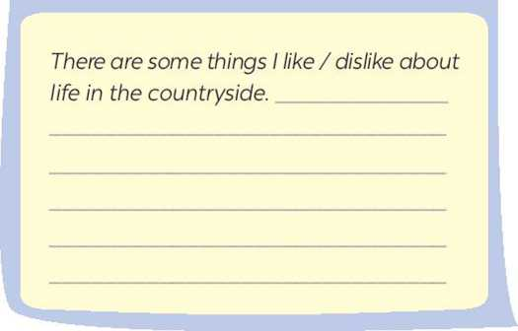  5: Write a paragraph (80 - 100 words) about what you like or dislike about life in the countryside.  Suggested answer:  There are some things I like about life in the countryside. One of the main attractions is its peacefulness. This helps people living there feel comfortable and relaxed) Additionally, I enjoy its natural beauty. The countryside often offers picturesque views of rolling hills, rolling meadows, and vast green fields. This can be a great source of inspiration. Finally, I appreciate the strong sense of community in rural areas. Rural people are very tight-knit and always willing to help their neighbours. Overall, these are just some of the many things I enjoy about rural life.  * Home assignment  - Complete the paragraph  - Prepare: Looking back and Project

V. FEEDBACK:
With 8A …………………………..………………………………………………………………..…

Period:15
UNIT 2: LIFE IN THE COUNTRYSIDE
Lesson 7: Looking back - Project P₂₆
Class |  | Date of teaching | Attendence
8A | 01/09/2023 | 09/10/2023

I. OBJECTIVES: * By the end of this unit, students will be able to:
1. Knowledge:
+ Vocabulary: Review
+ Language: - Review the vocabulary and grammar of Unit 2.
- Apply what they have learnt (vocabulary and grammar) into practice through a project
+ Pronunciation: Sounds: /ə/ and /ɪ/
2. Competence:
a) General competencies:
- Develop communication skills and creativity.
- Be collaborative and supportive in pair work and teamwork.
- Actively join in class activities.
b) Specific competencies:
- Group work and independent working, pair work, linguistic competence, cooperative learning and communicative competence.
- Sts can introduce themselves or one another fluently
3. Qualities: - Love talking about activities in the countryside. Having benefits of their hobbies in daily life. Ss have the good attitude to working in groups, individual work, pair work, cooperative learning.
II. PREPARATIONS
Teacher: Grade 8 textbook, TV, pictures and realia, Computer connected to the Internet. Phần mềm tương tác hoclieu.vn
Students: Text books, pencils, pics, blank papers, realia,….
III. PROCEDURE
1. WARM-UP (7’-IW, PW, GW)
a. Aim:
- To create an active atmosphere in the class before the lesson.
- To lead into the revision.
b. Content: - Revision.
c. Product: - Ss can tell the teacher what they have learnt in unit 2.
d. Implementation:
TEACHER’S AND STUDENTS’ ACTIVITIES | CONTENTS AND BOARD DISPLAY
Questions:  Step 1: Task delivering  - Teacher asks Ss to think of what they have learnt already in Unit 2.  - What have we learnt in Unit 2?  Step 2: Task performance  - Ss’ Observation  - Questions & answers  Step 3: Report and discussion  - Ss work in pairs to do the task.  - Teacher calls some students to retell.  Step 4: Judgement  - Teacher confirms and leads them to do all the exercises in books. | Revision (7 mins)  Suggested answers:  - words about life in the countryside  - the sounds /ə/ and /ɪ/ in words and sentences  - comparative forms of adverbs  - giving and responding to compliments  - reading about different aspects of a Vietnamese village  - talking about the village or town where someone lives  - listening to someone’s opinion about life in the countryside  - writing a paragraph about what someone likes or dislikes about life in the countryside
2. PRACTICE (23’-IW, PW, GW)
a. Aim:
- To create an active atmosphere in the class before the lesson.
- To lead into the revision.
b. Content:
- Task 1: Write a phrase from the box under the correct picture.
- Task 2: Choose the correct answer A, B, or C.
- Task 3: Complete the sentences with the comparative forms of the adverbs in brackets.
- Task 4: Underline the mistakes in the sentences and correct them.
c. Product:
- Students remember the vocabulary learnt.
- Ss can tell the teacher what they have learnt in unit 2.
d. Implementation:
Task 1: Write a phrase from the box under the correct picture.  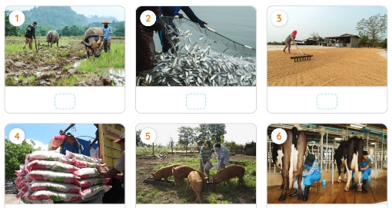  Step 1: Task delivering  - Have Ss do Task 1 individually.  Step 2: Task performance  - Students’ Observation  - Compare their answers with their partners.  Step 3: Report and discussion  - Student’s answers  - Ss’ answers or ask some Ss to read out their answers in front of the class.  Step 4: Judgement  - Confirm the correct answers.  Task 2: Choose the correct answer A, B, or C.  Step 1: Task delivering  - Have Ss do Task 1 individually.  Step 2: Task performance  - Students’ Observation  - Compare their answers with their partners.  Step 3: Report and discussion  - Student’s answers  - Ss’ answers or ask some Ss to read out their answers in front of the class.  Step 4: Judgement  - Confirm the correct answers. | * VOCABULARY REVISION  1: Write a phrase from the box under the correct picture.  Answer key:  1. ploughing fields  2. catching fish  3. drying rice  4. unloading rice  5. feeding pigs  6. milking cows  2: Choose the correct answer A, B, or C.  Student’s answers  Observation  Answer key:  1. B  2. C  3. A  4. C  5. A
Task 3: Complete the sentences with the comparative forms of the adverbs in brackets.  Step 1: Task delivering  - Ask Ss to do the exercise individually.  Step 2: Task performance  - Student’s observation  - Student’s answers  Step 3: Report and discussion  - Ss check their answers with a partner before discussing the answers as a class.  Step 4: Judgement  - Teacher confirms the correct answers.  - Remind Ss to keep a record of their original answers so that they can use that information in the Now I can … section.  Task 4: Underline the mistakes in the sentences and correct them.  Step 1: Task delivering  - Have Ss do this activity individually.  Step 2: Task performance  - Student’s observation  - Student’s answers  Step 3: Report and discussion  - Compare their answers with their partners.  - Ss’ answer or ask one student to write his / her answer on the board.  Step 4: Judgement  - Teacher confirms the correct answers.  - Remind Ss to keep a record of their original answers so that they can use that information in the Now I can … section. | * GRAMMAR REVISION  3: Complete the sentences with the comparative forms of the adverbs in brackets.  Answer key:  1. earlier  2. more fluently  3. more easily  4. more heavily  5. harder / better  4: Underline the mistakes in the sentences and correct them.  Answer key:  1. as → than  2. quicklier → more quickly  3. more hardly → harder  4. the earlier → earlier  5. more highly → higher
4. APPLICATION (15’-IW, PW, GW)
a. Aim:
- To help Ss practise making their own poster about their favourite village and present their work.
b. Content: - To help Ss develop the skill of working in groups to do a project.
c. Product: - Students’ speaking
d. Implementation:
- Ask Ss to read the instructions again (T has already assigned the project since the first lesson of the Unit and checked their progress after each lesson). Let students have some time to check their posters for the final time and make any adjustments if necessary.  - T has groups show their posters and present them to the class. Remember to have the “show and tell” session and vote for the best poster.  - Students vote for the best poster.  - Teacher gives feedback.  * Home assignment  - T assigns the homework.  - Ss copy their homework.  - T explains it carefully. | * PROJECT (14 mins)  Students’ conversations/ interactions  Observation  Suggested outcome:  Students’ posters & presentations  * Home assignment  - Prepare for UNIT 3: GETTING STARTED  - Revise lesson at home
V. FEEDBACK:
With 8A ……………………………………………………………………………………..…
………………………….……………………………………………………….……

