Period : 16


UNIT 3: TEENAGERS
Lesson 1: Getting started - It’s great to see you again! P₂₈₋₂₉
Class | Date of planning | Date of teaching | Attendence
8A | 29/9/2023 | 11/10/2023

I. OBJECTIVES: * By the end of this unit, students will be able to:
- Gain an overview about the topic Teenagers
- Gain vocabulary to talk about teenagers.
1. Knowledge:
+ Vocabulary: forum (n), stress (n), stressful (adj), pressure (n), user-friendly (adj), midterm (adj).
+ Language: Simple sentences and compound senctences

+ Pronunciation: Sounds: /ʊə/ and /ɔɪ/.
2. Competence:
a) General competencies:
- By the end of the lesson students will be able to know the form and use Simple sentences and compound senctences.
- Develop communication skills and creativity.
- Be collaborative and supportive in pair work and teamwork.
- Actively join in class activities.
b) Specific competencies:
- Group work and independent working, pair work, linguistic competence, cooperative learning and communicative competence.
- Ability of using Present Simple Tense, some popular verbs of liking.
- Sts can introduce themselves or one another fluently
3. Qualities: - Show their sympathy with friends and responsibility for themselves talking about teenagers and their problems. Having benefits of their hobbies in daily life. Ss have the good attitude to working in groups, individual work, pair work, cooperative learning.
II. PREPARATIONS
Teacher: Grade 8 textbook, laptop, TV, pictures and realia, Computer connected to the Internet. Phần mềm tương tác hoclieu.vn
Students: Text books, pencils, pics, blank papers, realia,….
III. PROCEDURE
1. WARM-UP (5’-IW,PW)

a. Aim:

- To create an active atmosphere in the class before the lesson;

- To review the previous unit;

- To lead into the new unit.

- Review the previous unit before Ss open their books:

b. Content:

- Have some warm-up activities to create a friendly and relaxed atmosphere to inspire Ss to warm up to the new class.

c. Product:

- Having a chance to speak English and focus on the topic of the lesson.

d. Implementation:
TEACHER’S AND STUDENTS’ ACTIVITIES | CONTENTS
Game: I.N.I.T.I.A.L GAME  Step 1: Task delivering  - T divides the class into 2 teams.  - T shows 9 different pictures.  - Students are shown different pictures and they need to take the first letter from each picture to form the mystery word.  - Which team finds the mystery word first will become the winner.  Step 2: Task performance  - Ss’ observation.  Step 3: Report and discussion  - Questions & answers  Step 4: Judgement  - T leads to the new unit. Write the unit title Teenagers on the board. Ask Ss to guess what they are going to learn about in this unit. | 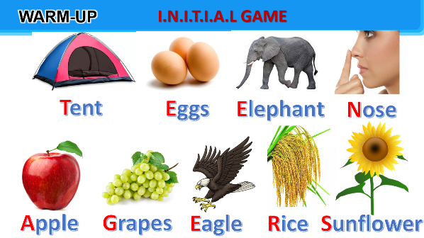  Mystery word: TEENAGERS
2. KNOWLEDGE FORMATION (10’-IW, PW, GW)

a. Aim:
- To set the context for the introductory dialogue;
- To introduce the topic of the unit.

b. Content:
- Vocabulary pre-teaching

c. Product:
- Know more new words.
- Understand the conversation; topic of the lesson,…

d. Implementation:
Vocabulary pre-teaching.  Step 1: Task delivering  - Teacher introduces the vocabulary.  - Teacher explains the meaning of the new vocabulary by pictures.  Step 2: Task performance  - Ss’ observation.  - Teacher reveals that these six words will appear in the reading text.  Step 3: Report and discussion  - Questions & answers  - asks students to open their textbooks to discover further.  Step 4: Judgement | * Vocabulary:  1. forum (n)  2. stress (n)  3. stressful (adj)  4. pressure (n)  5. user-friendly (adj)  6. midterm (adj)
3. PRACTICE (20’-IW, PW, GW)

a. Aim:
- To help Ss read for specific information about the class meeting.
- To help Ss learn words and phrases related to different school clubs;
- To help Ss further understand the text.

b. Content:
- Task 1: Listen and read.
- Task 2: Read the conversation again and tick T (True) or F (False) for each sentence.
- Task 3: Write a word or phrase from the box under the correct picture.
- Task 4: Complete each of the sentences with a word or phrase in 3. There is one extra word or phrase.

c. Product:
- Know more new words about school clubs, understand the conversation; topic of the lesson

d. Implementation:
Task 1: Listen and read.  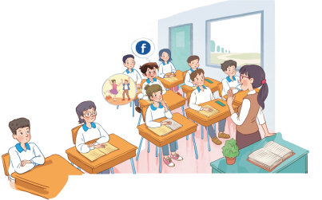  Step 1: Task delivering  - Teacher asks Ss to look at the pictures in the book and answer the questions.  Questions:  - Who are the people?  - What might they be talking about?  Step 2: Task performance  - Ss answer the questions in pairs.  - Teacher plays the recording twice.  Step 3: Report and discussion  - Ss listen and read.  Step 4: Judgement  - Teacher checks Ss’ prediction. T calls 4 Ss to read the conversation aloud in pairs.  Task 2: Read the conversation again and tick T (True) or F (False) for each sentence.  Step 1: Task delivering  - Ask Ss to work in pairs to read the conversation again.  Step 2: Task performance  - Student’s observation  - Ss underline the key words and phrases in the statements.  Step 3: Report and discussion  - Have pairs work together for one or two minutes to do the task.  - Ss read out the statements and say if the statements are true or false.  Step 4: Judgement  - Make sure they pronounce the words correctly.  - Teacher checks the answers as a class and gives feedback.  Task 3: Write a word or phrase from the box under the correct picture.  Step 1: Task delivering  - Ask Ss to work in pairs to match the pictures with the words or phrases.  Step 2: Task performance  - Student’s answers  - Observation  Step 3: Report and discussion  - Ask Ss to say the words / phrases aloud.  - Make sure they pronounce the words and phrases correctly.  Step 4: Judgement  - Teacher checks the answers as a class and gives feedback.  Task 4: Complete each of the sentences with a word or phrase in 3. There is one extra word or phrase.  Step 1: Task delivering  - Ask Ss to work independently to complete each sentence with a word or phrase in 3.  Step 2: Task performance  - Student’s answers  - Observation  Step 3: Report and discussion  - Allow Ss to refer to the pictures, the words and phrases in 3, and the conversation if needed.  Step 4: Judgement  - Check the answers as a class.  - Ask several Ss to read aloud the full sentences. Correct Ss’ pronunciation if needed. | 1: Listen and read.  Student’s answers  Observation  Suggested answers:  - They are teacher and students.  - They are in a class meeting.  - They are discussing their class forum, club activities to participate in, and their problems.  2: Read the conversation again and tick T (True) or F (False) for each sentence.  Answer key:  1. F  2. T  3. T  4. F  5. T  3: Write a word or phrase from the box under the correct picture.  Answer key:  1. language club  2. pressure  3. arts and crafts club  4. forum  5. sports club  6. chess club  4: Complete each of the sentences with a word or phrase in 3. There is one extra word or phrase.  Answer key:  1. arts and crafts club  2. forum  3. language club  4. pressure  5. sports club
4. APPLICATION (5’-IW, PW, GW)

a. Aim:
- To help Ss practise asking and answering questions for more information about their peers, and reporting information they have gathered;
- To create a fun atmosphere in the class.

b. Content:
- Task 5: Ask and answer the questions below. Report your friend’s answers to the class.

c. Product:
- Ss can report their friend’s answers about types of social media, kinds of pressure and clubs to the class.

d. Implementation:
Task 5: Ask and answer the questions below. Report your friend’s answers to the class.  Step 1: Task delivering  - Ask Ss to work in pairs to ask and answer questions.  Questions:  1. What types of social media do you have?  2. What kind of pressure do you have?  3. What clubs do you participate in?  4. Why do you choose to participate in that club?  Step 2: Task performance  - Encourage Ss to provide their partners with as much information as possible, using vocabulary they have learnt when they answer the questions.  Step 3: Report and discussion  - Ask some Ss to report information about their partners.  - Ask Ss to add any other issues relevant to teenagers which are not mentioned in the conversation.  - Ask Ss to name several school clubs, pressure, and social media.  Step 4: Judgement  * Home assignment  - T assigns the homework.  - Ss copy their homework.  - T explains it carefully. | Students’ talk  Observation  * Home assignment  - Name a list of school clubs and pressures.  - Do exercises in the workbook.  - Start preparing for the Project of the unit:  - Teacher randomly puts Ss in groups of 4 or 5 and asks them to brainstorm about the club they would like to have at school and make a poster about it. Students will show and present their posters in Lesson 7 – Looking back and Project. (Teacher should check the progress of students’ preparation after each lesson.)
V. FEEDBACK:
With 8A ………………….……………………………………………………………..…

Period :17
UNIT 3: TEENAGERS
Lesson 2: A closer look 1 P₃₀
Class | Date of planning | Date of teaching | Attendence
8A | 29/9/2023 | 12/10/2023

I. OBJECTIVES: * By the end of this unit, students will be able to:
- Identify the combination of some verbs and verb phrases that are often used when teens talk about using social media.
- Distinguish two sounds /ʊə/ and /ɔɪ/ correctly.
1. Knowledge:
+ Vocabulary: upload (v), browse (v), notification (n), log on to (v), check (n), account,
+ Language: Simple sentences and compound senctences

+ Pronunciation: Sounds: /ʊə/ and /ɔɪ/.
2. Competence:
a) General competencies:
- By the end of the lesson students will be able to know the form and use Simple sentences and compound senctences.
- Develop communication skills and creativity.
- Be collaborative and supportive in pair work and teamwork.
- Actively join in class activities.
b) Specific competencies:
- Group work and independent working, pair work, linguistic competence, cooperative learning and communicative competence.
- Sts can introduce themselves or one another fluently.
3. Qualities: - Show their sympathy with friends and responsibility for themselves talking about teenagers and their problems. Having benefits of their hobbies in daily life. Ss have the good attitude to working in groups, individual work, pair work, cooperative learning.
II. PREPARATIONS
Teacher: Grade 8 textbook, laptop, TV, pictures and realia, Computer connected to the Internet. Phần mềm tương tác hoclieu.vn
Students: Text books, pencils, pics, blank papers, realia,….
III. PROCEDURE
1. WARM-UP (5’-IW, PW, GW)

a. Aim:

- To create an active atmosphere in the class before the lesson;

b. Content:
- Have some warm-up activities to create a friendly and relaxed atmosphere to inspire Ss to warm up to the new class.

c. Product:
- Having a chance to speak English and focus on the topic of the lesson.

d. Implementation:
TEACHER’S AND STUDENTS’ ACTIVITIES | CONTENTS
Game: Word puzzles  Step 1: Task delivering  - Give Ss a few minutes to play a game. Have Ss play in two groups.  - Ask ss to find 6 meaningful words in the puzzles  Step 2: Task performance  - Observation  - Questions & answers  - The team with the more correct answers wins.  - T leads in the new lesson.  Step 3: Report and discussion  Tell the class the word they find.  Step 4: Judgement  - Check the answers as a class.  - T checks Ss’ vocabulary and gives feedback. | 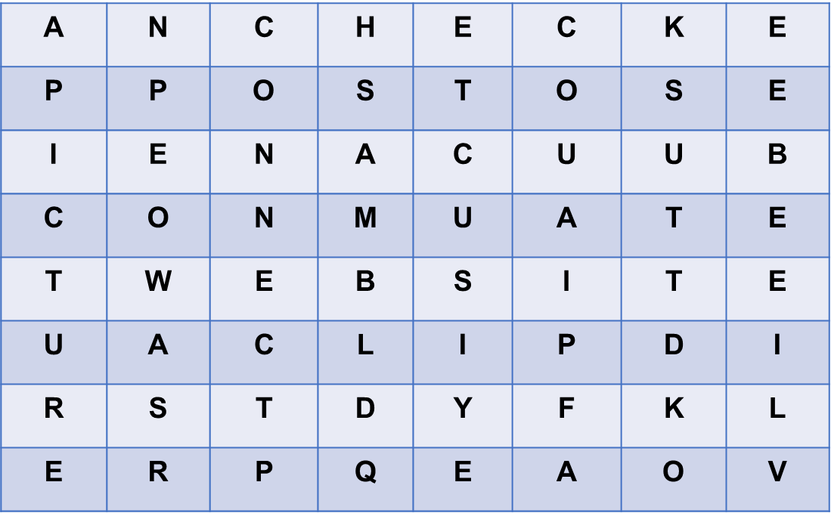  Answer key: CHECK; POST; WEBSITE; CLIP; PICTURE; CONNECT
2. KNOWLEDGE FORMATION (10’-IW,PW,GW)

a. Aim:
- To introduce some verbs and verb phrases that are often used when teens talk about using social media.
- To allow Ss to use the learnt words in contexts.

b. Content:
- Vocabulary
- Task 1: Circle the correct options to complete the phrases.

c. Product:
- Know more new verbs and verb phrases that are often used when teens talk about using social media.
- Know how to use learned words/ phrases in context.
d. Implementation:
Vocabulary pre-teaching  Step 1: Task delivering  - Teacher introduces the vocabulary.  - Teacher explains the meaning of the new vocabulary by pictures.  Step 2: Task performance  - Ss’ observation.  - Teacher reveals that these six words will appear in the reading text.  Task 1: Circle the correct options to complete the phrases.  Step 3: Report and discussion  - Have Ss read aloud the verbs and the word / phrases given.  - Ask Ss to work in pairs to circle the correct options to complete the phrases.  Step 4: Judgement  - Explain the meaning of the new verb phrases by using pictures or synonyms or even their mother tongue  - Invite Ss to take turns to read out their answers. Correct their pronunciation if needed.  - Check the answers as a class.  - T can also ask Ss to add more words / phrases to the verbs to make other phrases. This way, T can broaden Ss’ vocabulary if they are ready. | Vocabulary:  1. upload (v) = to copy or move programs or information to a larger computer system or to the internet  2. browse (v) = to look at things / check over sth  3. notifications (n)  4. log on (to) (v)  5. check (v)  6. account (n)  1: Circle the correct options to complete the phrases.  Answer key:  1. A  2. A  3. B  4. B  5. B
3. PRACTICE (25’-IW,PW,GW)

a. Aim:
- To introduce some verbs and verb phrases that are often used when teens talk about using social media.
- To allow Ss to use the learnt words in contexts.

b. Content:
- Task 2: Use the correct form of the verbs in 1 to complete the sentences.
- Task 3: Choose the correct answer A, B, or C.

c. Product:
- Know more new verbs and verb phrases that are often used when teens talk about using social media.
- Know how to use learned words/ phrases in context.
d. Implementation:
Task 2: Use the correct form of the verbs in 1 to complete the sentences.  Step 1: Task delivering  - Ask Ss to work individually to complete each of the sentences with a suitable verb from 1.  Step 2: Task performance  - Student’s answers  - Observation.  Step 3: Report and discussion  - Check the answers as a class.  - Have some Ss read aloud the complete sentences.  Step 4: Judgement  - Correct Ss’ pronunciation if necessary.  Task 3: Choose the correct answer A, B, or C.  Step 1: Task delivering  - T asks Ss to work individually.  - Ss choose the correct answer for each sentence.  Step 2: Task performance  - Student’s answers  - Observation.  Step 3: Report and discussion  - Ss swap their answers with their partners.  Step 4: Judgement  - T check the answers as a class.  - T can also ask some Ss to read out their answers. Then have Ss read the sentences aloud as a class. Correct Ss’ pronunciation if necessary. | 2: Use the correct form of the verbs in 1 to complete the sentences.  Answer key:  1. browsed  2. uploaded  3. connects  4. checked  5. logs on  3: Choose the correct answer A, B, or C.  Answer key:  1. B  2. C  3. A  4. A  5. B
4. APPLICATION (10’-IW, PW, GW)

a. Aim:

- To help Ss identify how to pronounce the sounds /ʊə/ and /ɔɪ/;

- To help Ss practise pronouncing the sounds /ʊə/ and /ɔɪ/ in context

b. Contents:

- Task 4: Listen and repeat the words. Pay attention to the sounds /ʊə/ and /ɔɪ/. Then put the words into the correct columns.

- Task 5: Listen and practise the sentences. Underline the words with /ʊə/ and circle the words with /ɔɪ/.

c. Product:

- Pronouncing the sounds /ʊə/ and /ɔɪ/ correctly;

d. Implementation:
Task 4: Listen and repeat the words. Pay attention to the sounds /ʊə/ and /ɔɪ/. Then put the words into the correct columns.  Step 1: Task delivering  - Have Ss listen to the recording once first. Then ask Ss to read out the words.  Step 2: Task performance  - Observation  - Student’s answers  Step 3: Report and discussion  - T play the recording for them to listen again.  - Ss repeat each word as a class, then as individuals.  - Play the recording as many times as possible.  Step 4: Judgement  - Have Ss complete the task.  - Check answers as a class.  Task 5: Listen and practise the sentences. Underline the words with /ʊə/ and circle the words with /ɔɪ/.  Step 1: Task delivering  - Have some Ss read the sentences first.  Step 2: Task performance  - Ss’ observation  - Student’s answers  Step 3: Report and discussion  - Play the recording for Ss to listen to, then repeat each sentence after the recording.  - Play the recording as many times as necessary.  - Ask them to underline the words with the sound /ʊə/ and circle the words with the sound /ɔɪ/.  Step 4: Judgement  - Check the answers as a class.  - Call some Ss to read the sentences individually. | * PRONUNCIATION  4: Listen and repeat the words. Pay attention to the sounds /ʊə/ and /ɔɪ/. Then put the words into the correct columns.  Student’s answers  Observation  Answer key:  /ʊə/: tourist, ensure, sure, tournament  /ɔɪ/: boy, toy, avoid, choice  5: Listen and practise the sentences. Underline the words with /ʊə/ and circle the words with /ɔɪ/.  Answer key:  1. She is a noisy and curious girl.  2. They joined a full-day city tour.  3. I found it enjoyable to watch the tournament.  4. She’ll record our voices during the interview.  5. He is not acting very mature and is starting to annoy me.
Game: Slap the board  - T writes on the board 15 words with the sounds /ʊə/ and /ɔɪ/.  - Teacher divides students into 2 teams.  - When T reads out word by word, one student will run to the board and slap on the correct word with the correct sound.  - The team with more correct answers will be the winner.  - Students play the game.  - Teacher invites the winner to read aloud their sentences.  - Teacher gives feedback.  * Home assignment  - T assigns the homework.  - Ss copy their homework.  - T explains it carefully | Student’s answers  Observation  15 words with the sounds /ʊə/ and /ɔɪ/:  * Home assignment  - Learn by heart vocabulary  - Practice pronounces the sounds /ʊə/ and /ɔɪ  Prepare: A closer look 2
  1. noisy  2. toy  3. tourist  4. tour  5. avoid  6. sure  7. boy  8. soil | 9. mature  10. annoy  11. voice  12. enjoy  13. tournament  14. ensure  15. choice

V. FEEDBACK:
With 8A …………………………..………………………………………………………………..…

Period : 18
UNIT 3: TEENAGERS
Lesson 3: A closer look 2 P₃₁₋₃₂
Class | Date of planning | Date of teaching | Attendence
8A | 29/9/2023 | 16./10/2023

I. OBJECTIVES: * By the end of this unit, students will be able to:

- review the knowledge of simple sentences

- distinguish between simple sentences and compound sentences

- identify words that connect independent clauses

- apply the coordinating conjunctions or conjunctive adverbs to combine two sentences
1. Knowledge:
+ Vocabulary: upload (v), browse (v), notification (n), log on to (v), check (n), account,
+ Language: Simple sentences and compound sentences (for, and, but, or, so/ however, therefore, otherwise)
+ Pronunciation: Sounds: /ʊə/ and /ɔɪ/.
2. Competence:
a) General competencies:
- By the end of the lesson students will be able to know the form and use Simple sentences and compound sentences.
- Develop communication skills and creativity.
- Be collaborative and supportive in pair work and teamwork.
- Actively join in class activities.
b) Specific competencies:
- Group work and independent working, pair work, linguistic competence, cooperative learning and communicative competence.
- Sts can introduce themselves or one another fluently.
3. Qualities: - Raise ss’ awareness of social media. Have a good attitude to school pressure. Show their sympathy with friends and responsibility for themselves talking about teenagers and their problems. Ss have the good attitude to working in groups, individual work, pair work, cooperative learning.
II. PREPARATIONS
Teacher: Grade 8 textbook, laptop, TV, pictures and realia, Computer connected to the Internet. Phần mềm tương tác hoclieu.vn
Students: Text books, pencils, pics, blank papers, realia,….
III. PROCEDURE

1. WARM-UP (7’-IW,PW,GW)

a. Aim:

- To create an active atmosphere in the class before the lesson;

b. Content:

- Game: Board race

c. Product:

- Having a chance to speak English and focus on the topic of the lesson.

d. Implementation:
TEACHER’S AND STUDENTS’ ACTIVITIES | CONTENTS
Game: BOARD RACE  Step 1: Task delivering  - Give Ss a few minutes to revise the simple sentences.  Step 2: Task performance  - Ss work in two teams.  - Ss receive slips of paper with simple sentences or compound sentences.  Step 3: Report and discussion  - Pick out all the simple sentences and run as fast as possible to stick them on the board,  - Underline the subjects and circle the verbs of those simple sentences.  - The team with the more correct answers will be the winner  Step 4: Judgement  + Ask each team to read out loud the sentences they have selected. Correct their pronunciation if necessary.  + The team with the most correct sentences wins.  - Ask Ss to look at A CLOSER LOOK 2 on page 31. | Observation  Questions & answers  1. She is a noisy and curious girl.  2. They joined a full-day city tour.  3. I found it enjoyable to watch the tournament.  4. She’ll record our voices during the interview.  5. Minh has some problems with his schoolwork.  6. Mark is hard-working; therefore, he usually gets high scores on exams.  7. Mai bought many books, for she likes reading.  8. He is a club member, but he never participates in any of the activities.
2. KNOWLEDGE FORMATION ACTIVITIES (10 minutes)

a. Aim:

- To review Ss’ knowledge of the simple sentences.

- To raise Ss’ awareness of the simple sentences and compound sentences.

b. Content:

- Review simple sentences

- Learn how a compound sentence is formed and conjunctions

c. Product:

- Recall the form of the simple sentences

- Know how a compound sentence is made up.

- Know some coordinating conjunctions and conjunctive adverbs.

d. Implementation:
Step 1: Task delivering  - T gives 2 sentences and asks ss to find their subject and verb.  - Ask them to check how many subjects and verbs are in each of the sentences.  Step 2: Task performance  - Tell them to read the Remember! box in pairs before giving further explanation.  - Then T explains to ss what a simple sentence or a compound sentence is.  Step 3: Report and discussion  - Ss underline the two independent clauses in Eg 2, circle the words in between the two independent clauses. Tell them that there are words other than and and but we use to connect two independent clauses in compound sentences.  Step 4: Judgement  - Ask Ss to read aloud as a class the words for, and, but, or, so, however, therefore, otherwise.  - Explain the meanings of these words if necessary. Tell Ss that they can also call these words connectors.  - Remind Ss to use a semicolon (;) before however, therefore, and otherwise, and the other connectors are followed by a comma (,) | Grammar: Simple sentences and compound sentences.  Student’s notes  Observation  Eg1: Minh has some problems with his  S V  Schoolwork.  Eg2: Mark is hard-working; therefore,  S1 V1 connectors  he usually gets high scores on exams.  S2 V2  * A simple sentence is made up of one independent clause.  * A compound sentence is made up of two or more independent clauses  * Connectors  - coordinating conjunctions: for, and, but, or, so  - conjunctive adverbs: however, therefore, otherwise.
3. PRACTICE ACTIVITIES (20’ - IW, PW, GW)

a. Aim:

- To review Ss’ knowledge of simple sentences.

- To raise Ss’ awareness of simple sentences and compound sentences.

- To help Ss distinguish between words that connect independent clauses.

b. Content:

- Task 1: Tick the simple sentences.

- Task 2: Write S for simple sentences and C for compound sentences.

- Task 3: Choose the correct answer A, B, or C.

- Task 4: Combine the two sentences to make compound sentences, using the words from the box.

c. Product:

- Recall the form of the simple sentences

- Know the differences between simple sentences and compound sentences.

- Know the differences between words that connect independent clauses.
d. Implementation:
Task 1: Tick the simple sentences.  Step 1: Task delivering  - Ask Ss to work individually to tick the simple sentences.  Step 2: Task performance  - Ask Ss to take turns to give their answers.  Step 3: Report and discussion  - Ask several Ss to read aloud the full sentences.  - Then T asks some Ss to underline the subjects and circle the verbs of simple sentences.  Step 4: Judgement  - Check the answers as a class.  - Correct their pronunciation if necessary.  Task 2: Write S for simple sentences and C for compound sentences.  Step 1: Task delivering  - Have Ss work in pairs to write S for simple sentences and C for compound sentences.  Step 2: Task performance  - Ask some Ss to read out the sentences and say S or C.  Step 3: Report and discussion  - Correct their pronunciation mistakes if necessary.  Step 4: Judgement  - Check the answers as a class.  Task 3: Choose the correct answer A, B, or C.  Step 1: Task delivering  - Have Ss work individually to choose the correct answer A, B, or C.  - Remind them of the meanings of the connectors and the punctuation (the comma and semicolon) for the connectors.  Step 2: Task performance  - Ask some Ss to read out the complete sentences.  - Check the answers as a class.  Task 4: Combine the two sentences to make compound sentences, using the words from the box.  Step 1: Task delivering  - Have Ss work in groups of four for five minutes.  Step 2: Task performance  - Write on their posters complete compound sentences using the words in the box.  - Remind them to use commas and semicolons when necessary.  Step 3: Report and discussion  - Ss swap answers with other groups.  - Have the class read out the sentences.  Step 4: Judgement  - Check the answers as a class.  - Correct their spelling and grammar mistakes when necessary. | 1: Tick the simple sentences.  Student’s answers  Observation  Answer key: 1, 2, 4  2: Write S for simple sentences and C for compound sentences.  Student’s answers  Observation  Answer key:  1. S  2. S  3. C  4. S  5. C  3: Choose the correct answer A, B, or C.  Answer key:  1. C  2. B  3. A  4. A  5. C  4: Combine the two sentences to make compound sentences, using the words from the box.  Answer key:  1. Phong has to study harder; otherwise, he may fail the exam.  2. She is very sensitive, so don’t comment on her new hairstyle. / She is very sensitive; therefore, don’t comment on her new hairstyle.  3. Mi wants to have more friends, but she doesn’t connect well with others.  4. Students can work in groups, or they can work in pairs.  5. My friend likes showing off her new things; therefore, she often posts pictures on social media. / My friend likes showing off her new things, so she often posts pictures on social media.
4. APPLICATION (5’-IW, PW, GW)

a. Aim:

- To enable Ss to make compound sentences correctly.

b. Content:

- Task 5. GAME: Which group has the most sentences?

c. Product:

- Students are able to make compound sentences correctly.

d. Implementation:
Task 5. GAME: Which group has the most sentences?  Work in groups. Each group makes as many compound sentences as possible. The group with the most correct sentence is the winner.  Step 1: Task delivering  - Instruct Ss to play the game in groups.  - Have Ss work for two minutes to write compound sentences using given words on their strips of paper (the words on the slips of paper given to Ss can be for, and, but, or, so, however, therefore, otherwise).  Step 2: Task performance  T may instruct Ss to write their compound sentences on A1-size paper.  Step 3: Report and discussion  - Invite groups to read out their compound sentences or to stick the A2-size paper with compound sentences they have written on the board.  Step 4: Judgement  - Check the answers as a class.  - Correct their spelling and grammar mistakes when necessary.  - The group with the most correct sentences is the winner.  * Home assignment  - T assigns the homework.  - Ss copy their homework.  - T explains it carefully | 5. GAME: Which group has the most sentences?  Student’s answers  Observation    * Home assignment  - Practice the grammar point  - Prepare: Communication

Period : 19
UNIT 3: TEENAGERS
Lesson 4: Communication P₃₂₋₃₃
Class | Date of planning | Date of teaching | Attendence
8A | 29/9/2023 | 18/10/2023

I. OBJECTIVES: * By the end of this unit, students will be able to:

- Identify how to make requests in English.

- Understand some everyday English phrases and expressions about the different social media that are popular among teens, how often and what they use these media for.

- Practise reading for specific information.
1. Knowledge:
+ Vocabulary: upload (v), browse (v), notification (n), log on to (v), check (n), account,
+ Language: Making requests: - Can you…, please? - Could you…(, please)?
+ Pronunciation: Sounds: /ʊə/ and /ɔɪ/.
2. Competence:
a) General competencies:
- By the end of the lesson students will be able to know to Make requests.
- Develop communication skills and creativity.
- Be collaborative and supportive in pair work and teamwork.
- Actively join in class activities.
b) Specific competencies:
- Group work and independent working, pair work, linguistic competence, cooperative learning and communicative competence.
- Sts can introduce themselves or one another fluently.
3. Qualities: - Raise ss’ awareness of social media popular among teens; Have a good attitude when making polite requests. Show their sympathy with friends and responsibility for themselves talking about teenagers and their problems. Ss have the good attitude to working in groups, individual work, pair work, cooperative learning.
II. PREPARATIONS
Teacher: Grade 8 textbook, laptop, TV, pictures and realia, Computer connected to the Internet. Phần mềm tương tác hoclieu.vn
Students: Text books, pencils, pics, blank papers, realia,….
III. PROCEDURE

1. WARM-UP (7’-IW,PW,GW)

a. Aim:

- To create an active atmosphere in the class before the lesson;

b. Content:

- Chatting between teacher and students

c. Product:

- Have a chance to speak English and focus on the topic of the lesson.

d. Implementation:
TEACHER’S AND STUDENTS’ ACTIVITIES | CONTENTS
Chatting:  Step 1: Task delivering  - T asks ss some questions:  + What do you say when you want sb to pass you a pen?  + What do you say when you want sb to tell you more about the music club?  + What will we do if we want to politely ask somebody to do sth?  Step 2: Task performance  - Ss’ observation  Step 3: Report and discussion  - Questions & answers  Step 4: Judgement  - T leads in the new lesson: If we want to politely ask somebody to do sth, we make requests. There are two ways of making requests that we will learn in Lesson 4. Communication.  - Ask Ss to look at COMMUNICATION on page 32. | Suggested answers:  - Can/ Could you pass me the pen?  - Can/ Could you tell me more about the music club?
2. KNOWLEDGE FORMATION (15’-IW, PW, GW)

a. Aim:

- To introduce two ways to make requests

- To help Ss practise making requests.

b. Content:

- Task 1: Listen and read the dialogue below. Pay attention to the highlighted sentences.

- Task 2: Work in pairs. Make similar conservations, using the cues below.

c. Product:

- Know two ways of making requests.

d. Implementation:
Task 1: Listen and read the dialogue below. Pay attention to the highlighted sentences.  Step 1: Task delivering  - Play the recording.  - Ss listen and read the dialogue between a student and a school club leader.  Step 2: Task performance  - Ss’ observation  - Ss pay attention to the highlighted sentences.  Step 3: Report and discussion  - Emphasise the ways to make requests (in the contents column).  - Tell Ss that Can you and Could you are similar in meaning, and only different in the degree of formality. Could you is more formal than Can you.  Step 4: Judgement  - Have Ss practise the dialogue.  - Check the answers as a class.  Task 2: Work in pairs. Make similar conservations, using the cues below.  - Ask Ss to work in pairs to make similar dialogues.  - Tell them to use the contexts given and the sample requests.  - Give feedback on their dialogues. | * EVERYDAY ENGLISH  1: Listen and read the dialogue below. Pay attention to the highlighted sentences.  1. Can you tell me more about the music club, please?  2. Could you show me the way to the college, please?  2: Work in pairs. Make similar conservations, using the cues below.  Observation  Questions & answers  Can you lend me your book that you finished reading, please?  - Request some advice on how to do your science project.  Could you tell me how to start a science project?
Task 3: Read some posts on a forum about different social media and match the names of the posters with their activities.    Step 1: Task delivering  - Ask some Ss to read the posts aloud.  - Ss work in pairs to read the posts to match the name of the four teenagers and their activities (1 - 5).  Step 2: Task performance  - Student’s observation  - Ask some pairs to read out their answers.  Step 3: Report and discussion  - Some Ss to retell information from the posts or to role-play a conversation.  Step 4: Judgement  - Check the answers as a class.  - Correct if necessary.  Task 4: Work in pairs. Ask and answer questions about what social media the teens in 3 use, why, and how often they use them.  - Have Ss work in pairs to ask and answer questions about which social media each of the four teenagers uses, what for and how often they use the media.  - Ask them to follow the example in the Student’s Book.  - Invite some pairs to role-play, asking and answering questions in front of the class. Correct any grammar or pronunciation mistakes if necessary. | * SOCIAL MEDIA POPULAR AMONG TEENS (25 mins)  3: Read some posts on a forum about different social media and match the names of the posters with their activities.  Answer key:  Ann: 2  Tom: 4,5  Trang: 1  Nam: 3  4: Work in pairs. Ask and answer questions about what social media the teens in 3 use, why, and how often they use them.  Model dialogue:  Tom: What social media does Ann use?  Nam: She uses YouTube.  Tom: What does she use it for?  Nam: She uploads her videos and watches other people’s videos.  Tom: How often does she use it?  Nam: Every day.
4. APPLICATION (7’-IW,PW,GW)

a. Aim:

- To help Ss practise asking and answering questions about which social media teens often use, how often and why they use these media.

b. Content:

- Task 5: Work in groups. Discuss the following questions and then report your group’s result to the class.

- Home Assignment.

c. Product:

- Ss practise reading for specific information.

- Ss are able to about which social media they often use, how often and why they use these media.

- Take note home assignment.

d. Implementation:

Task 5: Work in groups. Discuss the following questions and then report your group’s result to the class.  Step 1: Task delivering  - Have Ss work in groups.  - Discuss the answers to the three questions about social media.  Step 2: Task performance  - T tells them that they can give more than one reason to explain their choice.  Step 3: Report and discussion  - Ask them to use the information from the posts in 3 as cues.  - Invite group representatives to report their group’s answers.  Step 4: Judgement  - Check the answers as a class.  - Correct if necessary.  * Home assignment  - T assigns the homework.  - Ss copy their homework.  - T explains it carefully | Student’s answers  Observation  1. What social media do you use?  2. How often do you use it?  3. What do you use social media for?  * Home assignment  - Practice making requests and list some popular social media among teens.  - Prepare: Skills 1
V. FEEDBACK:
With 8A …………………………..………………………………………………………………..…

Period :20
UNIT 3: TEENAGERS
Lesson 5: Skills 1 P₃₃₋₃₄
Class | Date of planning | Date of teaching | Attendence
8A | 29/9/2023 | 19/10/2023

I. OBJECTIVES: * By the end of this unit, students will be able to:

- Recognise reading skills for specific information and general information about school clubs.

- Remember the lexical items related to school clubs.

- Recognise how to make a conversation to ask and answer about school clubs
1. Knowledge:
+ Vocabulary: concentrate (v), craft (n), focused (adj), beforehand (adv), practical (adj).
+ Language: Making requests: - Can you…, please? - Could you…(, please)?
+ Pronunciation: Sounds: /ʊə/ and /ɔɪ/.
2. Competence:
a) General competencies:
- By the end of the lesson students will be able to know to make requests.
- Develop communication skills and creativity.
- Be collaborative and supportive in pair work and teamwork.
- Actively join in class activities.
b) Specific competencies:
- Group work and independent working, pair work, linguistic competence, cooperative learning and communicative competence.
- Sts can introduce themselves or one another fluently.
3. Qualities: - Raise ss’ awareness of social media popular among teens; Have a good attitude when making polite requests. Show their sympathy with friends and responsibility for themselves talking about teenagers and their problems. Ss have the good attitude to working in groups, individual work, pair work, cooperative learning.
II. PREPARATIONS
Teacher: Grade 8 textbook, laptop, TV, pictures and realia, Computer connected to the Internet. Phần mềm tương tác hoclieu.vn
Students: Text books, pencils, pics, blank papers, realia,….
III. PROCEDURE

1. WARM-UP (5’-IW, PW, GW)

a. Aim:

- To create an active atmosphere in the class before the lesson

- To remind Ss of some activities and school clubs teens often take part in

b. Content:

- Brainstorming

- Pictures describing

c. Product:

- Be able to speak English and focus on the topic of the lesson.

d. Implementation:
TEACHER’S AND STUDENTS’ ACTIVITIES | CONTENTS
Brainstorming (Task 1)  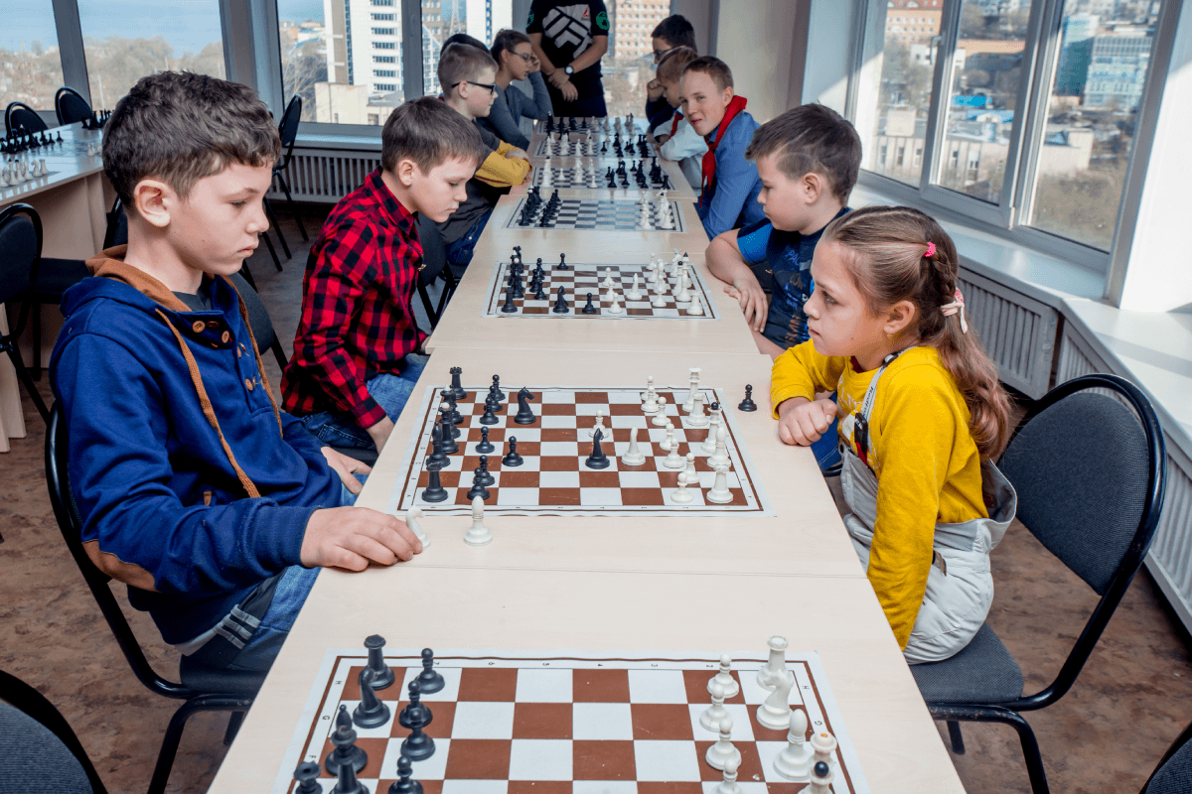  Step 1: Task delivering  - Ask Ss to list school clubs teens often take part in.  - Have the class work in pairs to describe the pictures and say what club the teenagers in the pictures are taking part in.  Step 2: Task performance  - Student’s observation  - Ask some pairs to read out their answers.  Step 3: Report and discussion  - Ss discuss the reasons they want to join a school club like these.  Step 4: Judgement  - Ask Ss to look at SKILLS 1 on page 33. | Observation  Questions & answers  Suggested answers:  - Badminton/ basketball club, English club, chess club, arts club, football club, …  - 2 clubs in the pictures: Chess club, arts and craft club
2. KNOWLEDGE FORMATION (5’ - IW)

a. Aim:

- To introduce some new words and set the context for the reading

b. Content: - Vocabulary pre-teaching

c. Product: - Know more new words

d. Implementation:
Vocabulary pre-teaching  Step 1: Task delivering  - Teacher introduces the vocabulary.  Step 2: Task performance  - Student’s observation  Step 3: Report and discussion  - Teacher explains the meaning of the new vocabulary by pictures.  - Teacher reveals that these five words will appear in the reading text and asks students to open their textbook to discover further.  Step 4: Judgement  - Check the answers as a class.  - Correct if necessary. | * Vocabulary:  1. concentrate (v)  2. focused (adj)  3. craft (n)  4. beforehand (adv)  5. practical (adj)
3. PRACTICE (20’- IW, PW, GW)

a. Aim:

- To improve Ss’ skill of reading for general information and details.

b. Content:

- Task 2: Read the conversation and tick T (True) or F (False) for each sentence.

- Task 3: Read the conversation again and choose the correct answer A, B, or C.

c. Product: Know more new words
d. Implementation:
* WHILE-READING  Task 2: Read the conversation and tick T (True) or F (False) for each sentence.  Step 1: Task delivering  - Ask Ss to work individually to read the conversation and to decide if the statements below the conversation are true or false.  Step 2: Task performance  - Ss read and tick T (True) or F (False).  - Ask Ss to underline the evidence to support each statement.  Step 3: Report and discussion  - Ss work in pairs to swap answers or to check answers together.  - Some Ss to read out loud the statements and say true or false.  Ss show the parts in the reading where they found the answers.  Step 4: Judgement  - Check the answers as a class.  - Correct if necessary.  Task 3: Read the conversation again and choose the correct answer A, B, or C.  Step 1: Task delivering  - Have Ss work individually for seven minutes.  - Circle the correct answers.  Step 2: Task performance  - Remind them to underline the keywords in the questions and the evidence for the answers.  - Ask Ss to take turns giving the answers.  Step 3: Report and discussion  Ask them to show the parts in the reading where they found the answers.  Step 4: Judgement  - Check the answers as a class.  - Correct if necessary. | READING  2: Read the conversation and tick T (True) or F (False) for each sentence.  Student’s answers  Observation  Answer key:  1. T  2. T  3. F: when he was five => 5 years ago  4. T  3: Read the conversation again and choose the correct answer A, B, or C.  Student’s answers  Observation  Answer key:  1. B  2. C  3. B  4. B  5. C
4. APPLICATION (15’ - IW, PW, GW)

a. Aim:

- To help Ss practise asking and answering questions for information about school clubs;

- To give Ss an opportunity to practise explaining their reasons or the benefits they gain.

b. Content:

- Practise asking and answering questions for information about school clubs;

- Practise explaining their reasons or the benefits they gain.

c. Product:

- Speak about school clubs

- Know the benefits of school clubs and talk about them.

d. Implementation:
* POST-READING (SPEAKING)  Task 4: Work in pairs. Make conversations using the given information  Step 1: Task delivering  - Have Ss work in pairs to ask and answer questions about the guitar club and painting club.  Step 2: Task performance  - Student’s observation  - Student’s answers  Step 3: Report and discussion  - Assist Ss to make questions when necessary.  - Ask them to practise giving some benefits / reasons. Encourage them to think of other possible benefits / reasons.  - Some pairs to role-play.  Step 4: Judgement  - Check the answers as a class.  - Correct if necessary. | 4: Work in pairs. Make conversations using the given information.  Suggested questions:  - What time does the club meet?  - Where does it meet?  - How can I contact the club? / What is the contact number of the club?  - Who will coach the club?  - What are the benefits you get when you join the club? / Why do you want to join this club?
Task 5: Work in groups. Ask and answer questions about a club at your school. Report the answers to your class.  - Have Ss work in groups to ask and answer questions about a school club they would like to participate in.  - Ask them to give as many benefits and/ or reasons why they want to take part in the club. Tell them to explain the reasons based on their likes, dislikes, abilities, or personalities.  - Invite one representative of each group to report their group’s answers to the class.  * Home assignment  - T assigns the homework.  - Ss copy their homework.  - T explains it carefully | 5: Work in groups. Ask and answer questions about a club at your school. Report the answers to your class  Students’ conversations/ interactions  * Home assignment  - Learn by heart vocabulary  - Prepare for skills 2
V. FEEDBACK:
With 8A …………………………..………………………………………………………………..…

Period : 21
UNIT 3: TEENAGERS
Lesson 6: A Skills 2 P₃₅
Class | Date of planning | Date of teaching | Attendence
8A | 29/9/2023 | 23/10/2023

I. OBJECTIVES: * By the end of this unit, students will be able to:
- Listen for general and specific information about teen stress
- Recall the lexical items related to pressures teens face
- Write a paragraph about the causes and solutions
1. Knowledge:
+ Vocabulary: parental (adj), peer (n), bully (v), bullying (n).
+ Language: Simple sentences and compound senctences
+ Pronunciation: Sounds: /ʊə/ and /ɔɪ/.
2. Competence:
a) General competencies:
- By the end of the lesson students will be able to know to write a paragraph about the causes and solutions
- Develop communication skills and creativity.
- Be collaborative and supportive in pair work and teamwork.
- Actively join in class activities.
b) Specific competencies:
- Group work and independent working, pair work, linguistic competence, cooperative learning and communicative competence.
- Sts can introduce themselves or one another fluently.
3. Qualities: - Raise ss’ awareness of social media. Have a good attitude to school pressure. Show their sympathy with friends and responsibility for themselves talking about teenagers and their problems. Ss have the good attitude to working in groups, individual work, pair work, cooperative learning.
II. PREPARATIONS
Teacher: Grade 8 textbook, laptop, TV, pictures and realia, Computer connected to the Internet. Phần mềm tương tác hoclieu.vn
Students: Text books, pencils, pics, blank papers, realia,….
III. PROCEDURE
1. WARM-UP (5’- IW, PW, GW)

a. Aim:

- To create an active atmosphere in the class before the lesson

- To help ss focus on the listening & writing topic

b. Content:

- Use the technique “Table cloth” to elicit some types of pressure that teens face.

c. Product:

- Ss can identify and name types of pressure that teen may face

d. Implementation: teacher’s instruction.
TEACHER’S AND STUDENTS’ ACTIVITIES | CONTENTS
Game: Table cloth  Step 1: Task delivering  - Divide the class into 4 groups.  Step 2: Task performance  - Ss’ observation  - Questions & answers  Step 3: Report and discussion  - Ss write down on the poster as many types of pressure as possible. (In 2 minutes)  - The group with the most correct answers will be the winner.  Step 4: Judgement.  - T check ss’ answers and gives feedback  - Ask Ss to look at SKILLS 2 on page 35. | Suggested answers:  Pressure  from parents, pressure from work, pressure from schoolwork, pressure from friends, peer pressure, exam pressure, pressure to get into gifted/ high schools, pressure of getting higher marks, …
2. KNOWLEDGE FORMATION (5’-IW, PW)

a. Aim:

- To improve Ss’ skill of listening for general information.

- To improve Ss’ listening comprehension and note taking skills.

b. Content: - Learn some new words.

c. Product: - Know more new words about teen pressure

d. Implementation:
* PRE-LISTENING (5’)  Vocabulary pre-teaching.  Step 1: Task delivering  - Teacher introduces the vocabulary.  - Teacher explains the meaning of the new vocabulary by pictures.  Step 2: Task performance  Ss’ observation & answers  Step 3: Report and discussion  - Teacher reveals that these four words will appear in the listening text and asks students to open their textbook to discover further.  Step 4: Judgement  - Make sure they pronounce the words correctly.  - Teacher checks the answers as a class and gives feedback. | * Vocabulary:  1. parental (adj)  2. bully (v)  3. bullying (n)  4. peer (n)
3. PRACTICE (20’-IW,PW,GW)

a. Aim:

- To improve Ss’ skill of listening for general information.

- To improve Ss’ listening comprehension and note taking skills.

b. Content:

- Task 1: Which types of pressure below do you think teens face?

- Task 2: Listen to a conversation and choose the correct answer to each question.

- Task 3: Listen to the conversation again and fill each blank with ONE word.

c. Product:

- Use new words about teen pressure to listen for general information.

- Get specific information about teen pressure through listening

d. Implementation:
* WHILE-LISTENING  Task 1: Which types of pressure below do you think teens face?  Step 1: Task delivering  - Ask Ss to work in pairs  Step 2: Task performance  - Ss’ observation & answers  - circle the types of pressure teens face.  Step 3: Report and discussion  - Ask Ss to add as many stress types as they know.  - Tell Ss that they are going to listen to a conversation between some students about the pressures and causes of stress teens face.  Step 4: Judgement  - Have Ss complete the task.  - Check answers as a class.  Task 2: Listen to a conversation and choose the correct answer to each question.  Step 1: Task delivering  - Ask Ss to work individually to read through Questions 1 and 2.  - Ask them to underline keywords in the questions, for example, “How many ...” or “What ... discussing”.  Step 2: Task performance  - Ss’ observation & answers  Step 3: Report and discussion  - Play the recording once for Ss to circle the answers.  - Check Ss’ answers and play the recording again for them to better understand the conversation among Minh, Ann and Mi. Stop or rewind the recording where necessary.  Step 4: Judgement  - Have Ss complete the task.  - Check answers as a class.  Task 3: Listen to the conversation again and fill each blank with ONE word.  Step 1: Task delivering  - Ask Ss to work in pairs to read the table and to predict the word they will need to fill in each blank.  Step 2: Task performance  - Ss think about the part of speech of the word they will need to use for each blank (eg: adjective, verb, or noun).  - T reminds them of the possible plural and singular forms of nouns.  Step 3: Report and discussion  - Play the recording once. Give them two minutes to fill in the blanks. Remind Ss that they should write only ONE word for each blank.  Step 4: Judgement  - Have Ss complete the task.  - Play the recording again and check answers as a class. | 1: Which types of pressure below do you think teens face?  Suggested answer:  A, C, D  2: Listen to a conversation and choose the correct answer to each question.  Answer key:  1. C  2. B  3: Listen to the conversation again and fill each blank with ONE word.  Student’s answers  Observation  Answer key:  1. parents  2. abilities  3. body / weight  4. good  5. sister  6. talk
4. APPLICATION (15’-IW, PW, GW)

a. Aim:

- To provide Ss with vocabulary and ideas about the causes of teens’ stress and solutions

- To improve Ss’ writing skill of writing a paragraph about the causes of the stress and solutions to stress.

b. Content:

- Task 4: Match the causes of teen stress with the possible solutions. There may be more than one solution to a problem.

- Task 5: Write a paragraph (80 - 100 words) about the cause(s) of your stress and offer solutions.

- Home assignment.

c. Product:

- Ss are able to identify the causes of teen stress and give their solutions

- Write a paragraph about the causes of the stress and their solutions.

- Take note home assignment.

d. Implementation: Teacher’s instruction.
* POST-LISTENING  Task 4: Match the causes of teen stress with the possible solutions. There may be more than one solution to a problem.  Step 1: Task delivering  - Ask Ss to work in pairs to read the suggested ideas in the table.  - Match causes of teens’ stress with solutions.  Step 2: Task performance  - Student’s observation  - Remind them that they can match more than one solution to a cause.  - Ss add any more causes and solutions they can think of.  Step 3: Report and discussion  - Ask some Ss to read out loud each cause and solution. Tell them that they can add any more solutions they can think of.  Step 4: Judgement  - Correct their pronunciation where necessary.  - Comment and give feedback. | * WRITING  4: Match the causes of teen stress with the possible solutions. There may be more than one solution to a problem.  Student’s answers  Observation  Suggested answer:  1. B  2. D  3. C  4. A, B, D
Task 5: Write a paragraph (80 - 100 words) about the cause(s) of your stress and offer solutions.  Step 1: Task delivering  - Ask Ss to work individually to write for 5 minutes.  - Use the information in 4 and any other ideas they may think of.  Step 2: Task performance  - T asks one student to read out his / her paragraph.  - If time allows, T can also ask Ss to work in groups and record ideas on an A1 / A0 size piece of paper, then T organizes a gallery walk.  Step 3: Report and discussion  - Ss walk around and offer feedback on peers’ writing.  - Show paragraphs  Step 4: Judgement  - Have Ss complete the task.  - Comment and give feedback.  * Home assignment  - T assigns the homework.  - Ss copy their homework.  - T explains it carefully | 5: Write a paragraph (80 - 100 words) about the cause(s) of your stress and offer solutions.  Suggested answer:  I often feel stressed because of schoolwork, and here are the ways I deal with my stress. First, I often talk to my parents about how I feel and what I expect my parents to help. Second, I stopped staying up late to play games or chat with peers. I turn off my computer and smartphone at 10 p.m. Third, I also tell my parents that I am making efforts, but there are subjects that I don’t really like so I can’t get very high marks as they expect. I also stop going to extra classes and increase self-study.  * Home assignment  - Learn by heart vocabulary  - Prepare: Looking back and Project

V. FEEDBACK:
With 8A …………………………..………………………………………………………………..…

Period :22
UNIT 3: TEENAGERS
Lesson 7: Looking back - Project P₃₆₋₃₇
Class | Date of planning | Date of teaching | Attendence
8A | 29/9/2023 | 25/10/2023

I. OBJECTIVES: * By the end of this unit, students will be able to:

- Repeat and distinguish the structures of simple sentences and compound sentences

- Memories the uses of some conjunctions

- Memories some words related to teen school clubs, teens’ use of social media, and teen stress and pressure.
1. Knowledge:
+ Vocabulary: parental (adj), peer (n), bully (v), bullying (n).
+ Language: Simple sentences and compound sentences
+ Pronunciation: Sounds: /ʊə/ and /ɔɪ/.
2. Competence:
a) General competencies:
- By the end of the lesson students will be able to know to write a paragraph about the causes and solutions
- Develop communication skills and creativity.
- Be collaborative and supportive in pair work and teamwork.
- Actively join in class activities.
b) Specific competencies:
- Group work and independent working, pair work, linguistic competence, cooperative learning and communicative competence.
- Sts can introduce themselves or one another fluently.
3. Qualities: - Consolidate ss’ awareness of teen school clubs, teens’ use of social media, and teen stress. Have a positive attitude toward pressures and know how to deal with them. Show their sympathy with friends and responsibility for themselves talking about teenagers and their problems. Ss have the good attitude to working in groups, individual work, pair work, cooperative learning.
II. PREPARATIONS
Teacher: Grade 8 textbook, laptop, TV, pictures and realia, Computer connected to the Internet. Phần mềm tương tác hoclieu.vn
Students: Text books, pencils, pics, blank papers, realia,….
III. PROCEDURE
1. WARM-UP (5’-IW, PW,GW)

a. Aim:

- To create an active atmosphere in the class before the lesson;

- Recall types of pressure that teen may face

b. Content:

- Have ss play the game “Kim’s game”

c. Product:

- Ss are able to recall the words and phrases about types of pressure through the given pictures

d. Implementation:
TEACHER’S AND STUDENTS’ ACTIVITIES | CONTENTS
Kim’s game:  Step 1: Task delivering  - T asks students to work in groups of three or four students.  - Tell ss that the pictures will disappear after 2 seconds, so they should try to remember all the pictures without writing them down.  - After all the pictures disappear, ss have 1 minute to write down the kinds of pressure in each picture on their poster. (2 points for each correct answer).  Step 2: Task performance.  - Ss’Observation.  - Ss look at the pictures about some kinds of pressure on the screen.  - Do the exercise individually.  Step 3: Report and discussion  - T gets ss to swap the posters among groups and give corrections after T shows the answers.  Step 4: Judgement  - Ss give marks to their friends’ answers.  - T leads in the lesson. | 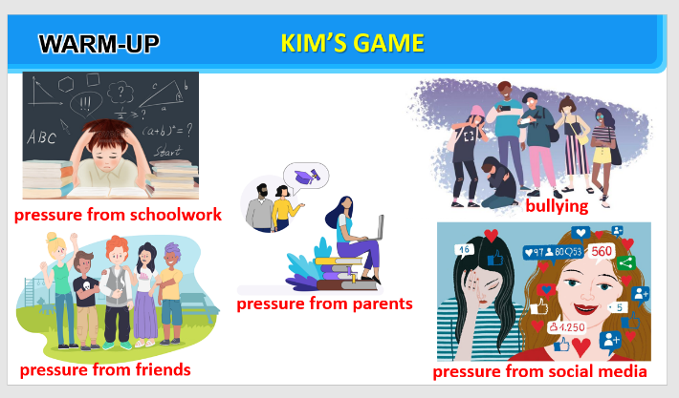
2. KNOWLEDGE FORMATION (5’-IW,PW)

a. Aim: - To help Ss review the vocabulary learnt.

b. Content: - Task 1: Complete the webs with suitable words and phrases.

c. Product: - Recall the vocabulary learnt
d. Implementation:
Task 1: Complete the webs with suitable words and phrases.  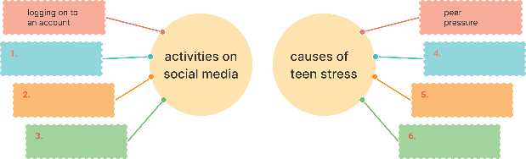  Step 1: Task delivering  - Have Ss work individually to complete the webs with words / phrases.  Step 2: Task performance  - Ss’observation.  - Complete the webs with words / phrases.  Step 3: Report and discussion.  - Student’s answers  - Ss read out their words/phrases from their webs.  Step 4: Judgement  - Check answers as a class.  - Correct Ss’ pronunciation if necessary. | * VOCABULARY REVISION  1: Complete the webs with suitable words and phrases.  Student’s answers  Observation  Suggested answers:  - activities on social media: browsing websites, uploading pictures, checking notifications, connecting with friends, discussing problems, sharing opinions, commenting on posts, sharing posts  - causes of teen stress: pressure from parents, pressure from schoolwork, bullying, spending too much time on social media
3. PRACTICE

a. Aim:

- To help Ss review compound sentences.

- To help Ss create compound sentences by writing a simple sentence to complete the given sentences.

b. Content:

- Task 2: Fill each blank with the correct form of the words in the box.

- Task 3: Use the conjunctions provided to connect the sentences

- Task 4: Complete the sentences below. Then compare your sentences with your partners’.

c. Product:

- Recall the vocabulary learnt

- Recall the uses of conjunctions and structures of compound sentences and practise through grammar exercises

d. Implementation:
Task 2: Fill each blank with the correct form of the words in the box.  Step 1: Task delivering  - Have Ss work individually to fill in each blank with the correct form of the words from the box.  Step 2: Task performance  - Ss’observation.  - Fill in each blank with the correct form of the words from the box.  Step 3: Report and discussion  - Ask some Ss to read the passage aloud.  Step 4: Judgement  - Check answers as a class.  - Correct Ss’ pronunciation if necessary.  Task 3: Use the conjunctions provided to connect the sentences.  Step 1: Task delivering  - Have Ss work individually to connect the two simple sentences to create a compound sentence using the words in bold.  - Remind them of the meanings and use of the connectors.  Step 2: Task performance  - Ss’observation.  - Ss work in pairs to swap and check their answers.  Step 3: Report and discussion.  - Create a compound sentence using the words in bold.  - Ask one student to read out the sentences.  Step 4: Judgement  - Check answers as a class.  - Correct his / her pronunciation if necessary.  Task 4: Complete the sentences below. Then compare your sentences with your partners’.  Step 1: Task delivering  - Ask Ss to work individually to complete the sentences as requested.  - Ask one or two Ss to go to the board and write their full sentences.  Step 2: Task performance  - Ss’observation.  - Complete the sentences as requested.  Step 3: Report and discussion  - Then ask the class to work in pairs.  - Ss swap their sentences and check their partner’s answers.  - Ask some Ss to read out their sentences.  Step 4: Judgement  - Check the sentences on the board.  - Have all Ss correct their partner’s answers. | GRAMMAR REVISION  2: Fill each blank with the correct form of the words in the box.  Answer key:  1. participates  2. clubs  3. connects  4. skills  5. upload  6. bullies / bullying  3: Use the conjunctions provided to connect the sentences  Answer key:  1. Mai is the head of the club, so she knows the members very well.  2. Lan wanted to go to the party, but she couldn’t choose a suitable dress.  3. Tom felt stressed; however, he tried to finish his homework.  4. He isn’t a member of the chess club; therefore, he won't join the chess competition.  5. We will have a short holiday; otherwise, we will feel very stressed  4: Complete the sentences below. Then compare your sentences with your partners’.  Suggested answer:  1. Teens need to have good health, so they should do some sport(s).  2. His parents have high expectations of him, but they don’t care about his abilities.  3. Teenagers should develop social skills; otherwise, they may not be able to communicate with peers and other people.  4. We sometimes feel lonely and sad; therefore, we need our families and friends.  5. He does very well at school; however, he doesn’t have teamwork or communication skills.
4. APPLICATION (20’-IW, PW, GW)

a. Aim:

- To raise Ss’ awareness of the need to participate in a school club;

- To improve Ss’ teamwork and public speaking skills.

b. Content:

- Present the poster to the class.

c. Product:

- Present the poster of a club ss would like to have at their school.

d. Implementation:
Step 1: Task delivering  - Ask Ss to read the instructions again (T has already been assigned the project since the first lesson of the Unit and checked their progress after each lesson).  Step 2: Task performance  - Ss’observation.  - Check their posters for the final time and make any adjustments if necessary.  Step 3: Report and discussion  - T has groups show their posters and present them to the class.  - Comment & give feedback.  * Home assignment  - T assigns the homework.  - Ss copy their homework.  - T explains it carefully | PROJECT  Our school club  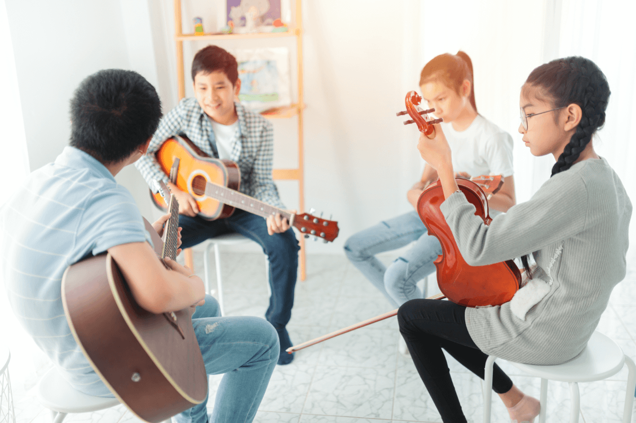  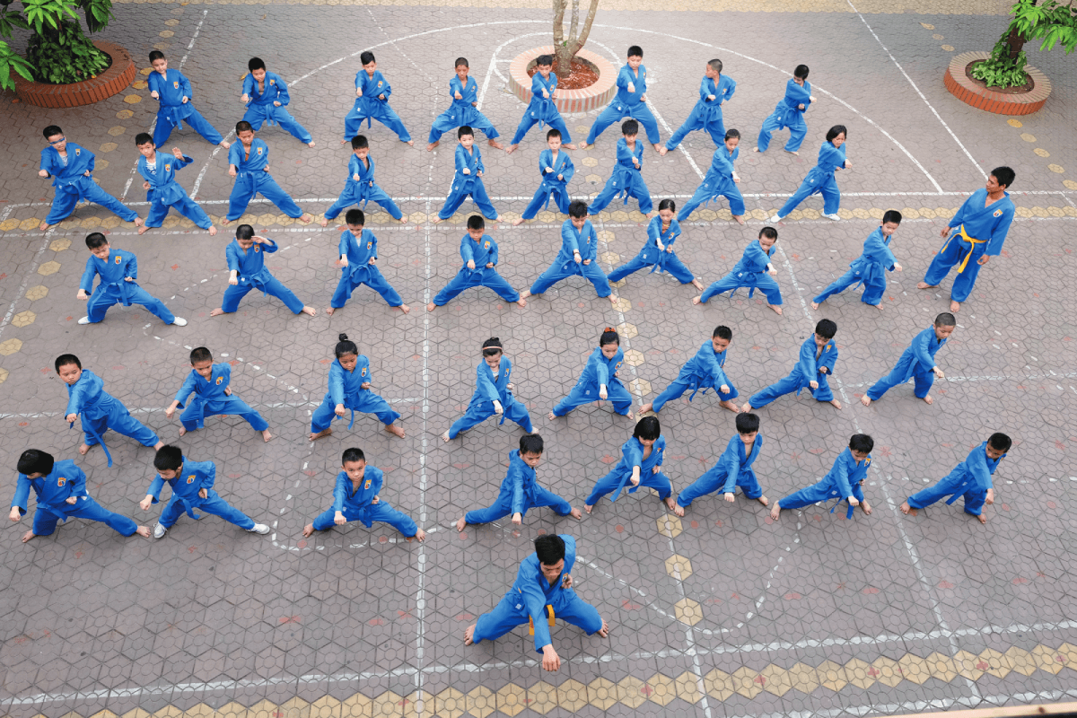  Suggested outcome:  Students’ posters & presentations  * Home assignment  - Prepare for UNIT 4: GETTING STARTED  - Revise lesson at home
V. FEEDBACK:
With 8A …………………………………………………………………………………..…

