Period: 35


UNIT 5: OUR CUSTOMS AND TRADITIONS
Lesson 1: Getting started - Tet is coming! P₅₀₋₅₁
Class | Date of planning | Date of teaching | Attendence
8A | 05/11/2023 | 30/11/2023

I. OBJECTIVES: * By the end of this unit, students will be able to:
- Gain an overview about the topic Customs And Traditions
- Gain vocabulary to talk about Customs and Traditions
1. Knowledge:
+ Vocabulary: admire (v), chase away, pray (v), offering (n), ornamental tree,
+ Language: Zero article; Giving advice
+ Pronunciation: Sounds: /n / and /ŋ/
2. Competence:
a) General competencies:
- Develop communication skills and creativity.
- Be collaborative and supportive in pair work and teamwork.
- Actively join in class activities.
b) Specific competencies:
- Group work and independent working, pair work, linguistic competence, cooperative learning and communicative competence.
- Sts can introduce themselves or one another fluently
3. Qualities: - Love talking about customs and traditions. Ss have the good attitude to working in groups, individual work, pair work, cooperative learning.
II. PREPARATIONS
Teacher: Grade 8 textbook, laptop, TV, pictures and realia, Computer connected to the Internet. Phần mềm tương tác hoclieu.vn
Students: Text books, pencils, pics, blank papers, realia,….
III. PROCEDURE
1. WARM-UP (5’-IW, PW, GW)
a. Objectives:
- To create an active atmosphere in the class before the lesson
- To lead into the new unit.
b. Content:
- Asking questions to introduce Tet holiday in Vietnam.
c. Product:
- Ss have general ideas about the topic “Our Customs and Traditions”.
d. Implementation:
TEACHER’S AND STUDENTS’ ACTIVITIES | CONTENTS
Asking questions:  Step 1: Task delivering  - T asks Ss some questions about festivals in Viet Nam.  - T asks Ss what they do before and during Tet holiday.  1. Can you name some festivals in Viet Nam?  2. Do you like the Mid-Autumn Festival?  3. Do you like Tet holiday?  4. What do you do before Tet holiday?  5. What do you do during Tet holiday?  Step 2: Task performance  - Ss’ observation  - Ss answer the question individually.  - T draws a mind map on the board to summarise Ss’ ideas. Write the title on the board Our customs and Traditions.  Step 3: Report and discussion  - Student’s answers  - T asks Ss to guess what the conversation might be about.  Step 4: Judgement  - Teacher checks students’ pronunciation and gives feedback. | Suggested answers:  1. Mid Autumn Festival, Tet holiday, …  2. Yes, I do / No, I don’t  3. Yes I do / No, I don’t  4. Clean my house, buy some flowers, decorate my house, cut hair,…  5. Visit my relatives, receive lucky money…
2. KNOWLEDGE FORMATION (10’-IW, PW, GW)
a. Objectives:
- To introduce some vocabulary related to the topic.
- To introduce the topic of the unit, the vocabulary, the sounds, and the grammar points to be learnt.
b. Content:
- Vocabulary pre-teach
- Task 1: Listen and read.
c. Product:
- Ss know how to pronounce the new words correctly and use them in appropriate situations.
d. Implementation:
Vocabulary pre-teaching  Step 1: Task delivering  - Teacher introduces the vocabulary.  - Teacher explains the meaning of the new vocabulary by pictures.  Step 2: Task performance  - Ss’ observation  - Teacher checks students’ understanding with the Matching Game.  Step 3: Report and discussion  - Listen and repeat./read.  Step 4: Judgement  - Teacher gives feedback and asks students to open their textbook to discover further.  Task 1: Listen and read.  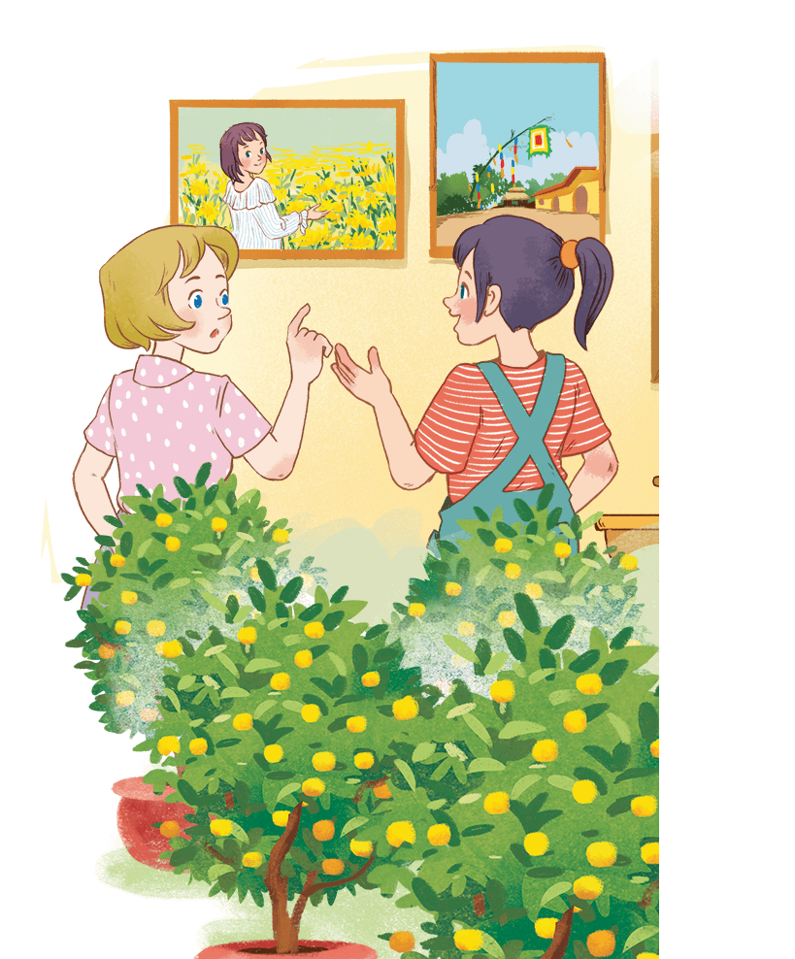  Step 1: Task delivering  - Teacher asks Ss to look at the pictures on page 50 in the book and answer the questions.  Questions:  - What can you see in each picture?  - Can you guess the places that the picture shows?  - Ss answer the questions in pairs.  - Teacher plays the recording twice. Ss listen and read.  Step 2: Task performance  - Ss’ observation  - Teacher has Ss underline the words / phrases that are related to the topic of the unit while they are listening and reading.  Step 3: Report and discussion  - Teacher invites some pairs of Ss to read the conversation aloud.  - Teacher has Ss say the words in the text that they think are related to the topic Customs and Traditions. Quickly write the words on one part of the board.  Step 4: Judgement  - T comments and gives feedback on Ss’ answers. | * Vocabulary  1. admire (v)  2. chase away  3. pray (v)  4. offering (n)  5. ornamental tree  1: Listen and read.  Suggested answers:  flower village, kumquat trees, ornamental trees, bamboo pole, decorative items, chase away bad luck
3. PRACTICE (20’-IW, PW, GW)
a. Objectives:
- To set the context for the introductory dialogue
- To develop students’ reading skills.
b. Content:
- Task 2: Read the conversation again and tick T (true) or F (False).
- Task 3: Match the phrases with the correct pictures.
- Task 4: Complete the sentences with the verbs from the box.
c. Product:
- Students can read and understand general and specific information about Tet holiday.
d. Implementation: Teacher’s instruction.
Task 2: Read the conversation again and tick T (true) or F (False).  Step 1: Task delivering  - Teacher tells Ss to read the conversation again and work independently to find the answers.  - Remind Ss to underline the information and correct the false statements.  Step 2: Task performance  - Ss’ observation  - Ss work independently to find the answers.  Step 3: Report and discussion  - Teacher has Ss compare the answers in pairs before checking with the whole class.  - Student’s answers  Step 4: Judgement  - Teacher checks the answers as a class and gives feedback.  Task 3: Match the phrases with the correct pictures.  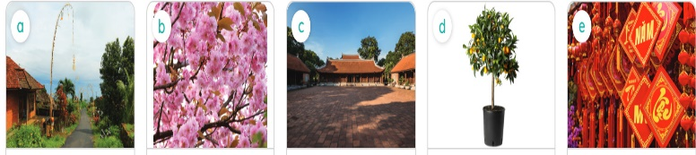  Step 1: Task delivering  - Teacher asks Ss to name the things they see in the pictures.  - Teacher has Ss work individually to match the phrases 1 - 5 with the correct pictures.  Step 2: Task performance  - Ss’ observation  - Ss name the things they see in the pictures.  Step 3: Report and discussion  - Student’s answers  - Teacher lets them compare their answers with a partner.  Step 4: Judgement  - Teacher checks the answers with the whole class. Confirm the correct answers.  - Teacher has some Ss practice saying the phrases again.  Task 4: Complete the sentences with the verbs from the box.  Step 1: Task delivering  - Teacher has Ss look at the verbs in the box.  - Check if they know these verbs.  Step 2: Task performance  - Ss’ observation  - Teacher has Ss read the sentences and complete each sentence with a verb from the box.  Step 3: Report and discussion  - Student’s answers  - Teacher asks for Ss’ answers and confirms the correct ones.  Step 4: Judgement  - Teacher has some Ss read aloud the sentences.  - For more able classes, challenge them to think of other words that can go with the given verbs. | 2: Read the conversation again and tick T (true) or F (False).  Answer key:  1. F (Trang’s cousin is at Sa Dec Flower Village.)  2. T  3. T  4. F (plants and flowers are an important part of Tet)  5. T  3: Match the phrases with the correct pictures.  Answer key:  1. d  2. a  3. e  4. b  5. c  4: Complete the sentences with the verbs from the box.  Answer key:  1. place  2. admire  3. chase  4. pray
4. APPLICATION (10’-IW, PW, GW)
a. Objectives:
- To help Ss broaden their knowledge about New Year customs and traditions from other countries;
- To motivate Ss.
b. Content:
- Task 5: QUIZ: New Years around the world.
- Home assignment.
c. Product:
- Students can gain more knowledge about New Year customs and traditions from other countries.
- Take notes Home assignment.
d. Implementation: Teacher’s instruction
Task 5: QUIZ: New Years around the world.  Step 1: Task delivering  - Teacher has Ss work in pairs and complete with each other.  - Teacher sets time (3 minutes) for Ss to do this activity. The first student to finish calls out “Bingo!”  Step 2: Task performance  - Ss’ observation  - Complete with each other.  Step 3: Report and discussion  - Teacher checks answers with the whole class.  - Compliment those with all correct answers.  - For a more able class, teacher asks each pair to write two questions about New Year customs and traditions of two countries they know.  Step 4: Judgement  - Student’s answers  - T collects the questions and reads aloud some of them. Ss compete to give their answers to the questions. The one with the most correct answers win the game.  * Home assignment  - T assigns the homework.  - Ss copy their homework.  - T explains it carefully | 5: QUIZ: New Years around the world.Answer key:  1. B  2. A  3. A  4. B  5. B  * Home assignment  - Learn by heart vocabulary  - Practise talking about Tet Holiday.  - Prepare the next lesson: A closer look 1  - Prepare Project:  Teacher randomly puts Ss in groups of 4 or 5 and asks them to choose a custom or tradition  practised in your hometown and make a poster about it (suggested information in Project lesson). Students will show and present their posters in Lesson 7 - Looking back and Project. (Teacher should check the progress of students’ preparation after each lesson.)

V. FEEDBACK:
With 8A …………………………..………………………………………………………………..…
With 8B …………………………………………...……………………………………..……………
With 8C ………………………………………………………………………………………….……

Period: 36
UNIT 5: OUR CUSTOMS AND TRADITIONS
Lesson 2: A closer look 1 P₅₂₋₅₃
Class | Date of planning | Date of teaching | Attendence
8A | 05/11/2023 | 4/12/2023
I. OBJECTIVES: * By the end of this unit, students will be able to:
- Use the lexical items related to the topic Customs And Traditions
- Know how to use words and phrases often used with Customs And Traditions
1. Knowledge:
+ Vocabulary: . wedding ceremony, whale worship, food offerings, family reunion, martial arts (n), festival goer, acrobat (n), maintain (v), longevity (n).
+ Language: Zero article; Giving advice
+ Pronunciation: Sounds: /n / and /ŋ/
2. Competence:
a) General competencies:
- Develop communication skills and creativity.
- Be collaborative and supportive in pair work and teamwork.
- Actively join in class activities.
b) Specific competencies:
- Group work and independent working, pair work, linguistic competence, cooperative learning and communicative competence.
- Sts can introduce themselves or one another fluently
3. Qualities: - Promote pride in the values of Vietnamese culture, Develop love for family
Ss have the good attitude to working in groups, individual work, pair work, cooperative learning.
II. PREPARATIONS
Teacher: Grade 8 textbook, laptop, TV, pictures and realia, Computer connected to the Internet. Phần mềm tương tác hoclieu.vn
Students: Text books, pencils, pics, blank papers, realia,….
III. PROCEDURE
1. WARM-UP (5’-IW, PW, GW)
a. Objectives:
- To create an active atmosphere in the class before the lesson
- To lead into the new unit.
b. Content:
- Play a game to introduce some customs and traditions in Viet Nam.
c. Product:
- Ss have general ideas about the topic “Our Customs and Traditions”.
d. Implementation:
TEACHER’S AND STUDENTS’ ACTIVITIES | CONTENTS
Hidden pictures game:  Step 1: Task delivering  - Teacher divides the class into 8 groups and gives instructions.  Step 2: Task performance  - Ss’ observation  - The teacher slowly removes the squares while the groups write the answers on their mini boards.  Step 3: Report and discussion  - The groups that guesses the right word will have the points. | Observation  Questions & answers  Suggested answers:  1. family reunion  2. wedding ceremony  3. food offerings  4. Tet holiday  5. lucky money
2. KNOWLEDGE FORMATION (10’-IW, PW, GW)
a. Objectives:
- To present some phrases related to customs and traditions.
- To help Ss practise the phrases related to customs and traditions.
b. Content:
- Vocabulary pre-teach.
c. Product:
- Ss know how to pronounce the new words correctly and use them in appropriate situations.
d. Implementation:
Vocabulary pre-teaching  Step 1: Task delivering  - Teacher introduces the vocabulary by:  + Providing the definition of the words  + Providing the pictures of the words  Step 2: Task performance  - Ss’ observation  - Teacher has students read the phrases aloud and correct their pronunciation if necessary.  Step 3: Report and discussion  - Teacher asks students for the Vietnamese meanings of these phrases.  - Ss say the words.  - Student’s answers  Step 4: Judgement  - Other Ss correct if the previous answers are incorrect.  - Teacher shows and says the words aloud and asks Ss to repeat them. | * Vocabulary:  wedding ceremony  whale worship  food offerings  family reunion  martial arts (n)  festival goer  acrobat (n)  maintain (v)  longevity (n)
3. PRACTICE (15’-IW, PW, GW)
a. Objectives:
- To present some phrases related to customs and traditions.
- To help Ss practise the phrases related to customs and traditions.
- To give further practice with expressions about customs and traditions.
b. Content:
- Task 1: Write a phrase from the box under each picture.
- Task 2: Complete each sentence with the correct option A, B, or C.
- Task 3: Complete the sentences with the words from the box.
c. Product:
- Ss know how to pronounce the new words correctly and use them in appropriate situations.
d. Implementation:
Task 1: Write a phrase from the box under each picture.  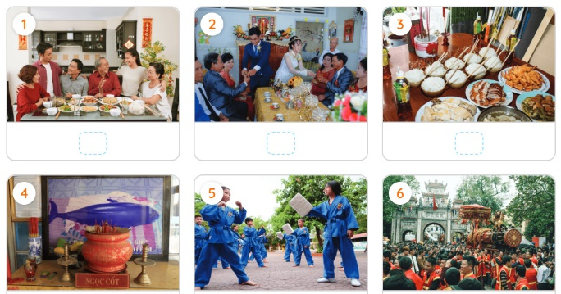  Task 2: Complete each sentence with the correct option A, B, or C.  Step 1: Task delivering  - Teacher has Ss do this exercise individually.  - Tell them to read all the sentences carefully to make sure they understand the sentences and choose the correct options.  Step 2: Task performance  - Teacher has them share their answers in pairs  Step 2: Task performance  - Ss’ observation  - Teacher invites some Ss to give their answers and confirm the correct ones.  Step 4: Judgement  - Student’s answers  - Explain the options that challenge Ss.  - With a more able class, T challenges Ss to list new phrases. For example, T writes “family _______”, “_______ ceremony”; “worshipping _______” on the board, and has Ss think of appropriate words to fill in the blank.  Task 3: Complete the sentences with the words from the box.  Step 1: Task delivering  - Go over the words in the box with Ss.  - Make sure Ss understand them before moving on. For example, draw Ss’ attention to “break with tradition” and have them guess its meanings. Also, tell them that the verb “practise” can go with “customs” or “traditions”.  Step 2: Task performance  - Ss’ observation  - Have Ss read the sentences in pairs and choose the appropriate words to complete the sentences.  - Invite Ss to share their sentences orally or in writing.  Step 4: Judgement  - Confirm the correct answers as a class.  - Have Ss choose one or two expressions and make sentences with them. | 1: Write a phrase from the box under each picture.Answer key:  1. family reunion  2. wedding ceremony  3. food offerings  4. whale worship  5. martial arts  6. festival goers  2: Complete each sentence with the correct option A, B, or C.  Answer key:  1. A  2. C  3. B  4. B  5. A  Note: 1. hold a family reunion but have a family meal  3: Complete the sentences with the words from the box.  Answer key:  1. break  2. Traditionally  3. practise  4. keep  5. custom
4. APPLICATION (10’-IW, PW, GW)
a. Objectives:
- To help Ss identify how to pronounce the sounds /n/ and /ŋ/;
- To help Ss practise pronouncing these sounds correctly in words and in sentences.
- To motivate Ss.
b. Content:
- Task 4: Listen and repeat the words. Pay attention to the sounds /n/ and /ŋ/.
- Task 5: Listen and practise the sentences. Underline the words with the sound /n/ and circle the words with the sound /ŋ/.
c. Product:
- Students can pronounce the sound /n/ and /ŋ/ correctly.
d. Implementation:
Task 4: Listen and repeat the words. Pay attention to the sounds /n/ and /ŋ/.  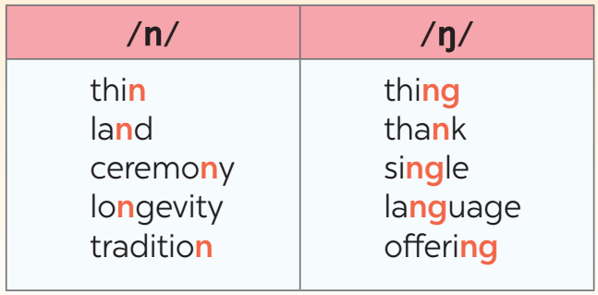  Step 1: Task delivering  - Teacher has some Ss read out the words first.  - T plays the recording for them to listen and repeat the words they hear.  - T plays the recording as many times as necessary.  Step 2: Task performance  - Ss’ observation  - Teacher explains to Ss that these words have the sounds /n/ and /ŋ/.  - Tell them how to make the two sounds and have them practise saying the sounds several times.  - Teacher goes over the list of the words again with Ss. Draw their attention to words like longevity, thank, and language.  Step 3: Report and discussion  - Teacher asks Ss to work in pairs to practise saying the words.  - Student’s answers  Step 4: Judgement  - Teacher invites some Ss to say some words they know that include either of the two sounds.  Task 5: Listen and practise the sentences. Underline the words with the sound /n/ and circle the words with the sound /ŋ/.  Step 1: Task delivering  - Teacher has Ss quickly read the sentences.  - T plays the recording for Ss to listen to the sentences.  - T asks them to pay attention and underline the words with /n/ and circle the words with /ŋ/.  Step 2: Task performance  - Ss’ observation  - Teacher invites some Ss to share their answers.  Step 3: Report and discussion  - Student’s answers  - Teacher plays the recording again for Ss to repeat the sentences.  - Teacher has Ss practise the sentences in pairs.  Step 4: Judgement  - T invites some pairs to read the sentences aloud.  - T comments on their pronunciation of the sounds.  * Home assignment  - T assigns the homework.  - Ss copy their homework.  - T explains it carefully | 4: Listen and repeat the words. Pay attention to the sounds /n/ and /ŋ/.  Students can pronounce the sound /n/ and /ŋ/ correctly.  5: Listen and practise the sentences. Underline the words with the sound /n/ and circle the words with the sound /ŋ/.  Answer key:  1. Mary wore a pink dress last night.  2. I think we should buy this ornamental tree.  3. He thanked the host for the enjoyable party.  4. My mum made the spring rolls for the longevity party.  5. I will bring some food to the party on Saturday.  * Home assignment  - Learn by heart vocabulary  - Practice pronounces the sounds /n/ and /ŋ/.  - Prepare: A closer look 2
V. FEEDBACK:
With 8A …………………………..………………………………………………………………..…
With 8B …………………………………………...……………………………………..……………
With 8C ………………………………………………………………………………………….……

Period: 37
UNIT 5: OUR CUSTOMS AND TRADITIONS
Lesson 3: A closer look 2 P₅₃₋₅₄
Class | Date of planning | Date of teaching | Attendence
8A | 05/11/2023 | 06/12/2023

I. OBJECTIVES: * By the end of this unit, students will be able to:
- Use the lexical items related to the topic Customs And Traditions
- Know how to use words and phrases often used with Customs And Traditions
1. Knowledge:
+ Vocabulary: . wedding ceremony, whale worship, food offerings, family reunion, martial arts (n), festival goer, acrobat (n), maintain (v), longevity (n).
+ Language: - Use the article (a / an, the, the zero articles) correctly.
+ Pronunciation: Sounds: /n / and /ŋ/.
2. Competence:
a) General competencies:
- Develop communication skills and creativity.
- Be collaborative and supportive in pair work and teamwork.
- Actively join in class activities.
b) Specific competencies:
- Group work and independent working, pair work, linguistic competence, cooperative learning and communicative competence.
- Sts can introduce themselves or one another fluently
3. Qualities: - Be encouraged to know more about Vietnamese’ customs and traditions. Develop love for family. Ss have the good attitude to working in groups, individual work, pair work, cooperative learning.
II. PREPARATIONS
Teacher: Grade 8 textbook, laptop, TV, pictures and realia, Computer connected to the Internet. Phần mềm tương tác hoclieu.vn
Students: Text books, pencils, pics, blank papers, realia,….
III. PROCEDURE

1. WARM-UP (10’ - IW, PW, GW)
a. Objectives:
- To create an active atmosphere in the class before the lesson.
- To lead into the new unit.
b. Content:
- Option 2: watch a video.
c. Product:
- Ss have general ideas about the topic “Our Customs and Traditions”.
d. Implementation:
TEACHER’S AND STUDENTS’ ACTIVITIES | CONTENTS
Step 1: Task delivering  - Teacher lets the students watch a video: www.youtube.com/watch?v=uqNugAvxXXo  Step 2: Task performance  - Ss’ observation  - Teacher introduces the objectives of the lesson.  - Write the objectives in the left corner of the board.  Step 3: Report and discussion  - Student’s answers  - Ss tell when we use a / an / the.  Step 4: Judgement  - Teacher asks them what part of speech “a” is. T asks them if they remember other articles. T tells them that today they are going to revise “a, an, the” and learn about “zero article”. Lead to the lesson. | Suggested outcome:  1. We held a family reunion last week.  2. My mom prepares food offerings at Tet.
2. KNOWLEDGE FORMATION (10’ - IW)
a. Objectives:
- To review articles: a, an, the and teach how to use the zero article.
b. Content:
- The article a / an, the and zero article.
c. Product:
- Ss understand how to use the article correctly.
d. Implementation:
Step 1: Task delivering  Write two sentences on the board:  - Elicit from Ss the use of a, an, the and when to use them.  Step 2: Task performance  - Ss’ observation  - Go through the Remember! box with Ss.  - Draw their attention to the example sentence for each case.  Step 3: Report and discussion  - Identify the uncountable noun, the general statement and the general form of transport in each example sentence.  - Encourage Ss to give their own examples.  Step 4: Judgement  - T comments and gives feedback on Ss’ answers. | * GRAMMAR  The article a / an, the and zero article.  the: definite article  a/an: indefinite article  a + singular noun beginning with a consonant  an + singular noun beginning with a vowel  Introduction of zero article  - Explain that sometimes, we can use nouns without a / an or the. We call this case zero article.  Eg:  1. She is an engineer.  2. We held a family reunion last week. The party was enjoyable.
3. PRACTICE (20’-IW, PW, GW)
a. Objectives:
- To help Ss identify the use of articles at the sentence level.
- To help Ss recognise and use the articles correctly.
- To give practice with articles at sentence and text level.
b. Content:
- Task 1: Choose the correct option in each sentence below.
- Task 2: Which of the underlined parts in each question is incorrect? Find and correct it.
- Task 3: Complete the sentences with a, an, the, or Ø (zero article).
- Task 4: Complete the text with the or Ø (zero article).
c. Product:
- Students can use the articles correctly.
d. Implementation:
Task 1: Choose the correct option in each sentence below.  Step 1: Task delivering  - Teacher has Ss do this exercise individually.  Step 2: Task performance  - Ss’ observation  - do the exercise individually.  - Choose the correct option in each sentence.  Step 3: Report and discussion  - Compare their answers with a partner.  - Explain their choices.  Step 4: Judgement  - T confirms the correct answers.  Task 2: Which of the underlined parts in each question is incorrect? Find and correct it.  Step 1: Task delivering  - Teacher shows a picture of the Kitchen Gods Worshipping Ceremony.  - Encourage Ss to say aloud what they know about the ceremony (when it is, what happens, etc.)  Step 2: Task performance  - Ss’ observation  - Teacher tells Ss that they are going to read sentences about this ceremony.  - Tell them that one of the articles in each sentence is not used correctly.  - Teacher demonstrates the activity with the first sentence (find the mistake and correct it).  Step 3: Report and discussion  - Ss do this exercise individually and then compare the answers with another classmate.  - Ss write their answers on the board.  Step 4: Judgement  - Teacher checks the answers with the whole class. T has some Ss explain their answers.  - T confirms the correct answers.  Task 3: Complete the sentences with a, an, the, or Ø (zero article).  - Teacher has Ss do this exercise individually and then compare their answers with a partner.  - Teacher asks some Ss to share their answers and have them explain their choice. Confirm the correct answers.  Task 4: Complete the text with the or Ø (zero article).  Step 1: Task delivering  - Teacher writes on the board (or shows pictures on the slide) the following activities: playing cards, watching TV, singing karaoke.  - Teacher asks Ss if their family often does these activities together.  - Teacher tells Ss that we call activities that a family often do together family time traditions.  - Teacher tells Ss that the text is about the benefits of family time traditions, and they have to read and complete the blanks with the or Ø (zero article).  Step 2: Task performance  - Ss’ observation  - Teacher has Ss work individually to complete the text.  - Teacher invites some Ss to write their answers on the board. Have Ss explain their answers.  Step 4: Judgement  - Teacher confirms the answers.  - For a stronger class, T asks them to talk about the benefits of family time traditions. | 1: Choose the correct option in each sentence below.  Suggested outcome:  1. an  2. a  3. Ø  4. Ø  5. the  2: Which of the underlined parts in each question is incorrect? Find and correct it.  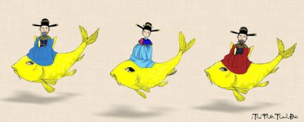  Suggested outcome:  1. A (The → Ø)  2. C (a → the)  3. B (the → Ø)  4. C (a → Ø)  5. A (The → Ø)  3: Complete the sentences with a, an, the, or Ø (zero article).  Suggested outcome:  1. Ø  2. a  3. Ø  4. the  5. an  4: Complete the text with the or Ø (zero article).  Suggested outcome:  1. the  2. Ø  3. Ø  4. Ø  5. the
4. APPLICATION (5’-IW)
a. Objectives: - To give further practice with articles at sentence and text level.
b. Content:
- Task 5: Game
- Home assignment.
c. Product:
- Students can use the articles correctly.
- Take note home assignment.
d. Implementation:
Task 5: Game: Bingo!  Step 1: Task delivering  - Teacher has Ss work in groups of four or five.  - Teacher gives each group a list of five sentences.  - T tells them that there is one mistake in each sentence, and they have to find and correct it.  Step 2: Task performance  - Ss’ observation  - Teacher has Ss work in their groups, find and correct the mistakes. They say “Bingo!” as soon as their group finishes.  Step 3: Report and discussion  - For stronger classes, T lets groups write two sentences with article mistakes. T collects the sentences and picks out some sentences randomly for the whole class to find and correct the mistakes.  Step 4: Judgement  - Teacher confirms the correct answers. The first group to come up with all the correct answers wins.  * Home assignment  - T assigns the homework.  - Ss copy their homework.  - T explains it carefully | Suggested outcome:  1. I usually meet my cousin at the weekends. (the → Ø)  2. My uncle moved to United States three years ago. (United States → the United States)  3. Our teachers assigned us a homework for our history and science classes. (a → Ø)  4. I turn off the light and go to the bed at 11 p.m. (the → Ø)  5. Mark often wears red sweater to match his red hair. (red sweater → a red sweater)  * Home assignment  - Make 5 sentences by using the articles.  - Do exercises in the workbook.  - Prepare: Communication

V. FEEDBACK:
With 8A …………………………..………………………………………………………………..…
With 8B …………………………………………...……………………………………..……………
With 8C ………………………………………………………………………………………….……

Period: 38
UNIT 5: OUR CUSTOMS AND TRADITIONS
Lesson 4: Communication P₅₄₋₅₅
Class | Date of planning | Date of teaching | Attendence
8A | 05/11/2023 | 7/12/2023

I. OBJECTIVES: * By the end of this unit, students will be able to:
- Read about a local festival
- Compare two local festivals.
1. Knowledge:
+ Vocabulary: wedding ceremony, whale worship, food offerings, family reunion, martial arts (n), festival goer, acrobat (n), maintain (v), longevity (n).
+ Language: Giving advice: Perhaps you should…; It’s a good idea…….; Don’t…..
+ Pronunciation: Sounds: /n / and /ŋ/.
2. Competence:
a) General competencies:
- Develop communication skills and creativity.
- Be collaborative and supportive in pair work and teamwork.
- Actively join in class activities.
b) Specific competencies:
- Group work and independent working, pair work, linguistic competence, cooperative learning and communicative competence.
- Sts can introduce themselves or one another fluently
3. Qualities: - Be encouraged to know more about Vietnamese’ customs and traditions. Develop love for family. Ss have the good attitude to working in groups, individual work, pair work, cooperative learning.
II. PREPARATIONS
Teacher: Grade 8 textbook, laptop, TV, pictures and realia, Computer connected to the Internet. Phần mềm tương tác hoclieu.vn
Students: Text books, pencils, pics, blank papers, realia,….
III. PROCEDURE
1. WARM-UP (10’-IW)
a. Objectives:
- To create an active atmosphere in the class before the lesson
- To lead into the new unit.
b. Content:
- To introduce table manners.
c. Product:
- Ss have general ideas about table manners.
d. Implementation:
TEACHER’S AND STUDENTS’ ACTIVITIES | CONTENTS
GUESSING GAME:  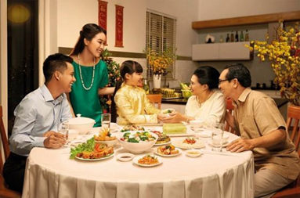  Step 1: Task delivering  - T shows a picture of a child having dinner with family.  - Ask Ss what the child is doing and whether she is behaving well at the table.  Step 2: Task performance  - Ss’ observation.  - Student’s talk  Step 3: Report and discussion  - Tell Ss that “table manners” means the polite ways of behaving when eating. These behaviours differ from one culture to another.  - Ask Ss to give some examples of table manners that they know.  Step 4: Judgement  - Lead in to the lesson.  - T comments and gives feedback on Ss’ answers. | Suggested answers:  - Wait for the table arrangement before sitting down  - Wait for the oldest people to start first  - Pass your bowl with two hands  - Do not stick the chopstick against the bowl  - Do not flip the fish on the plate  - Do not point the chopsticks to anyone  - Do not dig into the dish  - Do not eat directly from shared dishes  - Stay until other people finish  - Say Thanks to the host after the meal
2. KNOWLEDGE FORMATION (15’-IW)
a. Objectives:
- To introduce ways of giving advice.
- To help Ss practise giving advice.
b. Content:
- Task 1: Listen and practise the conversation.
- Task 2: Work in pairs. Make similar conversations with the following situations.
c. Product:
- Ss understand how to give advice.
- Students can make dialogue by giving advice.
d. Implementation:
Task 1: Listen and practise the conversation.  Step 1: Task delivering  - Teacher plays the recording for Ss to listen and read the dialogue between Tom and Mai.  - T asks Ss to pay attention to the highlighted language.  Step 2: Task performance  - Ss’ observation  - T elicits from Ss that the first two highlighted phrases are ways to advise what one should do, and the last highlighted word is for saying what one should NOT do.  Step 3: Report and discussion  - Teacher has Ss practise the dialogues in pairs.  - Some pairs to practise the dialogues in front of the class.  -> Structure: to give advice  - Perhaps you should + V₀  - It’s a good idea to + V₀  - Don’t + V₀  Step 4: Judgement  - T comments and gives feedback on Ss’ answers.  Task 2: Work in pairs. Make similar conversations with the following situations.  Step 1: Task delivering  - Teacher asks Ss to work in pairs (5 minutes) to make similar dialogues with the given situations, using the expressions they have learnt.  Step 2: Task performance  - Ss’ observation  - Teacher moves around to observe and provide help.  Step 3: Report and discussion  - T calls on some pairs to practise in front of the class.  - Student’s talk  Step 4: Judgement  - T comments on their performance. | * EVERYDAY ENGLISH  1: Listen and practise the conversation.  Ss understand how to give advice.  -> Structure: to give advice  - Perhaps you should + V₀  - It’s a good idea to + V₀  - Don’t + V₀  2: Work in pairs. Make similar conversations with the following situations.  Students can make dialogue by giving advice.  Suggested answers:  1. Perhaps you should bring warm clothes, a scarf, coat, jacket,…  2. It’s a good idea to bring a gift such as a birthday cake, pen, pencil, clothes…
3. PRACTICE (10’ - IW, PW, GW)
a. Objectives:
- To provide Ss with information about lion dance in Japan.
- To help Ss compare the Vietnamese unicorn dance with the Japanese lion dance.
b. Content:
- Task 3: Read the text about the lion dance in Japan and complete the table with the information from the text.
c. Product:
- Ss can understand the text and fill in the blank with right information.
d. Implementation:
Task 3: Read the text about the lion dance in Japan and complete the table with the information from the text.  Step 1: Task delivering  - Teacher writes “Lion Dance” on the board or shows a picture of a lion dance.  - T tells Ss that this is called the lion dance and it is popular in many Asian countries.  - T elicits from Ss the occasion(s) when they may see a lion dance performance.  - Teacher tells Ss that they are going to read about lion dance in Japan.  - Teacher has Ss look at the table of information and think of the type of information they need for each blank.  Step 2: Task performance  - Ss’ observation  - Teacher asks Ss to work in pairs to do this activity.  Step 3: Report and discussion  - They can draw this table on a sheet of paper. After pairs finish their work, T asks them to share their table with the whole class.  - If time allows, have some pairs use the information in the table to talk about the Japanese lion dance without looking again at the text.  Step 4: Judgement  - Teacher comments on their answers. | * THE JAPANESE LION DANCE AND VIETNAMESE UNICORN DANCE  3: Read the text about the lion dance in Japan and complete the table with the information from the text.  Answer key:  1. shishi-mai  2. New Year celebrations  3. acrobatics  4. flutes  5. bad spirits
4. APPLICATION (10’ - IW, PW, GW)
a. Objectives:
- To help Ss compare the Vietnamese unicorn dance with the Japanese lion dance.
b. Content:
- Task 4: Work in groups. Read Mai’s notes on the Vietnamese unicorn dance. Compare the Vietnamese unicorn dance with the Japanese lion dance.
c. Product:
- Students can compare the Vietnamese unicorn dance with the Japanese lion dance.
d. Implementation:
Task 4: Work in groups. Read Mai’s notes on the Vietnamese unicorn dance. Compare the Vietnamese unicorn dance with the Japanese lion dance.  Step 1: Task delivering  - Teacher shows two pictures, one of the Vietnamese unicorn dance and one of the Japanese lion dance next to each other.  - Teacher has Ss look at the pictures and point out some similarities and differences between the two pictures.  - T encourages Ss to use the structures “Both…. and …..” and “…. but….”.  Step 2: Task performance  - Ss’ observation  - Teacher tells Ss to look at Mai’s notes on Vietnamese unicorn dance.  - T asks them if there is any information they didn’t know.  Step 3: Report and discussion  - Teacher has Ss work in groups to compare the Vietnamese unicorn dance and the Japanese lion dance, using the tables in 3 and 4.  - Tell the groups that they need to write at least 5 sentences using 5 pieces of information from the tables.  - Teacher asks some Ss to report their group’s answers to the class.  Step 4: Judgement  - T comments and gives feedback on Ss’ answers.  * Home assignment  - T assigns the homework.  - Ss copy their homework.  - T explains it carefully | 4: Work in groups. Read Mai’s notes on the Vietnamese unicorn dance. Compare the Vietnamese unicorn dance with the Japanese lion dance.  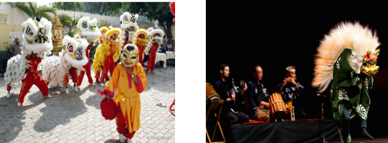  Suggested answers:  - There are one or more performers in both Vietnamese Unicorn dance and Japanese Lion dance.  - Both Vietnamese Unicorn dance and Japanese Lion dance perform in the New Year Festival.  - Vietnamese Unicorn dance needs Ong Dia but Japanese Lion dance doesn’t need it.  …  * Home assignment  - Do exercise in workbook  - Compare Vietnamese Tet Holiday and Chinese Tet Holiday.  - Prepare: Skills 1

V. FEEDBACK:
With 8A …………………………..………………………………………………………………..…
With 8B …………………………………………...……………………………………..……………
With 8C ………………………………………………………………………………………….……

Period: 39
UNIT 5: OUR CUSTOMS AND TRADITIONS
Lesson 5: Skills 1 P₅₅₋₅₆
Class | Date of planning | Date of teaching | Attendence
8A | 05/11/2023 | 11/12/2023

I. OBJECTIVES: * By the end of this unit, students will be able to:
1. Knowledge:
+ Vocabulary: release (v), contestant (n), family bonding.
+ Language: + Reading: Read for specific information about village festival day; + Speaking: Talk about family event.
+ Pronunciation: Sounds: /n / and /ŋ/.
2. Competence:
a) General competencies:
- Develop communication skills and creativity.
- Be collaborative and supportive in pair work and teamwork.
- Actively join in class activities.
b) Specific competencies:
- Group work and independent working, pair work, linguistic competence, cooperative learning and communicative competence.
- Sts can introduce themselves or one another fluently
3. Qualities: - Be benevolent and responsible. Develop love for family. Ss have the good attitude to working in groups, individual work, pair work, cooperative learning.
II. PREPARATIONS
Teacher: Grade 8 textbook, laptop, TV, pictures and realia, Computer connected to the Internet. Phần mềm tương tác hoclieu.vn
Students: Text books, pencils, pics, blank papers, realia,….
III. PROCEDURE
1. WARM-UP (5’-IW, PW, GW)
a. Objectives:
- To create an active atmosphere in the class before the lesson
- To lead into the new unit.
b. Content:
- Describe the festival.
c. Product:
- Ss can describe the festival.
d. Implementation:
TEACHER’S AND STUDENTS’ ACTIVITIES | CONTENTS
Asking questions:  Step 1: Task delivering  - T asks Ss some questions about festivals in Viet Nam.  Questions:  1. Have you ever been to a Festival?  2. Do you like it? (Do you know any festivals?)  3. Can you describe it? (When and Where is the festival celebrated? What activities there are? What do you and your family do during the festival?)  Step 2: Task performance  - Ss’ observation  - Student’s answers  Step 3: Report and discussion  - T asks Ss to describe one of the festivals they have ever been to.  - Student’s talk  Step 4: Judgement  - Lead to the new lesson: Reading and Speaking lesson about a festival day and a family event.  - Introduce the objectives of the lesson. Write the objectives in the left corner of the board. | Observation  Questions & answers  Suggested answers:  1. Yes, I have been to the Full Moon festival,... / No, I haven’t  2. Yes, I do / No, I don’t  3. I celebrated the Full Moon festival on the 15th day of the 8th Lunar Month in our country.  4. We can eat moon cake during this Festival. We can give gifts to others. We can appreciate the Moon,….
2. KNOWLEDGE FORMATION (5’-IW)
a. Objectives: - To introduce some vocabulary
b. Content: - Vocabulary
c. Product: - Ss understand new vocabulary
d. Implementation: Teacher’s instruction
* PRE-READING  - Teacher introduces the vocabulary.  - Teacher explains the meaning of the new vocabulary by pictures and definitions. | * Vocabulary:  1. release (v)  2. contestant (n)  3. family bonding
3. PRACTICE (20’-IW, PW, GW)
a. Objectives:
- To activate Ss’ knowledge of the topic of the reading text.
- To help Ss develop the skill of reading for the main idea (skimming), specific information (scanning) and guessing word meaning in context.
b. Content:
- Task 1: Work in pairs. Look at the picture and answer questions.
- Task 2: Read the text. Choose the correct answer A, B, or C.
- Task 3: Read the text again. Complete the mind map about a family party.
c. Product:
- Ss understand new vocabulary
- Ss can answer the questions correctly.
- Students can understand the text and choose the right answers.
- Ss can complete the mind map.
d. Implementation:
* WHILE-READING  Task 1: Work in pairs. Look at the picture and answer questions.  - Teacher has Ss look at the picture in the book or show the picture in the book on a slide. Ask Ss two questions in the book:  1. What are the men doing?  2. When do you think this event occurs?  - Teacher tells Ss that they are going to read a text about a festival in a village.  Task 2: Read the text. Choose the correct answer A, B, or C.  Step 1: Task delivering  - Teacher asks Ss to read the first paragraph and find the time that the festival happens (the third day of Tet).  - Teacher tells Ss to read the first sentence of the second and the third paragraph.  - T asks Ss what each paragraph is going to be about.  - Teacher tells the Ss to do the same with the last paragraph.  - Teacher asks Ss to look at Question 1 and choose the correct option.  - Teacher tells Ss that Questions 2 and 4 ask about specific information. Question 3 asks them to guess the meaning of words in context.  Step 2: Task performance  - Ss’ observation  - T elicits from Ss the steps: Read the questions, underline the key words in each question, locate the key words in the text and find the information to answer the question.  Step 3: Report and discussion  - Teacher asks Ss to locate the paragraphs with the information for each question.  - Ss do the exercise individually and checks their answers in pairs.  - Teacher invites some Ss to share their answers.  - Have them explain their answers.  Step 4: Judgement  - T comments and gives feedback on Ss’ answers.  Task 3: Read the text again. Complete the mind map about a family party.  Step 1: Task delivering  - Teacher asks Ss to look at the mind map and identify the paragraph with the information for each question in the mind map.  Step 2: Task performance  - Ss’ observation  - Then T has Ss do the exercise in pairs.  Step 3: Report and discussion  - Student’s talk  - Teacher invites some pairs to share their answers.  - Have them explain their answers.  Step 4: Judgement  - T confirms the correct answers.  - Teacher tells Ss that when they describe a family event, they should mention categories of information like in the mind map. | * READING  1: Work in pairs. Look at the picture and answer questions.  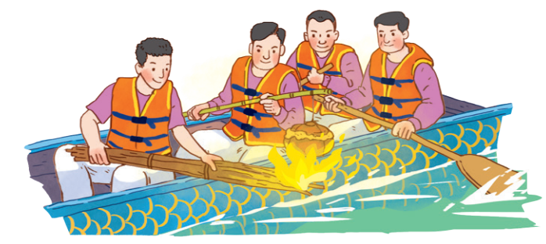  Suggested answers:  1. They are rowing a boat. They are cooking rice on an open fire.  2. This event may occur in a festival in the North of Viet Nam.  2: Read the text. Choose the correct answer A, B, or C.  Answer key:  1. A  2. B  3. A  4. C  3: Read the text again. Complete the mind map about a family party.    Answer key:  1. third day  2. home  3. dishes  4. food
4. APPLICATION (15’-IW, PW)
a. Objectives:
- To help Ss predict the content of a dialogue about a family event.
- To help Ss practise talking about a family event.
b. Content:
- Task 4: Work in pairs. Put the questions (A - E) in the correct blanks (1 - 5) to make a complete dialogue. Then role-play it.
- Task 5: Make notes about a normal family event that you take part in. Use the questions below as cues. After that, work in pairs. Make a dialogue asking and answering about the event. You can use your notes.
c. Product:
- Students can complete the dialogue.
- Students can make the dialogue about their family events.
* POST-READING  Task 4: Work in pairs. Put the questions (A - E) in the correct blanks (1 - 5) to make a complete dialogue. Then role-play it.  Step 1: Task delivering  - Teacher draws a mind map with “a family event” in the middle and “when, where, who, what” as the categories.  - Teacher tells Ss to look at the questions in the box and match the questions with the appropriate categories.  - Teacher tells Ss to read the dialogue and complete the dialogue with the given questions.  Step 2: Task performance  - Ss’ observation  - Ss read the dialogue.  - Complete the dialogue with the given questions.  Step 3: Report and discussion  - Student’s answers  Step 4: Judgement  - Teacher confirms the answers.  - T has Ss practise reading aloud the dialogue in pairs.  Task 5: Make notes about a normal family event that you take part in. Use the questions below as cues. After that, work in pairs. Make a dialogue asking and answering about the event. You can use your notes.  Step 1: Task delivering  - Teacher asks Ss to think of a family event and make notes about it in the form of a mind map.  - Teacher tells them to look at the mind map on the board and revise the questions that can be used.  Step 2: Task performance  - Ss’ observation  - Teacher has Ss work in pairs.  Step 3: Report and discussion  - Ss take turns to ask and answer about the family event.  - Teacher has some pairs act out the dialogue in front of the class.  Step 4: Judgement  - Teacher comments on their performance.  * Home assignment  - T assigns the homework.  - Ss copy their homework.  - T explains it carefully | * SPEAKING  4: Work in pairs. Put the questions (A - E) in the correct blanks (1 - 5) to make a complete dialogue. Then role-play it.  Answer key:  1. B  2. D  3. E  4. A  5. C  5: Make notes about a normal family event that you take part in. Use the questions below as cues. After that, work in pairs. Make a dialogue asking and answering about the event. You can use your notes.  Suggested answers:  Various answers  * Home assignment  - Learn by heart vocabulary  - Do exercise in the workbook.  - Prepare for skills 2
V. FEEDBACK:
With 8A …………………………..………………………………………………………………..…
With 8B …………………………………………...……………………………………..……………
With 8C ………………………………………………………………………………………….……

Period: 40
UNIT 5: OUR CUSTOMS AND TRADITIONS
Lesson 6: Skills 2 P₅₇
Class | Date of planning | Date of teaching | Attendence
8A | 05/11/2023 | 13/12/2023

I. OBJECTIVES: * By the end of this unit, students will be able to:
1. Knowledge:
+ Vocabulary: release (v), contestant (n), family bonding.
+ Language: + Reading: Read for specific information about village festival day; + Speaking: Talk about family event.
+ Pronunciation: Sounds: /n / and /ŋ/.
2. Competence:
a) General competencies:
- Develop communication skills and creativity.
- Be collaborative and supportive in pair work and teamwork.
- Actively join in class activities.
b) Specific competencies:
- Group work and independent working, pair work, linguistic competence, cooperative learning and communicative competence.
- Sts can introduce themselves or one another fluently
3. Qualities: - Be benevolent and responsible. Develop love for family. Ss have the good attitude to working in groups, individual work, pair work, cooperative learning.
II. PREPARATIONS
Teacher: Grade 8 textbook, laptop, TV, pictures and realia, Computer connected to the Internet. Phần mềm tương tác hoclieu.vn
Students: Text books, pencils, pics, blank papers, realia,….
III. PROCEDURE
1. WARM-UP (5’-IW)
a. Objectives:
- To create an active atmosphere in the class before the lesson
- To lead into the new unit.
b. Content:
- Guess the name of the festivals.
c. Product:
- Ss know about some festivals.
d. Implementation:
TEACHER’S AND STUDENTS’ ACTIVITIES | CONTENTS
Guessing game  Step 1: Task delivering  - Teacher shows a set of pictures and have Ss call out the name of the festivals.  - T should arrange the festivals from the most popular to least popular ones, but show the picture of Ok Om Bok festival at last.  Step 2: Task performance  - Ss’ observation  Step 3: Report and discussion  - Student’s answers  - Ss call out the name of the festivals.  Step 4: Judgement  - Lead to the new lesson: Listening and Writing lesson about a traditional festival.  - Introduce the objectives of the lesson. Write the objectives in the left corner of the board. | Answer key:  1. Lunar New Year / Tet holiday  2. Mid-Autumn Festival / Full Moon Festival  3. Hung King Temple Festival  4. Buddha’s Birthday  5. Giong Festival  6. Ok Om Bok festival
2. KNOWLEDGE FORMATION (5’-PW, GW)
a. Objectives:
- To help Ss develop the skill of listening for specific information.
- To help Ss further develop the skill of listening for specific information.
b. Content:
- Task 1: Work in pairs. Look at the picture and answer the following questions.
c. Product:
- Ss can answer the questions correctly.
- Ss can develop the skill of listening for specific information
d. Implementation:
PRE-LISTENING  Task 1: Work in pairs. Look at the picture and answer the following questions.  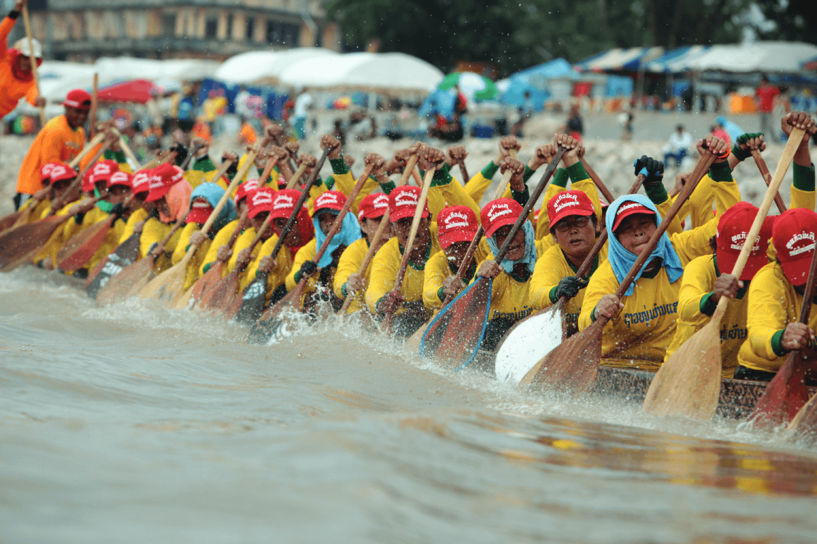  Step 1: Task delivering  - Teacher has Ss look at the picture.  - Ask Ss the questions in the book.  1. What can you see in the photos?  2. In which part of Viet Nam might the festival occur  Step 2: Task performance  - Ss’ observation  Step 3: Report and discussion  - Student’s talk  - Student’s answers  Step 4: Judgement  - Teacher elicits answers from Ss. This is an open activity, so accept all answers provided that they make sense. | 1: Work in pairs. Look at the picture and answer the following questions.  Suggested answers:  Various answers.
3. PRACTICE (5’-PW, GW)
a. Objectives:
- To help Ss develop the skill of listening for specific information.
- To help Ss further develop the skill of listening for specific information.
b. Content:
- Task 2: Listen to part of the programme “Charming Viet Nam”. Fill in each blank with no more than TWO words.
- Task 3: Listen again and tick T (True) or F (False).
c. Product:
- Ss can answer the questions correctly.
- Ss can develop the skill of listening for specific information.
d. Implementation:
* WHILE-LISTENING  Task 2: Listen to part of the programme “Charming Viet Nam”. Fill in each blank with no more than TWO words.  Step 1: Task delivering  - Teacher tells Ss that they are going to listen to part of the programme called “Charming Viet Nam”. In the programme, MC is introducing the Ok Om Bok Festival, a festival of the Khmer people.  Step 2: Task performance  - Ss’ observation  - T has Ss read the sentences first and guess the type of information and the part of speech for each blank.  - T encourages Ss to make as detailed guesses as possible.  - T writes their guesses on the board.  Step 3: Report and discussion  - T plays the recording and asks Ss to listen and complete each blank with no more than two words.  - Ss work in pairs to compare their answers.  - T has some Ss go to the board and write their answers.  Step 4: Judgement  - T confirms the correct answers.  - T has Ss listen again when needed.  Task 3: Listen again and tick T (True) or F (False).  Step 1: Task delivering  - Teacher asks Ss to look at the sentences and guess whether they are true or false.  - T writes their guesses on the board.  Step 2: Task performance  - Ss’ observation  - Teacher tells Ss that they are going to listen to part of the programme again and check their guesses.  Step 3: Report and discussion  - Teacher plays the recording and asks Ss to listen again and complete the task.  - Teacher asks for Ss’ answers to exercise 3.  Step 3: Report and discussion  - T confirms and ticks the correct answers. T plays the recording again when needed. | LISTENING  2: Listen to part of the programme “Charming Viet Nam”. Fill in each blank with no more than TWO words.  Answer key:  1. end  2. young rice  3. fashion shows  4. Race  3: Listen again and tick T (True) or F (False).  Answer key:  1. T  2. F  3. T  4. F
APPLICATION (15’-IW, PW, GW)
a. Objectives:
- To write an email to give advice on taking part in a traditional festival.
b. Content:
- Task 4: Work in groups. Read the following pieces of advice for tourists at the Ok Om Bok Festival. Put them in the correct column.
- Task 5: Write an email.
c. Product:
- Students can write an email correctly.
d. Implementation:
*POST-LISTENING WRITING  Task 4: Work in groups. Read the following pieces of advice for tourists at the Ok Om Bok Festival. Put them in the correct column.  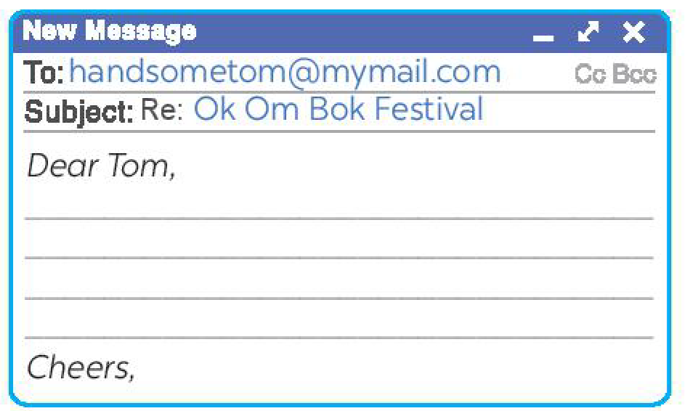  Step 1: Task delivering  - Teacher goes over the pieces of advice with the Ss.  - T makes sure Ss understand each piece of advice before moving on.  Step 2: Task performance  - Teacher has Ss work in groups to put the pieces of advice in the correct column.  - Teacher reminds Ss about the structure of an email.  Step 3: Report and discussion  - Teacher has Ss write their email individually based on their answers in Activity 4.  - T tells them that they don’t need to use all ideas in Activity 4.  - Teacher asks one student to write his or her email on the board.  Step 4: Judgement  - Ss and T comment on the email on the board.  - Then T collects some writings to correct at home.  - T comments on Ss’ answers.  * Home assignment  - T assigns the homework.  - Ss copy their homework.  - T explains it carefully | * WRITING  4: Work in groups. Read the following pieces of advice for tourists at the Ok Om Bok Festival. Put them in the correct column.  Answer key:  Dos: a, b, d  Don’ts: c, e, f  Suggested answers:  Dear Tom,  Glad to hear you are coming to Soc Trang. You can’t miss the Ok Om Bok Festival. Here are a few things for you to remember when joining the festival.  First, you should wear polite clothes when attending the Moon God offering ceremony. Always show respect to monks and elderly people. Remember to keep quiet when the monks and the elders are talking.  Besides, there are many animal statues in the temple ground. Don’t climb on them. The young rice represents the hope for luck in the new year. Don’t refuse when the elders give you some.  Send me an email if you need more information.  Warm regards,  * Home assignment  - Rewrite the email on the notebook.  - Prepare for Lesson 7 - Looking back & Project.

V. FEEDBACK:
With 8A …………………………..………………………………………………………………..…
With 8B …………………………………………...……………………………………..……………
With 8C ………………………………………………………………………………………….……

Period:41
UNIT 5: OUR CUSTOMS AND TRADITIONS
Lesson 7: Looking back - Project P₅₈₋₅₉
Class | Date of planning | Date of teaching | Attendence
8A | 05/11/2023 | 14/12/2023

I. OBJECTIVES: * By the end of this unit, students will be able to:
1. Knowledge:
+ Vocabulary: - Review the vocabulary and grammar of Unit 5
+ Language: - Apply what they have learnt (vocabulary and grammar) into practice through a project.
+ Pronunciation: Review
2. Competence:
a) General competencies:
- Develop communication skills and creativity.
- Be collaborative and supportive in pair work and teamwork.
- Actively join in class activities.
b) Specific competencies:
- Group work and independent working, pair work, linguistic competence, cooperative learning and communicative competence.
- Sts can introduce themselves or one another fluently
3. Qualities: - Be benevolent and responsible. Develop love for family. Ss have the good attitude to working in groups, individual work, pair work, cooperative learning.
II. PREPARATIONS
Teacher: Grade 8 textbook, laptop, TV, pictures and realia, Computer connected to the Internet. Phần mềm tương tác hoclieu.vn
Students: Text books, pencils, pics, blank papers, realia,….
III. PROCEDURE
1. WARM-UP (5’ - IW, PW)
. WARM-UP
a. Objectives:
- To help students revise the vocabulary items they have learnt in the unit
- To enhance students’ skills of cooperating with team mates.
b. Content:
- Review what Ss have learnt in Unit 5.
c. Product:
- Ss can remember the knowledge that they have learnt.
d. Implementation:
TEACHER’S AND STUDENTS’ ACTIVITIES | CONTENTS
BRAINSTORMING  Step 1: Task delivering  - Teacher asks Ss to think of what they have learnt already in Unit 5.  Step 2: Task performance  - Ss’ observation  - Ss work in pairs to do the task.  Step 3: Report and discussion  - Teacher calls some students to retell.  Step 4: Judgement  - Teacher confirms and leads them to do all the exercises in books.  - Teacher checks students’ pronunciation and gives feedback. | Suggested answers:  About festivals, customs, traditions, table manners, how to write an email, how to give advice….
2. KNOWLEDGE FORMATION (5’ - IW, PW)
a. Objectives:
- To help Ss revise the vocabulary items they have learnt in the unit.
- To help Ss revise the form of the vocabulary items they have learnt in the unit.
- To help Ss revise the use of articles at sentence and text level.
b. Content:
- Task 1: Choose the correct option to complete each sentence below.
- Task 2: Fill in each blank with the suitable form of the word given.
c. Product:
- Ss remember about the vocabulary items and their form.
d. Implementation:
Task 1: Choose the correct option to complete each sentence below.  Step 1: Task delivering  - Teacher has Ss do this activity individually.  - Complete each sentence.  Step 2: Task performance  - Ss’ observation  - Compare their answers with their partners.  Step 3: Report and discussion  - Teacher asks for Ss’ answers or asks one student to write his / her answer on the board.  Step 4: Judgement  - Teacher confirms the correct answers.  Task 2: Fill in each blank with the suitable form of the word given.  Step 1: Task delivering  - Teacher has Ss read the sentences.  - Identify the part of speech needed in each blank.  Step 2: Task performance  - Ss’ observation  - Ss do this exercise in pairs or individually.  - T tells Ss to pay attention to spelling of the words, too.  Step 3: Report and discussion  - Teacher invites some Ss to write their answers on the board.  - Student’s answers  Step 4: Judgement  - T and other Ss comment.  - T confirms the correct answers. | VOCABULARY REVISION  1: Choose the correct option to complete each sentence below.  Answer key:  1. B  2. A  3. A  4. B  5. B  2: Fill in each blank with the suitable form of the word given.  Answer key:  1. reunion  2. offerings  3. goers  4. traditional  5. worshipping
3. PRACTICE (10’ - IW, PW)
a. Objectives:
- To help Ss revise the vocabulary items they have learnt in the unit.
- To help Ss revise the form of the vocabulary items they have learnt in the unit.
- To help Ss revise the use of articles at sentence and text level.
b. Content:
- Task 3: Complete the sentences with a, an, the or Ø (zero article).
- Task 4: Complete the text with a, an, the or Ø (zero article).
c. Product:
- Ss remember about the vocabulary items and their form.
- Ss remember how to use the articles.
d. Implementation:
Task 3: Complete the sentences with a, an, the or Ø (zero article).  Step 1: Task delivering  - Teacher has Ss recall the use of a, an, the and zero article that they have learnt in the unit.  Step 2: Task performance  - Ss’ observation  - Teacher has Ss do this exercise individually.  Step 3: Report and discussion  - Compare their answers with a partner.  - T calls on some Ss to give the answers.  Step 4: Judgement  - T confirms the correct answers and writes them on the board.  Task 4: Complete the text with a, an, the or Ø (zero article).  Step 1: Task delivering  - Teacher tells Ss that they are going to complete a text about how to make children aware of customs and traditions.  - T tells Ss that they need to read the text carefully and fill in each blank with an appropriate article.  Step 2: Task performance  - Ss’ observation  - Ss do this exercise individually.  Step 3: Report and discussion  - Compare their sentences with a partner.  - Student’s answers  Step 4: Judgement  - Teacher invites some Ss to read their answers aloud. T gives feedback. | * GRAMMAR REVISION  3: Complete the sentences with a, an, the or Ø (zero article).  Answer key:  1. Ø  2. an  3. The  4. a  5. Ø  4: Complete the text with a, an, the or Ø (zero article).  Answer key:  1. Ø  2. a  3. Ø  4. the  5. an
4. APPLICATION (20’-IW, PW)
a. Objectives:
- To help Ss develop the skill of working in groups to do a project.
b. Content:
- Present the poster to the class.
c. Product:
- Students can read and understand general and specific information about Tet holiday.
d. Implementation:
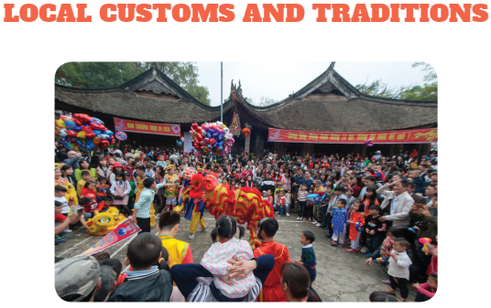  Step 1: Task delivering  - Ask Ss to read the instructions again (T has already assigned the project since the first lesson of the Unit and checked their progress after each lesson).  Step 2: Task performance  - Ss’ observation  - Student’s talk  Step 3: Report and discussion  Let students have some time to check their posters for the final time and make any adjustments if necessary.  - T has groups show their posters and present them to the class.  Step 4: Judgement  - T comments and gives feedback on Ss’ answers.  * Home assignment  - T assigns the homework.  - Ss copy their homework.  - T explains it carefully | * PROJECT  Local customs and traditions  Suggested outcome:  Students’ posters & presentations  * Home assignment  - Prepare for UNIT 6: GETTING STARTED  - Revise lesson at home
V. FEEDBACK:
With 8A …………………………..………………………………………………………………..…
With 8B …………………………………………...……………………………………..……………
With 8C ………………………………………………………………………………………….……

