UBND HUYỆN VĨNH BẢO  TRƯỜNG TH HIỆP HOÀ  (Đề đề xuất) | ĐỀ KHẢO SÁT CHẤT LƯỢNG HỌC KỲ II  MÔN TIẾNG ANH LỚP 3  NĂM HỌC 2023 – 2024  (Thời gian làm bài: 40 phút)
PART I: Listening
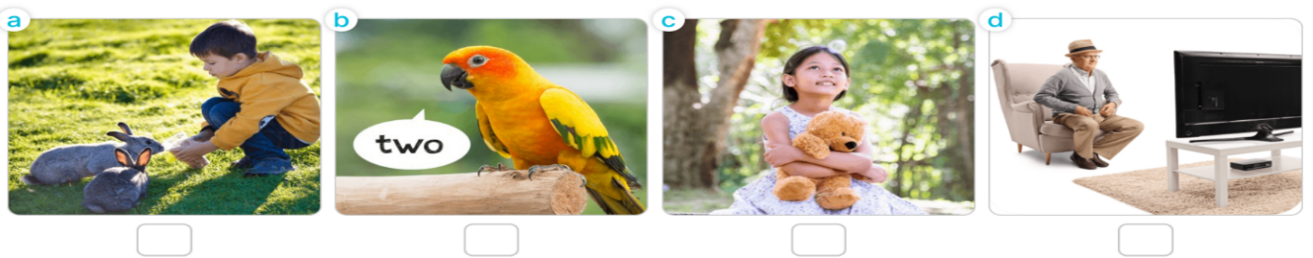
Question1 1: Listen and Number (1p)
Question 2: Listen and tick (1pt)
- 2
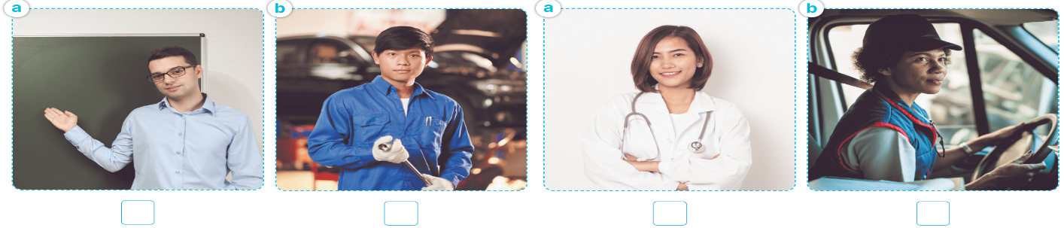
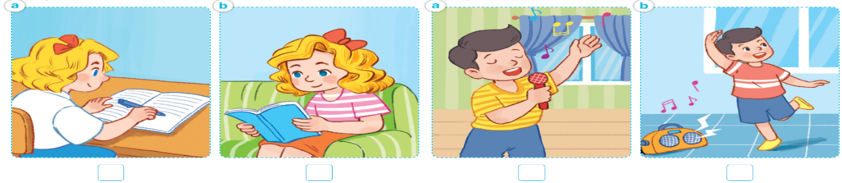
3 4
Question 3: Listen and complete (1p)

1. A: Who’s this?  B: It’s my _______________. | 2. A: What’s her job?  B: She’s a________________.
3. A: Where’s the ___________________?  B: It’s there. | 4. A: What would you like to ___________?  B: I’d like some milk, please.
PART II: Reading
Question 4: Odd one out (1.5p)
1. a. doctor b. job c. worker d. teacher
2. a. bedroom b. bathroom c. kitchen d. house
3. a. playing b. listen c. draw d. watch
4. a. dancing b. basketball c. reading d. singing
5. a. Where b. What c. picture d. Who
6. a. chairs b. bedroom c. tables d. lamps
Question 5: Choose the best answer (1.5p)
1. Do you have any birds? Yes, I ______________.
a.are b. am c. do d. don’t
2. How many ____________ do you have?
a. birds b. parrot c. dog d. cat
3. I ___________three dogs.
a. isn’t b. am c. have d. is
4. They are________________badminton.
a. playing b. doing c. singing d. running
5. What ___________he doing?
a. are b. am c. is d. does
6. What is she doing? She is _____
a. painting b. paint c. paints d. draw
Question 6: Read and tick T/F (1.5p)
Nam and his family are at the dining table. There is a lot of food and drinks on the table. His father and mother would like some rice, beans and some water. His sister would like some bread, meat and some milk. Nam would like some rice, fish and some juice.

 | T | F
1. Nam and his family are at the dining table.
2. There isn’t any food and drinks on the table.
3. His father would like some rice and fish.
4. His sister would like some bread, meat and milk.
5. His mother would like rice, beans and water.
6. Nam would like some rice, fish and lemonade.
Phần III: Writing
Question 7: Look at the pictures and write the words (1p)

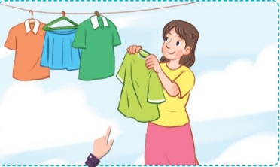  1.That’s my.......................................... |   2. My borther is ........................ years old.
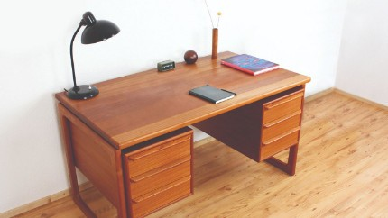  3. There’s .............................in the living room. | 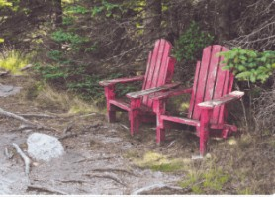  4. The chairs are.............................

Question 8: Arrange the words to make sentences (1.5p)
1. would / some / like/ juice / you?
____________________________________________
2. what / like / would / to / drink / you/?
____________________________________________
3. like / would / bread, / I / please / some.
____________________________________________
4. doing /the/ What’s /parrot/?
____________________________________________
5. see / four / a / I / peacock / and/ can / tigers. ____________________________________________
6. a / tiger / see /a / They/ can/ monkey/, /many/ and / peacocks.
____________________________________________________________

