UNIT 9: IN THE GROCERY STORE
Task 1:Look read and circle.
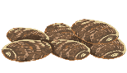


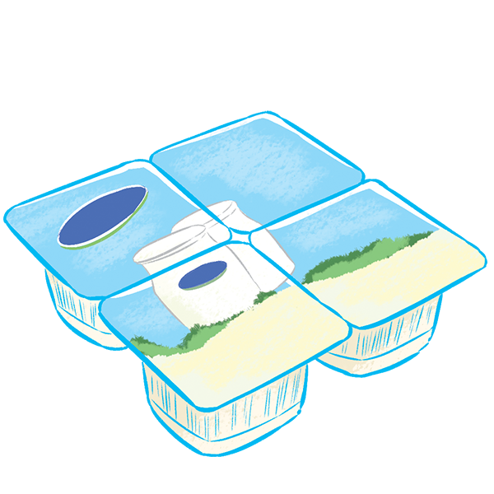

1. a. jam
b. yams
4.a. fox
b. top

3.a. yogurt
b. Chips
2.a. yo-yos
b. boxes

Task 2 : Leave one out.
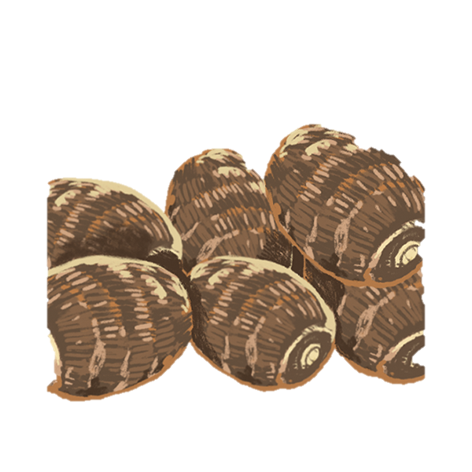
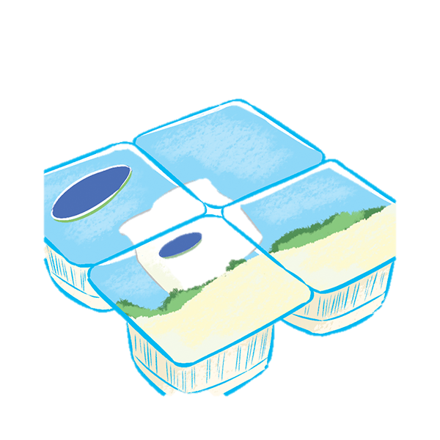

1. 2. 3.
YO-YBOS
YBAMS
CYOGURT



4. 5. 6
FTOP
AAPPLES
ORCANGES

Task 3: Look , read and draw lines.
I want some yams.

I want the jelly.

I want some lemons.
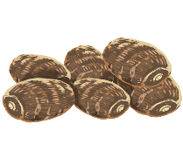

I want some tops.
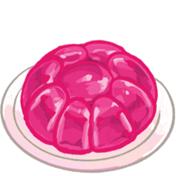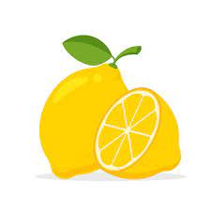
I want some yogurt.
I want some oranges.
I want some apples.
I want some yo-yos.

Task 4: Look, read and put a tick or r cross .


Hello, I’m Mai. I’m in the grocery store. I want……


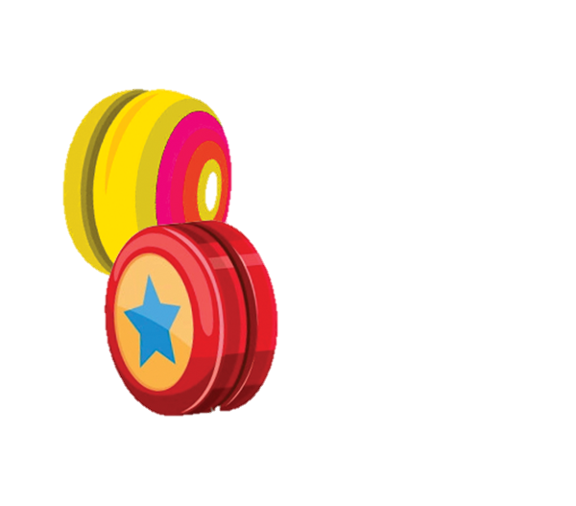

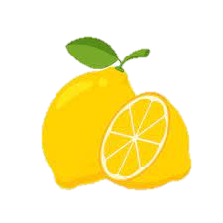

2. I want some oranges.

1. I want some yo- yos.

3. I want some yams.

4. I want some yogurt.

Task 5: Read and put the words in order.
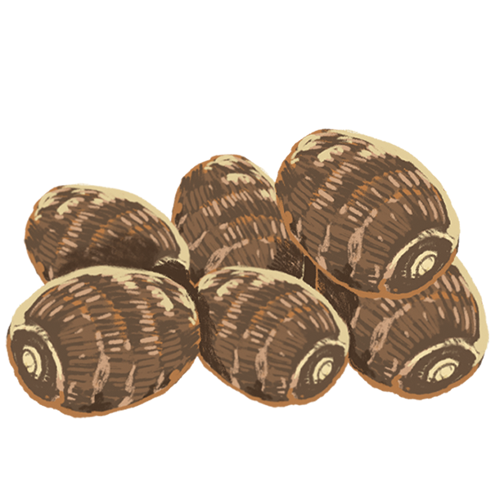 | 1. you /What /do/ yams./ want/ some /?/ I /want /  …………………………………………………
2. you/ want /What /do /?/ some /I /want / yogurt/.

………………………………………………….
3. want /? /What /do/ you/ yo-yos/./I /want /some/
………………………………………………….
 | 4. does/ she/ What /want/ ?/ some/ apples/ . /She /wants /  ………………………………………………….
 | 5. the /Can/ you /see/ oranges/? / I/ can/./Yes,/  ………………………………………………….
Task 6: Look , read and color the correct beginning letter of each word.

Y
L

MMm
L
PG
Y
O
P


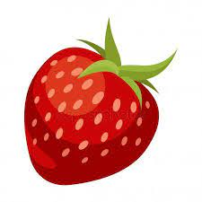

T
S
Z
Y
S
X
A
L

Task 7: Look , read and write.



4.………………
3.………………
2.………………
1………………

Task 8: Read and number
1.Can you see the strawberry?
2. I want some tops.
3. I want some apples.
4. I want some yams.
5. Can you see the yogurt?
6. Can you see some yo-yos?



c
b
a

1. 2. 3. 4. 5. 6.
f
e
d

UNIT 10: AT THE ZOO
Task 1: Look read and circle.
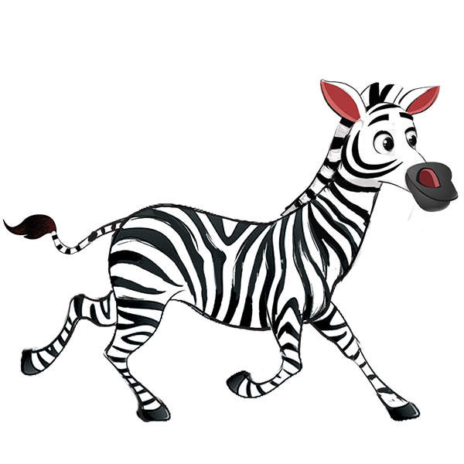
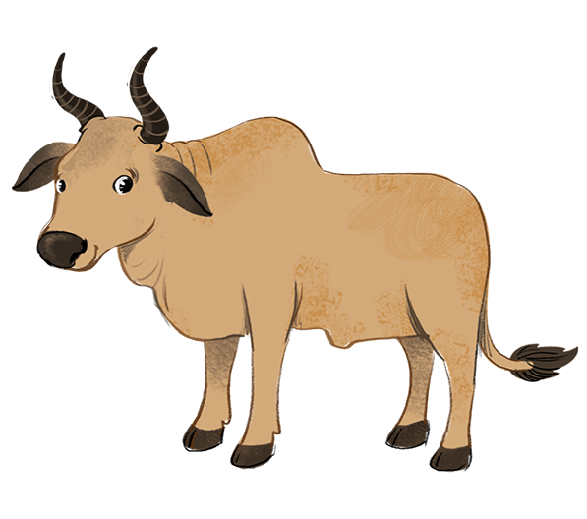
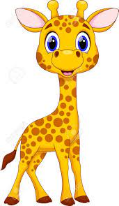
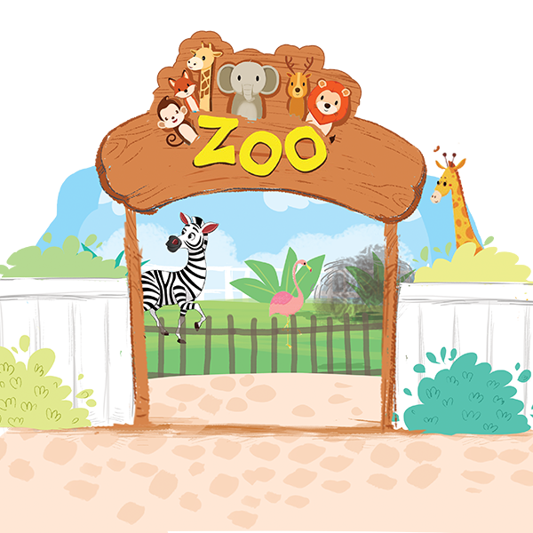

4.a. giraffe
b. duck

1. a. ox
b. zebra
3.a. zoo
b. store

2.a. zebu
b. fox

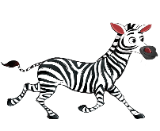
Task 2: Leave one out.
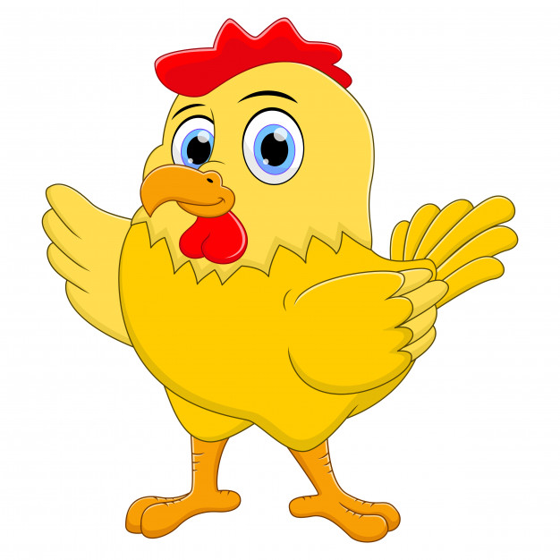
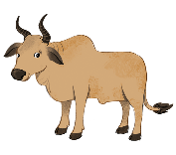

1. 2. 3.
vzebra
chficken
zebbu

4. 5. 6.
gmiraffe
zoyo

tiurtle

Task 3: Look , read and draw lines.
Do you like the zebu?

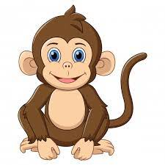
That’s a tiger.

Do you like the yogurt?

No, I don’t like zebra.

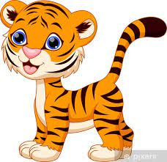

Do you like the monkey?

Can you see the yams?

I want some yo-yos.

We’re at the zoo.

Task 4: Look, read and complete
 |  |  |  | 
Ha | Mai | Tom | Alfie | Nick
 | 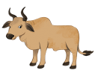 | 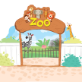 | 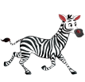
1. Do you like the ………………, Ha? Yes , I do.
2. Do you like the ………………, Mai? Yes , I do.
3. Do you like the ………………, Tom? No , I don’t.
.

4. Do you like the ………………, Alfie? No , I don’t.
.

5. Do you like the ………………, Nick? Yes , I do.
.

Task 5: Complete the sentences, then write the answers.



1
Do you like…………………… ? …………………

2
……………………………..….……………………………..….

33
……………………………..….……………………………..….

4
……………………………..….……………………………..….

Task 6: Find and circle the words.

astigerkl
avzebucv
ryzooui
fhzebramm

Task 7: Look , read and match. .

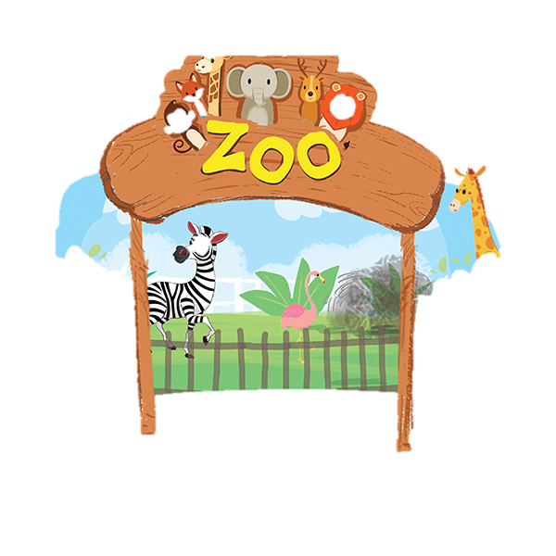

zebu
zebra
zoo
monkey

Task 8: Read and put the words in order.
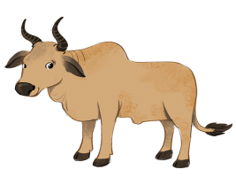 | 1. like / the / I / you / do. / zebu? / Yes, / Do  ……………………………..….……………………………..…
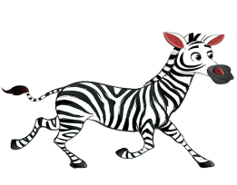 | 2. No, / the / zebra? / I / you / don’t. / like / Do  ……………………………..….……………………………..…
3. / tiger. / you / monkey? / I / the / Do / the / like / like / No,
……………………………..….……………………………..…
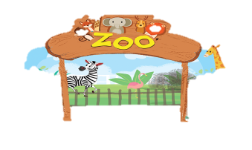 | 4. the / zoo. / We / at / / are  ……………………………..….……………………………..…

