UNIT 11: IN THE PLAYGROUND
Task 1: Khoanh vào đáp án đúng.

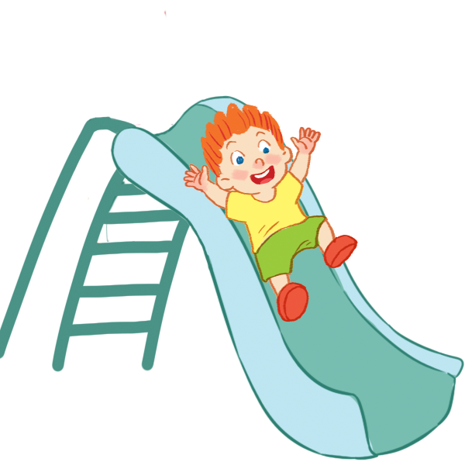
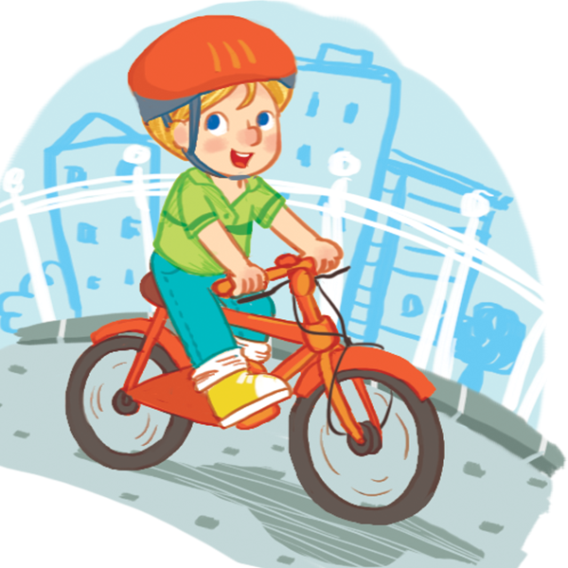
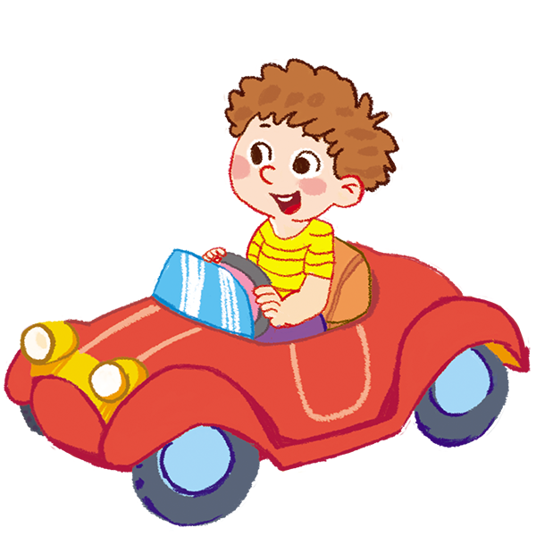

4.a.drawing
b. playing

3.a. singing
b. sliding

2.a. flying
b. riding

1.a. sailing
b. driving

Task 2: Bỏ chữ cái bị thừa

1. 2. 3.
riditng a bike
adriving
slidming


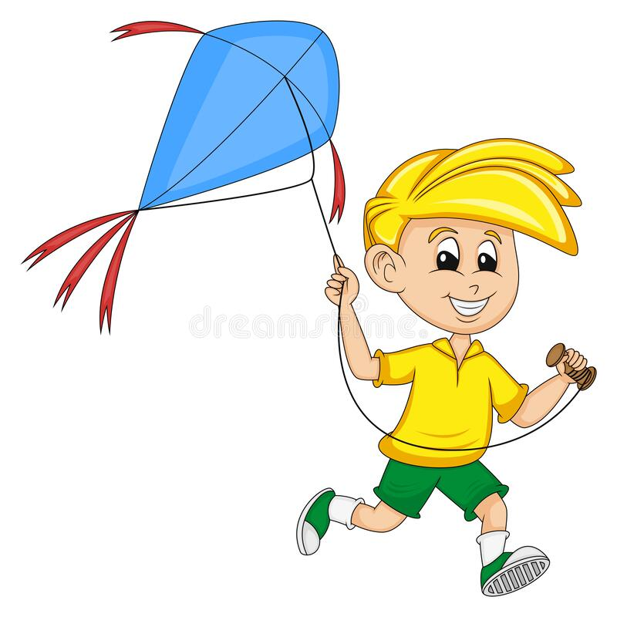

4. 5. 6
pnlaying with a dog

rdrawing

flyincg a kite

Task 3: Đọc và nối

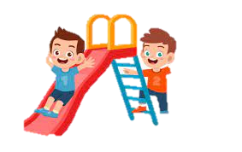
Flying kites.
1.They’re…………
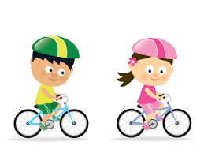
driving cars.
2. They’re ……………
riding bikes.

Sliding.
4. They’re…………
3. They’re
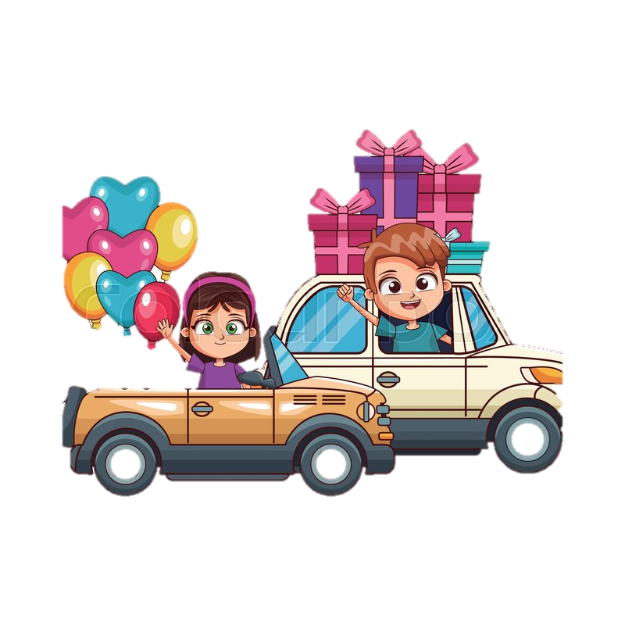


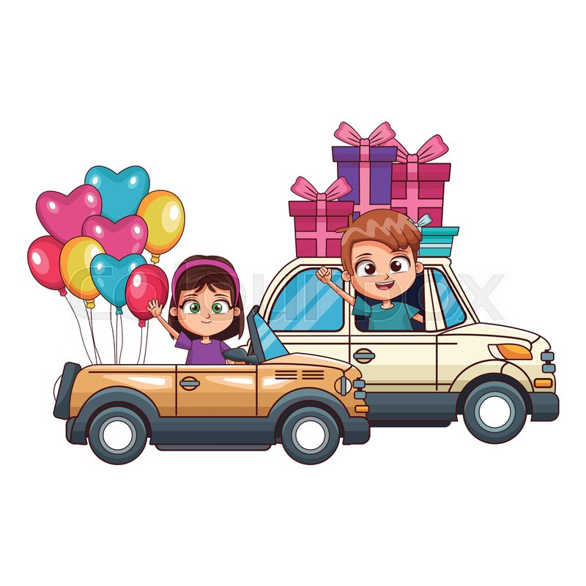

Task 4: Nối các câu với bức tranh đúng
They’re riding bikes.

They’re sliding.

They’re driving cars.

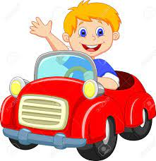
He’s flying a kite.

They’re flying kites.


He’s sliding.

He’s riding a bike.

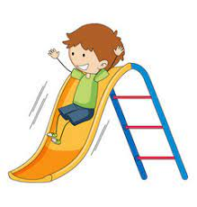
He’s driving a car.

Task 5 : Sắp xếp các câu sau
 | 1. They’re / kites. / flying /  ………………………………………………….
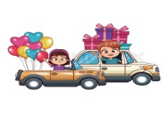 | 2. driving / cars. / They’re  ………………………………………………….
3. sliding. / are / / They
………………………………………………….
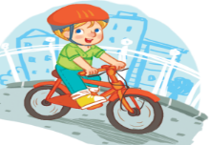 | 4. / bike. / He’s / a / riding  ………………………………………………….
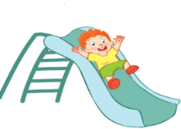 | 5. sliding. / / He’s  ………………………………………………….
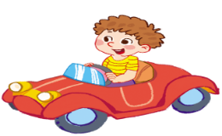 | 6. driving / / a / car. / He’s  ………………………………………………….
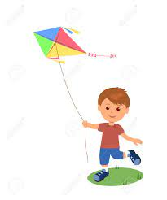 | 7. / a / He’s / kite. / flying  ………………………………………………….
8. bikes. / / They’re / riding
.………………………………………………….
Task 6: Đọc các câu bên dưới và điền câu vào chỗ trống.

c
b
a

f
e
d

e
- They’re sliding.
- He’s driving a car .
- They are flying kites.
- He’s flying a kite .
- He’s riding a bike .
- He’s sliding.

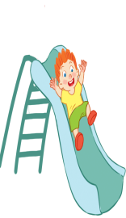  Sliding | 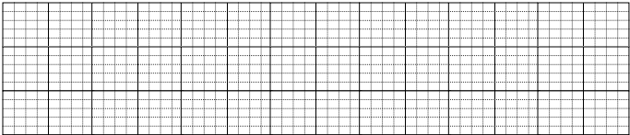
Riding a bike
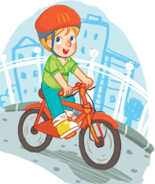

Driving
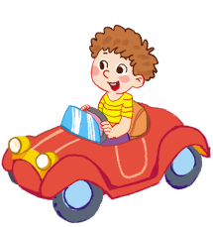

They’re driving .
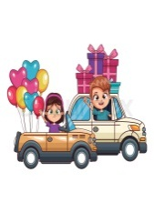

They’re sliding.

They’re riding.
.

UNIT 12: AT THE CAFÉ
EX1: Khoanh đáp án đúng

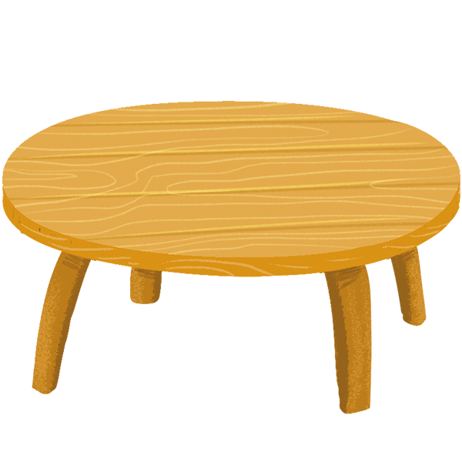
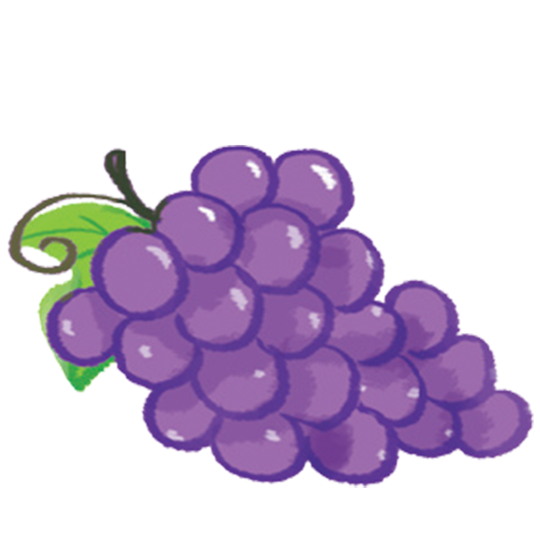


1.a. candy
b. cake
4.a. juice
b. banana

3.a. table
b. box

2.a. grapes
b. lemons

EX 2: Bỏ chữ cái bị thừa.
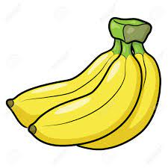

1. 2. 3.
grapaes
cafke
abananas
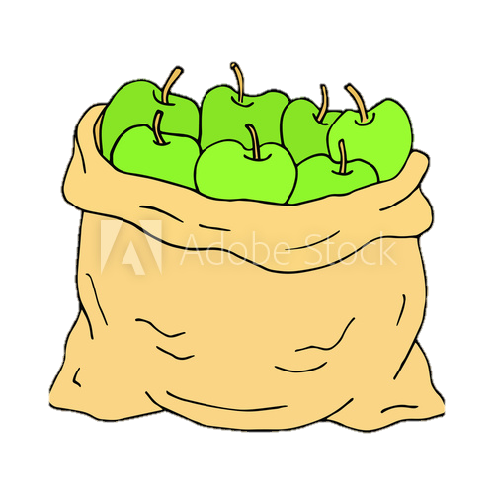
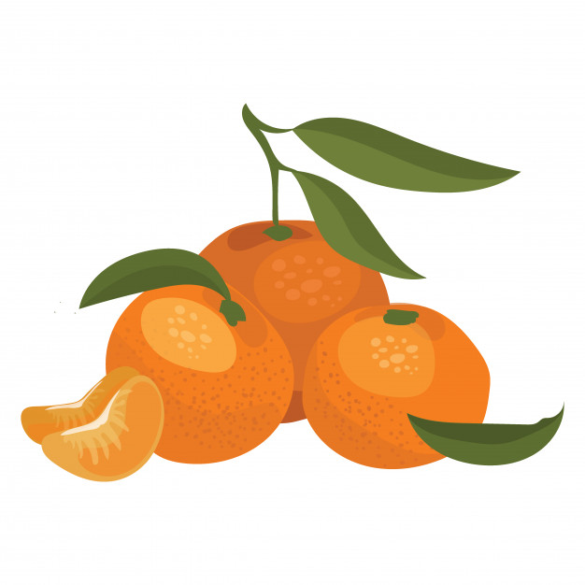

oyranges

4. 5. 6.
atpples

tabled

EX 3: tick câu đúng
1.a. Look at the grapes.
b. Look at the apples.
.
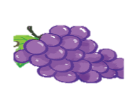
2.a. There is a table
b. There is a box.
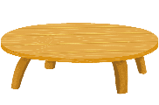
3.a. The oranges are on the table.
b. The bananas are on the table.
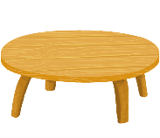
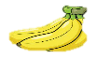

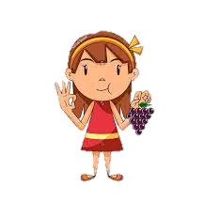
4.a. She’s having grapes .
b. He’s having grapes.

EX 4: Đọc và nối
The grapes are on the table.


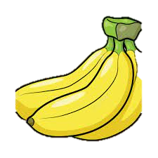
Look at the table.

He’s having a cake.

The cake is on the table.

She’s having grapes.
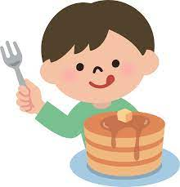
Look at the apples.

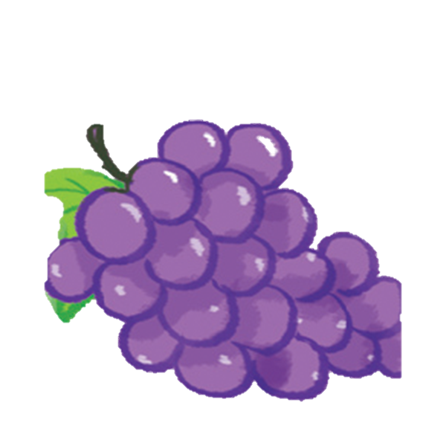

The bananas are on the table.

It’s a cake.

EX 5: Sắp xếp câu
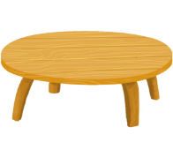 | 1. are / the / table. / grapes / The / on  …………………………………………………….
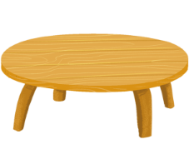 | 2. is / The / cake / the / table. / on  …………………………………………………….
3. the / at / Look / bananas.
…………………………………………………….
4. He / cake. / is / a / having

…………………………………………………….
5. having / is / Ha / / grapes.
…………………………………………………….
6. apples. / at / Look / the
…………………………………………………….
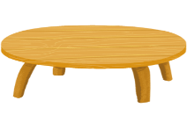  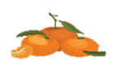 | 7. The / the / oranges / on / are / table.  …………………………………………………….
EX 6: Tìm câu phù hợp với bức tranh và điền vào ô trống

c
b
a

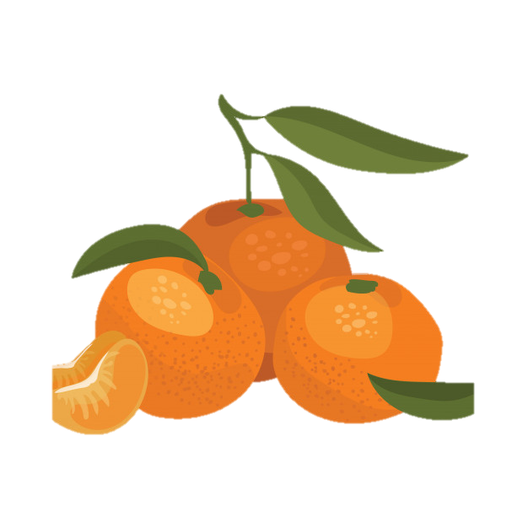
f
e
d

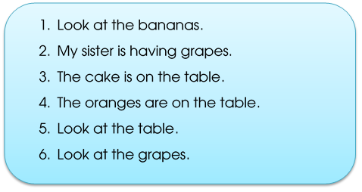

Grapes

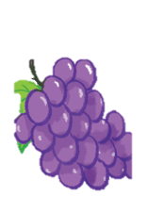
Cake
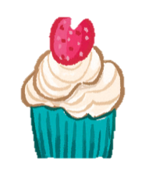

Table
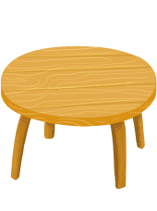

The grapes are on the table.

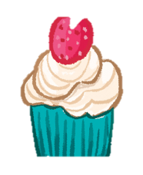
The cake is on the table.

The bananas are on the table.

.

