Class: 5

Period 60 Unit 9:Lesson 3 Activity 1-3

A. OBJECTIVES:
By the end of the lesson, Ss will be able to:
1. Knowledge:
- correctly pronounce the three-syllable words with the stress on the first syllable as in ˈcinema and ˈbakery in isolation and as in the sentences I was at the ˈcinema yesterday. and We were at the ˈbakery yesterday.
- identify the stress on some three-syllable words and circle the word with a different stress pattern from the other two words.
- say the chant with the correct word stress, rhythm, and pronunciation.
- Vocabulary: Review
- Skills: speaking, listening, reading and writing.
2. Competences:
- Communication and collaboration: work in pairs and groups to complete the learning tasks.
- Self-control and independent learning: perform pronunciation and listening tasks.
3. Attitude/ Qualities:
- Show their love and interest in doing free-time activities.
- Be friendly when doing activities with their friends.
B. TEACHING AIDS:
- Teacher: Teacher’s guide Pages 152, 153; audio Tracks 93, 94, 95; website hoclieu.vn, posters, laptop, pictures, textbook, lesson plan, TV or projector.
- Students: Students’ book Page 66, notebooks, workbooks, school things.
C. PROCEDURES:
Teacher’s activities | Students’ activities
1.Warm- up and review: (5’)  Sing: What did you do? (Track 92)  *Aims: to create a friendly and active atmosphere in the class to beginning the lesson.  *Procedure:  - - Show the song on the screen.  - Ask ss to listen, sing and dance the song.  - Say “Open your book page 66” and look at “Unit 9, Lesson 3 (1, 2, 3)”.  2. Presentation (9’)  Activity 1. Listen and repeat:  *Aims: Ss will be able to correctly pronounce the three-syllable words with the stress on the first syllable as in ꞌcinema and ꞌbakery in isolation and as in the sentences I was at the ꞌcinema yesterday. and We were at the ꞌbakery yesterday.  *Procedure:  - Have Ss point at the words ꞌcinema and ꞌbakery with the stress on the first syllable, in isolation and in the sentences I was at the ꞌcinema yesterday. and We were at the ꞌbakery yesterday.  - Play the recording for Ss to listen and repeat in chorus and individually until they feel confident.  - Let Ss work in pairs or groups, saying the words and reading the sentences.  - T invites some Ss to practice.  3.Practice: (17’)  Activity 2. Circle, listen and check.  *Aims: Ss will be able to identify the stress on some three-syllable words and circle the word with a different stress pattern from the other two words.  *Procedure:  - Tell Ss circle the word having a different stress from each line. Then listen to the recording to check their answers.  - Set a time for Ss to do the task.  - Play the recording, once or twice, for Ss to listen and check their answers.  - Get Ss to swap books with a partner and check their answers before checking as a class.  - Play the recording again for Ss to double-check their answers.  - Invite a few Ss to read aloud all the words in the words.  Key:  1. ꞌbakery 2. ꞌcinema 3. ꞌafternoon  Activity 3. Let’s chant  *Aims: Ss will be able to say the chant with the correct word stress, rhythm, and pronunciation.  *Procedure:  - Introduce the title and lyrics of the chant.  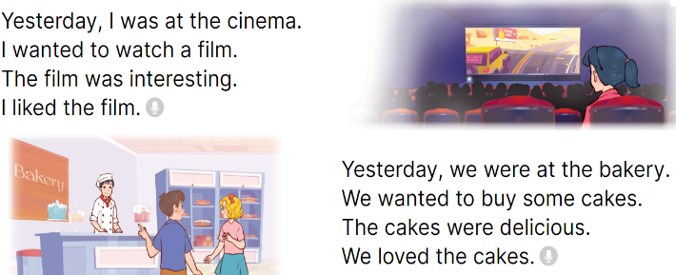  - Play the recording for Ss to listen to the whole chant.  + Have them repeat the title and lyrics line by line.  + Ask Ss to attend to three-syllable words with the stress on the first syllable in the chant, yesterday, cinema and interesting.  - Play the recording all the way through for Ss to listen to pronunciation and melody.  - Play the recording line by line for Ss to listen and repeat  - Play the recording for Ss to chant and clap along.  - Ask Ss to practice chant and clap along in pairs or groups.  - Invite groups to the front of the classroom to perform the chant  3. Fun corner and wrap- up (4’)  Game: Stand up - Sit down  - Tell ss how to play the game.  - Have five ss in each group take turns playing the game.  - Have ss listen to the words and stand up or sit down.  + If they hear the word with the stress on the first syllable, they will stand up.  + If they hear the word with the stress on the second syllable, they will sit down.  - Repeat the game until all the words are said. | - Ss sing and dance the song  - Ss open their books  - - Ss point and pay attention  - Ss listen to the recording again and repeat.  -Ss work in pairs and practice  -Ss say the words and sentences  - Ss pay and listen to the teacher’s explanation.  - Ss do the task  - Ss listen to the recording to check their answers (individual)  - Ss swap books with a partner and check the answers  - Ss listen to the recording again and check their answers again.  - Ss stand up and read aloud the words.  - Ss look and listen.  - Ss listen to the chant  - Ss listen and repeat line by line without clap their hands  - Ss note the rhythm and pronunciation.  -Ss listen to melody of the chant  - Ss listen and chant line by line.  - Ss chant and clap along.  - Ss work in groups (two groups) to chant  -Ss perform in front of the class.  -Ss listen  -Ss play the game  -Ss play the game

