UBND HUYỆN CÁT HẢI  TRƯỜNG TH NGUYỄN VĂN TRỖI |  | ĐỀ KIỂM TRA CUỐI HỌC KÌ II  Năm học: 2023 - 2024  Môn: Tiếng Anh 3 Thời gian 35 phút
 |  | Giám thị  ................................ | Giám khảo  ............................
I.LISTENING
Task 1. Listen and number . 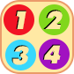

 |  |  | 
a. | b. | cbccc. | dcbccc.

Task 2. Listen and tick . 

 |  |  | 
1. | a. | b. | cbccc.
 | 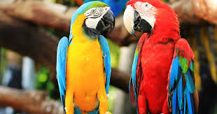 |  | 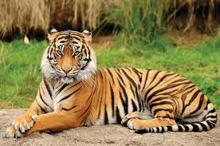
2. | a. | b. | cbccc.
II. READING AND WRITING
Task 1. Read and match.
0. What colour is you pen? | 0. c | a. I have three.
1. What can you see? | 1. | b. She’s listening to music.
2. Do you have any cats? | 2. | c. It’s yellow.
3. How many birds do you have? | 3. | d. I can see a tiger.
4. What’s she doing? | 4. | e. Yes, I do.

Task 2. Read and circle.
- ___________is Engish room?

- When b. What c. where

- He is playing football __________ the park.

- in b. on c. of

Task 3. Read the passage and tick  True or False. 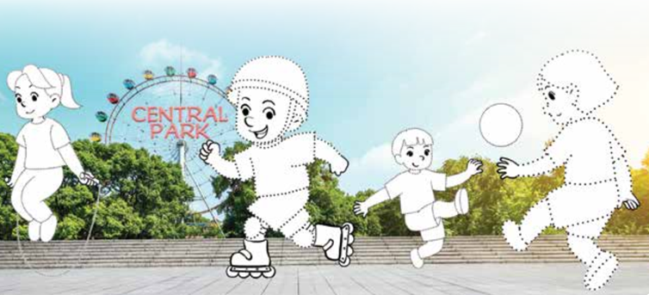
Mai | Tom | Phong | Linh
True | False
My name is Mai. I have three friends: Tom, Phong and Linh. We like sports and games. We are in the park now. I am skipping. Tom is skating. Phong and Linh are playing football.
- Mai has three friends.
- They don’t like sports.
- They are in the play ground now.
- Phong and Linh are playing football.
Task 4: Look and write.

1. A. What can you see?  B. I can see ________________ |   2. A. What is he doing?  B. He’s _______________________

Task 5. Reorder the words to make sentences
- singing / She / is / song. /a
She is singing a song ?
- do / have? / many / How / goldfish / you /
_______________________________________________________________
- am / I / playing / badminton /friends./ my / with
_______________________________________________________________
- see/ I /can /a/ tiger /and/ elephant./an
________________________________________________________________

