ĐỀ 1
PART I: Listening
Question 1. Listen and number (1pt)
a.  b. c. 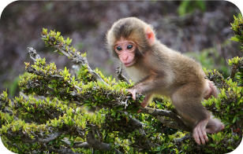 d. 

Question 2: Listen and tick (1pt)
1. a.  b.  | 3. a.  b. 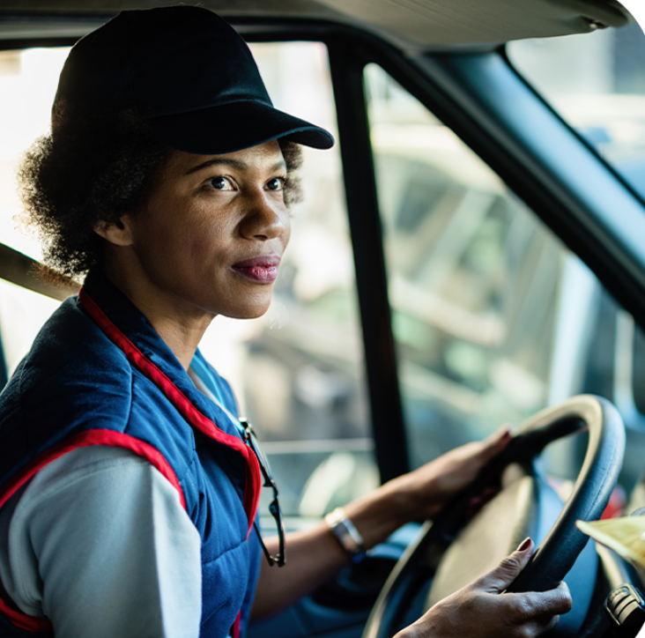
2. a.  b. 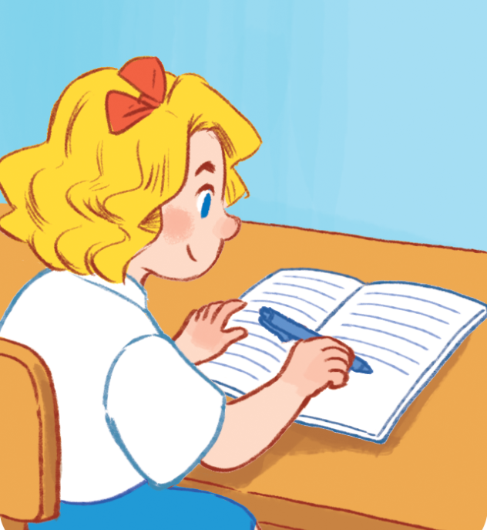 | 4. a.  b. 
Question 3. Listen and complete (1pt)
1. A: Who’s this?  B: It’s my …………................…... | 3. The ………………… is small.
2. A: Where’s the ………………………?  B: It’s there. | 4. A: What would you like to drink?  B: I’d like some ……………………, please.
Part II. Reading
Question 4. Odd one out (1.5pts)
- A. nurse B. farmer C. cooker D. driver
- A. job B. teacher C. driver D. doctor
- A. bedroom B. kitchen C. bathroom D. house
- A. table B. room C. chair D. lamp
- A. writing B. sing C. dancing D. listening
- A. morning B. reading C. playing D. cycling
Question 5. Choose the best answer (1.5pts)
- Mai _________singing.
A. is B. are C. am
- Is he skating?
A. No, he isn’t B. No, isn’t he C. No, he is
- What _________ she _______? – She’s dancing.
A. is/ do B. does/do C. is/ doing
- Do you have any cats?
A. Yes, I do B. Yes, you do C. Yes, I am
- I have ____________
A. two goldfishs B. two goldfish C. two goldfishes
- She _______ three rabbits.
A. have B. haves C. has
Question 6. Read and complete (1.5pts)
dining any drinks like rice some and
Nam and his family are at the (1) _________________ table. There is a lot of food and (2) _________________ on the table. His father and mother would (3) _________________ some rice, beans and some water. His sister would like (4) _________________ bread, meat and some (5) _________________ Nam would like some milk, fish (6)_________________ some juice.
PART III. WRITING
Question 7. Look at the picture and write the words (1pt)

1. This is my _________ 2. My brother is __________
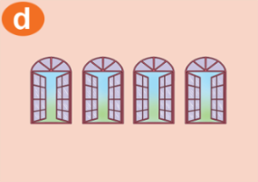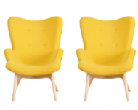
3. There are four ______________ 4. Two __________________
Question 8. Arrange these words to make the correct sentences (1.5pts)
1. to/ would/ what/ eat/ you/ like/?
_____________________________________________________________________________________
2. horse/ doing/ the/ is/ What/ ?/ .
_____________________________________________________________________________________
3. we/ can/ see/ elephant/ an/.
_____________________________________________________________________________________
4. likes/ my/ brother/ bread/.
_____________________________________________________________________________________
5. swinging/ the monkeys/ on/ are/ tree/ the/.
_____________________________________________________________________________________
6. a/ I’d/ orange/ and/ like/ banana/ an/ , please / .
_____________________________________________________________________________________

ĐÁP ÁN
UBND HUYỆN VĨNH BẢO  TRƯỜNG TIỂU HỌC  VĨNH AN | ĐỀ KHẢO SÁT CHẤT LƯỢNG HỌC KÌ 1  MÔN TIẾNG ANH LỚP 3  NĂM HỌC 2023 - 2024  (Thời gian làm bài : 40 phút)
PART I : Listening
Question 1: Listen and number (1pt)
4 câu x 0,25 = 1đ
1. d 2. b 3. a 4. c
Question 2: Listen and tick (1pt)
4 câu x 0,25 = 1đ
1. a 2. b 3. a 4. a
Question 3: Listen and write one word (1pt)
4 câu x 0,25 = 1đ
1. father 2. window 3. living room 4. milk
PART II : Pronunciation
Question 4: Odd one out (1,5đ)
6 câu x 0,25 = 1,5 đ
1. c 2. a 3. d 4. b 5. b 6. a
PART III : Reading
Question 5: Look and read: Choose the best answer (1,25pt)
6 câu x 0,25 = 1,5đ
- A 2. a 3. c 4. a 5. b 6. c
Question 6: Read and tick True/ False (1,25 pt)
6 câu x 0,25 = 1,5đ

1. dining room 2. Drinks 3. Like 4. Some 5. Rice 6. and
PART IV : Writing
Question 7: Look at the picture and write the word (1pt)
4 câu x 0,25 = 1đ
1. father 2. fifteen 3. windows 4. chairs
Question 8: Arrange the words to make sentenmces (1,5pt)
6 câu x 0,25 = 1,5đ
- What would you like to eat?
- What is the horse doing?
- We can see an elephant.
- The monkey are swinging on the tree
- What is the monkey doing?
- I’d like an orange and a banana, please.

