ĐỀ 1
PART I: LISTENING
Question 1: Listen and number. (1pt)
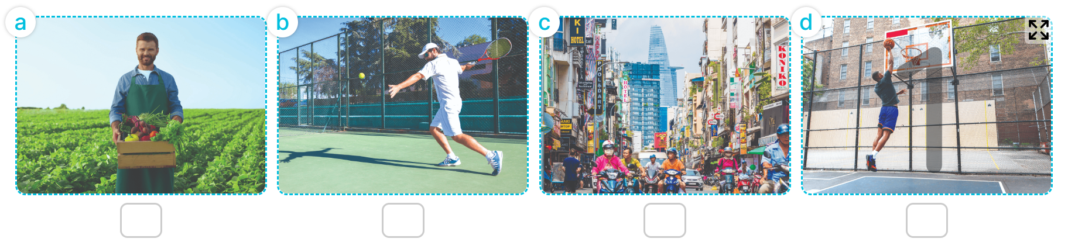
Question 2: Listen and tick or cross. (1pt)
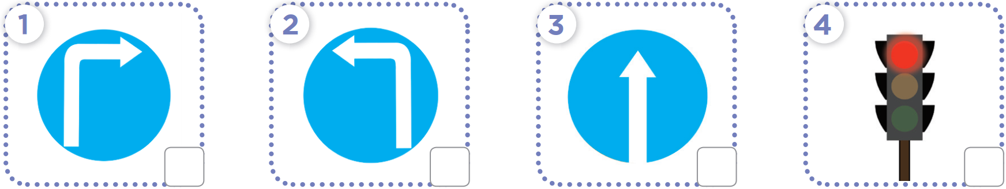

Question 3: Listen and write one word in each blank. (1pt)
1. The weather was ___________________ yesterday.
2. The weather was ___________________ last saturday
3. The weather was cloudy last ___________________
4. The weather was sunny in the ___________________ last Sunday.
PART II. READING
Questions 4: Circle the word which has the stressed syllable different from the rest ones (1,0pt)
1. a. email | b. village | c. visit | d. between
2. a. loudly | b. repeat | c. sunny | d. cloudy
3. a. city | b. invite | c. be come | d. return
4. a. behind | b. noisy | c. busy | d. loudly
Question 5: Odd one out. (1,25pts)
1. a. cook meals | b. watch films | c. do yoga | d. sports centre
2. a. merrily | b. roar | c. dance | d. run
3. a. story | b. build | c. tent | d. photo
4. a. crocodiles | b. hippos | c. animals | d. elephants
5. a. campfire | b. cinema | c. swimming pool | d. gym
Question 6: Choose the best answer. (1,25pts)
1. What does your…………………..._do? - She’s a farmer.
a. brother b. mother c. father d. uncle
2. My father is a worker. He works _.............................._______________
a. at a factory b. at a school c. at a nursing home d. at a school
3. What does he look like?
a. He has a long hair b. He has a round face
c. he has a big eyes d. He has slim and short.
4. Mai and I study at Sao Mai school. We are …………………………… _______________
a. a teacher b. a pupil c. pupils d. teachers
5. Is your grandmother tall?
a. Yes, he is b. No, he isn’t c. Yes, she does d. No, she isn’t
Question 7. Read and complete
garden | flat | weekends | quiet | Sundays
I live in a small (1)…………..with my parents. It is in Le Lai Street. The street is very busy. At the (2)_...................., I visit my grandparents. They live in a big house with a beautiful (3)…………… in a village. The village is (4)………………….and beautiful.
PART III: WRITING
Question 8: Look and write. (1pt)

 |  | 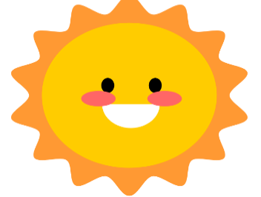 | 
I want to go to the __________________ | He’s_________________ | It’s ___________ | My mother works at a ……………..
Question 9: Arrange the words to make sentences. (1,5pts)
1. clean / floor / I / morning / the / in / the /./
_____________________________________________________________________________
2. a / she / housework / Sundays / lot / does / of / on /./
_______________________________________________________________________________
3. afternoon / What / you / in / do / do / the /?/
_______________________________________________________________________________
4. giraffes / long / these / have / necks / legs / and /./
_______________________________________________________________________________
5. loves / because / dance / Ben / peacocks / they / beautifully /./
______________________________________________________________________________
6. you / like / Why / do / lions /?/
_______________________________________________________________________________

PART I : Listening
Question 1: Listen and number (1pt)
4 câu x 0,25 = 1đ
1c 2a 3d 4b
Question 2: Listen and tick or cross (1pt)
4 câu x 0,25 = 1đ
1. V 2. X 3. V 4. x
Question 3: Listen and complete (1pt)
4 câu x 0,25 = 1đ
1 - windy 2 - rainy 3 - weekend 4 - countryside
PART II : Pronunciation
Question 4: Choose the words which have stress different from the others (1,0pt)
4 câu x 0,25 = 1,0 đ
1. d 2. b 3. a 4. a
PART III : Reading
Question 5: Odd one out (1,25pt)
5 câu x 0,25 = 1,25 đ
1. d 2. a 3. b 4. c 5. a
Question 6: Choose the best answer (1,25 pt)
5 câu x 0,25 = 1,25đ
- b 2. a 3. b 4. c 5. d
Question 7: Read and tick True/ False (1pt)
4 câu x 0,25 = 1 đ
- flat 2. Weekends 3. Garden 4. Quiet
PART IV : Writing
Question 8: Look at the picture and write the word (1pt)
4 câu x 0,25 = 1đ
1. supermarket 2. an actor 3. sunny 4. Nursing home.
Question 8: Arrange the words to make sentenmces (1,5pt)
6 câu x 0,25 = 1,5đ
- I clean the floor in the floor.
- She does a lot of housework on Sundays.
- What do you do in the afternoon?
- These giraffes have long necks and legs.
- Ben loves peacocks because they dance beautifully.
- Why do you like lions ?

