ANH 5 – ĐỀ 18
PART I: Listening
Question 1: Listen and number (1pt)
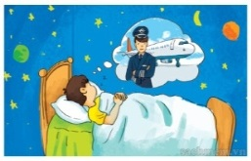  a) | 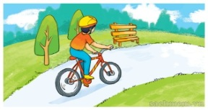  b) | 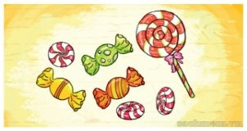  c) | 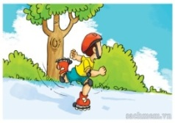  d)
Question 2: Listen and circle a, b or c (1pt)
1. Da Lat is more……………. than London
a. interesting b. exciting c. peaceful
2. Ha Long City is more ……………….. than Sydney.
a. beautiful b. wonderful c. exciting
3. New York City is more …………….. than Da Lat.
a. beautiful b. exciting c. expensive
4. London is more ……………….. than Da Lat.
a. peaceful b. beautiful c. exciting
Question 3: Listen and complete (1pt)
1. Quan has a …………………… He should go to the doctor now.
2. Tony ………………. feel well. He has a fever.
3. Phong can’t eat ……………………… because he has a bad toothache.
4. Mrs Green has a …………………..
PART II : Pronunciation
Question 4: Odd one out (1,5 pts)
- a. sunny b. rainy c. stormy d. weather
- a. head b. fever c. cough d. backache
- a. intelligent b. stupid c. clever d. good at
- a. yesterday b. last weekend c. tomorrow d. ago
- a. place b. temple c. pagoda d. museum
- a. driver b. nurse c. artist d. write
PART III: Reading
Question 5: Choose the best answer (1,0pt)
1. Mary ……………… to cook the cabbage yesterday.
a. to want b. want c. wants d. wanted
2. …………… shouldn’t play with the knife ……………. she may cut yourself.
a. Why/ because b. she/ with c. she/ because d. Why/ should
3. I’d like to visit Ngoc Son ……………….
a. Pagoda b. Temple c. City d. ancient Town
4. Ha Long Bay is ………………than Cat Ba island.
a. attractive b. attractiver c. more attractive d. more attractiver
5. Peter’s ………….his bike too fast.
a. riding b. ride c. to ride d. rides
6. ………… he run down the stairs?
a. Why b. Can c. Should d. Do
Question 6: Read and complete (1,25pt)
seasons | rainy | south | usually | favourite
My name is Quang. I am from Can Tho. It is in the (1)………….. of Viet Nam. But now I am living with my parents in Ho Chi Minh City. There are only two (2)…………. here. They are the dry season and the (3)………….. season. The dry season lasts from November to April. It is usually cool and dry in this time of the year. This is my (4)………………… season because I can go for a picnic with my friends. The rainy season lasts from May to October. It is (5)………….. hot and wet. There is a lot of wind too.
Question 7: Read and choose the best answer (1,25pt)
The Fox and the Crow
A long time ago, there was a fox and a crow. The crow stood on the roof of a house with a piece of meat it its beak. The hungry fox was standing on the ground. The fox asked the crow, “Can you give me some meat?” The crow shook its head. Then the fox asked, “Can you dance?” The crow shook its head. Then the fox asked, “Can you sing?” “Yes……” the crow opened his beak and said. He dropped the meat on the ground. The fox picked up the meat and said, “Ha Ha! Thanks for the meat.”
1. What kind is this story?
a. a fairy tale b. a funny story c. a short story d. a folk tale
2. Where was the fox standing?
a. On the roof b. On the ground c. in the house d. on the tree
3. Was the fox hungry?
a. Yes, he was b. Yes, he is c. Yes, he does d. Yes, he had some meat
4. Can the fox sing?
a. Yes, it is b. Yes, he can’t c. No, he can’t d. Yes, he can’t
5. What can the crow do?
a. He can dance b. He can talk c. He can sing d. He can draw.
PART IV: Writing
Question 8: Arrange the words to make sentences (1,25pt)
1. drink/ how/ you/ lemonade/ do/ much/? / everyday/
............................................................................................................................
2. usually/ is/ cool/ stormy/ and/ autumn/ the/. /
............................................................................................................................
3. winter/ like/ in/ is/ what/ country/ your/? /
............................................................................................................................
4. please./ chocolate, / a/ I’d/ bar/ like/ of/
............................................................................................................................
5. for/ picnic/ rainy/ it/ you/ can’t/ if/ is/ go/ a/. /
............................................................................................................................

