ANH 3- ĐỀ 18
PART I: Listening
Question 1: Listen and number (1pt
Question 2: Listen and tick (1pt)

1.a. b.  | 2.a. b. 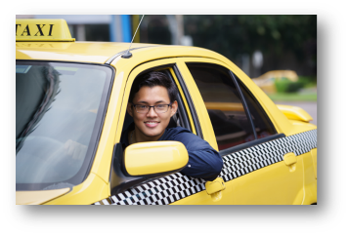
3. a 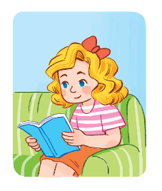b. 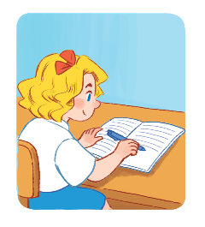 | 4. a. 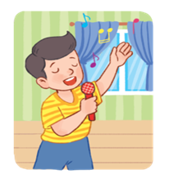 b. 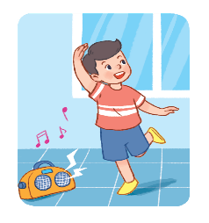
Question 3:Listen and complete (1pt)
1. My brother is ............................... years old
2. He is a ............................................
3. The .................................. are on the table.
4. Would you like some ............................?- Yes, please
II. Part 2: Reading
Question 4: Odd one out (1, 5pts)
1 | A: doctor | B: cook | C: nurse | D: farm
2 | A: writing | B: drawing | C: pictures | D: skating
3 | A: play | B: football | C: badminton | D: basketball
4 | A: table | B: chairs | C: lamp | D: room
5 | A: how | B: where | C: Is | D: what
6. | A: stand | B: count | C: sing | D: song
Question 5: Choose the best answer (1, 5pts)
1. Do you have ………………….. cats? – Yes, I do.
a. a b. some c. any
2. How many…………….. do you have? – I have three parrots.
a. a parrots b. parrots c. three parrots
3. What’s Linh doing? - ………. walking.
a. She’s b. She c. They are
4. Do you have two rabbits?
a. Yes, I don’t b. Yes, I am c. No. I have one rabbit.
5. He has some …………………..
a. goldfish b. goldfishs c. goldfishes
6. ………. Mai playing basketball?
a. Are b. Is c. Do
Question 6: Read and complete (1,5 pts)
dining | drinks | like | rice | some | milk
Nam and his friends are at the (1)……………… table. There is a lot of food and (2)………………… on the table. His father and mother would (3)…………… some rice, beans and some water. His sister would like (4)……………….. bread, meat and some (5)…………….. Nam would like some (6)………………., fish and some juice.
III. Part 3: Writing
Question 7:Look at the pictures and write the words (1pt)
1. There are ……………. people in my family.  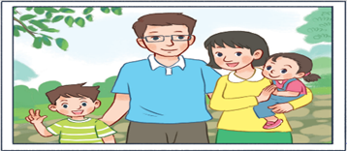 | 2. The …………………. are big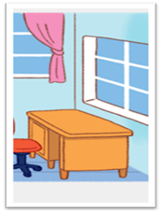
3.That’s my …………………….   | 4. This is my………………  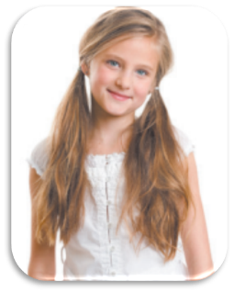

Question 8: Arrange the words to make sentences (1, 5pts)
1. like/ would/ to/ drink/ what/? / you/
……………………………………………………………………
2. beans/ like/ water, / I’d/ some/ please/ and/. /
…………………………………………………………………….
3. doing, / the/ what/ elephants/ Nam/ are/? /
……………………………………………………………………
4. some/ would/ lemonade/ like/ chicken/ I / and /.
……………………………………………………………………..
5. the/ at/ dancing/ zoo/ is/ peacock/ the/? /
……………………………………………………………………..
6. see/ you/ zoo/ what/ at/ can/ the/? /
…………………………………………………………………….

