ANH 3 – ĐỀ 11
PART I: Listening
Question 1: Listen and tick (1pt)
1. a.  | b. 
2. a. | b. 
3. a. 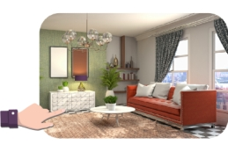 | b. 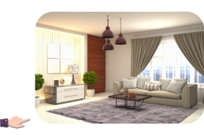
4. a.  | b. 
Question 2. Listen and number (1pt)
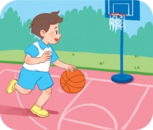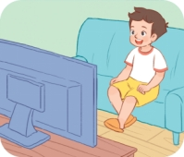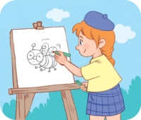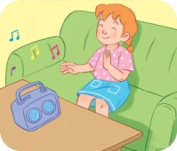
a. b. c. d.
Question 3. Listen and complete.(1 pt).
A. Come ............... , please !
Wow , I ………. your house !
B. Where’s your ……………….?
It’s....................
Part II : Reading
Question 4: Odd one out. (1.5pts)
1. | a. singer | b. doctor | c. mother | d. nurse
2. | a. father | b. sister | c. teacher | d. mother
3. | a. bathroom | b. bedroom | c. livingroom | d. library
4. | a. walking | b. running | c. swinging | d.park
5. | a. jobs | b. driver | c.singer | d.worker
6. | a. desk | b. chair | c. kitchen | d. bed
Question 5 : Choose the best answer (1.5 pt)
1. There are …… in the kitchen
A. a cat B . two cats C. three cat D. cat
2. Do you have any rabbits ? Yes , I …..
A. can B is C . do D. does
3. Mai and Quan ……… many toys
A. are B has C . have D. do
4 . What is he doing ? He’s …….. badminton.
A. play B . cycling C. playing D plays
5. The children are ….. a kite in the park.
A. playing B flying C listenning D working
6. What is your grandmother doing ? …….is cooking
A. She B. He C . her D. his
Part III : Writing
Question 6 : Write True (T) or False ( F) (1.5pt)
I’m Hung. I’m seven years old .I and my friends love pets very much. They have many pets. Nam has two dogs. Mary has three cats and one rabbit. Linh doesn’t have parrots, but she has five birds. Daisy and her brother have eight goldfish. I have four dogs and five goldfish.
(T) or ( F)
1. Hung and his friends love pets very much. ……….
2. Hung and his friends have many pets. ……….
3. Mary has three cats and three rabbits. ……….
4. Linh has parrots and five birds. ……….
5. Hung has four dogs and five goldfish. ……….
6. Hung is eight years old. ……….
Question 7 :Look at the pictures and write the words ( 1pt )

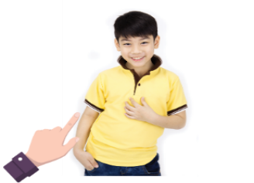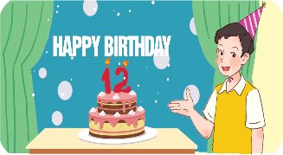
1 .This is my ……… 2. My ……………..is big 3. This is my ………… 4 . He’s ………… years old
Question 8 : Arrange the words to make sentences ( 1.5pt)
1 . window / is / The / big .………………………………………………………………………..
2. likes / TV / watching / Mary …………………………………………………………………
3. Can / see / you / bird / a ?………………………………………………………………………
4. you/ Do / like / milk / some ?……………………………………………………………………
5. don’t / I / like / beans / fish / and . ………………………………………………………….
6. monkey / is /The / climbing /tree/ the/in . …………………………………………………….
The end

