ANH 4- ĐỀ 11
PART I. LISTENING
Question 1. Listen and number (1pt)
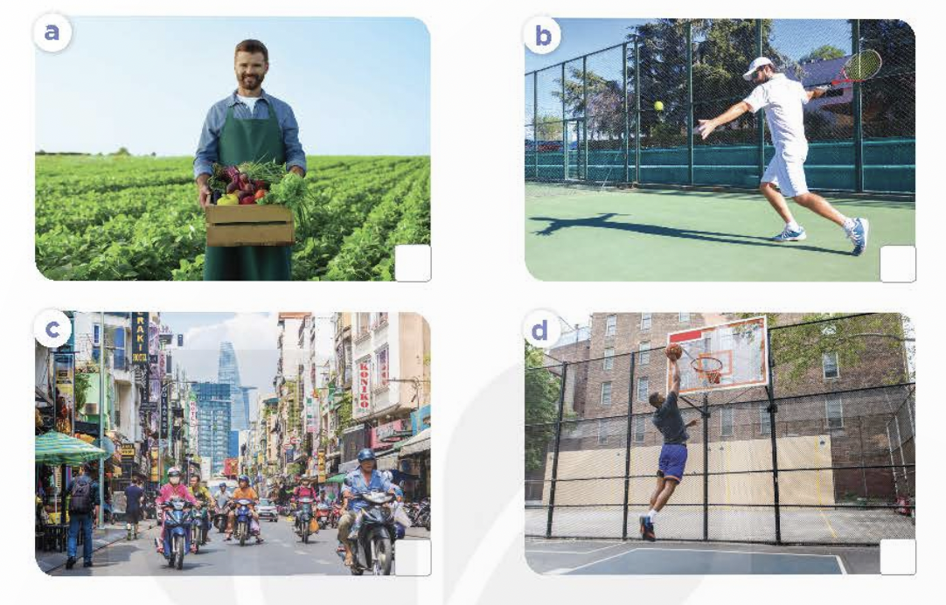
Question 2. Listen and tick (V) or cross (X) (1pt)
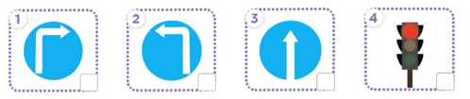
Question 3: Listen and complete. ( 1pt)
1. A: What was the weather like yesterday? B: It was …………….
2. A: What was the weather like last Saturday? B: It was …………….
3. A: What was the weather like last weekend? B: It was …………….
4. A: What was the weather like? B: It was …………….
PART II. PRONUNCIATION
Question 4. Circle the word which has different stress from the other words. (1pt)
- A. repeat B. invite C. sandals
- A. jumper B. enjoy C. trousers
- A. jacket B. complete C. begin
4. A. return B. monkey C. tiger
Question 5 :Odd one out ( 1.25pt)
A. beautifull B. hippo C. elephant D. monkey
A. shopping centr B. gym C. cinema D. father
A. run B. sing C. roar D. lion
A .watching TV B . swimming C. cooking D last weekend
A. merrily B. quickly C . roarly D . crocodile
Question 6 : Choose the best answer ( 1.25pt)
1. How____ people are there in your family?
A. many B. much C. any D. does
2.She’s ________ office worker.
A. is B. a C. an D. the
3.Is your mother a singer ?
A. Yes , it is B .No , she is C. Yes , she is D. No , he isn’t
4.What does he look like?
A. He's a worker. B . He’s a doctor C. He’s tall D. She’s cooker
5. How is your father , Mai ? He’s fifty years old.
A. old B. many C. often D. much
Question 7 : Read and complete
and | between | bookshop | pen | thousand
Ben is at the shopping centre.
Ben: Where’s the (1) ____________, please?
Shop assistant: It’s over there. It’s (2) ____________ the gift shop (3) ____________ the bakery.
Now, Ben is at the bookshop.
Ben: How much is this (4) _____________?
Shop assistant: It’s ten (5) ____________ dong.
Question 8 : Look at the pictures and write the words:
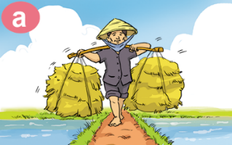 1. My father is a ………….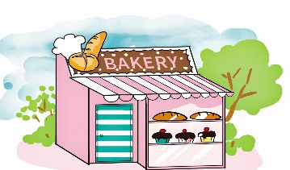3. This is a ……………
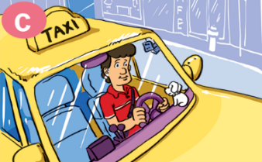2 . He is a……………….. 4. I go to the …………….
Question 9 :Arrange the words to make sentences:
1. does/ What / look /like / she ?
………………………………………………………………………………………….
2. watch / I / TV / the / in / morning .
………………………………………………………………………………………….
3. in/ what / do / do / the / you / afternoon ?
………………………………………………………………………………………..
4. you / Do / to /music /listen / in the evening ?
………………………………………………………………………………………
5. They /lions / are / monkeys /and .
…………………………………………………………………………………………..
6. Because / are / elephants / the / strong .
…………………………………………………………………………………………..
THE END

