ANH 5- Đề 11
Question 1. Listen and number (1pt)
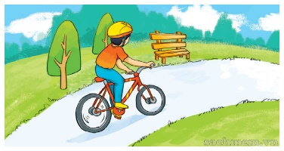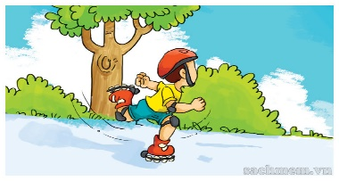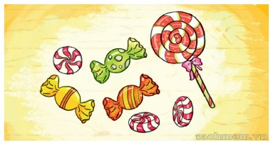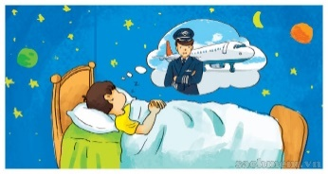
a b c d
Question 2. Listen and tick (1pt)
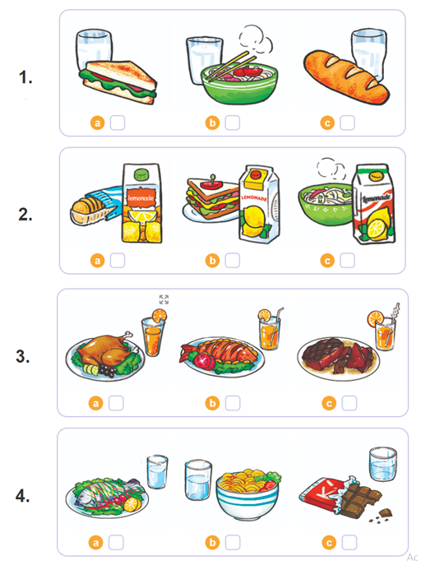Question 3 : Listen and complete (1pt)
1 . What would you like to be in the future? I'd like to be a (1)…………..
2. Where would you like to (2)………? I'd like to work in a (3)………….
3. Why would he like to be a teacher? Because he'd like to teach young (4)………...
Question 4:Circle the word which has pronounced differently.(1,5pts)
- a.learns b.stops c.cleans d.plays
- a.wanted b.looked c.brushed d.washed
- a.rulers b.pens c.players d.boxes
- a.cold b.old c.month d.go
- a.cooked b.listened c.played d.enjoyed
- a.photo b.son c.sold d.so
Question 5:Choose the best answer (1,5pt)
1. You shouldn’t play with the ………………….because you may get a burn.
a. motorbike b. stove c. helmet d. knife
2. A: Why shouldn’t he play with the knife? B: Because he may ………………………
a. cut out b. cut himself c. get a burn d. break his arm
3. ………………… ride your bike too fast!
a. Do b. Did c.Aren’t d. Don’t
4. Which place would Linda like ………….? Bai Dinh Pagoda
a. visitting b. to visit c. to be d. going
5. What …… you do yesterday ? I visited Tran Quoc Pagoda.
a. don’t b . did c . do d. does
6. What do you ……….. of Ha Long Bay? - It's more attractive than I expected.
a. get b. think c. do d. visit
Question 6: Choose the correct words and write them on the lines (1,25pt)
like |  | reading | Snow | Seven | free
Quan: What do you do in your (1)...................... time?
Linda: I read a lot. I like fairy tales.
Quan: I see. What are you (2).................. now?
Linda: (3)............ White and the (4)........... Dwarfs. What about you? Do you like fairy tales?
Quan: No, I don't. I (5)........................ reading stories.
Linda: What are you reading now?
Quan: A Halloween story.
Question 7 :Read and choose the best answer (1.25pt)
Hello. My name is Nam. My hobby is reading folk tales. Folk tales are usually short and interesting.I often read folk tales in my free time. I like The story of Mai An Tiem. AnTiem is hard - working. I love folk tales very much because each of them gives me a lesson in life.
1. What is his name?
A. My name is Nam B . His name is Nam C . Her name is Nam D . She is Nam
2. What does he do in his free time?
A. Watching TV B . Reading folk tales C . Listening to music D . Doing homework
3.What is An Tiem like?
A. hard – working B . gentle C. beautiful D. hotboy
4. How are Folk tales ?
A. good and short B . short and interesting C . interesting D. short and tall
5.Why does he love folk tales?
A. Because each of them gives me a lesson in life B.My hobby is reading folk tales
C. I often read folk tales in my free time D. Because folk tales are usually short
Question 8:Arrange the words to make sentences.(1,5pts)
1. would / you / eat. / What /like / eat / to
…………………………………………………………………………………………..
2. weather / will/ What / the / be/ like / tomorrow ?
…………………………………………………………………………………
3. like / I / would /bar / a / chocolate / please.
………………………………………………………………………………………
4. she / How much / does / water / everyday / drink ?
………………………………………………………………………………………..
5. more / It’s / expected / beautifull / I / than.
………………………………………………………………………………………

THE END

