ANH 3- ĐỀ SỐ 9
Question 1 : Listen and number (1pt)
a. 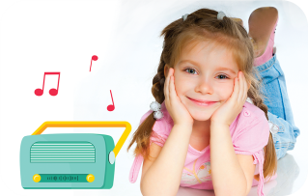 | b.  | c. 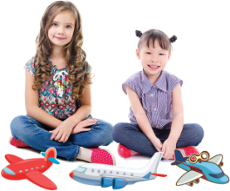 |  | d.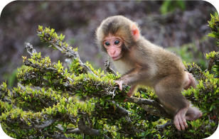
Question 2: Listen and tick (1pt)
1.   |  | 2.   | 
a. | b. | a. | b.

3.   |  | 4.  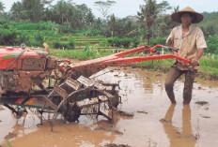 | 
a. | b. | a. | b.
Question 3. Listen and complete .(1 pt)
1. A: How old is your…………….?
B: He’s fourteen years old.
2. A: What’s his job?
B: He’s …………………..
3. A: Where are the .................?
B: They’re on the table.
4 . A: Would you like some ...............?
B: Yes, please.
Question 4: Odd one out (1,5 pt)
1. a. job | b. teacher | c. doctor | d.driver
2 a. bedroom | b. house | c. kitchen | d.bathroom
3.a chairs | b. lamp | c.book | d. table
4.a. morning | b. writing | c. dancing | d. reading
5. library | b. music room | c. art room | d. school
6. a. activity | b. draw | c. count | d. listen
Question 5. Choose the best answer (1.5pt)
1.Do you have..................cats?
a.some b. many c. a d. any
2..How mamy …………… do you have?
a. rabbit b. bird c . parrots d. dog
3. These are my........................
a. rabbit b. goldfish c . goldfishs d. dog
4. Is Nam singing? – Yes, he ……………………….
A is. b. does c. do d. isn’t
5. Nam is .............… a kite.
a. playing b. cycling c. flying d. skating
6. They............a lot of fun in the park.
a. are b. have c. is d. has
Question 6. Read and tick True or False(1,5 pt)
Linh and Lucy are my friends. They like toys. They have many toys. They have a train, a truck and three ships. They have two planes, too. How many toys do you have?

 | T | F
1. Linh and Linda are my friends.
2. Lucy likes toys
3. They have two trains.
4. They have three ships.
5. They have two trucks.
6. They have a lot of toys.

Question 7. Look and write (1 pt)

1.  | 2.  | 3. 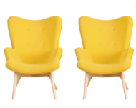 | 4. 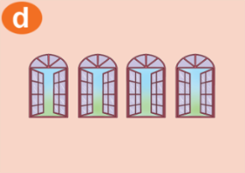
He' s .................. .. .. years old. | This is my ........................... | There are two new  .............................. | There are four  .....................

Question 8. Arrange the words to make sentences (1.5 pt)
1. you/to/ would / What/ like/ eat / ?/
________________________________________________________________________
2.would/I/some/chicken/like/please./
__________________________________________________________________________
3. What/the/is/elephant/doing/?/
__________________________________________________________________________
4. monkeys/two/climbing/tree/are/the/.
_________________________________________________________________________
5. zoo ?/ What/ you / at / can / the/ see/
__________________________________________________________________________
6.my/father/mother/my/and/like/would/some/beans/rice/water/some/and/. __________________________________________________________________________

