ANH 5- ĐỀ SỐ 9
Question 1: Listen and number (1pt)
a. 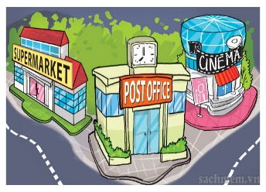 | b. 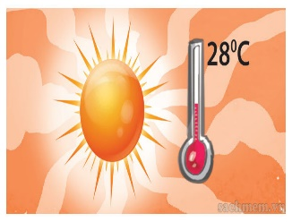 | c. 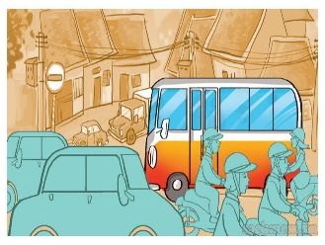 | d. 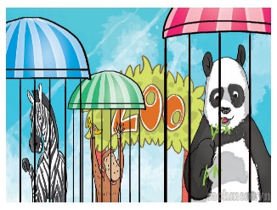

Question 2: Listen and tick the correct pictures. (1pt)
1. 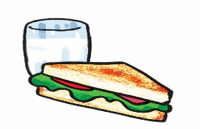 A | 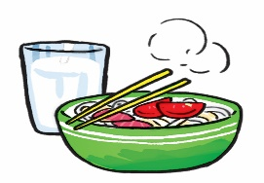 B | 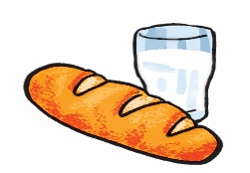 C
2. 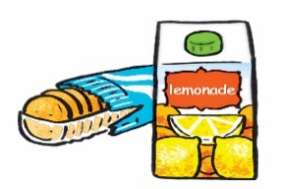 A | 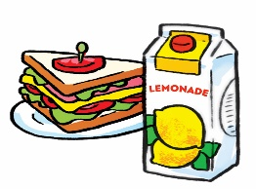 B | 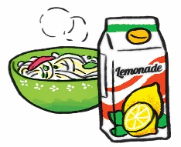 C
3. 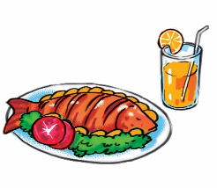 A | 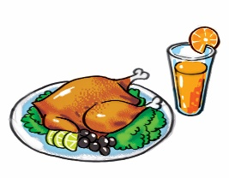 B | 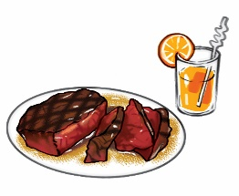 C
4. 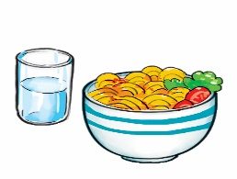 A | 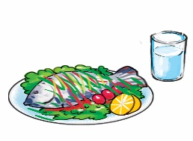 B | 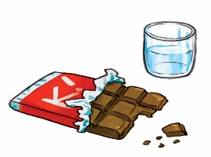 C
Question 3. Listen and complete .(1 pt)
1.Trung would like to be an ………………………..
2.Mai would like to be………………………………..
3.Tony would like to fly ………………………………
4.Tom would like to……………………………………
Question 4: Odd one out (1,5 pt)
1. a. future | b. writer | c. doctor | d. architect
2. a. summer | b. season | c. winter | d. autumn
3. a. headache | b. earache | c. stomach ache | d. temperature
4. a. place | b. park | c. museum | d. pagoda
5. a. boat | b. bus stop | c. coach | d. plane
6. a. bananas | b. sausages | c. rice | d. bottles
Question 5. Choose the best answer (1.5pt)
1. ................ride your bike too fast!
a. Do b. Don't c. Let's d. Does
2. What.............your father do in..................free time?.
a. do/your b. do/his c. does/his d . do/her
3.It's more..................than I expected.
a. small b. large c. attractive d. big
4. You shouldn't ...........down the stairs because you may fall.
a. see b. sit c. have d. run
5. I'd like to visit Thien Mu...............
a. pagoda b. park c. temple . d. bridge
6. The panda ............ very cute and did everything .......... .
a. was/ slowly b. were/ slowly c. are/ slowly d.is/ slowly
Question 6. Read and complete (1,25 pt)
weather watch forecast go stormy
Mai: Let's (1).............. for a picnic tomorrow.
Tony: What will the (2) ................... be like tomorrow?
Linda: Well, it will be cold and (3) .....................
Mai: How do you know that?
Linda: I watched the weather (4)..................... on TV.
Tony: We can't go for a picnic if it's stormy.
Mai: OK, let's stay home, eat popcorn and (5) .................... cartoons.
Tony and Linda: Great idea!
Question 7. Read and choose the best answer . (1,25 pt)
Hi, I'm Mai. My hobby is reading folk tales. Folk tales are usually short and interesting. They often give me one surprise after another. The characters are sometimes honest, sometimes greedy, sometimes wise, sometimes stupid. I like The Fox and the Crow very much. The fox was clever and the crow was not. The crow lost its delicious meat and the fox got it. I love folk tales very much because each of them gives me a lesson in life.
1.What kinds of stories does Mai like reading?
a. folk tales. b. fairy tales c. detective stories.
2.What does she think of folk tales?
a. They're usually long. b. They're usually short and interesting. c . They're short.
3. She thinks the characters are sometimes ............
a. hard-working b. kind c. greedy
4.Does she like The Fox and the Crow ?
a. I like The Fox and the Crow. b. Yes, she does. c. No, she doesn't.
5.Why does she love folk tales?
a. Because each of them gives her a lesson in life.
b. Because each of them gives her a gift in life.
c. Because each of them gives her a story in life.
Question 8. Arrange the words to make sentences (1.5 pt)
1. would/what/to/like/drink/you?
.............................................................................................................................................
2.like/I'd/biscuits/packet/of/a.
..................................................................................................................................................
3. bottles/how/do/you/of/every day/many/water/drink?
.....................................................................................................................................................
4. is/that/weather/for/forecast/tomorrow/the.
....................................................................................................................................................
5. winter/in/your/what/is/like/country?
..................................................................................................................................................
6.summer/I/because/like/are/there/lots/flowers/plants/of/and.
....................................................................................................................................................

