Name:………………………………………………… Class:………..
PART A: LISTENING
I. Listen and number the pictures from 1 to 4.
E
A
D
C
B
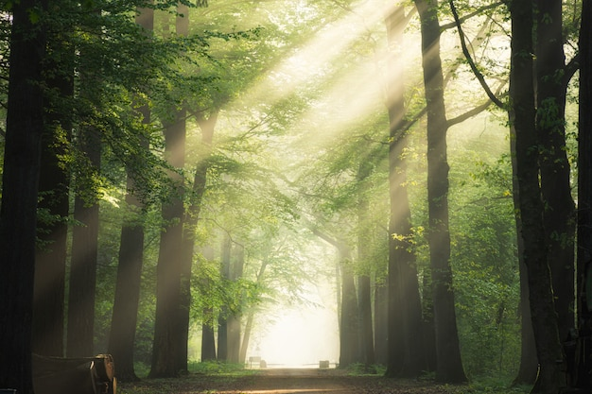

II. Listen and circle the correct answer.
5. Anna.… | A. finishes lessons at 7 a.m.  B. has lunch at school.  C. has lunch at 4 p.m at school.
6. Bob … | A. rides a bike on rainy days.  B. takes a bus on rainy days.  C. is off on rainy days.
7. Mia… | A. doesn’t do exercise.  B. gets up at 6.30.  C. does exercise in the morning.
8. Rosie……. | A. has history on Wednesdays.  B. has maths at 2 p.m.  C. has maths on Tuesdays.
PART B: READING & WRITING
I. Circle the one with different ending sound.
0. | A. plays | B. sings | C. works
9. | A. kisses | B. does | C. brushes
10. | A. sings | B. walks | C. wakes
II. Circle the word which is stressed differently.
0. | A. expensive | B. fantastic | C. funny
11. | A. projector | B. mother | C. banana
12. | A. computer | B. develop | C. favourite
13. | A. father | B. happy | C. fantastic
14. | A. fantastic | B. clever | C. friendly
II. Circle the best answer A, B , C or D to complete the sentences.
15. When you were nine years old, my favourite toys ___________ balls.
A. were | B. is
C. was | D. are
16. My favourite thing is my comic book. It is interesting ______________fun.
A. but | B. because
C. when | D. and
17. She sometimes __________ to art clubs after school.
A. go | B. goes | C. going | D. is going
18. Children don’t go to school __________ the weekend.
A. at | B. in | C. on | D. by
III. Look and match.
 | 19. What time do they start their lessons? |  |  | A. Yes, she does.
 | 20. What does she have at 8 p.m? |  |  | B. They start their lessons at 7 a.m.
 | 21. Does she often wash her bike? |  |  | - I go there by bus.
 | 22. How do you go to art clubs? |  |  | - She has maths lesson at 8 p.m.
 |  | 19. ______ | 20. ______ |  | 21. ______ | 22.___________
IV. Read and write T (True) or F (False).
This is my friend, Linda. She usually gets up at 6 in the morning. She always has breakfast with her parents at 6.30 a.m. She leaves the house at 7 a.m. and walks to the bus stop. She goes to school by bus. Linda starts her lessons at 8 a.m. Her mother always picks her up from school at 4 p.m. Sometimes they go to the supermarket. However, every Wednesday afternoon Linda goes to art clubs. In the evening, Linda often has dinner at 7 p.m. After dinner, she watches TV with her sister. She goes to bed at 10 p.m. at night. At the weekend she meets her friends and goes to the park.
23. Linda walks to school at 7 o’clock.
24. Linda finishes school at 5 o’clock.
25. Linda often has dinner at 7 p.m.
26. Linda’s sister watches TV after dinner.

