TRAN VAN ON PRIMARY SCHOOL  Ngày kiểm tra: ............................ | THE FIRST SEMESTER TEST: GRADE 3  School year: 2023-2024  Time: 35 minutes
Full name: ……………………………………………….. - Class: 3……..

Marks | Listening | Reading | Writing | Speaking | GV coi  (kí, ghi rõ họ tên) | GV chấm  (kí, ghi rõ họ tên)

Comment: ...........................................................................................................................................

PART I: LISTENING
Question 1 (1pt): Listen and tick. There is one example.
Example  0 | A  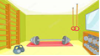 | B  
1 | A   | B  
2 | A  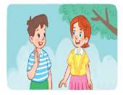 | B  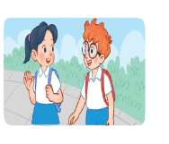
3 | A   | B  
4 | A   | B  

Question 2 (1 pt): Listen and draw lines . There is one example
4

1

2

0

3

A B C D E:
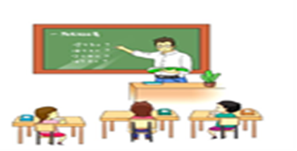 |  | 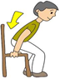 |  | 
Question 3 (1 pt): Listen and write. There is one example
0. A: Do you have an eraser?
B: Yes, I do.
1. A: Is ………………………….Mary?  B: Yes, it is. | 2. A: Is this our………………………?  B: Yes, it is.
3. A: How old are you?  B: I’m ……………………years old. | 4. A: Do you have a…………………?  B: Yes, I do.

PART II: READING (2.5pt)
Question 4 (0,75 pts): Read and circle the correct answer. There is one example.
0. A: What’s your hobby ?
B: I like _______.
D.
A.run B. cookking C. runing running
1. A: May I open the book ?
B: No, you_______.
A. can B. is C. can’t D. isn’t
2. A: Do you have a ruler ?
B: __________.
A. Yes, it is B. Yes, you can C. No, I don’t D. No, it isn’t
3. A: What colour is it ?
B: ______ red .
A. They’re B. It’s C. He’s D. She’s
Question 5 (1 pt): Read the paragraph and choose the correct answer to complete the sentences. There is one example.

Hello, (0) __my__ name is Minh . I’m eight years old. Welcome to our (1)_______. This is my (2)________. Here is the (3)_______ room. Now, let’s (4)_______ to the gym. We like our school very much.
B
0. A. your B. my C. his D. her
1. A. mouth B. book C. school D. ruler
2. A. classroom B. cooking C. orange D. running
3. A. school B. art C. playground D. park
4. A. go B. open C. touch D. hello
Question 6 (0.75 PT). Look and read. Put a tick TRUE or cross FALSE in the box. There is one example.
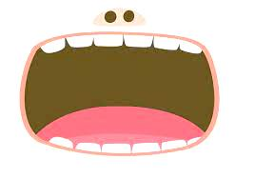 | 0. Open your mouth. | T
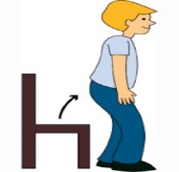 | 0.0. Sit down. | F
 | 1. I like playing badminton
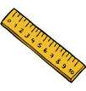 | 2. Do you have a ruler?  Yes, I do.
 | 3. My hobby is dancing.
PART III. WRITING (2.5 pt)
Question 7 (0.75 pt): Look at pictures and order the letter. There is one example.
 | 0. feca  → face
 | 1. smwinmig  → _ _ _ _ _ _ _ _
 | 2. esrare  → _ _ _ _ _ _
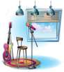 | 3. iumscorom  → _ _ _ _ _ _ _ _ _

Question 7 (1 pt). Look and complete. There is one example.
library
classroom
that
is
reading

Lucy: Hello, Nam. Is (0) that your classroom?
Nam: No, it isn’t. This is my classroom. Welcome to my (1) ……………….
Lucy: Great. Is that the (2)………………..?
Nam: Yes, it (3)………………...
Lucy: I like (4)……………………...Let’s go to the library.
Nam: Ok

Question 8 (0.75 pt): Reorder the words to make sentences. There is one example.
0. Hoa / am / I /.
-> I am Hoa.
1. is / your / hobby / What / ?
->______________________________________________________________?
2. you / a / Do / book / have / ?
->______________________________________________________________?
3. I / out / May / go /?
->______________________________________________________________?

-------------------------End-----------------------

