TRAN VAN ON PRIMARY SCHOOL  Ngày kiểm tra: ............................ | THE SECOND SEMESTER TEST: GRADE 3  School year: 2023-2024  Time: 35 minutes
Full name: ……………………………………………….. - Class: 3……..

Marks | Listening | Reading | Writing | Speaking | GV coi  (kí, ghi rõ họ tên) | GV chấm  (kí, ghi rõ họ tên)

Comment: .................................................................................................................................................

I. LISTENING
PART 1: Question 1 - 4: Listen and match. There is one example. (1 pt)

A.   | B.  | C. 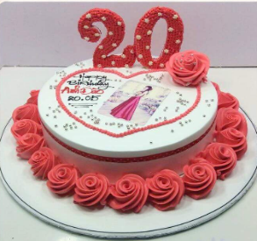 | D.  | E. 

3
2
0
4
1

PART 2: Question 1 - 4: Listen and number. There is one example. (1 pt)

  0 |   A. |   B. | 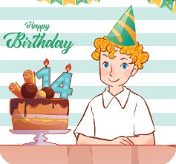  C. | 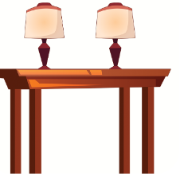  D.

PART 3: Question 1 - 4: Listen and tick. There is one example (1 pt)

0. A.  | B. 
1. A.  | B. 
2. A. 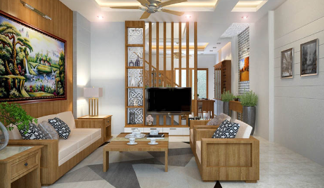 | B. 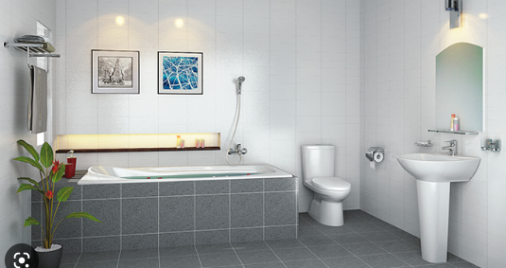
3. A.  | B. 
4. A.  | B. 

PART 4: Question 1 - 4: Listen and complete. There is one example. (1 pt)

0. Who’s this? - It’s my sister.

1. How old is she? – She is…………………

2. Where are the ……………….? – They’re in the living room.

3. How many parrots do you have? - I have ……………….

4. What are you doing? - I’m playing………………………
II. READING
PART 1: Question 1- 4: Look, read and circle the correct answer. There is one example. (1 pt)
0. A: How old are you?  B: I’m……....….years old.  a  a. eighteen b. nineteen c. ten | 
1. A: What’s her job?  B: She’s a………….  a. dancer b. singer c. singing | 
2. A: Where are the books?  B: They’re…………the table.  a. on b. in c. there | 
3. A: How many rabbits do you have?  B: I have…………..  a. many b. some c. any | 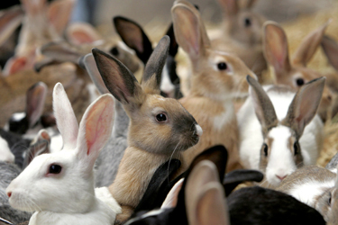
4. What are you doing?  B: I’m………………a picture.  a. paint b. painting c. paints | 

PART 2: Question 1- 4: Read and complete. There is one example (1 pt)

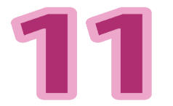  eleven | bedroom   | lamp  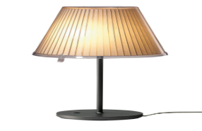 | on  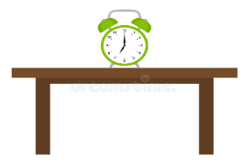 | house  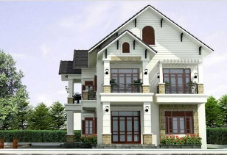

Hello, everyone. My name is Lucy. I’m (0) eleven years old. There are three bedrooms in my (1)……………... There is a (2)…………….. in each bedroom. My (3)……………... is very big. There is a bed and a desk in my bedroom. There is a clock (4)………….the desk.
III. WRITING
PART 1: Question 1- 3: Look at the picture and complete the sentences. There is one example. (0,75 pt)
0. I’m twelve years old. | 
1. My mother is a doctor and my father is a…………… | 
2. I’d like some………………, please. | 
3. What is she doing?  She is playing ……………. | 

PART 2: Question 1- 3: Reorder the words to make a correct sentence. There is one example. (0,75 pt)

0. Hoa / My / is/ name. => My name is Hoa.
1. room. / in the / There / two tables / are /

=> ………………………………….…….

2. do / How many / you / goldfish / have? /

=> ………………….……………..… …..

3. playing / I’m / my friend. / chess / with /

=> …………………….…………..… …..

PART 3: Question 1- 2: Order the letters. There is one example. (0,5 pt)

 | 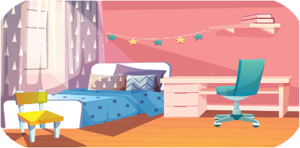 | 
0. t c e h a e r | 1. b r o e d o m | 2. k u c t r
=> teacher | =>…………….. | =>……………..

IV. SPEAKING (2,0 points)

