TRAN VAN ON PRIMARY SCHOOL  Ngày kiểm tra: ............................ | THE FIRST SEMESTER TEST: GRADE 5  School year: 2023-2024  Time: 35 minutes
Full name: ……………………………………………….. - Class: 5……..

Marks | Listening | Reading | Writing | Speaking | GV coi  (kí, ghi rõ họ tên) | GV chấm  (kí, ghi rõ họ tên)

Comment: .............................................................................................................................................

LISTENING
Part 1. Questions 1-4. Listen and match. There is an example. (1pt)
Example: You hear: 0. “I read a book every Sunday”. The answer is: C
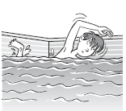 | 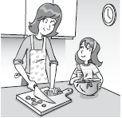 |  |  | 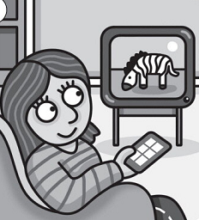 | 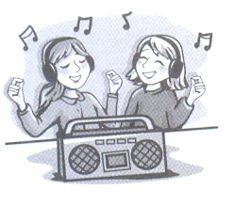
A | B | C | D | E | F
4
0
1
2
3

Part 2. Questions 5-7. Listen and tick (√) A, B or C. There is an example. (0.75pt)
Example: You hear: 0. What do you do after school?
In your test paper you see:
A. I visit my grandma every Sunday. |  | √
B. I don’t watch TV every Sunday.
C. I go swimming every Sunday.
The answer is (A) (I visit my grandma every Sunday.) So you tick A
5. ______________?
A. We like maths.
B. We haven’t got maths on Monday.
C. We’ve got maths.
6. ______________?
A. He doesn’t like balloons.
B. She likes nuts and chocolate.
C. I like nuts and chocolate.
7. ______________?
A. There are three computers.
B. There is a computer.
C. There are three computer rooms.
Part 3. Questions 8-10. Listen and write. There is an example. (0.75pt)
0. Nam can ride a bike.
8. She ………………………at six o’clock.
9. He……….. got maths on Monday
10. It’s raining. You should take ……………
READING
Part 1. Questions 1-3. Look and read. Write the correct words. There is an example. (0.75pt)
 |  | 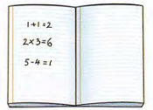 |  | 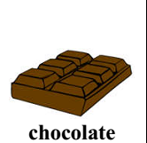 |  | 
 | 0. People use it to add flavour to cakes or eat it as a sweet. |  |  |  | chocolate
 | 1. You often paint and draw the pictures in there. |  |  |  | ..................
 | 2. It’s a thing that you often get on your birthday. |  |  |  | .................
 | 3. It’s a lesson that you learn about the numbers. |  |  |  | .................
Part 2. Questions 4-6. Read and circle. There is an example. (0.75pt)
0. What do you do after school?
A. I do my homework. B. I watches TV. C. I visit grandma.
4. What have we got on Friday?
A. We’ve got a Vietnamese. B. She’s got science.
C. We’ve got Vietnamese.
5. Can you play football on Thursday?
A. No, I can’t. B. Yes, I can. I like tennis.
C. I like playing football.
6. …….. does your mum do in the evening?
- She goes home, then she cooks dinner.
A. When B. What C. Where
Part 3. Questions 7-10. Read and tick (√) True or False. There is an example. (1pt)
Hi! I’m Luke. I like sport and art. On Monday, I play badminton with my dad. On Wednesday, I have an art lesson after school. After my art lesson, I visit my grandma. On Friday, I do my homework. Then I write emails. On Sunday, I play football in the park with my friends.
 |  |  | TRUE | FALSE
0. | Luke likes sport and art. |  | √
1. | On Monday, he plays badminton with his dad.
2. | On Wednesday, he has an art lesson after school.
3. | After his art lesson, he visits his grandpa.
4. | On Sunday, he plays badminton with his friends.
WRITING
Part 1. Questions 1- 4. Look at the pictures and write. There is an example. (1pt)
Example:
0. I play football on Saturday afternoon.
1. On Friday after school, I ...................... |  | 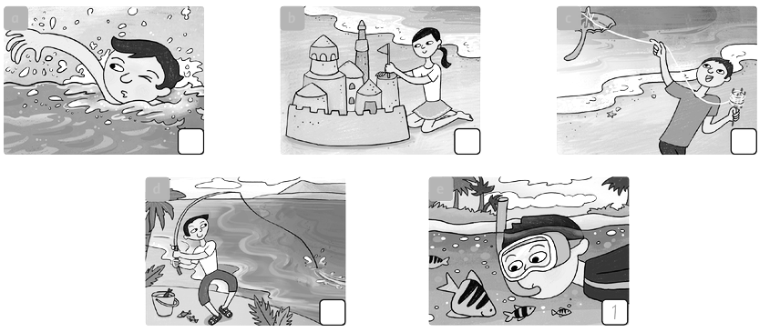
2. She doesn’t like ................... |  | 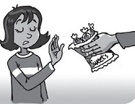
3. He ………………… PE on Thursday. |  | 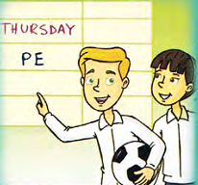
4. I go to school ………………………… |  | 

Part 2. Questions 5–8. Reorder the words to make a correct sentence. There is an example. (1pt)
0. up?/ you/ What/ do/ get/ time
=> What time do you get up?
5. basketball / boys / The / don’t / like /.
=>..............................................................................................
6. card/ a / for/ mum!/ Make/ your
=>..............................................................................................
7. her/ Rosy/ visits/ grandma/ Sunday./ and / Saturday /on
=>.............................................................................................
8. On/ after/TV/ I/ Friday,/ school./ watch
=>..............................................................................................
Part 3. Questions 9- 10. Answer about you. (0.5pt)
9. What do you do after school?
.............................................................................................................
10. What’s the weather like today?
.............................................................................................................
___________________________________

