UBND QUẬN HỒNG BÀNG
TRƯỜNG TIỂU HỌC TRẦN VĂN ƠN

ĐÁP ÁN BÀI KIỂM TRA HỌC KÌ II: MÔN TIẾNG ANH LỚP 5
NĂM HỌC 2023-2024

LISTENING
Part 1. Questions 1 - 4. Listen and match. There is an example. (1pt)
Mỗi câu đúng được 0.25 điểm
- My sister takes lots of photos on weekend
- He’s brushing his hair, now
- What are they doing? – They are washing the car.
- What’s she doing? – She’s singing
1. A 2. E 3. B 4. F
PART 2: Question 5 – 7: Listen and number. There is one example. (0.75pt)
Mỗi câu đúng được 0.25 điểm
- What’s she doing ? – She is talking with her mother.
- The birthday party was fun. Everybody was very happy.
- My costume was a big red coat with a hood.
5. E 6. B 7. D
Part 3. Questions 8-10. Listen and write. There is an example. (0.75pt)
Mỗi câu đúng được 0.25 điểm
- She’s wearing a blue shirt.
- There were some teachers in the classroom.
- They are talking with their friends
8. shirt 9. some 10. talking

READING
Part 1. Questions 1-3. Look and read. Write the correct words next to the suitable description. There is an example. (0.75pts)
Mỗi câu đúng được 0.25 điểm
1. Bride 2. Scarf 3. Band
Part 2. Questions 4-6. Read and circle. There is an example. (0.75 pt)
Mỗi câu đúng được 0.25 điểm
4. A 5. B 6. C
Part 3. Questions 7-10. Read the text carefully. Write True(T) or False(F). There is an example. (1pts)
Mỗi câu đúng được 0.25 điểm
7. F 8. T 9. F 10. T
WRITING
Part 1. Questions 1- 4. Look at the pictures and write. There is an example(0.75pt)
Mỗi câu đúng được 0.25 điểm
1. dress. 2. rubbish 3. invitation 4. making
Part 2. Questions 5–8. Reorder the words to make a correct sentence. There is an example. (1pts)
Mỗi câu đúng được 0.25 điểm
5. My cousin is wearing a green and yellow shirt. (My cousin is wearing a yellow and green shirt.
6. Peter was noisy and naughty.
7. There were not any students in the classroom.
8. Harry is talking to his friends in the wedding party.
Part 3. Questions 9- 10. Answer about you. (0.5pt)
Mỗi câu đúng được 0.25 điểm
9. I go to school ….. (at 7 o’clock, at three o’clock in the morning,……)
10. I was ….. (at home, in HCM city, ……..)

***************END****************

SPEAKING GRADE 5 1st TERM
Greeting & test taker’s name check.
The examiner says “My name is....... It’s nice to talk to you today.”
PART 1: Getting to know each other
1. What’s your name?
2. How do you spell your name?
3. How are you today?
PART 2: Talking about a familiar object
1. What subject?
2. When have you got it?
Do you like it? Why/Why not?
3. Tell me some school subjects that you like?
PART 3: Describing the picture
1. What do the people in the picture do?
What’s the time?
What time does he/she get up?
When does he/she skate?
2. What does your family often do in the evening?
Follow–up question:
When do you do your homework?
Do you watch TV in the evening?
Do you help your mum?
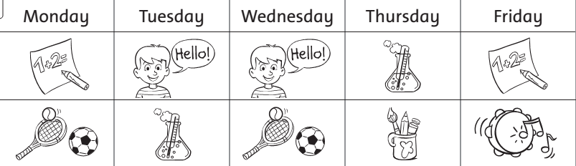
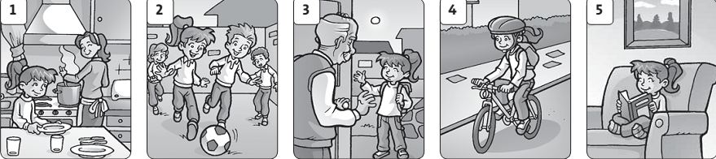
* Lưu ý đối với học sinh khuyết tật:
- Listening: Bỏ bài 2, tăng điểm ở bài 3- 0.75 điểm
- Reading: Bỏ bài 3, tăng điểm ở bài 2- 0.75 điểm
- Writing: Bỏ bài 2, tăng điểm ở bài 1- 1 điểm
- Speaking: Bỏ yêu cầu 3, tăng điểm ở yêu cầu 1 và 2 mỗi yêu cầu 0.5 điểm

***************Hết****************

