TRAN VAN ON PRIMARY SCHOOL  Ngày kiểm tra: ............................ | THE SECOND SEMESTER TEST: GRADE 5  School year: 2023-2024  Time: 40 minutes
Full name: ……………………………………………….. - Class: 5……..

Marks | Listening | Reading | Writing | Speaking | GV coi  (kí, ghi rõ họ tên) | GV chấm  (kí, ghi rõ họ tên)

Comment: ............................................................................................................................................

I. LISTENING (2.5 pts)
Part 1. Questions 1 - 4. Listen and match. There is an example (1pt)
Example: You hear: 0. “She helps her mum every Sunday”. The answer is: C
 |  | 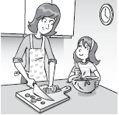 |  |  | 
A | B | C | D | E | F

0
1
2
3
4

Part 2: Question 5 – 7: Listen and number. There is one example. (0.75pt)
Example: You hear: 0. “She is eating a chocolate cake”.
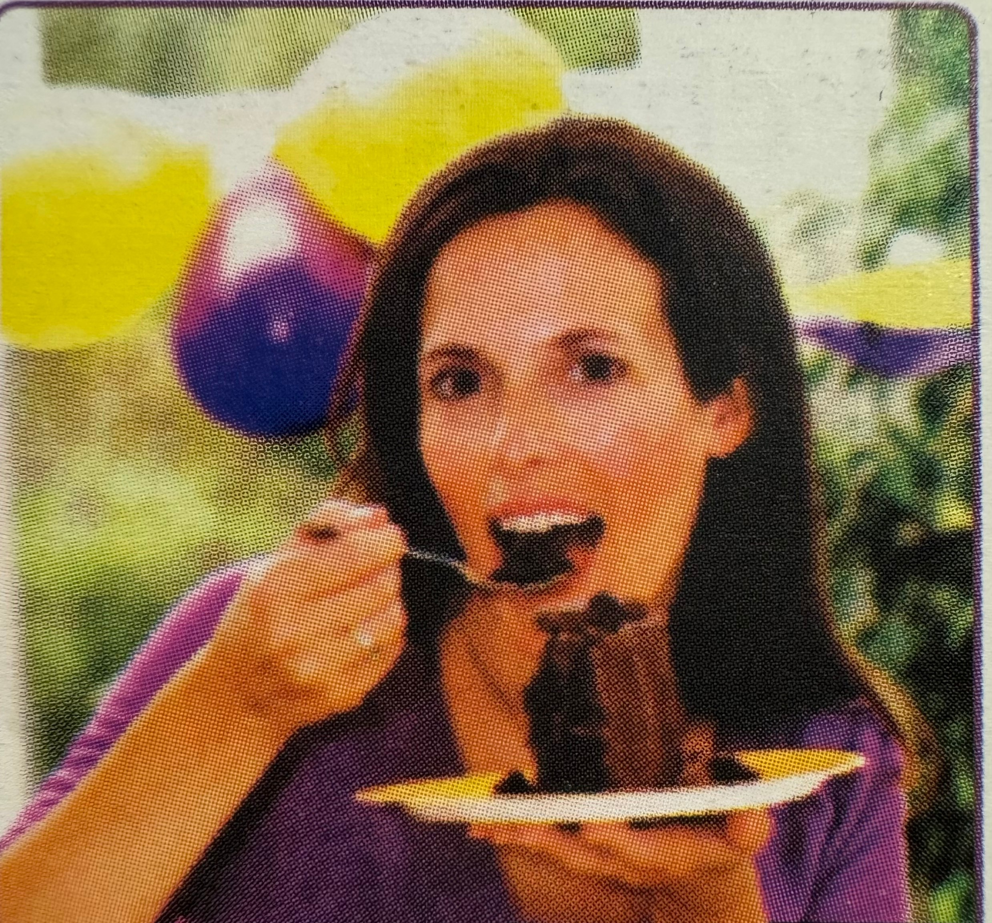  0 |   B |   C | 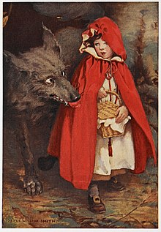  D | 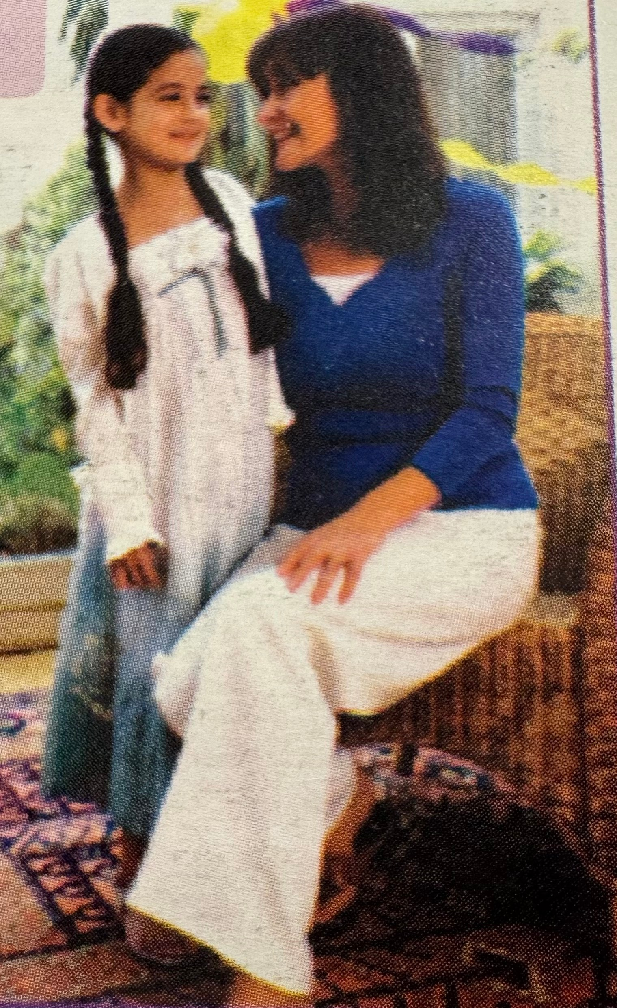  E
Part 3. Questions 8-10. Listen and write. There is an example. (0.75 pt)
- Nam can ride a bike.
8. She is wearing a blue..................
9. There were ................. teachers in the classroom
10. They are ...................... with their friends

II. READING. (2.5 pts)
Part 1. Questions 1-3. Look and read. Write the correct words next to the suitable description. There is an example. (0.75pts)
 |  |  |  | 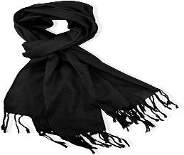 |  | 
0. It’s a thing that you often get on your birthday. |  |  |  |  | Present
1. She is very pretty in her wedding. |  |  |  |  | ..................
2. It’s a thing that make you warm in winter. |  |  |  |  | .................
3. They often sing and play music in groups. |  |  |  |  | .................

Part 2. Questions 4-6. Read and circle. There is an example. (0.75 pt)
0. What do you do after school?
A. I do my homework. B. He watches TV.
C. She visits her grandma.
4. What’s the weather like today?
A. It’s hot and sunny. B. He’s cold.
C. I’m hot.
5. What is he wearing?
A. I’m wearing a blue skirt. B. He’s wearing a yellow shirt.
C. She’s wearing a blue skirt.
6. What is she doing?
A. She is my teacher. B. She goes home at two o’clock.
C. She is watching TV.
Part 3. Questions 7-10. Read the text carefully. Write True(T) or False(F). There is an example. (1pts)
 | Hello, I’m Emily. I often get up at half past six everyday. Then, I have breakfast at home and go to school at quarter past seven o’clock. Today I have a birthday party with my family. We’re making a party cake now. I like the big chocolate cake but my mum likes the little cakes.
0. Emily often gets up at quarter to six everyday. |  |  | F
7. She has breakfast at home and goes to school at 7AM.
8. Today she has a wedding party with her family.
9. She’s choosing party dresses now.
10. Her mum likes the little cakes.
III. WRITING (2.5 pt)
Part 1. Questions 1- 4. Look at the pictures and write. There is an example (0.75pt)
Example:
0. It’s raining outside. |  | 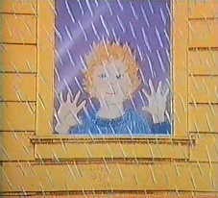
1. She’s wearing the green and white ........................ |  | 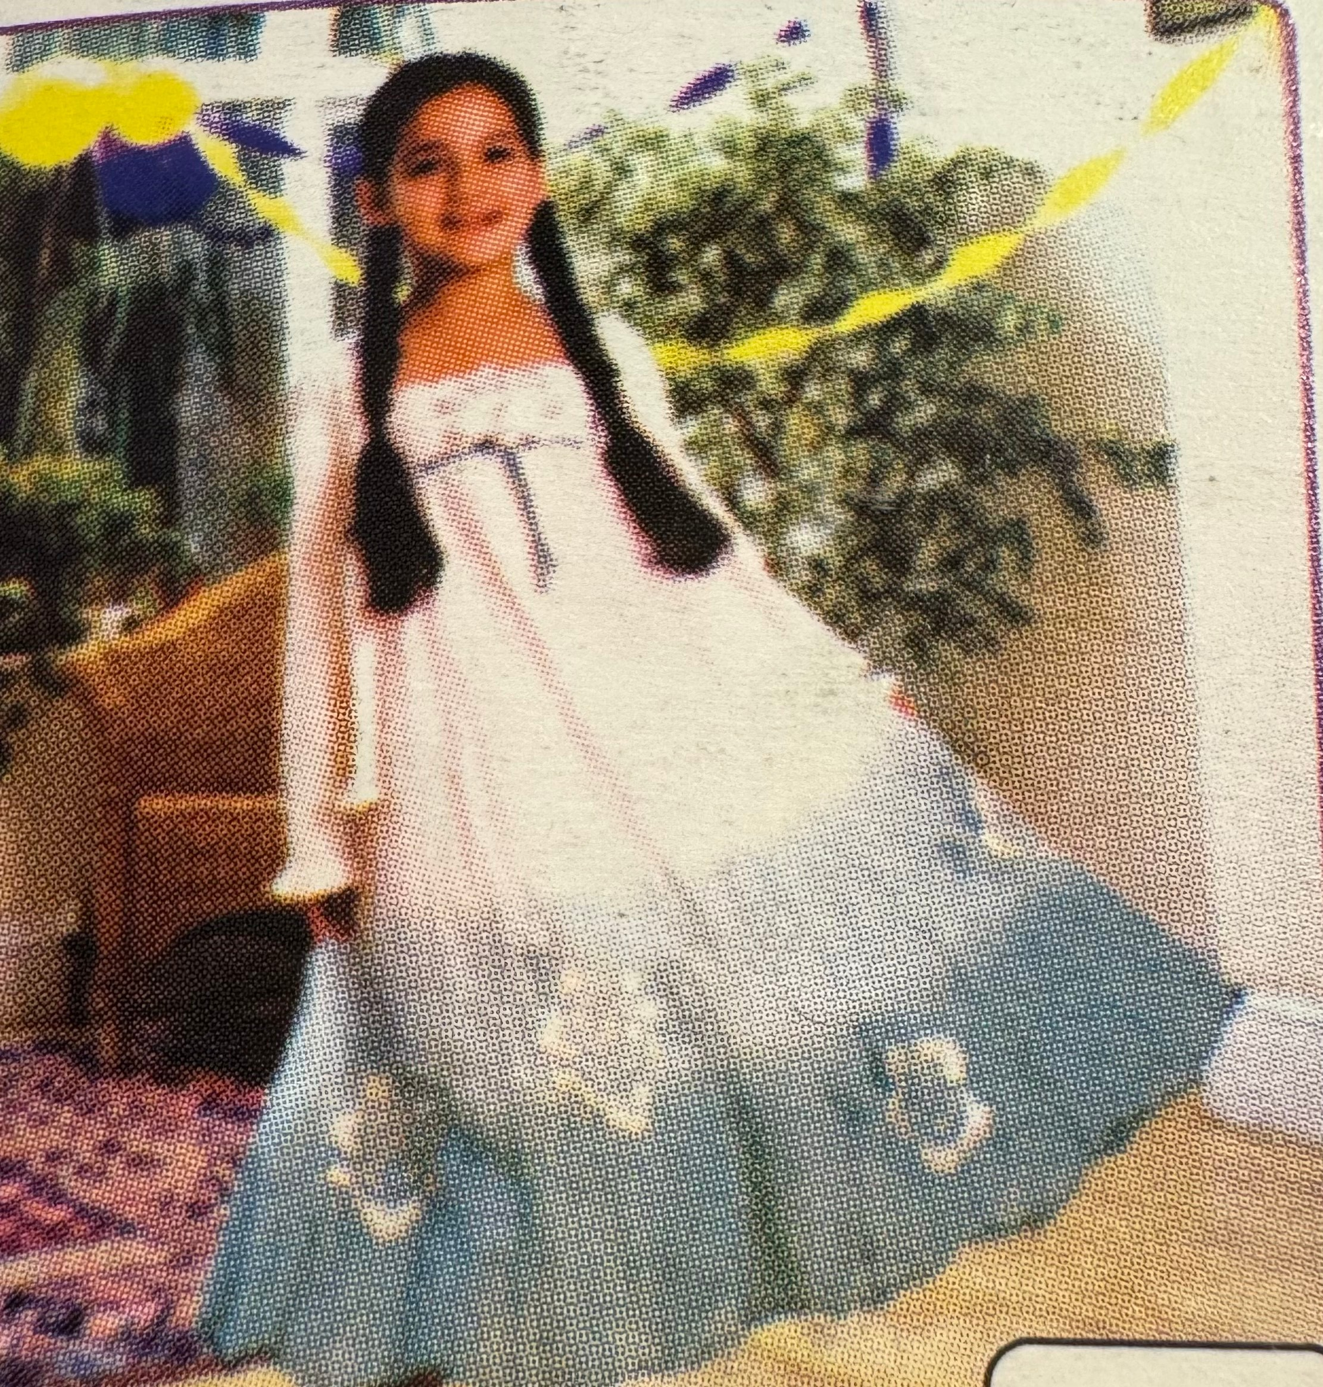
2. Put the .....................in the bin,please! |  | 
3. She’s writing the ………………… . |  | 
4. We’re ................... a cake for our relatives’weding. |  | 

Part 2. Questions 5–8. Reorder the words to make a correct sentence. There is an example. (1pts)
0. she / is / wearing? / What
=> What is she wearing?
5. a / is / wearing / My / cousin/ skirt/ green / yellow/ and/./ =>.............................................................................................
6. naughty./ Peter/ noisy/ was /and/
=>.............................................................................................
7. were/ students/ the/ not / classroom./ There/ any/ in
=>.............................................................................................
8. his / Harry / to / is / friends / talking / in/ party./ wedding/ the/
=>.............................................................................................
Part 3. Questions 9- 12. Answer about you. (0.5pts)
9. What time do you go to school?
......................................................................................

10. Where were you last summer?

......................................................................................

IV. SPEAKING (2,0 points)

