Mark | Speaking | Listening | Reading | Writing | Teacher’s comments
TRƯỜNG TIỂU HỌC TRẦN VĂN ƠN  Full name:............................................  Class: 1A.......... | BÀI KIỂM TRA CUỐI HỌC KÌ II  NĂM HỌC 2023 - 2024  MÔN TIẾNG ANH - LỚP 1  Time: 35 minutes  Proctor: ………..………
LISTENING (4pts)
Task 1. Listen and number the pictures. There is one example ( 1pt)
 |  |  |  | 
 |  | 0
Task 2. Listen and tick () the box (1pt)

Ex. |  |  | 
Ex. | A | B | C
 |   A |   B |   C
 |   A | 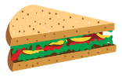  B |   C
 |  |  | 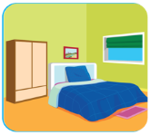
 | A | B | C
 |  |  | 
 | A | B | C

Task 3. Listen and color. There is one example (1pt)

- 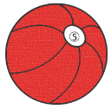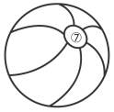
9. 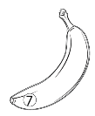
10. 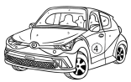
11. 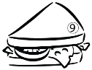
12. 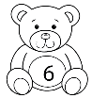
Task 4. Listen and draw lines. There is one example(1pt)
Sue
Vinh

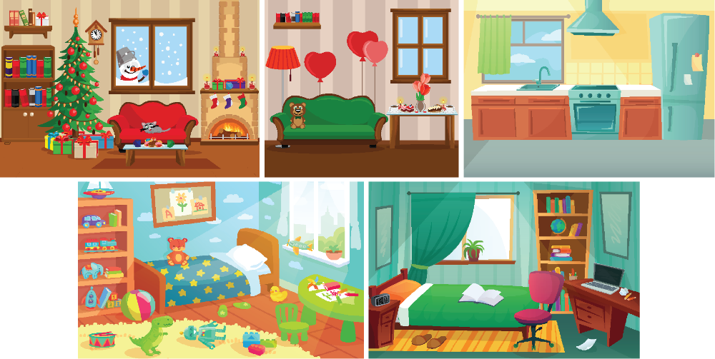

Bill
Anna
Lily

READING (1,5 pts)
Task 1. Look, read and circle.There is one example (1 pt)
Ex. |  | This is my juice. | This is my book.
1. |  | I can run. | I can swim.
2. | 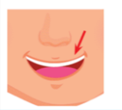 | This is my mouth. | This is my mouse.
3. |  | I want a sandwich. | I love my mom.
4. | 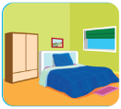 | This is my kitchen. | This is my bedroom.
Task 2. Read and put a () or a (). There is one example (0,5 pt)
Example:
 | 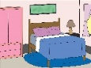 | 
0. I can run. | 5.This is my living room | 6. I want a sandwich.
WRITING.
Task 1. Fill the missing letter.There is one example (1 pt)
g h i j k l m
Example:  0. __irl ->girl |  | 1. __ick |  | 2. __ ove | 
 |  | 3. _uice |  | 4. __nk | 
Task 2. Order the words.There is one example (0,5 pt)
Example:
I
ball.
a
have

- I have a ball.
kitchen
.
This
is
my
5.
……………………………………………………………………………
6.  I | a | banana | want |  | .
……………………………………………………………………………

