Quang Hung Primary School  Class: 5 ……  Name: ………………………………… | THE FIRST SEMESTER TEST  ENGLISH - CLASS 5  School year: 2024 – 2025  Duration: 35 minutes
I. LISTENING
PART 1: Listen and number. There is one example.(1,0pt)
A   | B  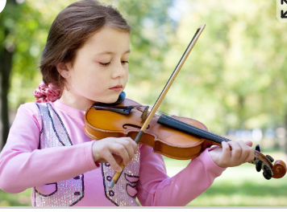 | C   | D   | E  
0

PART 2:Listen and choose the correct answers. There is one example.(1,0pt)
0. |  |  | 
  A.
  B.
  C.
1. |  |  | 
  A.
  B.
  C.
2. |  |  | 
  A.
  B.
  C.
3. |  |  | 
  A.
  B.
  C.
4. | 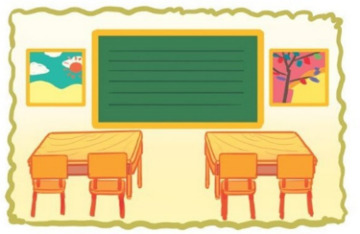 |  | 
  A.
  B.
  C.
PART 3: Listen and decide True (T) or False (F). There is one example.(1,0 pts)
- Her favourite school activity is reading books. A. True B. False
1. What’s Tom like? - He’s very clever. A. True B. False
2. What nationality is she? – She’s Australian. A. True B. False
3. What do you like doing in your free time? – I like going for a walk in the zoo.
A. True B. False
4. Do you live in this building? – No, I don’t. I live in Sunset Building.
A. True B. False
II. READING
PART 1. Read the questions and choose the correct answers. There is one example.
(1 pt)
0.Can you tell me about yourself ? | 0- c | a.Yes, we were.
1.Where are the pencils? | 1__ | b.I sometimes play the violin.
2.Were you at the theatre yesterday? | 2__ | c.I’m in class 5A. I live in the city.
3.What do you do at the weekend? | 3__ | d.I’d like to be a gardener.
4.What would you like to be in the future? | 4__ | e.They’re beside the notebooks.
PART 2 .Read and tick (√) True or False. There is one example .(1,0pt)
Hello, My name is Nam. I’m ten years old. I live in Gia Lai Province. My favourite subject is English. I often watch English cartoons in my free time. At the weekend, I sometimes play volleyball with my friends. I have some friends: Huy, Hoa and Quang. Huy is good at Maths. He likes solving maths problems in his free time. Hoa is good at music. She likes playing the piano and singing English songs at the weekend. Quang is good at sport. He likes playing football with his school team. He also likes playing volleyball with me in his free time.
 |  | TRUE | FALSE
0. | 0. Nam lives in Gia Lai Province. | √
1. | 1. Nam often watches English cartoons his free time.
2. | 2. Huy likes doing projects in his free time.
3 | 3. Hoa doesn’t like music.
4 | 4. Quang likes playing volleyball and football.
III. WRITING:
PART 1.Look at the pictures and the letters. Write the words. There is one example (1,0 pt)

 |  |  | 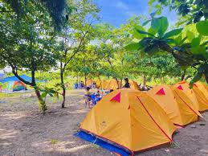 | 
0.seohu  house | 1. canrAmei  ______________ | 2. retprore  ______________ | 3. isetacpm  ______________ | 4. dingcan  ______________

PART 2. Look and write. Use ONE word only for each gap. There is one example. (1,0pt)
(0) Example  0) Where are the school bags?  - They’re under the desk. | A 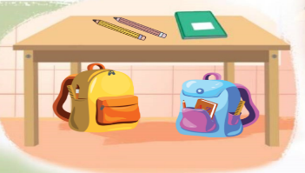
1. What’s your favourite food?  - It’s a………………………. | B 
2. What do you like doing in your free time?  - I like surfing the…………………... | C 
3.Why would you like to be a……………..?  -Because I’d like to write stories for children. | D 
4. Could you tell me the way to the art room?  - Go………………………….. | E 
PART 3. Rearrange the words to make the complete sentences. There is one
example. (1,0pt)

(0). summer /was /Lucy /Where /holiday /last /?/

→ Where was Lucy last summer ?

1. would/ like / What / in / you / to / the/ future / be / ?

………………………………………………………………………………………

2. playing /Why /they / games /do /like/?/

………………………………………………………………………………………

3. Australian / foreign / My / is / friend/./

………………………………………………………………………………………

4. me / way / Could / tell / room / the / to / computer /you /the/?/

………………………………………………………………………………………

VI. SPEAKING . (2.0 pts)

SPEAKING . (2.0 pts)
Part 1: Getting to know each other (0,5 pts)
The examiner asks 2 questions below:
- Can you tell me about yourself ?
- What’s your address?
Part 2: Look at the pictures and answer the questions. (0,5pts)
The examiner point to the pictures and ask Ss 4 questions.
1.What nationality is he/ she?
2.What’s he/ she like?
3.What school activity does he/she like?
4.Where are the……………?
5 What are they doing?
 |  |  | 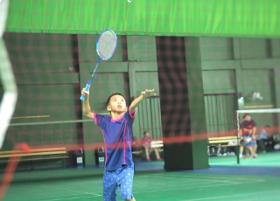
 |  |  | 
 |  |  | 
Part 3: Answer the questions. (1pt)
The examiner asks 4 questions below:
1.What do you like doing in your free time?
2.What would you like to be in the future?
3.Do you live in ……………….?
4.What did you do yesterday?

The end

UBND HUYỆN AN LÃO
TRƯỜNG TH & THCS QUANG HƯNG

ĐÁP ÁN VÀ BIỂU ĐIỂM BÀI KIỂM TRA ĐỊNH KỲ HỌC KÌ I
MÔN TIẾNG ANH LỚP 5 – NĂM HỌC 2024-2025
LISTENING
PART 1. (0,25*4 =1pt)
1. D 2.A 3. E 4.C
PART 2. (0,25*4 =1pt)
1. B 2. C 3. A 4.C
PART 3.(0,125*4 =1,0pt)
1.False 2. True 3. False 4. True
READING
PART 1 (0,125*4 = 1,0pt )
1. A 2.E 3.C 4.D
PART 2 (0,25 *4 = 1,0pt)
1. True 2. False 3. False 4. True
WRITING
PART 1 (0,125*4 =1,0 pt )
1. American 2. reporter 3. campsite 4.dancing
PART 2 (0,25 *4 = 1, 0pt)
1. sandwich 2.internet 3. writer 4.downstairs
PART 2 (0,25 *4 = 1,0pt)

1. What would you like to be in the future?

2. Why do the like playing games?

3. My foreign friend is Australian.

4. Could you tell me the way to the computer room?
SPEAKING
Greeting & test taker’s name check.
The examiner says “My name is…It’s nice to talk to you today.”
Part 1: Getting to know each other (0,5 pts)
The examiner asks 2 questions below:
- Can you tell me about yourself ?
- What’s your address?
Part 2: Look at the pictures and answer the questions. (1pts)
The examiner point to the pictures and ask Ss 4 questions.
1.What nationality is he/ she?
2.What’s he/ she like?
3.What school activity does he/she like?
4.Where are the……………?

Part 3: Answer the questions. (1pts)
The examiner asks 4 questions below:
1.What do you like doing in your free time?
2.What would you like to be in the future?
3.Do you live in ……………….?
4.What did you do yesterday?
That’s the end of the speaking test. You did a great job. Thank you.

Quang Hung, ngày 15 tháng 12 năm 2024
Duyệt của Chuyên môn Người ra đề

UBND HUYỆN AN LÃO
TRƯỜNG TH & THCS QUANG HƯNG

MA TRẬN BÀI KIỂM TRA ĐỊNH KỲ HỌC KÌ I - MÔN TIẾNG ANH LỚP 5 – NH: 2024-2025

Kỹ năng | Nhiệm vụ đánh giá/kiến thức cần đánh giá |  | Mức/Điểm |  |  | Tổng số câu, số điểm, tỷ lệ %
Nghe |  |  | M1 | M2 | M3 | 12 câu x  0,25 điểm  30%
Nghe | 1.Listen and number  Dolphin/ water the flowers/campsite/ clever |  | 2  0,5đ | 1  0,25đ | 1  0,25đ | 12 câu x  0,25 điểm  30%
Nghe | 2.Listen and choose the correct answers.  Japanese/ set square/ play chess/ above |  | 2  0,5đ | 1  0,25 | 1  0,25 | 12 câu x  0,25 điểm  30%
Nghe | 3.Listen and decide True (T) or False (F)  Helpful/ Australian/ go for a walk/ building |  | 2  0,5đ | 1  0,25đ | 1  0,25đ | 12 câu x  0,25 điểm  30%
Đọc | 1.Read the questions and choose the correct answers. |  | 2  0,5đ | 2  0,5đ |  | 8 câu x  2,5 điểm  20%
Đọc | 2.Read and tick True or False. |  | 2  0,5 | 1  0,25 | 1  0,25 | 8 câu x  2,5 điểm  20%
Viết | 1.Look at the pictures and the letters. Write the words. |  | 2  0,5đ | 2  0,5đ |  | 12 câu  2,5 điểm  30%
Viết | 2.Look and write. Use ONE word only for each gap. |  | 2  0,5 | 1  0,25đ | 1  0,25đ | 12 câu  2,5 điểm  30%
Viết | 3. Rearrange the words to make the sentences |  | 2  0,5 | 1  0,25đ | 1  0,25đ | 12 câu  2,5 điểm  30%
Nói | 1. Getting to know each other  - Can you tell me about yourself ?  - What’s your address? |  | 2  0,5 |  |  | 11 câu  2,0 điểm  20%
Nói | 2.Look at the pictures and answer the questions  The examiner point to the pictures and ask Ss 4 questions.  -What nationality is he/ she?  -What’s he/ she like?  -What school activity does he/she like?  -Where are the……………?  What are they doing?? |  | 2  0,2 | 2  0,2đ | 1  0,1đ | 11 câu  2,0 điểm  20%
Nói | 3.Answer the questions: The examiner asks 4 questions below:  -What do you like doing in your free time?  -What would you like to be in the future?  -Do you live in ……………….?  -What did you do yesterday? |  | 1  0,25đ | 2  0,5 | 1  0,25đ | 11 câu  2,0 điểm  20%
Tổng |  |  | 21 –  48,8 % | 14 –  32,5 % | 8 –  18,7% | 43câu/10 điểm  100%

