NAME OF SCHOOL:
…………………….Primary School
LESSON PLAN
UNIT 7: Sports
Lesson 2: Part 1-2-3

Full name of Teacher: ........................................................
Unit 7: Sports
Lesson 2: Part 1-2-3
Duration (period): 35 minutes
I. OBJECTIVES:
1. Knowledge:
Vocabulary:
- New words related to sport: control, fight, kick, mind, movement
- Listening and reading a dialogue about taekwondo.
2. Competences:
By the end of the lesson, students will be able to recognize new vocab and use vocab to talk about taekwondo.
3. Qualities:
- Students have a deeper insight into a particular sport.
- Students will be confident and active in communicating with friends and teachers.

II. EQUIPMENT AND MATERIALS:
- Basic things: Student’s book, flashcards.
- Advanced things: PPT, laptop, TV.
III. LESSON PROCEDURE:
Activity 1: Warm-up
Activity 2: Presentation
Activity 3: Practice
Activity 4: Production
Activity 5: Wrap-up & Assessment

 | Activity 1: Warm-up (5 minutes)
 | Teacher’s Activities | Students’ Activities
Aims:- Welcome students, and engage the class with a game “Order the words to make a sentence”.
- Warm-up activity to review the present continuous tense.
 | b, Procedure  - Greet students.  - Divide the class into many teams. Each team chooses their team names.  - Ask students to look at the words to rearrange the right sentence.  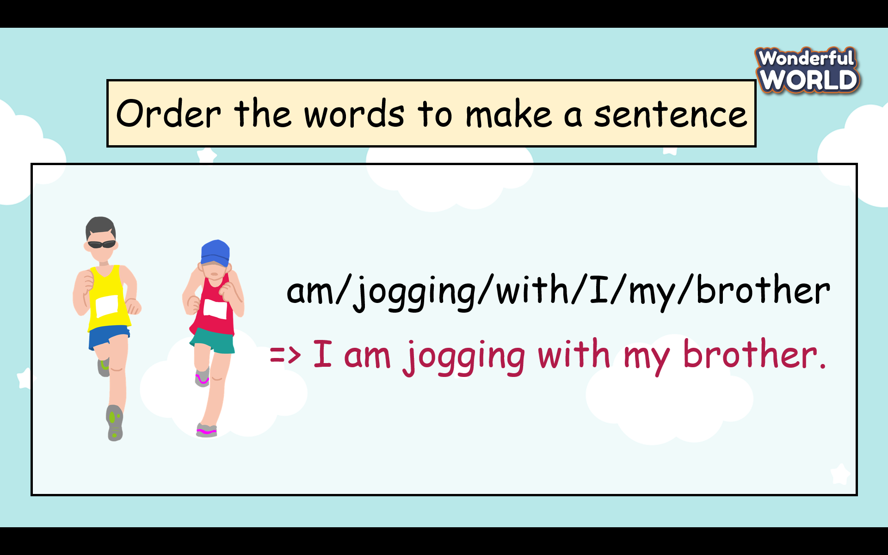  - T gives stars for the correct answer. | - Greet Teacher  - Choose the team name  - Join the activity.  - Look carefully and write the answers.  - Read the answers in front of the class.
Activity 2: Presentation (7 minutes)
Teacher’s Activities |  | Students’ Activities
- Aim: Learn vocabulary about taekwondo and practice the listening skill.
b, Procedure  Task 1 Listen and read. Then circle the correct words. TR: 7.4  -Before listening the teacher asks students to look at the picture and describe what they see in the picture. 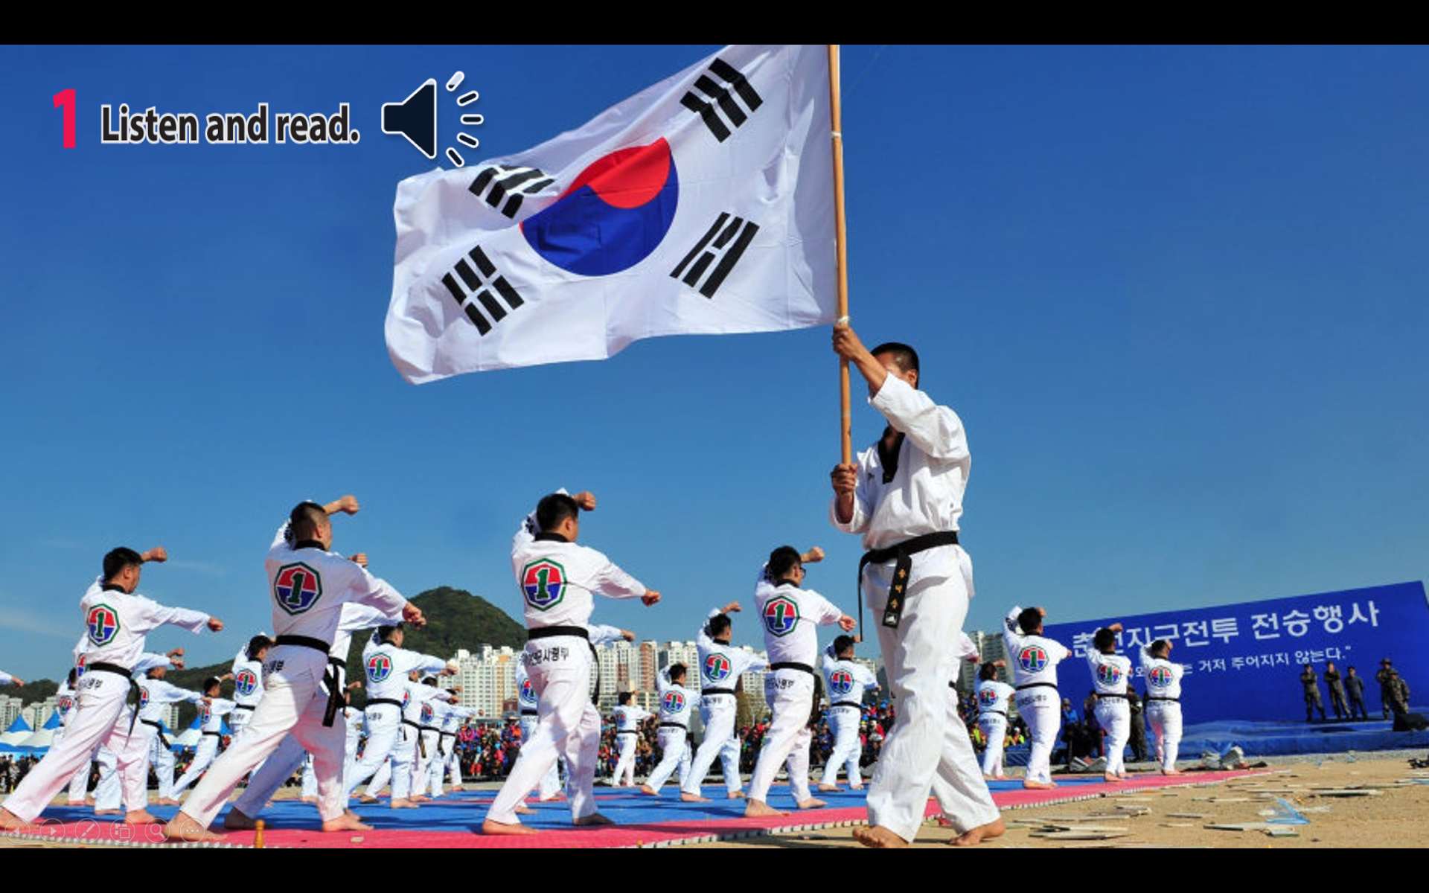  + Where is it?  + What are they doing?  Are they young people or old people?  + Do you know the name of this sport?  - Ask students to watch a video about taekwondo.  - Ask students to look at a short dialogue and play the recording twice.  - Have students listen and read it as a group and in pairs.  - Call two pairs to read it out loud and check pronunciation if necessary.  - Ask students to read the dialogue again and circle the correct words.  - Have students work in pairs to compare answers.  - Check answers as a class by asking individual students to read the answers out loud.  Task 2 Listen, point, and repeat. TR: 7.5  - Show the five pictures, explain what they see, and guess the meaning of each word.  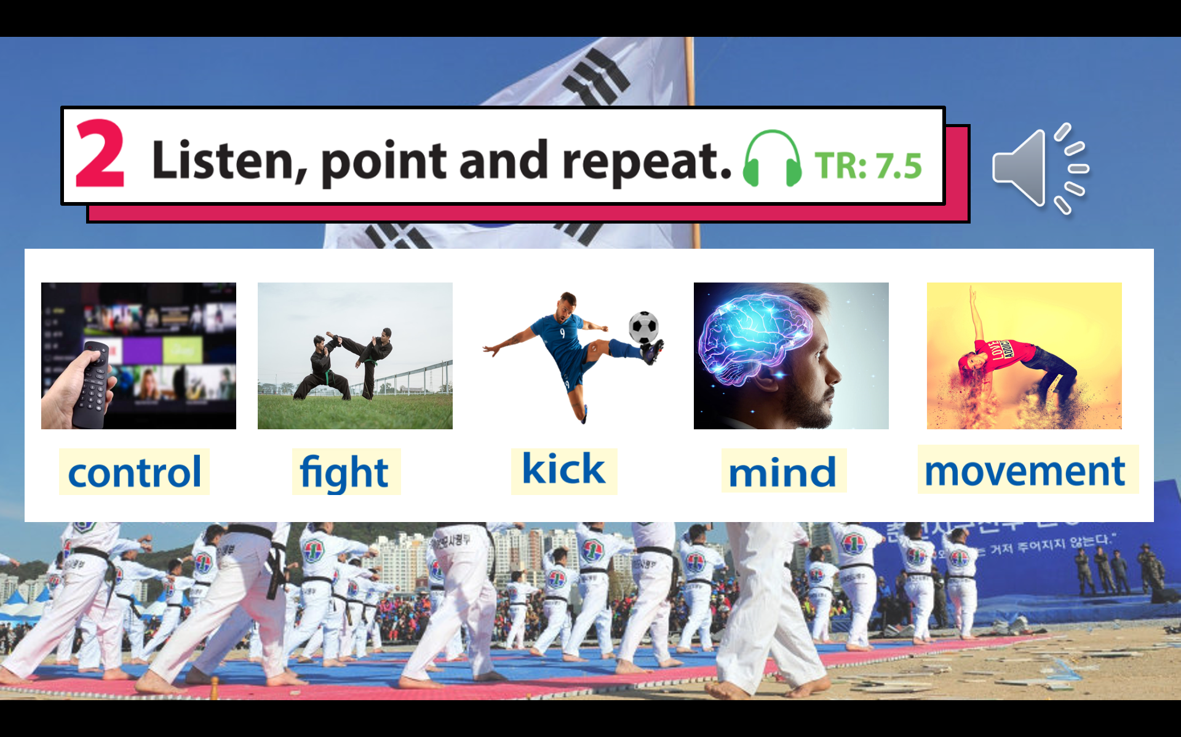  - Play the recording for students to listen, point to, and repeat the words as they hear them.  - Read out the new picture words in random order. Ask students to point to the correct pictures.  - Read each word again one by one and have students repeat. - Check pronunciation if necessary  * Mini game” look and say”  - Each picture runs across the screen and the teacher asks students to look as fast as possible and guess the picture  - T gives stars for the correct answer. |  | - Look at the picture carefully and answer the teacher’s questions.  (students can ask the teacher about words and structures if they are not sure).  - Write down ideas in the notebook( students can share ideas with their friends).  - Read each sentence in the dialogue and circle the right keywords.  2 In taekwondo, you use your mind to control your body’s movement / get ready for your body’s movement.  3 The word taekwondo means kicking / the way of the foot and the hand in Korean.  - Underline the words in the dialogue and guess the meaning of the word.  - Listen and repeat each word.( read in whole class, team and individual)  - Look quick and say fast
Activity 3: Practice (11 minutes)
Teacher’s Activities |  | Students’ Activities
- Aims: Help students have a chance to find out more information about this interesting sport( taekwondo).
b, Procedure  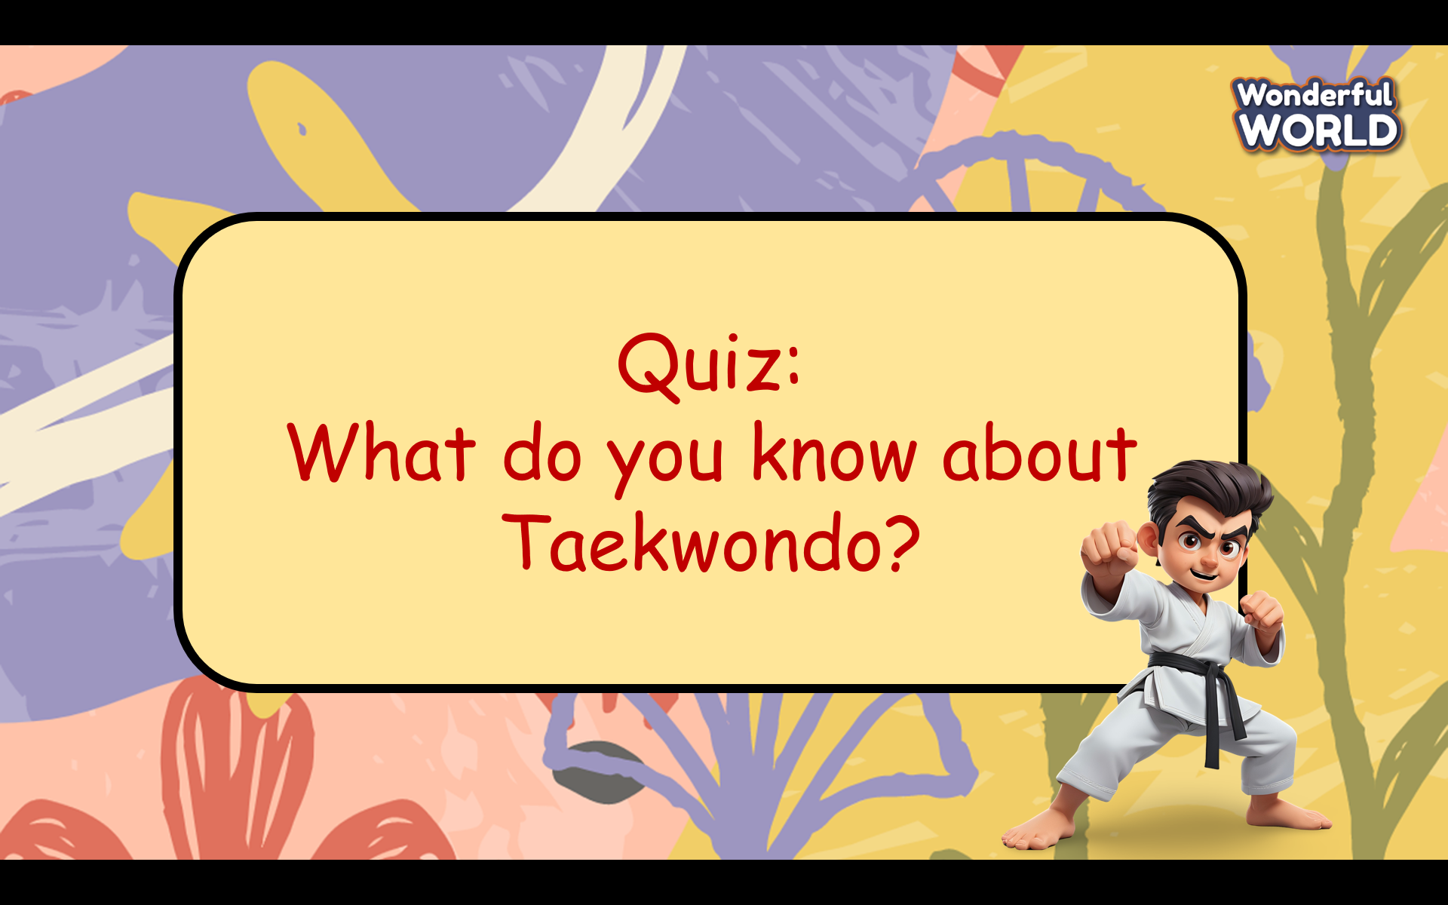  - Prepare some questions about taekwondo and ask students can read again the dialogue in task 1 (Some questions are beyond the scope of the dialogue.)  - Ask students can work in groups to choose the best answer.  - Give stars for the correct answers and the teacher can give further information on each answer. |  | - Read again the dialogue.  - Look at 4 options for each question carefully and choose the best answer.
Activity 4: Production (7 minutes)
Teacher’s Activities |  | Students’ Activities
- Aims: control the class and help students sum up the content of the lesson.

- Procedure  “Let’s make a mind map about Taekwondo!”  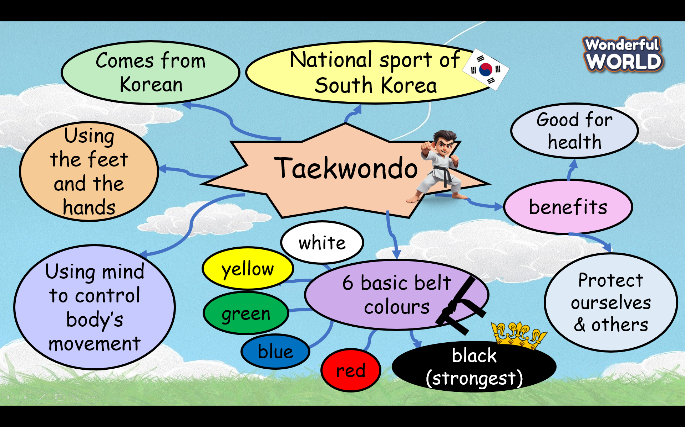  - Ask students to prepare A4 papers, pencils, crayons and work in a team of 2 or 4 students  - Ask students to make a mind map about taekwondo.  - Allow students enough time to complete the task.  - Circulate the class, providing support and guidance as needed.  - Ask each group to go to the board and present the mindmap.  - Give feedback to each team and choose the best mindmap to stick to the class’s wall. |  | - Listen to the teacher’s guide and prepare A4 papers, pencils, and crayons for the project.  -Work in a team of 2 or 4 students  - Go to the board and present the mind map in front of the class.  - Be confident and speak fluently.  - Clap their hands after each team finishes the task.
Teacher’s Activities |  | Students’ Activities
a, Aim:
- Check students’s understanding of what they have learnt.
- Students rehearse what they have learnt in the lesson.
- T asks sts to do the assessment (Look and circle the words)  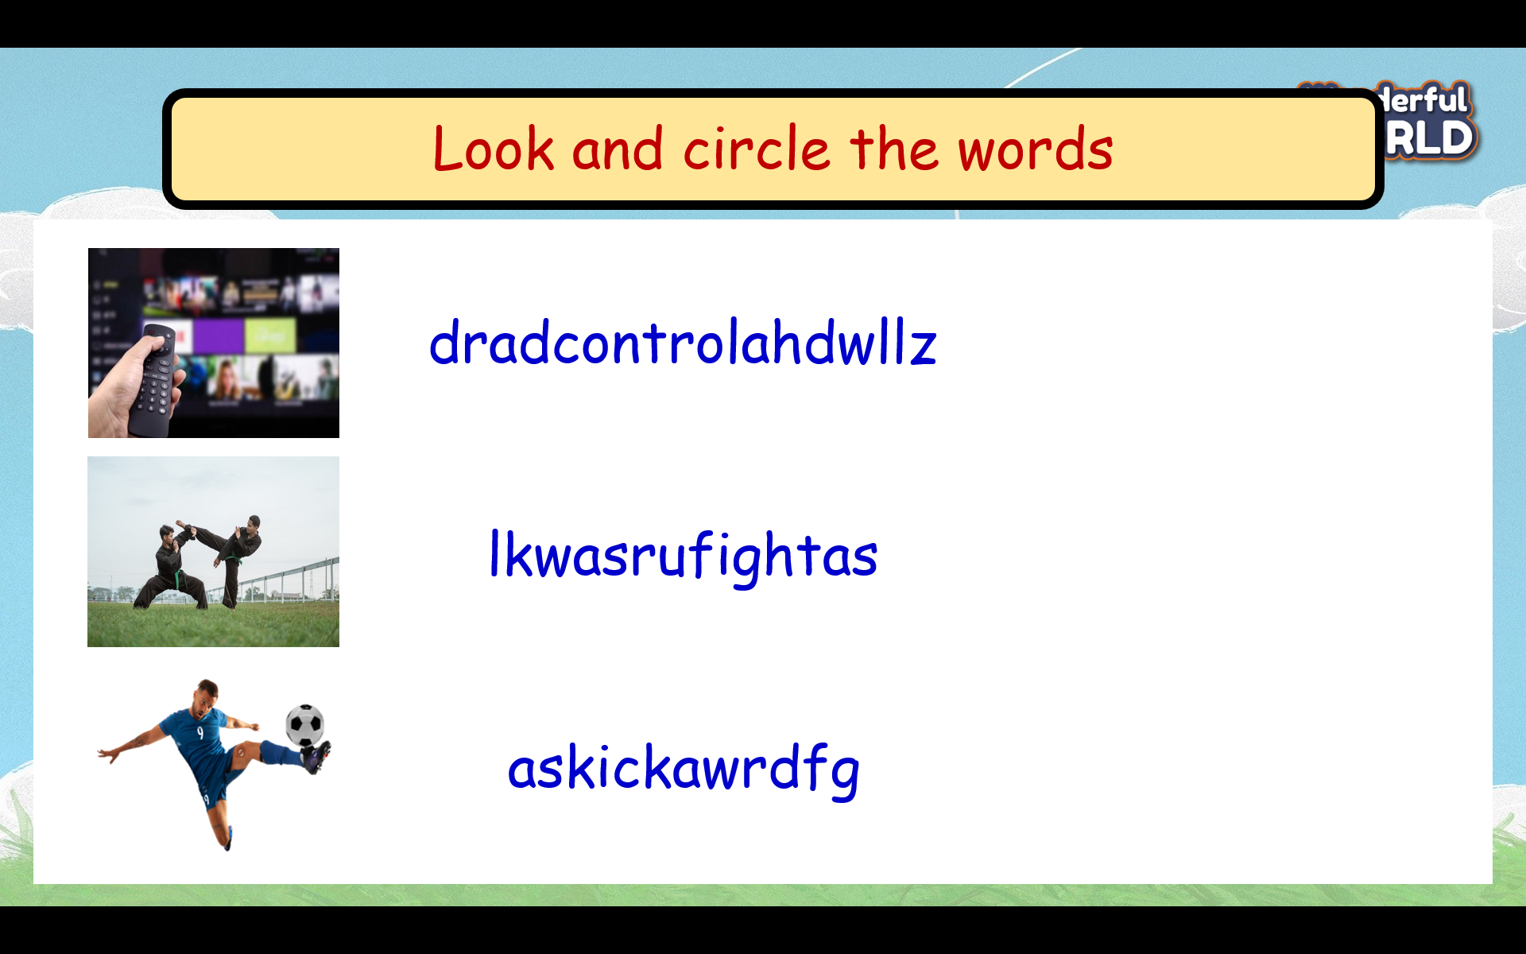  - Check with the class.  - Wrap-up  * Remember:  - Vocabulary: control, fight, kick, mind, movement |  | - Do the assessment.  - Check with the teacher  - Sts read the wrap-up  - Stand up and say goodbye to the teacher.

