Period 29
GRADE 4
UNIT 5: THINGS WE CAN DO
LESSON 1 – A1, 2, 3
I. OBJECTIVES
By the end of the lesson, pupils will be able to:
Language knowledge & skills | - understand and correctly repeat the sentences in two communicative contexts (pictures) in which pupils ask and answer questions about someone’s abilities.  - correctly say the phrases and use Can you _____? – Yes, I can. / No, I can’t. to ask and answer questions about someone’s abilities.  - enhance the correct use of Can you _____? – Yes, / No, _____. to ask and answer questions about pupils’ abilities in a freer context.
Competences | - Communication and collaboration: work in pairs and groups to complete the learning tasks  - Self-control & independent learning: perform listening tasks
Attributes | - Show pride in what they can do and great respect for other people’s abilities by using appropriate gestures and intonation when asking and answering about abilities.
II. RESOURCES AND MATERIALS
- Website hoclieu.vn; beeclass.vn; lophoc.net; quizziz.com; youtube.com
- Flash cards
- Tablets; smart TV; face mask
III. PROCEDURE | Warm-up and review – Look, listen and repeat – Listen, point and say  – Let’s talk – Fun corner and wrap-up

Procedure | Teacher’s and pupils’ activities | Interaction |  | Note
Warm-up and review: 4 - 5 minutes
 | Greet the class.  - Have students listen and sing the song “yes I can” on youtube.com.  - Divide class into 2 groups: boys- girls  - Introduce new unit 5, lesson 1 (1-3)  - Get students open their book on page 34. | Whole class/ Individual work
EXPLORATION
Activity 1. Look, listen and repeat. 6 - 7 minutes
a. Goal | To understand and correctly repeat the sentences in two communicative contexts (pictures) in which pupils ask and answer questions about someone’s abilities.
b. Input | - Context a: Mary: I can fly a kite. Mai: I can skip.  - Context b: Minh: Can you ride a bike? Mary: Yes, I can.  Mai: No, I can't.
c. Outcome | Pupils can listen to and understand two communicative contexts in which pupils ask and answer questions about someone’s abilities and tick the correct pictures.  Key: 1. b 2. b
d. Procedure | Step 1: Ask pupils to look at Pictures a and b and identify the characters in the pictures and pay their attention on things in two pictures.  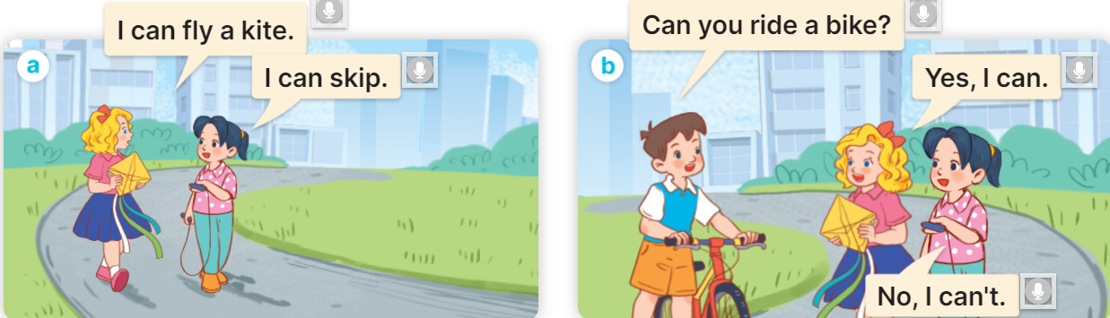Step 2: Draw pupils’ attention to the kite and the skipping rope in Picture a and predict what the characters can do or are talking about. Play the recording and have pupils check the prediction. Repeat the same procedure with Picture b.  Step 3: Play the recording again and encourage pupils to point at the characters while listening.  Step 4: Play the recording again, sentence by sentence, for pupils to listen, point at the sentences and repeat after each character. Correct their pronunciation where necessary.  Two teams role play each character in pictures to repeat again.  Extension: Invite a few pairs of pupils to act out the conversations in front of the class. |  | Whole class  Work in groups  Pair work
e. Assessment | - Performance products: Student’s answers  - Assessment tools: Observation; Questions & answers, Peer correction
KNOWLEDGE CONSTRUCTION
Activity 2. Listen, point and say. 8 - 9 minutes
a. Goal | To correctly say the phrases and use Can you ____? – Yes, I can. /  No, I can’t. to ask and answer questions about someone’s abilities.
b. Input | - Picture cues:  a. a girl riding a bike b. a boy who can’t ride a horse  c. a boy playing the piano d. a girl who can’t play the guitar  - Speech bubbles: Can you _____? – Yes, I can. / No, I can’t.  Audio script:  a. ride a bike / yes b. ride a horse / no  c. play the piano / yes d. play the guitar / no  a. A: Can you ride a bike?  B: Yes, I can.  b. A: Can you ride a horse?  B: No, I can’t.  c. A: Can you play the piano?  B: Yes, I can.  d. A: Can you play the guitar?  B: No, I can’t.
c. Outcome | Pupils can correctly say the phrases and use Can you ? – Yes, I can. / No, I can’t. to ask and answer questions about someone’s abilities.
d. Procedure | Step 1: Ask pupils to look at Pictures a, b, c, and d and identify the activities in the pictures.  - Teacher uses actions to introduce all the new words then stick them on the board.  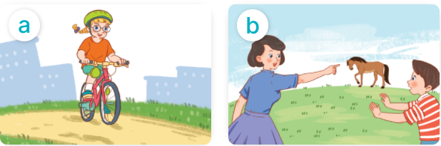 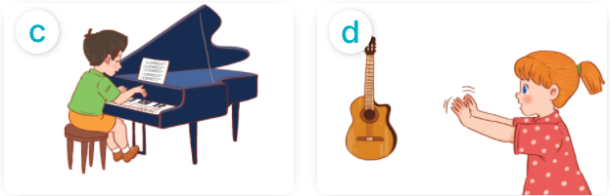Step 2: Play the recording for pupils to listen to and repeat the phrases under the pictures in chorus and individually until they feel confident. Use the flash cards for ride a bike, ride a horse, play the piano and play the guitar to practise the phrases.  - Have pupils play game “Guessing game” on the website: lophoc.net in order to help them remember all the new words.  Step 3: Draw pupils’ attention to the speech bubbles and elicit the missing words in the answer by pointing at Picture a. Play the recording for pupils to repeat the sentences in both bubbles a few times. Repeat the same procedure with Pictures b, c, and d.  Step 4: Have pupils practise asking and answering questions in pairs. Go around the classroom to offer help where necessary.  Step 5: Invite a few pairs to point at the pictures and ask and answer questions about what the pupils in the pictures can or can’t do.  - Have students stand up, sing and dance the song “ can you do something?” |  | Whole class/ Individual work  Whole class  Pair work  Pair work  Whole class
e. Assessment | - Performance products: Student's talks and interaction  - Assessment tools: Observation; Answer keys
PRACTICE
Activity 3. Let’s talk. 7 - 8 minutes
a. Goal | To enhance the correct use of Can you ? – Yes, / No, ____. to ask and answer questions about pupils’ abilities in a freer context.
b. Input | - Picture cue: A summer camp poster. There are four activities in the poster.  - Speech bubbles: Can you ____? – Yes, / No, ____.
c. Outcome | Pupils can enhance the correct use of Can you____? – Yes, / No,____. to ask and answer questions about their abilities in a freer context.
d. Procedure | Step 1: Draw pupils’ attention to the poster about the summer camp. Ask questions to help them identify the activities in the poster.  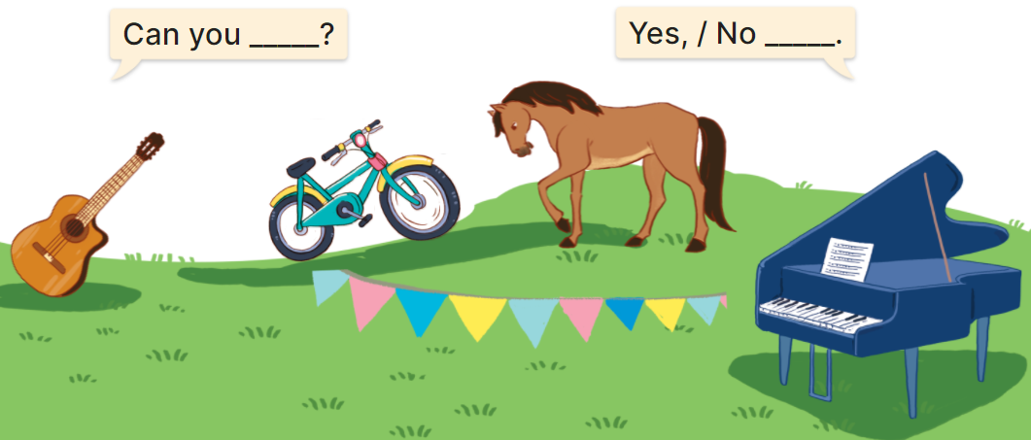Step 2: Elicit the missing words in the speech bubbles and write them on the board. Get pupils to say the completed sentences.  Step 3: Put pupils into pairs to ask and answer about their abilities. Go around the classroom to offer support where necessary.  Step 4: Invite a few pairs to point at the pictures and ask and answer questions about their abilities. |  | Whole class/  Individual work  Pair work  Pair work
e. Assessment | - Performance products: Student’s interaction and performance  - Assessment tools: Observation; Questions & answers
Fun corner and wrap-up: 4 - 5 minutes
 | Game Quizzizz  - Divide the class into 12 small groups and have one tablet in each group.  - Pupils in each team give test from website then answer questions in this.  - After 5 questions , the group with the most points is the winner.  - Teacher count the points in each team then give them homelink. |  | Group work

