UNIT 3 : MY FRIENDS
Lesson 1: GETTING STARTED
A surprise guest
Week 6
Period: 16
Class | Date of teaching | Attendance
I. OBJECTIVES:
By the end of the lesson, students are expected to achieve the following objectives:
1. Knowledge:
*Vocabulary:
- Use the words related to the topic Body parts and appearance
- Use the Personality adjectives to talk about about appearance and personality
- Vocabulary to learn: pass, biscuit, magazine, shoulder, blond, a great idea, come over
* Pronunciation:
- Pronounce the sounds /b/ and /p/correctly
* Grammar:
- Present continuous Tense
- Use the Present continuous Tense to talk about things happening now
- Give suggestions
2. Competencies:
a. General competencies:
By the end of the lesson, students are expected to:
- Be able to pratice reading and listening the conversation between Phong and Nam about experiences of going on a picnic.
- Use the words for body parts, appearance and personality;
- Pronounce the sounds /b/ and /p/ correctly;
- Use the present continuous to talk about things happening now;
- Ask about appearance and personality;
b. Specific competencies:
- Group work and independent working, pair work, linguistic competence, cooperative learning and communicative competence.
- Read for specific information about friends and summer camps;
- Talk about friends and summer camps;
- Listen for specific information about best friends;
- Write a diary entry about best friends.
3. Qualities:
- To teach Ss good behaviour toward friends
- The awareness about importance of friendship in life.
- Ss have the good attitude to working in groups, individual work, and pairwork, cooperative learning and working.
II. PREPARATIONS
Teacher: Text book, laptop, loudspeaker, projector…
Students: Text books, studying equipment’s….
III. PROCEDURE
ACTIVITY 1: WARM-UP
1. Aim:
- To create a friendly and atmosphere in the class before the lesson;
- To lead into the unit
2. Content:
- Have some warm-up activities to create a friendly and relaxed atmosphere to inspire Ss to warm up to the new class.
3. Products:
- Interest and concentration of Ss on the class activities.
- Having a chance to speak English and focus on the topic of the lesson..
4. Implementation:
- Teacher instructs
- Ss do as required
TEACHER AND STUDENTS' ACTIVITIES | CONTENTS
Step 1: Task delivering  - Chatting  Step 2: Task performance  *)Warm up:  - Teacher (T) asks Ss some questions about the previous lessons,  - T may introduce some warm-up activities to creat a friendly and relaxed atmostphere to inspire Ss to warm up to the subject and new class…  - T encourages Ss to talk in English as much as possible  - Students (Ss) listen and learn how to do it .  - Answer the teacher’s questions and enquirements.  + Lead to the new unit about frineds and friendship  - Write the unit title My friend on the board.  - Ss open their notebook and write .  Step 3: Report and discussion  - Ss work in group to talk about their friends  - Ss join in the discussion  Step 4: Judgement  - T summarizes the discussion and leads to Activity 2. | Question: “What can you do with your friend?”  Answer: “ We can do a lot of activities together  - We can eat and drink together  - We sing some songs  - We can play some games”
ACTIVITY 2: KNOWLEDGE FORMATION (15')
1. Aim:
- To set the context for the introductory;
- To introduce the topic of the unit, the vocabulary, the sounds, and the grammar points to be learned.
- To help Ss deeply understand the text.
2. Content:
- Learn some new words. Read the conversation and find out new words.
- Filling the blanks to understand more about the text.
3. Products:
- Vocabulary about the topic
- Understanding the conversation; topic of the lesson, grammar points…
- Understanding more about the text.
4. Implementation:
TEACHER AND STUDENTS' ACTIVITIES | CONTENTS
Step 1: Task delivering  - T sets the scene/ context for the listening and reading.  Step 2: Task performance  *) Pre- teach vocabulary:  - Teacher uses different techniques to teach vocabulary (situation, realia, translation .....)  + Follow the steps to teach vocabulary  - Repeat in chorus and individually  - Ss listen carefully and read aloud.  - Ss take note  + Check vocabulary  - Ss Take note.  Task 1. Listen and read.  - Set the context for the listening and reading.  - Ask Ss questions about the picture, e.g. What is Phong doing? What are they eating and drinking?  - T can also ask Ss to share any recent experiences of going on a picnic.  - Play the recording twice for Ss to listen and read along.  - Have Ss underline the words that are related to the topic of the unit while they are listening and reading.  - Invite some pairs of Ss to read the dialogue aloud.  - Have Ss say the words in the text that they think are related to the topic My friends.  - Quickly write the words on one part of the board.  - Comment on Ss'answers.  Task 2. Fill the blanks with the words from the conversation  - Ask Ss to read the conversation again and do this activity independently.  - Ask them how to do the activity.  - Remind them of the ways to do the activity if needed (e.g. (1) read the sentence and identify  the kind of information to fill the blank;  (2) read the conversation and locate the place to find the word(s) to fill the blank).  - Allow them to share answers before discussing as a class.  - Ss listen carefully to the instructions  - Ss Follow the teacher’s instructions  - Ss give the answers and check.  - T confirms and writes the correct answers on the board.  Step 3: Report and discussion  - Ss write down the new vocabulary  - T asks, Ss answer some more questions about the conversation  Step 4: Judgement  - T gives feedback on the reaction of Ss | 1. Vocabulary:  - pass (v) đưa, chuyển  - biscuit (n) bánh bích qui  - magazine (n) tạp chí  - shoulder (n) vai  - blond (adj) màu hoe vàng  - come over: đi đến  - a great idea: một ý kiến hay  2. Practice  Task 1. Listen and read.    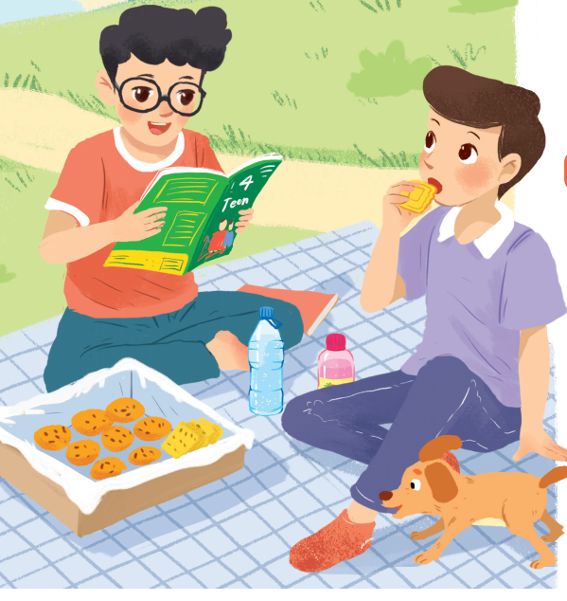  Task 2. Fill the blanks with the words from the conversation:  Key:  1. Phong and Nam are having a picnic.  2. 4Teen is Phong's favourite magazine.  3. Phong and Nam see Mai and Chau.  4. Chau has glasses and long black hair.  5. Mai and Chau are going to the bookshop.
ACTIVITY 3: PRACTICE
1. Aim:
- To help Ss understand the conversation.
- To introduce some vocabulary related to the topic of the unit;
- To revise and provide Ss with some vocabulary related to parts of the body.
- To revise and provide Ss with some vocabulary to describe parts of the body.
- To help Ss practise using words for body parts and appearance through a guessing game.
2. Content:
- Label words related to body parts.
- Complete the words related to body parts.
- Playing game to describe a classmate.
3. Products:
- Knowing more new words and using it correctly.
- Learning how to describe a classmate using the new words
4. Implementation:
TEACHER AND STUDENTS' ACTIVITIES | CONTENTS
Step 1: Task delivering  - T let Ss learn Task 3-4-5 – Getting Started - Unit 3  Step 2: Task performing  Task 3. Label the body parts with the words in the box.  - Ss may already know some appearance vocabulary, so first ask them to label the body parts they know, using the words given.  - Ss listen to the instructions clearly, - Learn how to do it  - Have Ss compare their answers with a classmate.  - Ss work independently and share the answers  If possible, show the picture on the slide / on the board and have Ss point at each body part and say its name.  - Check Ss'answers and confirm the correct ones.  If there are any body parts Ss do not know, quickly point to them and teach these.  - Have Ss work in groups and brainstorm all other words for body parts.  - T can ask them to write the words down on small boards or pieces of paper.  Then set a time limit for groups to write the words.  - Finally, invite the group with the most words to share their words.  Other teams add any different words  - Allow Ss to share answers before discussing as a class. Write the correct answers on the board.  - T gives correct answer  Task 4. Work in groups. Complete the word webs  - Explain that some words go together, e.g. long + hair, but some don't, e.g. long + eye.  - Have Ss work in groups and complete the word webs in a few minutes.  - Ss listen carefully and learn how to do.  - Ss do themselves. Give the answers  - T checks and confirms the correct answers.  - Other pairs look, comment and add any words they know.  - Introduce some other types of house if needed  Task 5. GAME- Guessing  - T explains the rules of the game: Ss work in groups.  - Ss take turns to describe a classmate for other group members to guess.  - T moves around to observe and offers help.  - Invites one or two Ss to describe a classmate in front of the class. Other Ss guess.  - Ss listen to the instructions carefully then do the tasks.  - SS ask and answer  Step 3: Report and discussion  - Ss work independently  - Share the answers  Step 4: Judgement  - T gives feedback on the answers. | Task 3. Label the body parts with the words in the box.  1. eye (mắt)  2. nose (mũi)  3. shoulder (vai)  4. hand (bàn tay)  5. leg (chân)  6. foot (bàn chân)  7. arm (cánh tay)  8. mouth (miệng)  9. cheek (má)  10. hair (tóc)  Task 4. Work in groups. Complete the word webs  Suggested answers:  - long / short: legs, arms, hair, etc.  - big / small: head, hands, ears, feet, eyes, nose, etc.  - hair: black, straight, fair, curly, wavy, long / short, etc.
ACTIVITY 4: APPLICATION (5' )
1. Aim:
- To help Ss revise some words and learn some more words to describe their friends
- To give Home assignments
2. Content:
- To learn some more words abour appearance and personality
- Home assignments
3. Products:
- Know more some words about home.
- Take note Home assignments
4. Implementation:
TEACHER AND STUDENTS' ACTIVITIES | CONTENTS
Step 1: Task delivering (Home assignment)  - Ask one or two Ss to tell the class what they have learnt.  - Ask Ss to say aloud some words they remember from the lesson.  - Home assignments  Step 2: Task performance  - Teacher summarizes all opinions  - T let Ss take note the hokme assignments  Step 3: Report and discussion  - T says something about the class time.  Step 4: Judgement  - T gives feedback and requires Ss do homework. | * Home assignments:  - Read again the conversation  - Do more exercises in workbook.
FEEDBACK:
………………………………………………………………………………………………………………………………………………………………………………………………………………………………………………………………………………………………

