UBND HUYỆN VĨNH BẢO  TRƯỜNG TH HIỆP HOÀ | ĐỀ KHẢO SÁT CHẤT LƯỢNG HỌC KỲ I  TIẾNG ANH LỚP 1  NĂM HỌC 2024 - 2025  (Thời gian làm bài: 40 phút)
PART I. LISTENING
Question 1. Listen and tick the box (1,5pt)
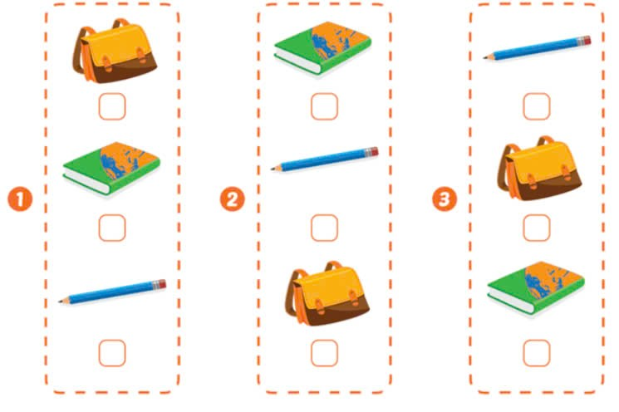

Question 2. Listen and circle the correct picture (1,5pt)

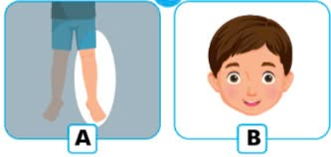  1. | 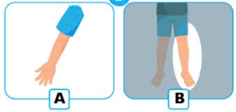  2. | 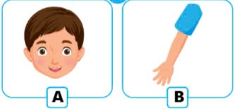  3.

Question 3. Listen and circle the correct letter (2pt)

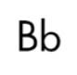  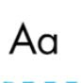  1. | 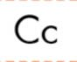  2.
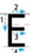  3. | 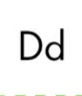  4.
PART II. READING
Question 4. Circle the odd one out (1.5pt)
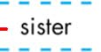  1.    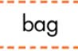 | 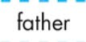  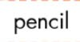    2. | 3.      

Question 5. Read and match (1.5 pts)
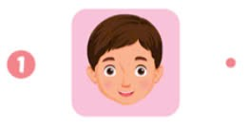 | 
 | 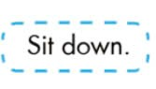
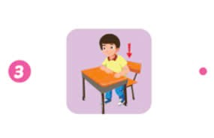 | 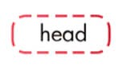
Question 6: Read and circle (A, B or C) (1pt)

  1.  - This is my father.  - This is my mother.  - This is my brother. |   2.  - It’s a snake.  - It’s a monkey.  - It’s a bear.

Question 7: Look and write the missing letter (1pt)

  1.  Touch your a__m. | 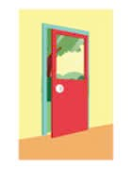  2.  This is a ___oor.
  3.  This is an eleph__nt. |   4.  To__ch your head.

