TRƯỜNG TIỂU HỌC  Số báo danh …….. Phòng thi…. | ĐỀ KHẢO SÁT CHẤT LƯỢNG HỌC KỲ I  TIẾNG ANH LỚP 4  NĂM HỌC 2024 - 2025  (Thời gian làm bài: 40 phút)
PART I: Listening
Question 1. Listen and number(1pt)

- 2 B. 1 C. 3 4 D.

Question 2. Listen and circle (1pt)
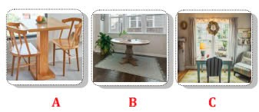  - Where is the table? | 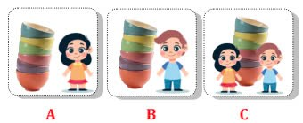  2. Whose bowls are they?
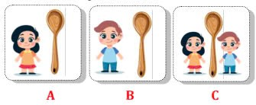  3. Whose spoon is it? | 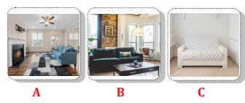  4. Where is the sofa?
Question 3. Listen and tick (1pt)
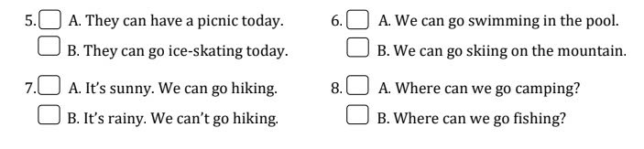
jmany
4.
3.
2.
1..
Question 4. Listen to the question and circle the correct answer (0,5pt)
1. A. We are playing football.  B. In the park. | 2. A. It’s cold and snowy.  B. It’s hot and sunny.
Question 5: Odd one out (1,5 pts)
1. a. beach b. forest c. mountain d. ice-skate
2. a. weather b. cloudy c. snowy d. stormy
3. a. clever b. kind c. pleasant d. twins
4. a. messy b. fridge c. plate d. sink
5. a. animals b. hands c. legs d. wings
6. a. soft drink b. sandwich c. spaghetti d. pizza
Question 6: Choose the best answer A, B, C or D to complete the sentences: (1,5 pts)
1.We can’t have a picnic in the park today because it’s so……………..
a. warm b. rainy c. sunny d. stormy
2. The sheep haven’t got ………
a. wings b. legs c. fur d, tails
3. The monkey has got two ……..
a, hands b, wings c, tails d, head
4. Have you got plants on the farms?
a. Yes, we have b. No, we have c. Yes, we haven’t d. No, we don’t
5. What can we do on the lake? - We can ………………….
a. walk the dog b. fly a kite c. pitch a tent d. ice- skate
6. _________ can we do near the sea?
a. What b. When c. Where d. Whose
Question 7: Choose the words from the box (1,5 pts)
1. The boxes ……. are.………on the floor.
2. It’s …… sunny …..…….. We can go to the beach.
3. There is a fridge ……… next ……….. to the sink.
4. They can go……… hiking …………. on the mountain.
5. It isn’t windy this afternoon. We ….. can’t ………. fly a kite.
6. …… have ………… you got an egg for your lunch?
Question 8: Reorder these words to make sentences (1pt)
1. summer/weather/is/What/like/in/the/? /
……What is the weather like in summer? ………..
2. playing /hide-and-seek/me/with/they/are/.
……They are playing hide- and - seek with me.……….
3. cooking/are/they/kitchen/now/in/the/.
……They are cooking in the kitchen now ……..
4. Where/Peter/Alex/and/playing/games/boards/are/? /
………Where are Peter and Alex playing board games ? ………..
Question 9: Look at the pictures and write one word only to complete sentences (1pt):
  1. My cousin is …………………….. |   2. My friends are……………….
  3. His father is ………………….. |   4.They are…………………..

Đáp án tiếng Anh 4
Question 1. Listen and number(1pt)
1B 2A 3C 4D
Question 2. Listen and circle (1pt)
1A 2B 3A 4B
Question 3. Listen and tick (1pt)
1B 2A 3A 4B
Question 4. Listen to the question and circle the correct answer (0,5pt)
1A 2B
Question 5: Odd one out (1,5 pts)
1.d. ice-skate
2.a. weather
3.d. twins
4.a. messy
5. a. animals
6. a. soft drink
Question 6: Choose the best answer A, B, C or D to complete the sentences: (1,5 pts)
1.d
2. a.
3. a,
4. a.
5. d.
6. a
Question 7: Choose the words from the box (1,5 pts)
- are
- sunny
- next
- hiking
- can’t
- have
Question 8: Reorder these words to make sentences; (1 pt)
1, What’s the weather like in summer?
2, They are playing hide- and – seek with me.
3, They are cooking in the kitchen now.
4, Where are Alex and Peter playing board games? / Where are Peter and Alex playing board games?
Question 9: Look at the pictures and write one word only to complete sentences: (1 pt)
1. clever
2. funny/ cheerful
3. polite
4. twins

