UBND HUYỆN VĨNH BẢO  TRƯỜNG TH HIỆP HOÀ | BÀI KIỂM TRA CUỐI HỌC KỲ I  TIẾNG ANH LỚP 4  NĂM HỌC 2024 - 2025  (Thời gian làm bài: 40 phút)
I. LISTENING
Question 1. Listen and number (1pt)
a.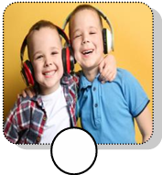 b.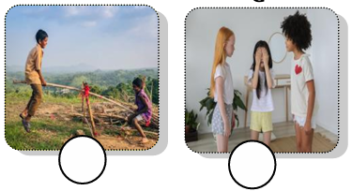 c. 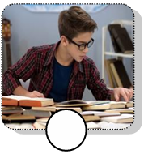 d.
Question 2. Listen and circle the correct picture (1pt)
1. Where is the table? 2. Whose bowl are they?
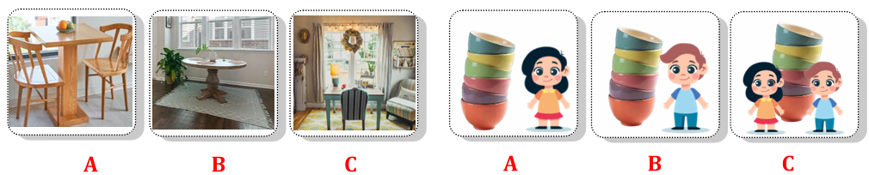
3. How many cupcakes are there? 4. What is your favourite drink?
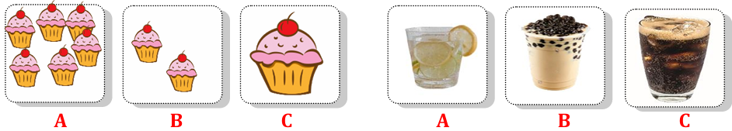
Question 3. Listen and tick (1pt)
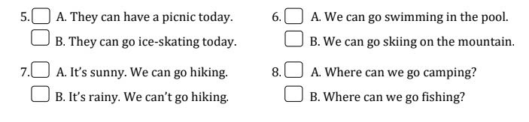

Question 4. Listen to the question and circle the correct answer. (0,5pt)
1. A. He’s jumping rope. 2. A. They’re playing basketball.
B. She’s jumping rope. B. We’re playing on the seesaw.
II. READING
Question 5. Odd the one out (1.5pt)
1. A. daughter B. son C. father D. polite
2. A. messy B. plate C. table D. sofa
3. A. hands B. fur C. legs D. tails
4. A. vegetables B. yogurt C. twenty D. pizza
5. A. tidy B. cloudy C. snowy D. rainy
6. A. beach B. camping C. forest D. moutain
Question 6. Read and choose the correct answer (1.5pt)
1. The cows haven’t got _____________________.
A. tails B. tail C. hand D. hands
2. We can’t make a campfire today __________________ it’s rainy.
A. but B. can C. because D. Le
3. Can we go swimming in the ___________? No, we can’t.
A. pool B. sea C. forest D. river
4. ________ are they watching a film? – In the cinema.
A. When B. What C. Where D. Why
5. The monkey has got two ___________________.
A. hands B. wings C. heads D. tails
6. My grandpa has got some fruit trees______________ the farm.
A. for B. on C. to D. under
Question 7. Fill in the blank with the given words (1,5pt)

1. There are ____ plates ____on the table.
2. ____ How____tidy is his bookshelf? - It’s very tidy.
3. I_____ would ___ like two pieces of pizza.
4. My favourite food is_____ spaghetti _______.
5. The green box is___ between _____ the red box and the yellow box.
6. How____ many ___ sandwiches has she got? She’s got 21.
Question 8. Reorder the words to make the correct sentence. (1pt)
1. is / weather/ today / The / sunny /.
____The weather is sunny today. __________
2. Are / tree / they / the / climbing /?
___Are they climbing the tree? _______
3. are / My grandma / and / reading / grandpa / books /.
____My grandma and grandpa are reading books. ______
4. video / your friends / Where / playing / are / games /?
____Where are your friends playing video games? ________
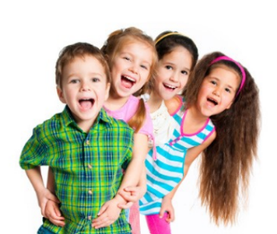
Question 9. Look and write (1pt)

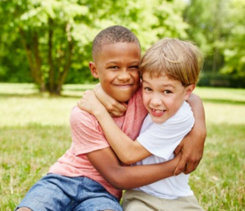
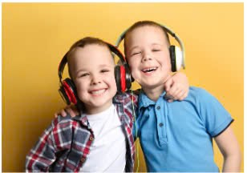

1. ____twins_____ 2. __clever_____ 3. ____cheerful___ 4. ___friendly___

