UBND HUYỆN VĨNH BẢO  TRƯỜNG TH HIỆP HOÀ | BÀI KIỂM TRA CUỐI HỌC KỲ I  TIẾNG ANH LỚP 4  NĂM HỌC 2024 - 2025  (Thời gian làm bài: 40 phút)
NAME: …………………….CLASS: ………
I. LISTENING
Question 1. Listen and number (1pt)
a. 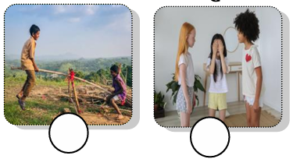 b. 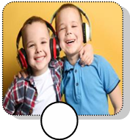 c. 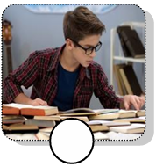 d.
Question 2. Listen and circle the correct picture (1pt)
1. What is he eating?  A B C | 2. What would you like to drink?  A B C
3. What would you like to eat?  A B C | 4. How many cookies have you got?  A B C
Question 3. Listen and tick (1pt)
1. A. The fish haven’t got wings.  B. The chicken has got wings. | 2. A. The goat has got white fur.  B. The goat has got black fur.
3. A. We have got animals on the farm.  B. We have got plants on the farm. | 4. A. The horses have long legs.  B. The horses have long tails.
Question 4: Listen the questions and choose the correct answer (0.5pt)
1.A. It’s cold and snowy  B. It’s sunny and windy | 2. A. She’s riding a horse  B. They’re playing hide-and-seek.
Question 5: Odd one out (1.5pt)
1.A. go hiking B. forest C. pitch a tent D. go camping
2.A. swim B. rainy C. sunny D. windy
3.A. father B. daughter C. hard-working D. son
4. A. between B. bookshelf C. next to D. behind
5. A. his B. my C. spoon D. their
6. A. messy B. dining room C. kitchen D. bedroom
Question 6: Choose the best answer A, B, C or D to complete the sentences (1.5pt)
1. ________ are they watching a film? – In the cinema.
a. When b. What c. Where d Why
2. The cows haven’t got ___________
a. tails b. legs c. hands d. wings
3. We can’t make a campfire today __________________ it’s rainy.
a. but b. can c. because d. and
4. Have you got sheep on the farm? - ________________.
a. Yes, we haven’t b. No, we haven’t c. No, we have d. No, we don’t
5. The _____________has got two legs.
a. cow b. chicken c. horse d. sheep
6. We can ________________ ice hockey today because it’s snowy.
a. go b. make c. play d. run
Question 7: Choose the words from the box (1.5pt)
tidy | favourite | twenty-one | our | How many | bubble tea
1………….……….. oranges have you got? I’ve got twenty oranges.
2. How…….…….. is his room? It’s very tidy.
3. What is your…….…………..… food? My favourite food is vegetable.
4.Whose spoons are they? They’re……..………spoons.
5.Would you like some………………….? Yes, please.
6. How many pieces of pizza have you got? I have…………………………... pieces of pizza.
Question 8: Reorder these words to make sentences (1pt)
1. winter / weather / What’s / like / in / the/?
………………………………………………………………………….
2. cold / It’s / and / today / windy/.
…………………………………………………………………………..
3. playing / are / They / living room /games /in / board /now/ the /.
…………………………………………………………………………..
4. they / Are / the / climbing / tree /?
…………………………………………………………………………..
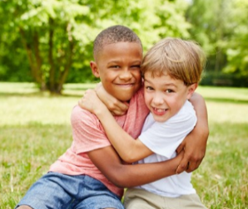

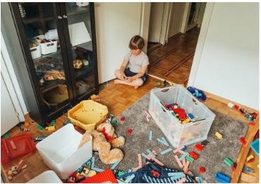
Question 9. Look and write (1pt)
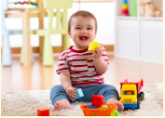
1. ______________ 2. ____________ 3. ______________ 4. _____________

