UBND HUYỆN VĨNH BẢO  TRƯỜNG TH HIỆP HOÀ | ĐỀ KHẢO SÁT CHẤT LƯỢNG CUỐI HỌC KỲ I  MÔN TIẾNG ANH LỚP 1  NĂM HỌC 2024 – 2025  (Thời gian làm bài: 40 phút)
Name: ………………………….. Class: ………………………..
I. LISTENING
Question 1. Listen and tick () (1.5 pt)
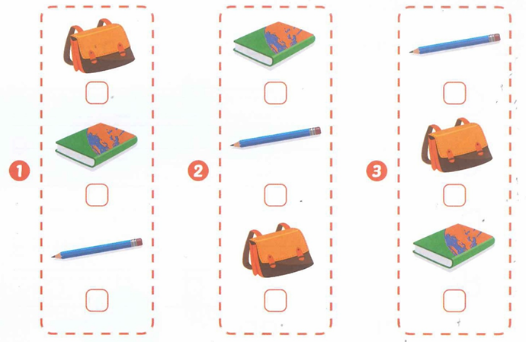
Question 2. Listen and circle the correct picture (1.5 pt)
1.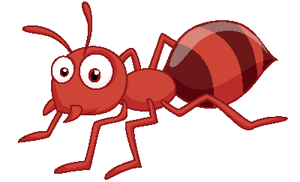 
A. ☐ B. ☐
A. ☐ B. ☐
2.  | 3. 
A. ☐ B. ☐ | A. ☐ B. ☐

Question 3. Listen and circle the correct letter (2pts)
1. Cc Dd 3. Cc Gg
2. Gg Dd 4. Gg Hh

II. READING
Question 4. Circle the odd one out (1.5 pt)
1. 
2. 
3.   
Question 5. Read and match (1.5pt)
1. Touch your head. | a. 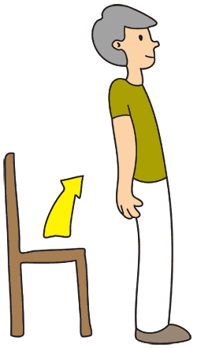
2. It’s a pink flower. | b. 
3. Stand up, please.. | c. 
Question 6. Read and circle (A, B or C) (1pt)
1.  | 2. 
A. I like cats.  B. I like dogs.  C. I like birds. | A. This is a snake.  B. This is my sister.  C. This is my mother.
Question 7. Look and write the missing letter (1pt)
1. 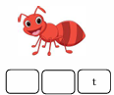 2. 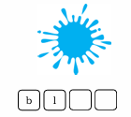3. 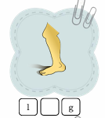4. 