ĐỀ 10 (TR.D)
PART I. LISTENING
Question 1. Listen and number (1pt)
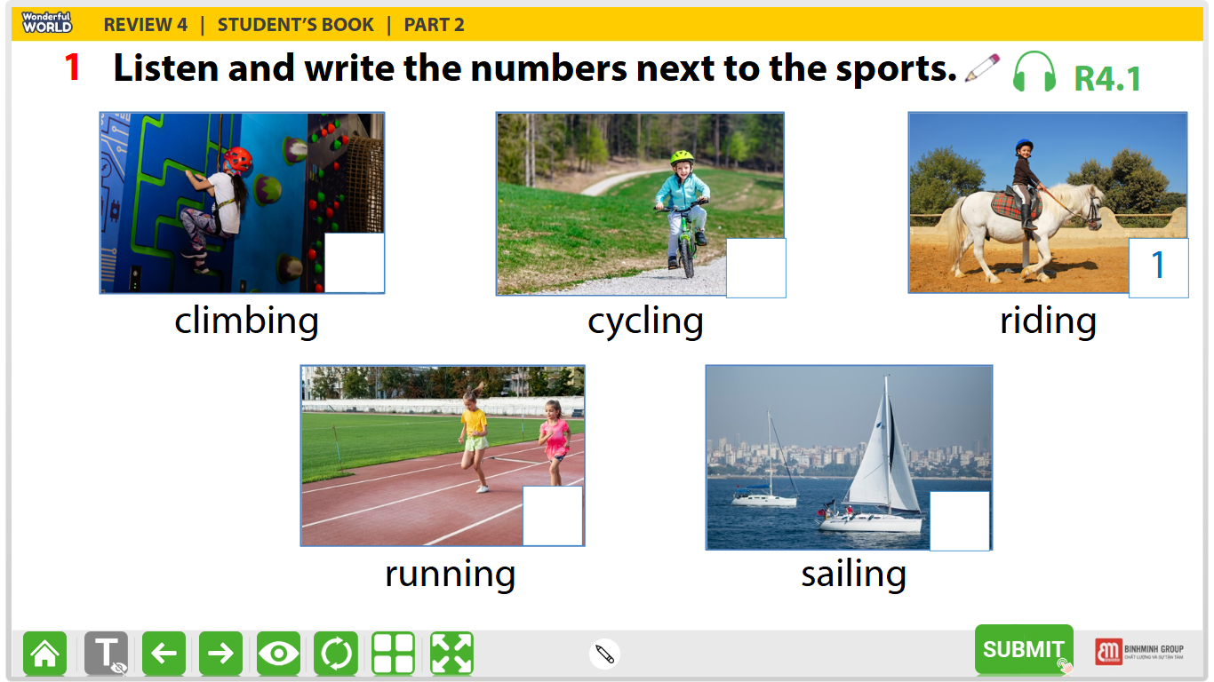
Question 2. Listen and write T for True or F for False (1pt)
 | T | F
- Barcelona is a large city in Spain.
- La Rambla is a small street in Barcelona’s city centre.
- In La Rambla, you can go shopping or have a snack is a café.
- The Sagrada Familia is a large church in Barcelona.
Question 3. Listen and circle the correct answers (1pt)
- What animal is she talking about?
- The tiger B. the crocodile C. the bear
- How long are crocodiles?
- 6 metres B. 7 metres C. 8 metres
- What do crocodiles eat?
- They eat vegetables: carrots, potatoes, tomatoes…….
- They eat a lot of fish, birds, snakes and they also eat very big animals.
- They eat a lot of apples, pears, bananas……
- How long do they usually live?
- 70 years B. 60 years C. 90 years
PART I. PRONUNCIATION
Question 4. Circle the odd one out (1.25pt)
1. | A. wanted | B. stopped | C. needed | D. visited
2. | A. looked | B. worked | C. wanted | D. touched
3. | A. needed | B. wanted | C. started | D. talked
4. | A. waited | B. touched | C. worked | D. walked
5. | A. looked | B. watched | C. liked | D. visited
PART III. READING AND WRITING
Question 5. Choose the best answer (1.25pts)
- Children …………… watch TV many hours a day.
- Should B. must C. shouldn’t D. are
- Mark liked the songs, but he……………. the book.
- Don’t like B. not like C. isn’t like D. didn’t like
- He …………. a horse at present .
- is riding B. ride C. rides D. are riding
- Did Stella go to the concert yesterday?
- No, I don’t. B. No, she didn’t. C. Yes, she didn’t. D. Yes, I did.
- ………….. was Charlie Chaplin? – He is an actor.
- What B. Who C. Why D. Where
Question 6: Read the passage and circle the correct answer (1.25pt)
Deep underground, there is a special heat: geothermal energy (geo means "earth" and thermal means "heat" in Greek). We need energy to light our homes and cook. The sun and wind provide clean energy, but geothermal energy can help people even more.
The Boiling River, deep in the Amazon rainforest, has very hot water (up to 99°C). This water is dangerous for animals. Scientists are studying the river to understand geothermal energy better. They also protect other parts of the Amazon. They don't want people to cut down trees and destroy the rainforest. We hope that people will save the environment and save geothermal energy.
- What do you call the special energy deep underground?
- Geothermal energy B. wind and fire C. the sun and wind
- What do the sun and wind provide?
- water B. fire C. clean energy
- Where is the Boiling River?
- In Barcelona B. In the Amazon C. in Rome
- How hot is the water in the Boiling River?
- Up to 77 ˚C B. up to 88 ˚C C. up to 99 ˚C
- Why are scientists studying the river?
- to understand geothermal energy better.
- to light our homes and cook.
- to cut down trees and destroy the rainforest.
Question 7. Find and circle the mistakes. (1pt)
1 Last night, my family sleeps in a hotel.
A B C D
2 Mary went shopping with his mother last weekend.
A B C D
3 Tom bought a pizzas from Little Italy restaurant last night.
A B C D
4 When I was a child, my mum tell me many bedtime stories.
A B C D
Question 8. Arrange the words to make sentences (1.25pt)
1. to the beach / to swim / They / often /go/.  - They often go to the beach to swim.  - They go often to the beach to swim.  - They often to swim go to the beach. | 2. went to / the zoo / to see / animals / We/.  - We went to the zoo to see animals.  - We went to see animals to the zoo.  - We to see animals went to the zoo.
3. plays / the / She / after school / to / piano / relax/.  A. She plays to the guitar relax after school.  B. She plays the guitar after school to relax.  C. She plays after school the guitar to relax | 4. friends / Cheetah cubs / play / need / to / with /.  A. Cheetah cubs need play with to friends.  B. Cheetah cubs play with friends need to.  C. Cheetah cubs need friends to play with.
5. some / bought / a / eggs / make / to / cake / He /.
- He bought some eggs to make a cake.
- He make a cake to bought some eggs.
- He bought a cake to make some eggs.
Question 9. Look at the picture and write the words (1pt)
 | 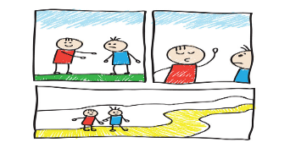 | 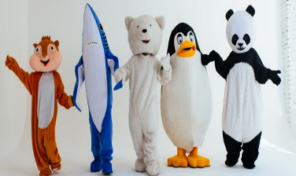 | 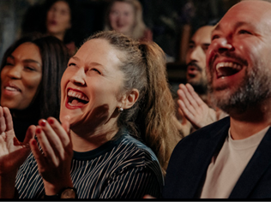
1. | 2 | 3. | 4.

