UBND HUYỆN VĨNH BẢO  TRƯỜNG TH HIỆP HOÀ | BÀI KIỂM TRA ĐỊNH KÌ HỌC KỲ II  NĂM HỌC 2024 – 2025  TIẾNG ANH LỚP 5  (Thời gian làm bài: 40 phút)
Name:………………………………. Class: ……….
PART I. LISTENING
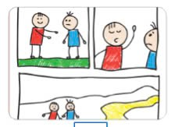
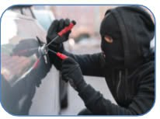


Question 1. Listen and number (1pt)
d...
c..
b..

Question 2. Listen and tick True (T) or False (F) (1pt)
 | T | F
1. My father watched an interesting TV show last night.
2. I travelled to Singapore with my friends last year.
3. My mother learned to play the piano when she was a child.
4. I wanted to listen to some rock music yesterday.
Question 3. Listen and circle the correct answers (1pt)
1. Which animal is she talking about?

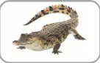
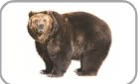
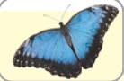
d
c
a.
b....

2. How long are crocodiles?
a. 6 metres b. 5 metres c. 7 metres d. 8metres
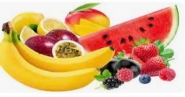
3. What do crocodiles eat?
d
c
b
a

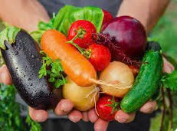
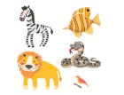

4. Where do crocodiles usually live? - They live in the ______________.
a. house b. park c. field d. river
Part II: Pronunciation
Question 4: Circle the word which has pronounced differently. (1,25pts)
1. a. jumped | b. watched | c. played | d. talked
2. a. pointed | b. needed | c. wanted | d. listened
3. a. asked | b. visited | c. worked | d. stopped
4. a. touched | b. travelled | c. liked | d. danced
5. a. visited | b. climbed | c. cycled | d. loved
PART III. READING AND WRITING
Question 5. Read and choose the best answer (1.25pts)
1. Linda …...................in the pool at present.
a. swimming b. is swimming c. swims d. is swiming
2. People should................................... exercise every day.
a. do b. doing c. does d. did
3. We …..................to the amusement park yesterday, but she …...................to the cinema.
a. go/ didn’t go b. went / didn’t go c. went/ didn’t went d. went / didn’t gos
4. She didn’t …................................her grandparents last Sunday.
a. visits b. visiting c. visited d. visit
5. 5. She goes to the sport centre three ____________ a week.
a. time b. go c. times d. once
Question 6: Read and choose the best answer
Deep underground, there is a special heat: geothermal energy (geo means "earth" and thermal means "heat" in Greek). We need energy to light our homes and cook. The sun and wind provide clean energy, but geothermal energy can help people even more.
The Boiling River, deep in the Amazon rainforest, has very hot water (up to 99°C). This water is dangerous for animals. Scientists are studying the river to understand geothermal energy better. They also protect other parts of the Amazon. They don't want people to cut down trees and destroy the rainforest. We hope that people will save the environment and save geothermal energy.
1. What does the word “geo” mean?
a. moon b. earth c. land d. sun
2. How do you call the special energy deep underground?
a. geothermal energy b. environment c. rainforest d. scientists
3. Where is the Boiling River? – In the________________.
a. Red River b. Nile River c. Amazon rainforest d. Mekong river
4. Is this water dangerous for animals?
a. Yes, it is b. No, it is c. No, it isn’t d. Yes, it does
5. We hope that people will ……… the environment and geothermal energy.
a. close b. save c. cut down d. destroy
Question 7: Find and circle the mistakes. (1pt)
1. Jim buys some orange juice from the restaurant yesterday.
A B C D
2. Did you travelled to Thailand with your friends last year?
A B C D
3. When I am tthree years old, my mum bought me a lot of toys.
A B C D
4. We went to the theatre last night, but we didn’t went to a restaurant.
A B C D
Question 8. Arrange the words to make the meaningful sentences (1pt)
1. are / than / snakes / longer / worms.
a. Worms are longer than snakes. b. Snakes are longer than worms.
c. Snakes are than longer worms. d. Worms than longer snakes.
2.often / they/ to /swim / beach / go/ the / to.
a. They often go to the beach to swim. b. They often go to swim to the beach.
c. They go often to the beach swim to. d. They go to the beach often to swim.
3. dog / my / really/ cute /is.
a. My cat really is cute. b. My dog is really cute.
c. My dog is cute really. d. My is dog really cute.
4. some / bought / a / eggs / make / to / cake / he.
a. He bought a eggs to make some cake. b. He bought a cake to make some eggs.
c. He bought some eggs to make a cake. d. He makes some eggs to bought a cake.
5. elephants / lions / stronger / Are / than / ? /
a. Are elephants than lions stronger? b. Are lions elephants than stronger?
c. Are than elephants lions stronger? d. Are elephants stronger than lions?
Question 9: Look at the pictures and write the words
 | 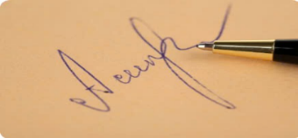 |   
        

