ĐỀ 1 (GB)
PART I. LISTENING
Question 1: Listen and number: (1.0pt)
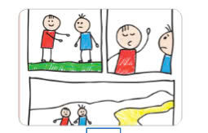

a. 2-3-4-1
b. 2-1-4-3
c. 4-3-2-1
Question 2. Listen and Tick T for True or F for False ( 1pt) 1.Barcelona is a large city in Spain.
a. T b.F
2.La Rambla is a small street in Barcelona’s city centra.
a. T b.F
3.In La Rambla,you can go shopping or have a snack in a café.
a. T b.F
4.The Sagrada Familia is a large chuch in Barcelona.
a. T b.F
Question 3. Listen and circle the correct answers (1pt)
1.Which animal is she talking about?
A B 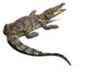 C 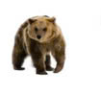
2.How long are crocodiles?
A. 6 metres B. 7 metres C. 8 metres
3. What do crocodiles eat?
A. B. 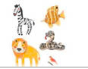 C. 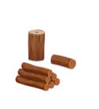
4.Where do they live? They live in the _____________
A. 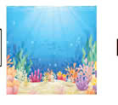 B. 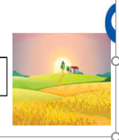 C. 
PART II- PRONUNCIATION
Question 4.Circle the word which has pronounced differently( 1,5pts)
1.a. enjoyed b. played c. arrived d. landed
2.a. visited b. watched c. liked d. looked
3.a. needed b. wanted c. started d. talked
4.a. waited b. touched c. worked d. walked
5.a. stopped b. pointed c. jumped d. asked
PART III-READING AND WRITING
Question 5. Choose the best answer (1.5pts)
1.Children_________________ watch TV many hours a day.
a.should b.shouldn’t c. shouln’t d. not should
2.He ___________ his bike so fast at the moment.
a. rided b. riding c. rides d.is riding
3.. Anime is a style of ___________ cartoon.
a. American b. Vietnamese c. Japanese d. Italian
4.. Mickey Mouse is a famous_____ character.
a. drama b. picture c. cartoon d. singer
5.A football player ____________ practise every day and __________eat junk food.
a. mustn’t/ must b. must/ must c. musn’t / musn’t d. must/ mustn’t
Question 6. Read and the correct answer ( 1pt)
"Deep underground, there is a special heat: geothermal energy (geo means 'earth" and thermal means "heat" in Greek).
We need energy to light our homes and cook.
The sun and wind provide clean energy, but geothermalenergy can help people even more.
The Boiling River, deep in the Amazon rainforest, has very hotwater (up to 99°C). This water is dangerous for animals.
Scientists are studying the river to understand geothermal energy better. They also protect other parts of the Amazon.
They don't want people to cut down trees and destroy the rainforest. We hope that people will save the environment and save geothermal energy.
1.What do people call the special energy deep underground?
a. enviroment b. Jungle c . energy d. geothermal energy
2. What is geothermal energy?
a. Solar energy b. Wind energy c. Heat energy from the Earth d. Water energy
3. Where is the Boiling River?
a. underground b. Jungle c. In the Amazon d. forest
4. How hot is the water in the Boiling River?
a. 100ºc b . 99ºc c. 50ºc d. 90ºc
5. What do we need to do to protect the Amazon rainforest?
a. cut down trees b. Don’t cut down trees c. Don’t destroy the rainforest d. All b & c
Question 7. Find the mistake ( 1pt)
1. My mother learned to play the piano when she was a child
A B C D
2.Did Mary went shopping with her mother last week?
A B go C D
3. Villagers felt safe , so they do not put doors on houses or shops.
A B did C D
4. Jim buys some orange juice from the restaurant yesterday .
A B C D
Question 8. Reoder the words to make the meaningful sentences ( 1pt)
1.went to/ the zoo/ to see/ animals/ we/
a.We went to see the zoo to animals. b. We went to the zoo to see animals.
c.We went to see animals to the zoo. d.We went to animals to see the zoo.
2. stronger/ are/ elepphants/ monkeys / than/
a. Monkeys than stronger elephants. b.Monkeys are stronger than elephants
c. Elephants are than stronger monkeys. d. Elephants are stronger than mokeys.
3.eggs/ bought/ some/ a / make/ he / cake / to/
a.He bought a cake to make some eggs. b. He bought some eggs to make a cake.
c.He bought some egg to make a cake. d. He bought some eggs to make a cakes.
4.is/ a/ really /it/ film / watch/ interesting.
a.It is a interesting really film to watch. b.It is a really film interesting to watch.
c.It is a really interesting film to watch. d.It really is a interesting film to watch.
5.pet/ I/ really/ want/ a/ don’t/ to/ have /
a. I really don’t want to have a pet. b. I don’t really want to have a pet.
c. I don’t want really have to a pet. d. I don’t want to have really a pet.
Question 9 Look at the pictures and write the words (1pt)
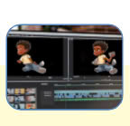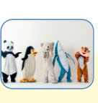

1. a. animated b. cartoon c. character
2. a. advert b. cartoon c. award
3. a. photograph b. autograph c. graph
4. a. director b. studio c. characters

