UBND HUYỆN VĨNH BẢO  TRƯỜNG TH HIỆP HOÀ | ĐỀ KHẢO SÁT CHẤT LƯỢNG HỌC KỲ II  TIẾNG ANH LỚP 5  NĂM HỌC 2024 - 2025  (Thời gian làm bài: 40 phút)
PART I. LISTENING
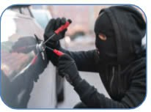


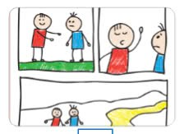
Question 1. Listen and number (1pt)
d...
c..
b..

Question 2. Listen and tick True (T) or False (F) (1pt)
T F
1. Nam wouldn’t like to live in a boathouse.
2. Mia would like to have two floors in her dream house.
3. Linda would like to visit the zoo in the city.
4. Mai would like to go to the beach.
Question 3. Listen and circle the correct answers (1pt)
1. Which animal is she talking about?
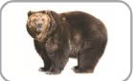

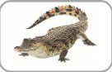

d
c
a.
b....

2. How long are crocodiles?
a. 6 metres b. 5 metres c. 7 metres d. 8metres
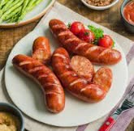

3. What do crocodiles eat?
d
c
b
a
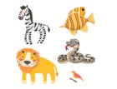
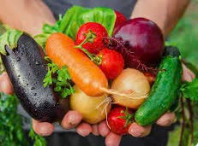

4. How long do crocodiles usually live?
a. 30 years b. 40 years c. 50 years d. 60 years
Part II: Pronunciation
Question 4: Circle the word which has pronounced differently.(1,25pts)
1. a. jumped | b. watched | c. played | d. talked
2. a. pointed | b. needed | c. wanted | d. listened
3. a. asked | b. visited | c. worked | d. stopped
4. a. touched | b. travelled | c. liked | d. danced
5. a. visited | b. climbed | c. cycled | d. loved
PART III. READING AND WRITING
Question 5. Read and choose the best answer (1.25pts)
1. Linda …...................in the pool at present.
a. swimming b. is swimming c. swims d. is swiming
2. People should................................... exercise every day.
a. do b. doing c. does d. did
3. We …..................to the amusement park yesterday, but she …...................to the cinema.
a. go/ didn’t go b. went / didn’t go c. went/ didn’t went d. went / didn’t gos
4. She didn’t …................................her grandparents last Sunday.
a. visits b. visiting c. visited d. visit
5. 5. She goes to the sport centre three ____________ a week.
a. time b. go c. times d. once

Question 6: Read and choose the best answer
Hi. My name’s James. Tomorrow is Saturday and it is so cold outside, so I am not going to go to the park. My Dad and Mum are going to stay at home too, so we are going to play some boards games indoors. Dad isn’t going to win because he always loses. Mum is a better player, but she is going to lose in the end because I’m the best player in my family!
Questions:
1. What are James’ family going to do tomorrow?
a. They are going to go to the park. b. They are going to stay at home.
c. They are going to go on a picnic d. They are going to go swimming.
2. What’s the weather outside like?
a. It’s sunny. b. It’s snowy. c. It’s cold. d. It’s warm.
3. They are going to play _________________indoors.
a. hide-and seek b. football c. some puzzles d. board games
4. Why isn’t Jame’s Dad going to win?
a. Because he always loses. b. Because he is a good player.
c. Yes, he is. d. Because he is better player.
5. Who is the best player in Jame’s family?
a. Jame’s father b. Jame c. Jame’s mother d. Jame’s sister.
Question 7: Find and circle the mistakes. (1pt)
1. Jim buys some orange juice from the restaurant yesterday.
A B C D
2. Did you travelled to Thailand with your friends last year?
A B C D
3. When I am tthree years old, my mum bought me a lot of toys.
A B C D
4. We went to the theatre last night, but we didn’t went to a restaurant.
A B C D
Question 8. Arrange the words to make the meaningful sentences (1pt)
1. are / than / snakes / longer / worms.
a. Worms are longer than snakes. b. Snakes are longer than worms
c. Snakes are than longer worm. d. Worms than longer snakes.
2.often / they/ to /swim / beach / go/ the / to.
a. They often go to the beach to swim. b. They often go to swim to the beach.
c. They go often to the beach swim to. d. They go to the beach often to swim.
3. dog / my / really/ cute /is.
a. My cat really is cute. b. My dog is really cute.
c. My dog is cute really. d. My is dog really cute.
4. some / bought / a / eggs / make / to / cake / he.
a. He bought a eggs to make some cake. b. He bought a cake to make some eggs.
c. He bought some eggs to make a cake. d. He make some eggs to bought a cake.
5. horses / faster / turtles / are / than?
a. Horses are faster than turtles? b. Are horses than faster turtles?
c. Are horses faster than turtles? d. Turtles are faster than horses?
Question 9: Look at the pictures and write the words
 | 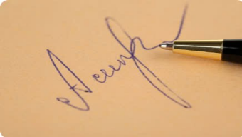 |   
      

