ĐỀ 8 (CM)
I. LISTENING
Question 1: Listen and number
  a. | 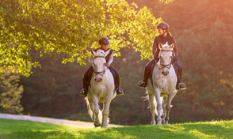  b. | 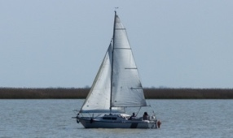  c. | 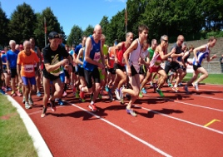  d.
Question 2: Listen and write T for True or F for False
True False
1. Barcelona is a large city in Spain
2. La Rambla is a small street in Barcelona.
3. In La Rambla, you can go shopping or have a snake in a café.
4. The Sagrada Familia is a large church in Barcelona.
Question 3: Listen and circle the correct answers.
1. Which animal is she talking about?
a. lion | b. crocodiles | c. elephant
2. How long are crocodiles?
a. six metres | b. seven metres | c. eight metres
3. What do crocodiles eat?
a. Fish, snake, bird, zebra, lion | b. leaf | c. wood
4. Where do they live?
a. sea | b. house | c. mountain
II. PRONUNCIATION
Question 4: Circle the odd one out.
1. a. looked | b. stopped | c. visited | d. watched
2. a. waited | b. pointed | c. wanted | d. played
3. a. stayed | b. tried | c. touched | d. learned
4. a. needed | b. wanted | c. started | d. talked
5. a. travelled | b. listened | c. asked | d. earned
III. READING AND WRITING
Question 5: Choose the best answer
1. He is ……………now.
a. runing | b. running | c. runed | d. run
2. They are…………….in the sea at present.
a. swim | b. swam | c. swimming | d. swiming
3. Max and Sam ……………to the amusement park yesterday.
a. go | b. went | c. goes | d. going
4. I ……………chess with my friend last night.
a. played | b. playing | c. plays | d. play
5. She saw the film, but she ……………..to play two days ago.
a. did not see | b. doesn’t see | c. didn’t saw | d. don’t see
Question 6: Read the passage and circle the correct answer.
Tomorrow is Saturday and it is so cold outside, so I’m not (1)………………..to go to the park. Dad and mum (2)………to stay at home too, so we are going to (3)………. some board games indoors. Dad isn’t going to (4) …………because he always loses! Mum is better player, but she’s going to (5)…………..in the end because I’m the best player in the family!
1. a. go | b. going | c. went | d. goes
2. a. is going | b. are going | c. is go | d. am going
3. a. play | b. playing | c. played | d. plays
4. a. win | b. to win | c. winning | d. winner
5. a. lose | b. losing | c. lost | d. losen
Question 7: Find and circle the mistakes.
1. Last night, I sleep in a hotel.
A B C
2. I travelled to Thailand with my friends next year.
A B C
3. What do you do yesterday?
A B C
4. They was the inventors of the hot – air ballon.
A B C
Question 8: Arrange the words to make sentences
1. went to/ the zoo/ to see/ animals/ We/.  a. We went to the zoo to see animals.  b. We went to see animals the zoo.  c. We went to see animals to the zoo. | 2. plays/ the/ She/ after school/ to/ piano/relax/.  a. She plays piano to relax the after relax.  b. She plays the piano after school to relax.  c. She play the piano after school to relax.
3. This park/ a/ really/ is/ interesting/ to/ place/ visit  a. This park is a really interesting place to visit.  b. This park is really interesting a place to visit.  c. This park is interesting a place really to visit. | 4. father/ runs/ My/ everyday/ healthy/ to/ keep/.  a. My father runs to keep heathy every day.  b. My father runs every day to keep healthy.  c. My father keep healthy to runs every day.
5. elephant/ stronger/ is / An/ than/ a/ rabbit/.
a. An elephant is stronger than a rabbit.
b. A rabbit is stronger than an elephant.
c. Rabbit is a stronger than an elephant.
Question 9: Look at the picture and write the words
1.  …………………… | 2. 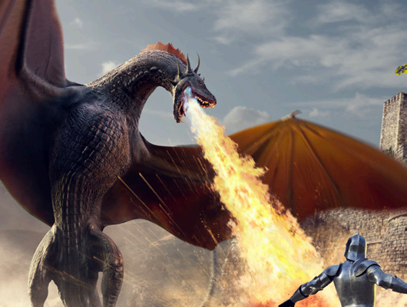 ……………………
3.  …………………… |   ………………………

