UBND HUYỆN VĨNH BẢO  TRƯỜNG TH HIỆP HOÀ | BÀI KIỂM TRA CUỐI HỌC KỲ II  TIẾNG ANH LỚP 2  NĂM HỌC 2024 - 2025  (Thời gian làm bài: 40 phút)

Phần I: LISTENING
Question 1. Listen and tick the box (1,5pt)
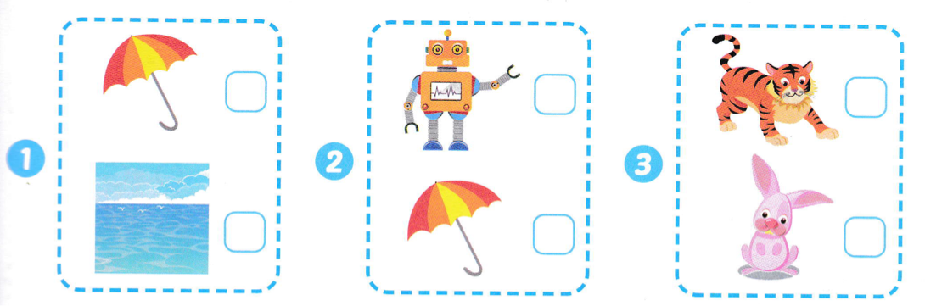
Question 2: Listen and circle the correct word (1.0p)
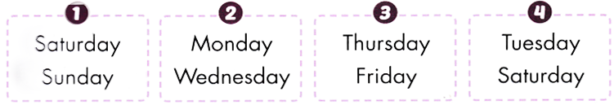
Question 3: Listen and number (1.0p)
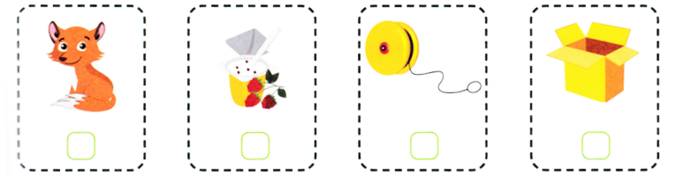
Phần 2: READING
Question 4: Circle the odd one out (1.0p)
- Bus | b. Motorbike | c. plane | d. shirt
- shorts | b. car | c. pants | d. Shorts
- T- shirt . | b. socks | c. dress | d. shirt
- zoo | b. bus | c. plane | d. motorbike
Question 5: Read and tick the box (1.5p).
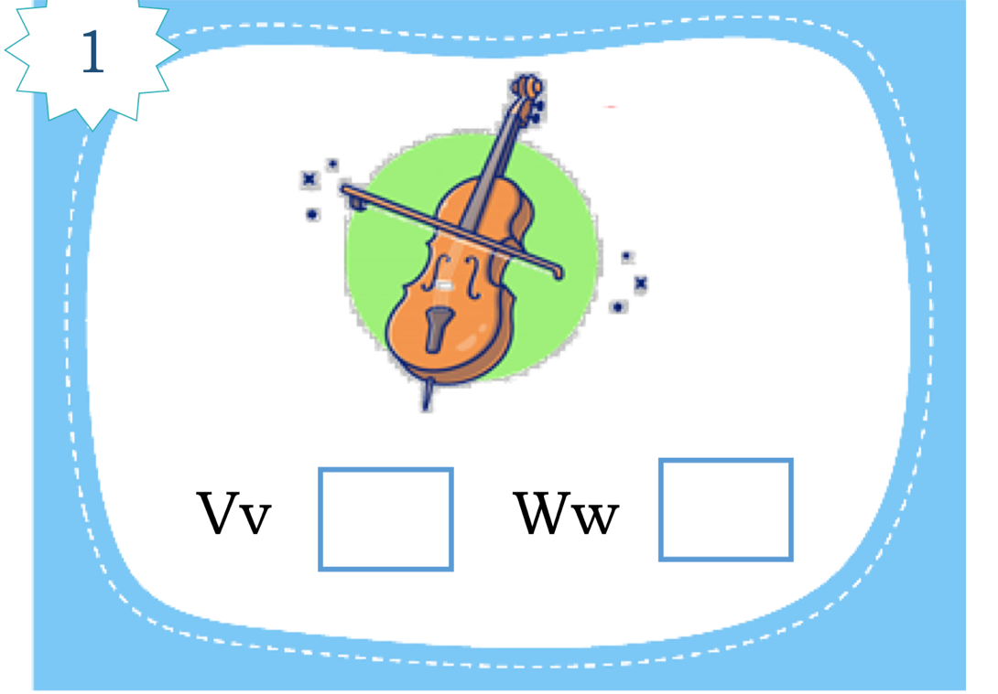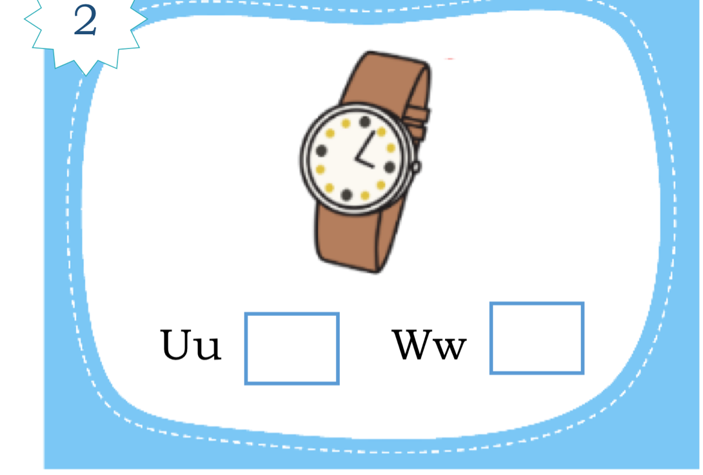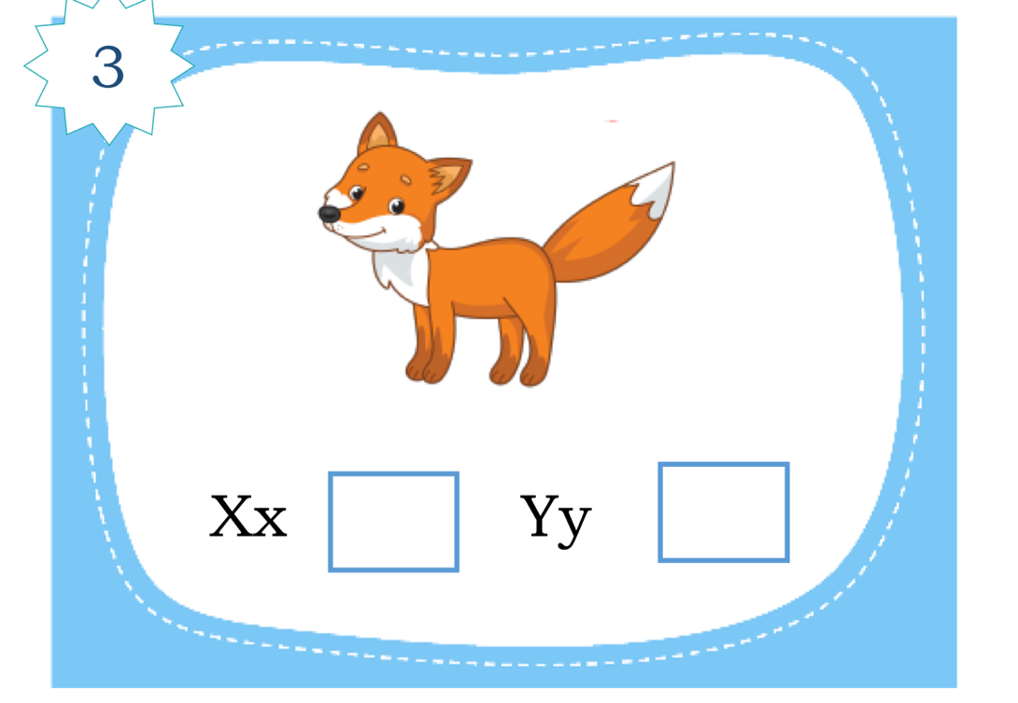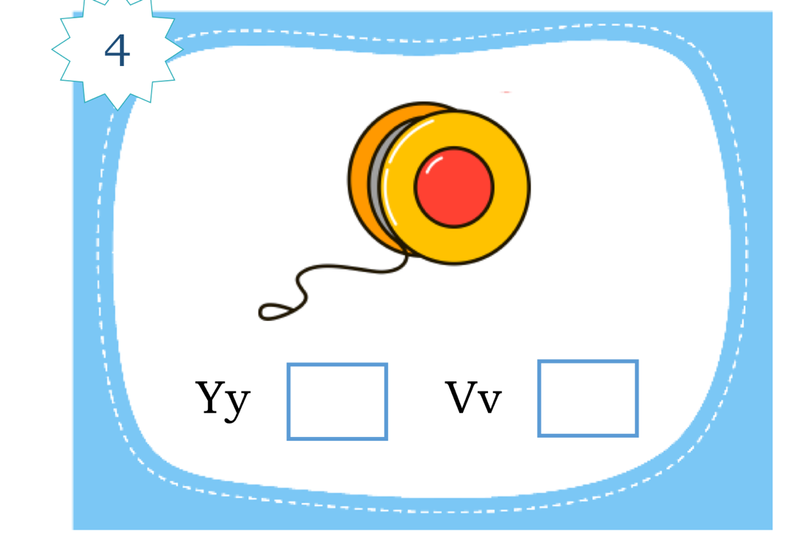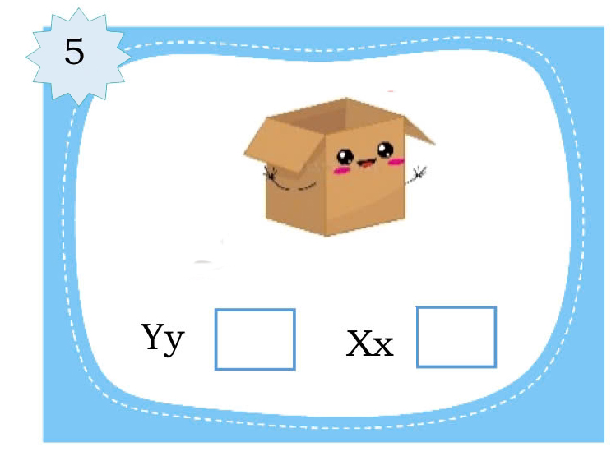
Question 6: Read and match (1.0p)
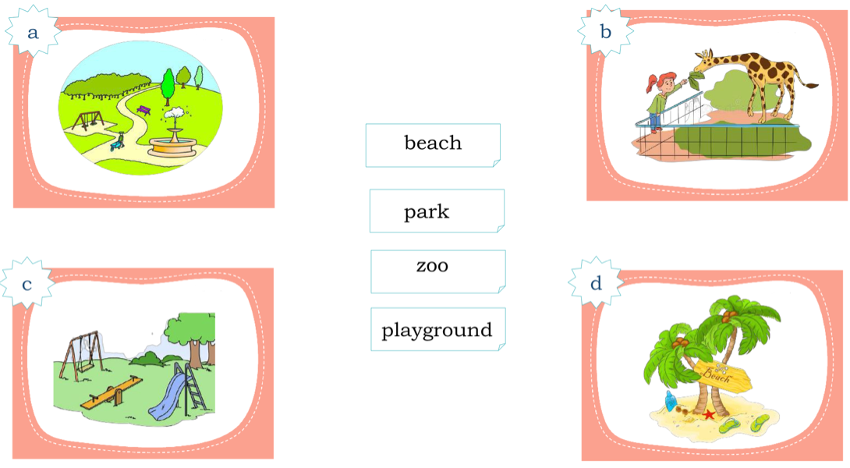
Phần III: WRITING
Question 7: Look and write the missing word (1,5 pt)

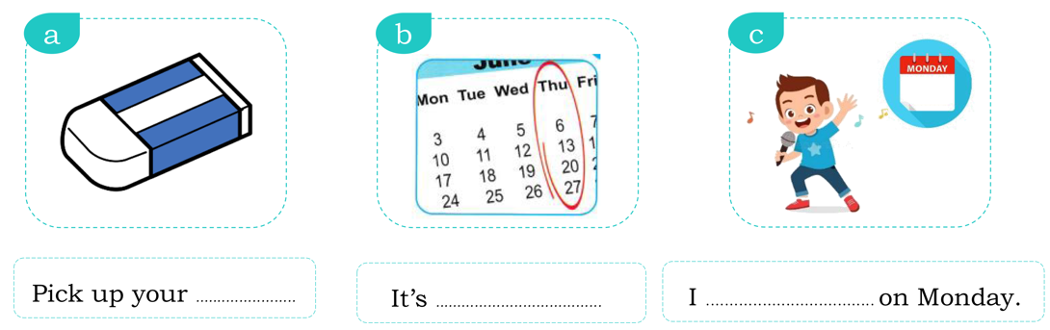Question 8: Reorder the words (1.5p)
- sing/ can / I / songs
________________________________________________________
- my/ pants/ are/ These
________________________________________________________
- Let’s / snacks/ eat
_______________________________________________________________________

