Tiết 7: Class: 3A

Period 81 Unit 12:Lesson 2 Activity 1-3
A. OBJECTIVES:
By the end of the lesson, Ss will be able to:
1. Knowledge:
- understand and correctly repeat the sentences in two communicative contexts (pictures) to ask and answer questions about someone’s job.
- correctly say the words and use Is he / she …………? and Yes, he / she is. / No, he / she isn’t. to ask and answer questions about someone’s job.
- enhance the correct use of Is he / she ………? – Yes, / No, ………..to ask and answer questions about someone’s job in a freer context.
- Vocabulary: cook, farmer, singer, nurse
- Model sentences:
A: Is he / she a cook?
B: Yes, he / she is. / No, he / she isn’t. He’s/ She’s….
- Skills: speaking and listening
2. Competences:
- Critical Thinking: talk about jobs
- Co-operation: ready to help friends in pair work/ group work.
- Oral Communication: speak about someone, ask and answer the questions
3. Attitude/ Qualities:
- Kindness: Help partners to complete learning tasks.
- Honesty: tell the truth about feelings and emotions
B. TEACHING AIDS:
- Teacher: Teacher’s guide Pages 154, 155; audio Tracks 16,17, website sachmem.vn, posters, laptop, pictures, textbook, lesson plan, TV or projector.
- Students: Pupil’s book Page 14, notebooks, workbooks, school things.
C. PROCEDURES:
Stages/Time | Teacher’s activities | Students’ activities
1.Warm- up:  (3’)  2. Presentation  (16’)  3.Practice: (7’)  4.Production: (7’)  5. Homework. (2’) | Game: Pass the ball  *Aims: to create a friendly and active atmosphere in the class to beginning the lesson.  *Procedure:  - T gives Ss a ball.  - T asks Ss to listen to music and transfer a ball around the class.  - When the music stops, Ss who keep a ball have to practice with partner using: What’s his/ her job? and He’s/ She’s……..  - T gives feedback.  - Say “Open your book page 8” and look at “Unit 12, Lesson 2 (1,2,3)”.  Activity 1. Vocabulary.  *Aims: Ss will be able to know the vocabulary in front of starting the new lesson.  *Procedure:  -T elicits the new words  + cook : đầu bếp (picture)  + farmer : nông dân (picture)  + singer : ca sĩ (picture)  + nurse : y tá (picture)  - T models (3 times).  - T writes the words on the board.  - Checking: Rub out and remember  Activity 2. Listen, point and repeat:  *Aims: Ss will be able to understand and correctly repeat the sentences in two communicative contexts (pictures) to to ask and answer questions about someone’s job.  *Procedure:  - Have Ss look at Pictures a and b and identify the characters and jobs in the pictures.  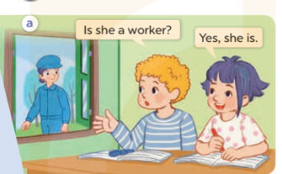  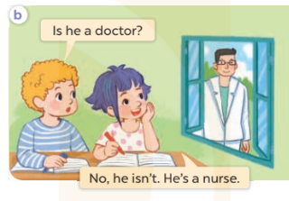  - Play the audio twice (sentence by sentence). Correct their pronunciation where necessary.  - Have Ss to practice the diaguage  - T invites a few pairs to the front of the class to practice.  - T checks pronunciation for ss.  Activity 3. Listen, point and say.  *Aims: Ss will be able to correctly say the words and use Is he / she ………? and Yes, he / she is. / No, he / she isn’t. to ask and answer questions about someone’s job.  *Procedure:  * Model sentences:  - T asks Ss look at picture a, b and helps Ss know the structure from the dialogue.  - T introduces new structure for Ss.  - T explains, models and gives meaning.  - Have Ss repeat the model sentences.  A: Is he / she a cook?  B: Yes, he / she is. / No, he / she isn’t.  *Drill pictures  - Elicit and check comprehension the name of each character.  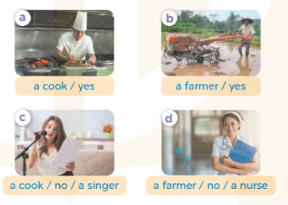  - Run through all the pictures.  - Run through model sentences.  +Run through the question sentences  +Run through the answer sentences  - Have Ss to practise:  + T asks, Ss answer picture a  + Ss ask, T answers picture b  + Group A ask, group B answer picture c  + Group B ask, group A answer picture d  - Ask Ss to work in pairs.  - T controls and corrects.  - Invite a few pairs to come to the front of the classroom, point at the relevant character in each picture, and act out his/her role.  - T gives feedbacks.  Activity 4. Let’s talk.  *Aims: Ss will be able to enhance the correct use of Is he / she ……….? – Yes, / No, ………. to ask and answer questions about someone’s job in a freer context.  *Procedure:  - Have Ss look at the pictures and elicit the jobs  + What can you see in the picture?  +Who are they?  +What’s his/ her job?  - T fills the gaps and writes the sentences on the board.  - T models  - T asks Ss use of Is he / she ……….? – Yes, / No, ………. to ask and answer (groups of four)  - Invite some groups to perform.  - Give feedbacks  *Consolidation  *Aims: Ss will be able consolidate and wrap up the content of the lesson.  *Procedure:  - T asks ss to answer the following questions:  + What have you learnt from the lesson today?  +What are the core values of the lesson? (if the teacher can take from the lesson).  - T review the vocabulary and model sentences.  - T praises some Ss who are hardworking / active/ good…. as well as encourage others to try more.  - Learn the number by heart  - Prepare the new lesson: Unit 12, Lesson 2 (4,5,6). | - Ss listen and keep the ball  - Ss listen to music and play the game  - Ss open their books  -Ss listen and answer  - - Ss listen and repeat  + Choral repetition (3 times).  + Individual repetition (3 ss)  - Ss take note  - Ss look, remember and write  -Look at the pictures and get to know the characters in the pictures.  + In picture a: Bill asks Is she a worker? And Linh answers Yes, she is.  – In picture b: Bill asks Is he a doctor?. And Linh answers No, he isn’t. He’s a nurse.  -Ss listen and repeat in chorus (twice)  -Ss work in pairs to practice  -Ss practice the diaguage  -Ss listen  -Ss look at the picture and answer.  -Ss listen  -Ss listen and repeat  -Ss repeat  - Ss look, listen and answer  + Picture a: a cook / yes + Picture b: a farmer / yes  + Picture c: a cook / no / a singer  + Picture d: a farmer / no / a nurse  -Ss practice in chorus  - Ss practice in chorus  -Ss work in pairs to practice  -Ss listen  -Ss point and say  -Ss go to the board and rold play.  -Ss listen  -Ss look at the picture and answer  + farmer, nurse, singer and cook  -Ss note  - Ss say the completed sentences.  -Ss work in groups  -Ss perform in front of the class.  -Ss answer the questions  - Ss listen  -Ss listen and clap their hands.  -Ss listen and take note

