UBND QUẬN ……………….  TRƯỜNG TIỂU HỌC ………………  Họ và tên: …………………….………  Lớp: ………………….……….……… | ĐỀ KIỂM TRA ĐỊNH KÌ CUỐI HỌC KÌ II  NĂM HỌC 2024- 2025  MÔN TIẾNG ANH - LỚP 5  (Thời gian làm bài 35 phút)  Mã phách  Giám thị: …………………………………....

Điểm: …………  Bằng chữ: ……………..… | Giám khảo  ……………………  ………………………………………… | Nhận xét của giáo viên  …………………………….……………………………………………………………  ………………………….……………….... | Mã phách

PART I. LISTENING (2 points)
Questions 1: Listen and match. There is an example. (1pt)
Example (0): “I want a banana.”
 |  | 
A |  | B
 |  | 
C |  | D
 |  | 
E |  | F
 | 
 | G

0 | A
 | ⬜ |  | ⬜
 | ⬜ |  | ⬜
Questions 2: Listen and tick A, B, or C. There is an example. (1pt)
Example:
(0) You hear: ‘ Good morning, John. How are you??’ Answer: A
- I’m fine, thank you.

- I’m 14 years old.
C. No, I’m not old.

- .....................................
- No, she is not a doctor. | ⬜
- Yes, she is a singer. | ⬜
- Yes, she teaches Math. | ⬜
- ......................................
- I don’t go to school today. | ⬜
- In 20 minutes. | ⬜
- It’s 7:30 now. | ⬜
- ......................................
- It is 50000 dong. | ⬜
- It is not expensive. | ⬜
- It leaves at 10:30. | ⬜
- ......................................
- It is across the street. | ⬜
- It is very big. | ⬜
- It is crowded now. | ⬜
PART II. READING (2 points)
Question 3: Look and read. Write the correct words. There is one example (1 pt).
 | 
A shark | Sad
 | 
A calendar | A sweater
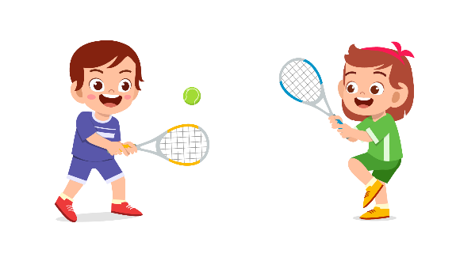 | 
Tennis | School

A pen
Example
(0) | You go to this place every weekday. You meet your  teachers and friends here. | school

1 | You use this to write on papers. | ___________
2 | This animal swims in the ocean and has sharp teeth. | ___________
3 | This sport needs two people to play with a ball. | ___________
4 | You feel this when you have bad marks. | ___________
Questions 4: Read the paragraph and tick True or False (1pt)
My name is Minh. Last week, I had a flight to Danang. The flight was good because the seat in my airplane was comfortable. I also had lunch on the airplane. The flight attendant brought food and drink to my seat. I didn’t need to buy anything. There was also a small window near my seat so I could see the sky and the cloud. It was so beautiful. Then, the airplane flew across the ocean. Everything looked really small from above. I could not see any people down there. I miss everything and hope that I can go again soon.
 | True | False
0. Minh went to Danang last week. | X
1. The seat in the airplane was uncomfortable.
2. He had to buy food and drink.
3. He sat near the window.
4. The airplane did not fly across the ocean.
PART III. LANGUAGE (2 points)
Question 5: Circle one odd one out. (0.5 pt)
0. | a. party | b. small | c. big | d. nice
1. | a. beard | b. mustache | c. nose | d. back
2. | a. chef | b. tourist | c. astronaut | d. vet
Question 6: Circle one word that its stress is different from others. (0.5pt)
0. | a. November | b. Saturday | c. October | d. November
1. | a. Christmas | b. toothache | c. singer | d. cartoon
2. | a. beside | b. upstairs | c. earache | d. fifteen
Question 7: Choose the best answer to complete the sentences. (1pt)
0. Can you play the piano? – No, I ........................
a. does | b. don’t | c. can’t | d. doesn’t
1. What did they play yesterday? – They ........................ the guitar.
a. plaied | b. playing | c. plays | d. played
2. Where will he go tomorrow? – I think he ........................ to Da Lat.
a. goes | b. go |  | c. will go | d. went
3. How does he kick the ball ? – He kicks the ball …………………..
a. hardly | b. quick | c. good | d. well
4. There is a “Stop” sign ahead. We ………….. go into that street.
a. mustn’t | b. can | c. shouldn’t | d. would
PART IV. WRITING (2 points)




Questions 8: Order the words. There is an example (0). Example: (1pt)

can

he

a

bike.


ride

He can ride a bike.
got/ pen/ you/ Have/ a/ schoolbag?/ in/ your | 
1. ______________________________________.
washing/ Do/ ever/ you/ do/ up?/ the | 
2. ______________________________________.
When/ listen/ you/ do/ news?/ the/ to | 
3. ______________________________________.
buy/ a/ you/ burger/ I/ will/ for/ tomorrow/?/ | 
4. ______________________________________.
Question 9: Write a short letter of about 30-40 words to your friend about your home. (1pt)
You should write about:
1.Who lives there
2.Where the house is
3. How many rooms there are
4.What you usually do at home
5.Invite your friend to come to your house

PART V. SPEAKING : Question 10 (2pts)

Hi ________,
I am writing to tell you about my house.
I live with ________________________________________________________.
It is _____________________________________________________________.
There are ________________________________________________________.
I usually ________________________________________________________
________________________________________________________________.
I’d like to invite you _______________________________________________.
Part 1: Interviewing (0,5 pt)
Part 2: Responding to physical prompts. (1,0 pt)
Part 3: Describing the picture (0,5 pt)

