UBND HUYỆN CÁT HẢI  TRƯỜNG TH NGUYỄN VĂN TRỖI |  |  | ĐỀ KIỂM TRA CUỐI KÌ I  Năm học: 2024 - 2025  Môn: Tiếng Anh 4 Thời gian: 35 phút
 | Listening, reading and writing | Speaking | Total | Giám khảo | Số phách
Mark
Comments

I.LISTENING
Task 1. Listen and number . 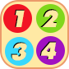
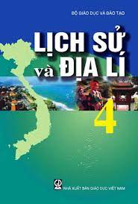 | 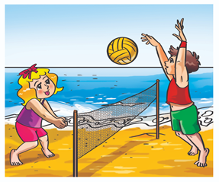 |  | 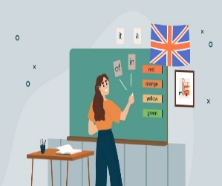
a. | b. | c. | d.

Task 2. Listen and Tick . 

  1.  a. |   b. |   c.
  2.  a. |   b. |   c.

II. READING AND WRITING
Examples: She’s a Maths teacher.. | She is drawing. 


1. He was on the beach last weekend. | 2. I was in Lodon yesterday.
 | 
Task 1. Read and tick or cross . There are two examples.

Task 2. Read and match . There is one example .

0.Where’s your school? | 0. e | a. No I was’nt.
1. What time does she go to school? | 1. | b. I have it four times a week.
2. Were you at school yesterday? | 2. | c. She goes to school at 7 o’clock.
3. How often do you have English? | 3. | d. I was in Tokyo.
4. Where were you last summer? | 4. | e. It’s in QuangTrung street.

Task 3. Read and tick True of Fasle.
Our sports day in November. It is in the school playground. There are many pupils and teachers. We play different sports and games. The boys play football. The girls play chess. The teachers play volleyball. It is a lot of fun!
 | TRUE | FALSE
1. The sport day is in November.
2. The sport day is in the school gym.
3. The boys play badminton.
4. The girls play basketball.
Task 4 . Look at the pictures and complete these sentences.
  He can…………………………… |   They are playing……………………….
She has ………………… ....on Monday. | He was at the………………………..
Task 5. Put the words in order . There is one example.
0. today?/ day/ is/What/ it/
What day is it today ?
1. subjects / what / do / have / you / today /?
_________________________________________________?
2. I / campsite / at / last / was / weekend. / the /
_________________________________________________
3. I / tobe / a / teacher. / Maths / because /like / Maths / I / want /
_________________________________________________
UBND HUYỆN CÁT HẢI
TRƯỜNG TH NGUYỄN VĂN TRỖI

MA TRẬN ĐỀ KIỂM TRA CUỐI HKI MÔN TIẾNG ANH LỚP 4
NĂM HỌC 2024-2025
Kỹ năng | Nhiệm vụ đánh giá/  kiến thức cần đánh giá | Mức/Điểm |  |  | Tổng số câu, số điểm, tỷlệ %
Nghe | Nhiệm vụ đánh giá/  kiến thức cần đánh giá | M1 | M2 | M3 |  | 6 câu  2,5 điểm  25%
Nghe | 1. Listen and number |  | 2  0,25đ | 2  0,25đ |  | 6 câu  2,5 điểm  25%
Nghe | 2. Listen and tick |  | 1  0,75đ | 1  0,75đ |  | 6 câu  2,5 điểm  25%
Đọc | 1. Read and tick or cross | 1  0,25đ | 1  0,25đ |  |  | 10 câu  2,5 điểm  25%
Đọc | 2. Read and match | 1  0,25đ | 1  0,25đ | 2  0,25đ |  | 10 câu  2,5 điểm  25%
Đọc | 3. Read and tick True or Fasle |  | 2  0,25đ | 2  0,25đ |  | 10 câu  2,5 điểm  25%
Viết | 4. Look and complete the sentences |  | 2  0,25đ | 2  0,25đ |  | 7 câu  2,5 điểm  25%
Viết | 5. Order the words to make sentences |  | 2  0,5 đ | 1  0,5 đ |  | 7 câu  2,5 điểm  25%
Nói | Getting to know each other | 1  0,25đ | 2  0,5đ |  |  | 10 câu  2,5 điểm  25%
Nói | Talking about familiar object |  | 1  0,25đ | 3  0,75đ |  | 10 câu  2,5 điểm  25%
Nói | Describing the picture |  | 1  0,25đ | 2  0,25đ |  | 10 câu  2,5 điểm  25%
Tổng |  | 4 | 15 | 15 | 34 câu  10 điểm

UBND HUYỆN CÁT HẢI
TRƯỜNG TH NGUYỄN VĂN TRỖI

HƯỚNG DẪN CHẤM KIỂM TRA CUỐI HKI MÔN TIẾNG ANH LỚP 4
NĂM HỌC 2024-2025
PART 1: LISTENING.
Task 1: Listen and number. (1 point).
1.B, 2.C, 3.D, 4.A
Task 2: Listen and tick. (1,5 points).
1.C, 2.A
PART 2: READING AND WRITING.
Task 1: Read and tick or cross (0.5 point).
1. 2.
Task 2: Read and match (1 point).
1. c, 2.a, 3. b, 4. d
Task 3 : Read and tick True of Fasle. (1 point).
1.T, 2.F, 3. T, 4.F
Task 4: Look at the pictures and complete these sentences. (1 point).
1. play the piano. 2. Basketball, 3. History and Geography, 4. Campsite.
Task 5: Reorder the words to make the sentences. (1,5 points).
1. What subjecs do you have today?
2. I was at the campsite last weekend.
3. I like Maths beacause I want to be a Maths teacher.
PART 3: SPEAKING. (2,5)

